Risk Factors for Hepatic Encephalopathy
in Hepatocellular Carcinoma after Sorafenib or Lenvatinib Treatment:
A Real-World Study

1, Bowen Chen; 2, Linzhi Zhang; 3, Jiamin Cheng; 4, Tong Wu; 5, Jin Lei;
6, Xu Yang; 7, Rongling Zhang; 8, Rifaat Safadi; 9,Yinyin Li; 10, Tongguo Si; 11, Yinying Lu

Table of contents
Fig. S1 2
Table S1 3
Table S2 4
Table S3 4
Fig. S2 5

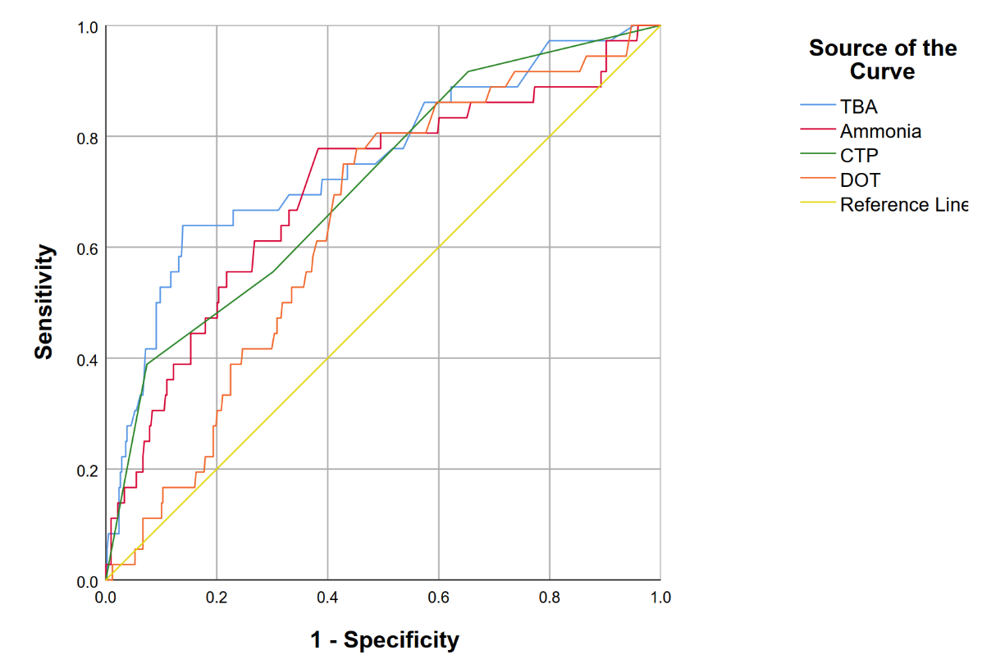

Fig. S1. Receiver Operating Characteristic (ROC) curves for Exploring Best Cut-off Value in Predicting Hepatic Encephalopathy Model.
Abbreviations in this figure: TBA: total bile acid; CTP: Child-Pugh; DOT: duration of treatment.
Table S1. Clinical Outcomes of Patients.

Variables | Sorafenib Group | Lenvatinib Group
Variables | (n = 214, %) | (n = 240, %)
Reasons for Treatment Discontinuation
Progression of Disease | 166 (77.6%) | 161 (67.1%)
Adverse Events | 19 (8.9%) | 50 (20.8%)
Rupture of Tumor | 2 (0.9%) | 4 (1.7%)
Conversion Therapy | 4 (1.9%) | 7 (2.9%)
Other Reasons | 3 (1.4%) | 2 (0.8%)
Combination of locoregional Therapy | 127 (59.3%) | 168 (70.0%)

Table S2. ROC Curves in Exploring Most Suitable Cut-Off Values.

Variables | Cut-Off Value | Sensitivity | Specificity | AUC (95%CI) | P-value
Ammonia (μmol/L) | 38.65 | 0.778 | 0.617 | 0.703 (0.607-0.799) | <0.001
Total bile acid (μmol/L) | 29.5 | 0.639 | 0.861 | 0.755 (0.592-0.788) | <0.001
Child-Pugh | 7.5 | 0.389 | 0.926 | 0.713 (0.624-0.802) | <0.001
Duration of Treatment (months) | 5.6 | 0.75 | 0.572 | 0.641 (0.557-0.725) | 0.005
Abbreviations in this table: ROC: receiver operating characteristic curve; AUC: area under curve; CI: confidence interval.

Table S3: Dynamic Changes of Serum Total Bile Acid and Ammonia 4-12 Weeks after Initiation of Treatment.
 | log₂(TBA) (μmol/L)  at baseline | log₂(TBA) (μmol/L)  4-12 weeks after initiation | t | P-value | log₂(Ammonia) (μmol/L)  at baseline |  | log₂(Ammonia) (μmol/L)  4-12 weeks after initiation | t |  | P-value
Sorafenib | 3.5 ± 1.6 | 3.1 ± 1.8 | 3.91 | <0.001 | 5.2 ± 0.6 |  | 5.2 ± 0.8 | 0.92 |  | 0.358
Lenvatinib | 3.3 ± 1.5 | 3.7 ± 1.7 | -3.86 | <0.001 | 5.1 ± 0.7 |  | 5.4 ± 0.9 | -3.7 |  | <0.001
Abbreviations in this table: TBA: total bile acid.

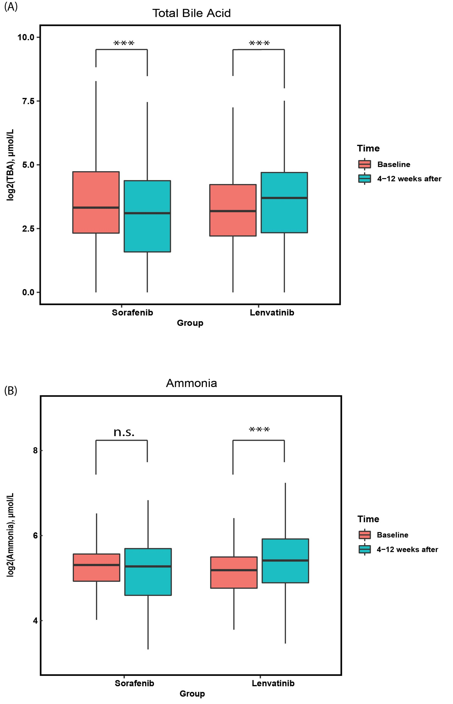
Fig. S2. Boxplot Showing Dynamic Changes of Serum Total Bile Acid and Ammonia 4-12 Weeks after Initiation of Treatment. (A) Change of Total Bild Acid; (B) Change of Ammonia. Levels of significance: *** P < 0.001; n.s.= not significant.

