Supplementary figure 1 The potential binding site of hsa_circ_0020792 and miR-193a-5p. Sequence alignment of miR-193a-5p with the putative binding sites within the regions of hsa_circ_0020792.
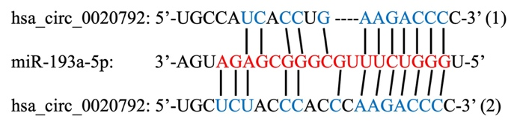

Supplementary figure 2 The level of hsa_circ_0020792 in TGF-β1-treated normal skin fibroblasts. RT-qPCR analysis of hsa_circ_0020792 level in TGF-β1-treated normal skin fibroblasts. **P < 0.01, n = 3.
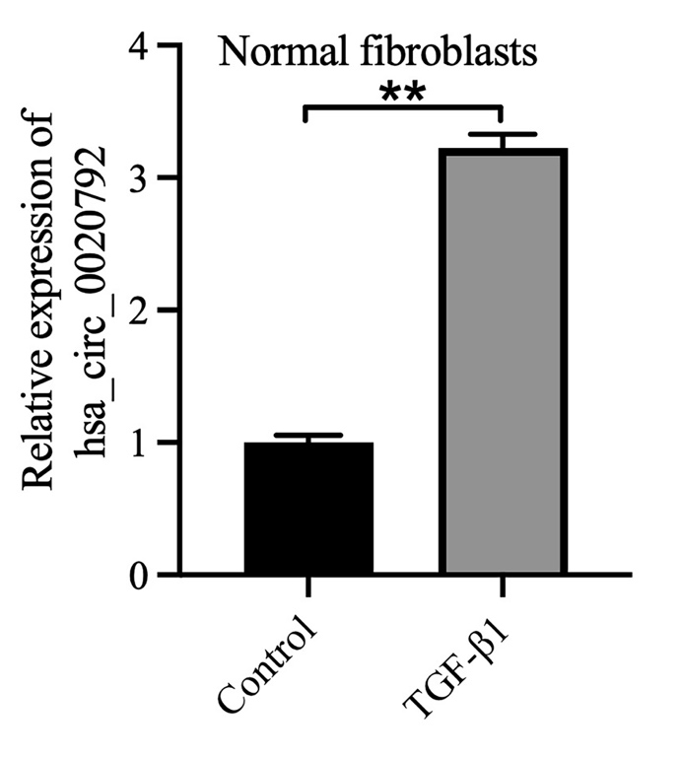
Supplementary figure 3 Knockdown of hsa_circ_0020792 inhibits the viability and induces the apoptosis of keloid fibroblasts via upregulating miR-193a-5p. Keloid fibroblasts were transfected with siR-NC, siR-circ-2, or siR-circ-2 + miR-NC or siR-circ-2 + miR-inhibitor. (A) The viability of keloid fibroblasts was detected using CCK-8 assay. (B, C) The apoptosis of keloid fibroblasts was measured using flow cytometry assay. **P < 0.01, n = 3.
