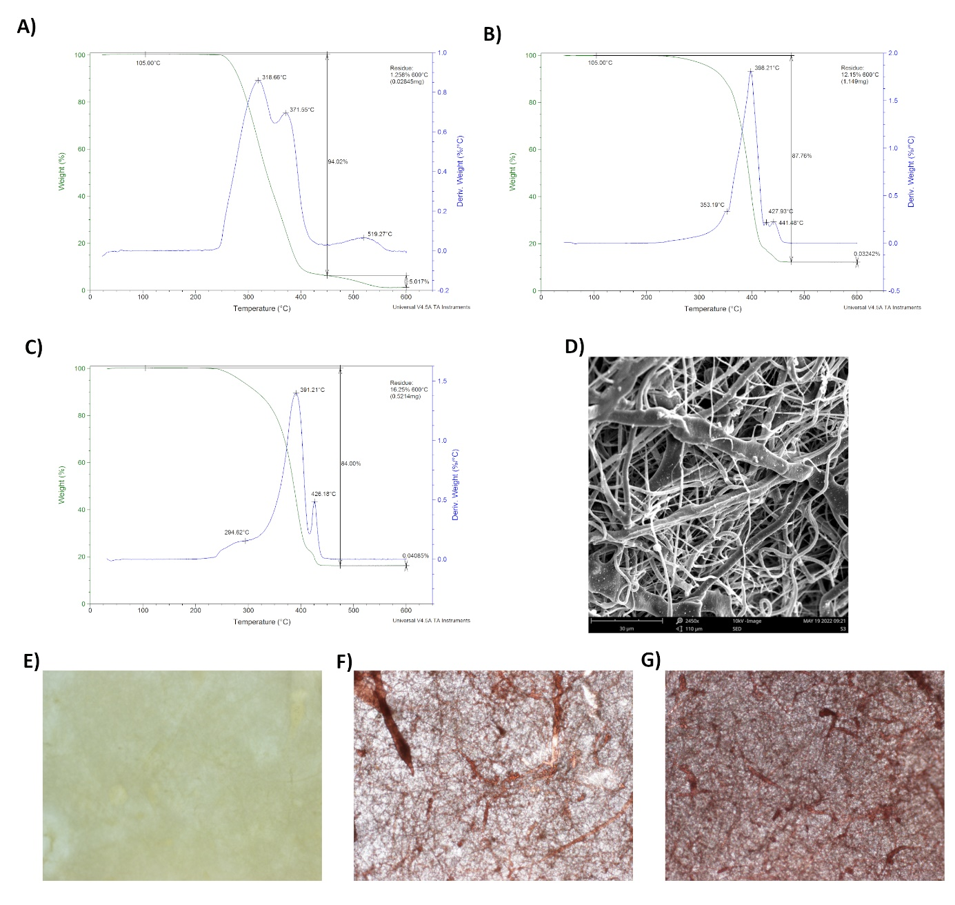
Supplementary figure 1: Detailed TGA thermographs obtained for samples S1 (ALN+, HA-, P31R1-) (A), S2 (ALN+, HA+, P31R1+) (B) and S3 (ALN-, HA+, P31R1+) (C). Residual weight (%) and weight derivative (%/ °C) curves compared for each sample. Scanning electron microscopy of S2 scaffold, scale bar 30 μm (D). Light microscope images of ARS staining of S1 (E), S2 (F) and S3 (G) scaffolds proved presence of HA on the S2 and S3 samples, magnification 40×.

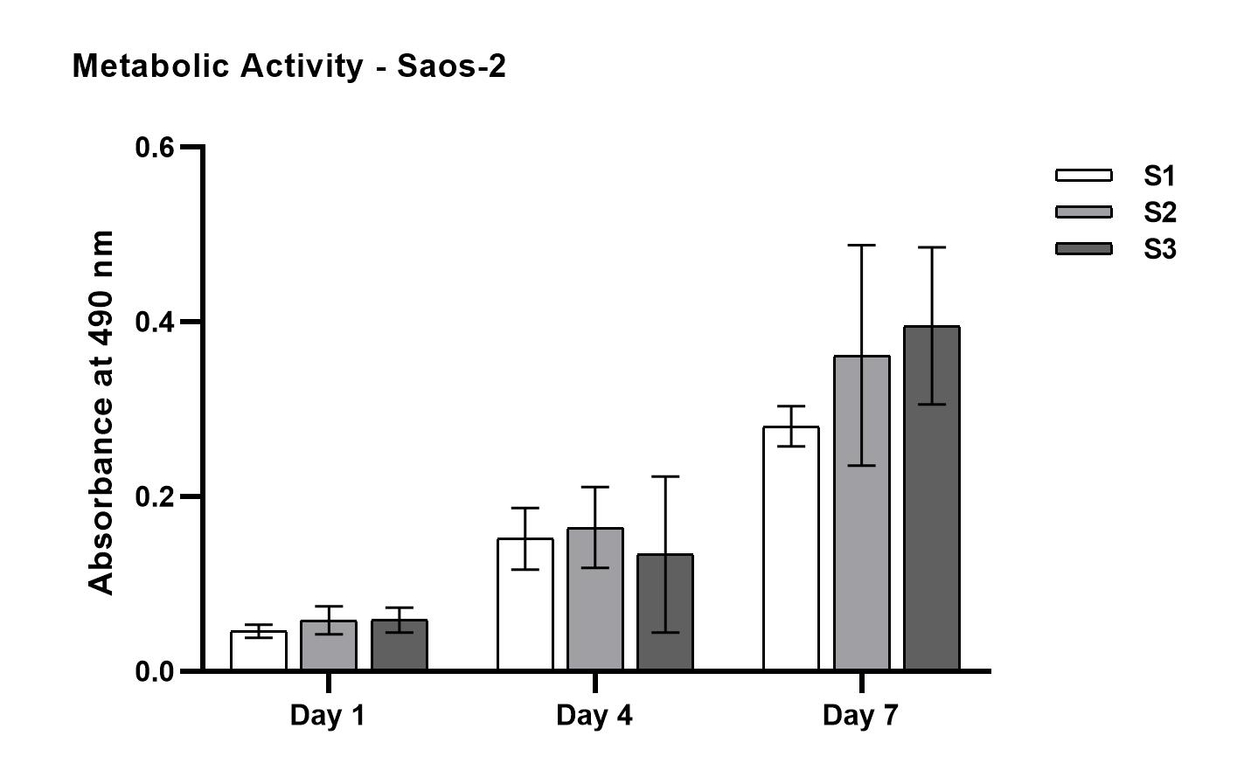
Supplementary figure 2: Metabolic activity of Saos-2 osteosarcoma cell line seeded on PCL scaffolds: S1 (ALN+, HA-, P31R1-), S2 (ALN+, HA+, P31R1+) and S3 (ALN-, HA+, P31R1+) scaffolds. An increase in metabolic activity throughout the one-week experiment was observed, no statistical significance was detected.
Abbreviations: ALN, alendronate; HA, hydroxyapatite; P31R1, pluronic P31R1.

