Supplementary Material

Supplementary Figures

Supplementary Figure 1. Kaplan-Meier curves and Log-rank test for overall survival according to different risk factors: (A) Hematogenous system metastases, (B) Lung metastases, (C) Bone metastases, (D) Inguinal LN metastases, (E) Retroperitoneal LN metastases, and (F) Disseminated metastases (metastases involved in lymph node and hematogenous systems).
Supplementary Figure 2. Kaplan-Meier curves and Log-rank test for patients with or without concurrent chemoradiotherapy in multiple metastases subgroup.

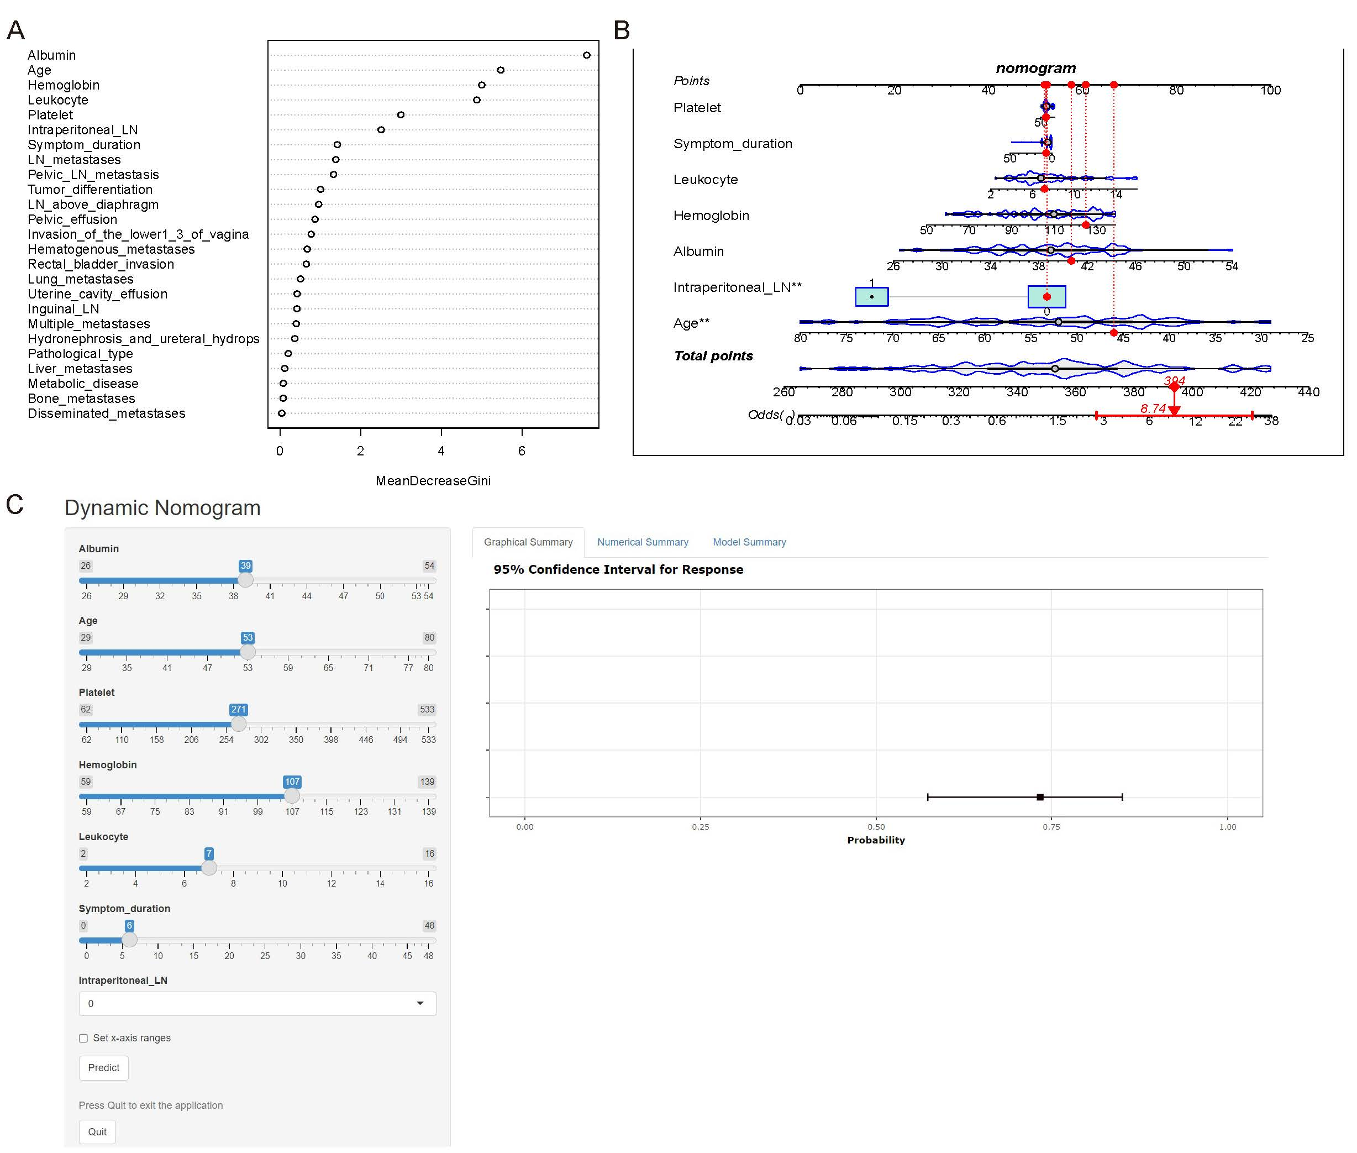
Supplementary Figure 3. Random forest algorithm screen variables associated with CCRT and construction of nomogram for CCRT. (A) Variable importance based on random forest algorithm for CCRT, (B) Nomogram for predicting the probability of patient being suitable for CCRT, (C) Dynamic nomogram for predicting the probability of mCC patient being suitable for CCRT in Shinyapps website.
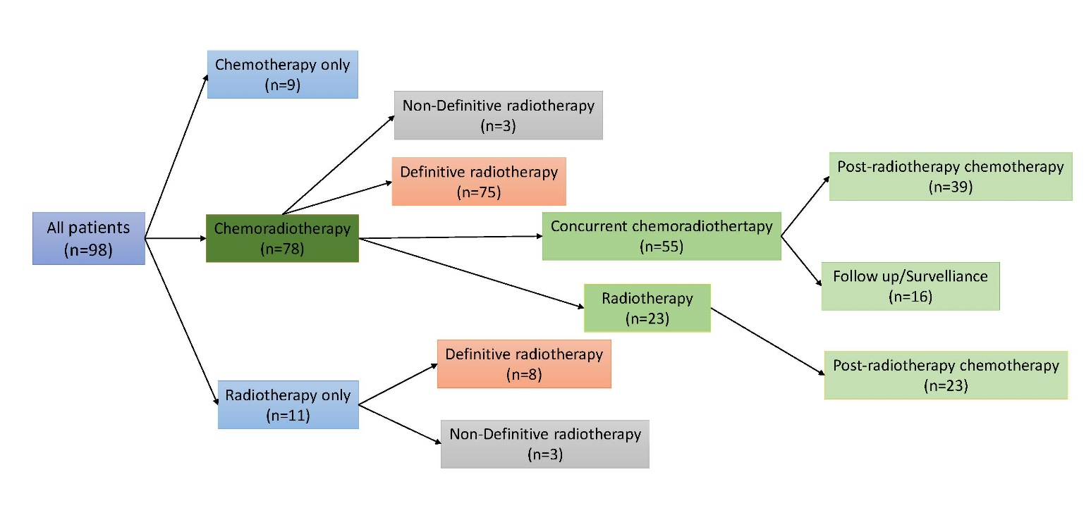
Supplementary Figure 4. The distribution of different therapy strategies for mCC patients in the overall cohort.

Supplementary Table
Supplementary Table 1. The clinicopathological characteristics of mCC patients stratified by concurrent chemoradiotherapy
Concurrent chemoradiotherapy |  | No  (n=43) | Yes  (n=55) | P
Age  Metabolic disease  Symptom duration（months） |  | 52.00 [45.00, 65.00]  9 (20.9%)  5.00 [1.70, 10.00] | 51.00 [43.00, 58.00]  8 (14.5%)  4.00 [1.25, 6.00] | 0.177  0.576  0.557
Pathological type |  |  |  | 0.139
 | Squamous cell carcinoma | 37 (86.0%) | 53 (96.4%)
 | Adenocarcinoma | 6 (14.0%) | 2 (3.6%)
Tumor differentiation |  |  |  | 0.66
 | Well differentiation | 4 (10.0%) | 3 (5.7%)
 | Moderately differentiation | 25 (62.5%) | 37 (69.8%)
 | Poorly differentiation | 11 (27.5%) | 13 (24.5%)
SCCAg(ng/ml) |  | 28.72±28.63 | 17.57±24.52 | 0.198
Hemoglobin (g/L) |  | 100.70±22.37 | 109.08±21.43 | 0.065
Platelet(10^9/L) |  | 267.74±104.59 | 257.15±100.54 | 0.618
Leukocyte (10^9/L) |  | 7.26±2.88 | 7.14±2.68 | 0.843
Albumin(g/L) |  | 37.35±5.48 | 39.47±4.06 | 0.032
Tumor maximum size (cm) |  | 5.97±3.32 | 4.88±2.10 | 0.154
Rectal/bladder invasion |  | 14 (32.6%) | 12 (21.8%) | 0.335
Pelvic LN metastases |  | 32 (74.4%) | 31 (56.4%) | 0.101
Pelvic effusion |  | 20 (50.0%) | 18 (38.3%) | 0.379
Hydronephrosis/ureteral hydrops |  | 11 (25.6%) | 12 (21.8%) | 0.845
Hematogenous metastases |  | 23 (53.5%) | 41 (74.5%) | 0.05
LN metastases |  | 34 (79.1%) | 27 (49.1%) | 0.005
Disseminated metastases |  | 14 (32.6%) | 14 (25.5%) | 0.584
Postradiotherapy chemotherapy |  | 23 (53.5%) | 39 (70.9%) | 0.053
Chemoradiotherapy |  | 23 (53.5%) | 55 (100.0%) | <0.001
Chemotherapy |  | 32 (74.4%) | 55 (100.0%) | <0.001
 | Chemotherapy cycle | 2.00 [1.00, 4.00] | 4.00 [2.00, 6.50] | 0.032
Definitive radiotherapy |  | 28 (63.6%) | 55 (100%) | <0.001
 | EBRT dose (Gy) | 50.00 [50.00, 50.00] | 50.00 [50.00, 50.40] | 0.004
 | Brachytherapy dose (Gy) | 25.00 [20.00, 25.00] | 20.00 [20.00, 25.00] | 0.284
 | Total pelvic dose (Gy) | 70.40 [50.40, 75.00] | 70.40 [70.00, 75.00] | 0.302

Abbreviations: SCCAg: Squamous cell carcinoma antigen, LN: Lymph node, EBRT: External beam radiation therapy.

 |  |  | Number (%) | Median OS (months)
Chemotherapy only |  |  | 9 (9.2) | NA.
Radiotherapy only |  |  | 11 (11.2) | 8
 | Definitive radiotherapy |  | 8 (8.2) | 9.5
 | Non-definitive radiotherapy |  | 3 (3.1) | 3
Chemoradiotherapy |  |  | 78 (79.6) | 47
 | Definitive radiotherapy |  | 75 (76.5) | 47
 | Non-definitive radiotherapy |  | 3 (3.1) | 12
 | Concurrent chemoradiotherapy |  | 55 (56.1) | 57
 |  | Postradiotherapy chemotherapy | 39 (39.8) | 57
 |  | Follow-up/Surveillance | 16 (16.3) | 30
 | Non-concurrent radiotherapy |  | 23 (23.5) | 23
 |  | Postradiotherapy chemotherapy | 23 (23.5) | 23
Supplementary Table 2. Distribution and overall survival of patients underwent different therapeutic regimen

Abbreviations: OS: Overall survival.

