Appendices
Interpretation | Fasting Blood glucose level
Normal | < 5.5 mmol/l
Impaired fasting blood glucose | 5.5 mmol/l – 7 mmol/l
Diabetic | ˃ 7 mmol/l
Reference ranges of biochemical hormones endorsed by the World Health Organization

Appendix (1)

Interpretation | Free thyroxine level (T4)
Normal | 0.8 ng/dl -1.8 ng/dl
Low | ˂ 0.8 ng/dl
High | ˃ 1.8 ng/dl

Appendix (2)

Interpretation | Thyroid stimulating hormone level (TSH)
Normal | 0.4 mIU/l – 4 mIU/l
Low | ˂ 0.4 mIU/l
High | ˃ 4 mIU/l

Appendix (3)

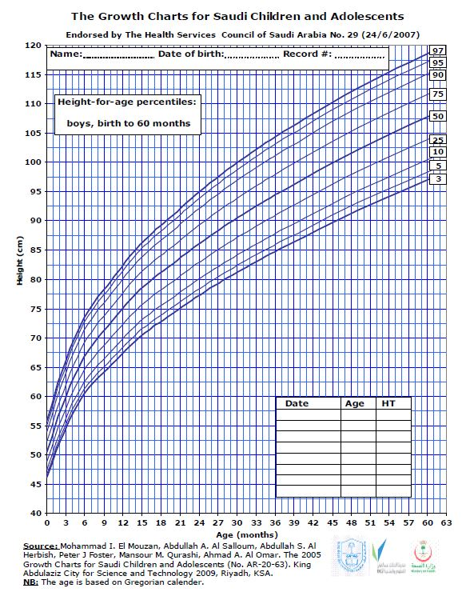

Appendix (4)

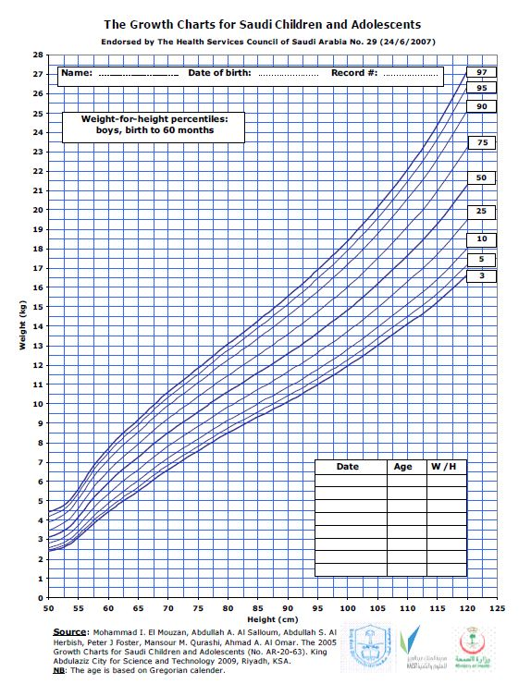

Appendix (5)
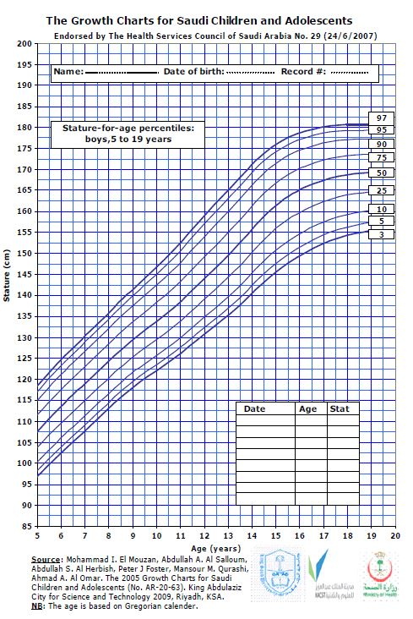

Appendix (6)

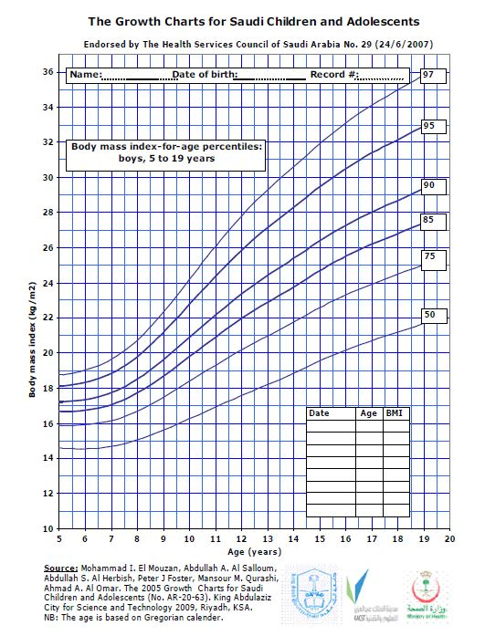
Appendix (7)
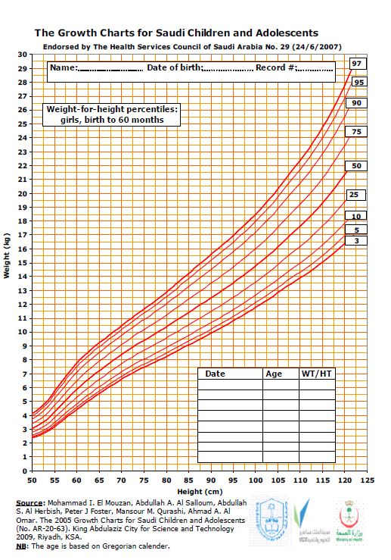
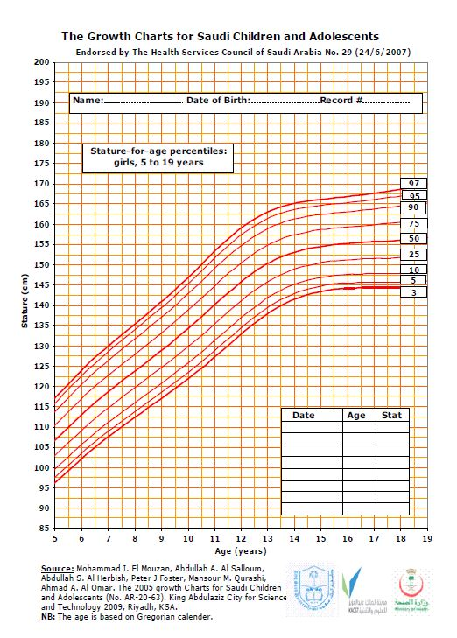
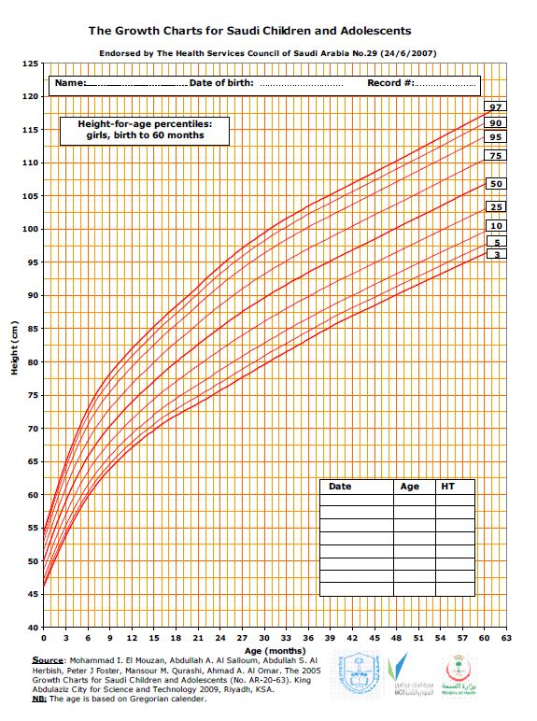
Appendix (8)
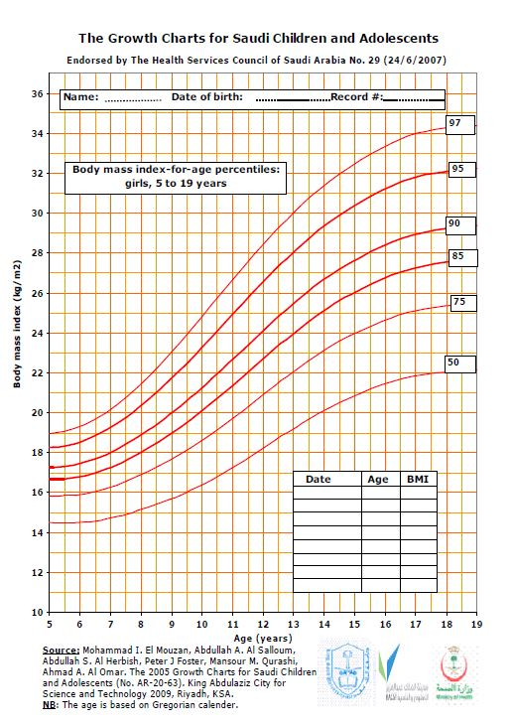
Appendix (9)
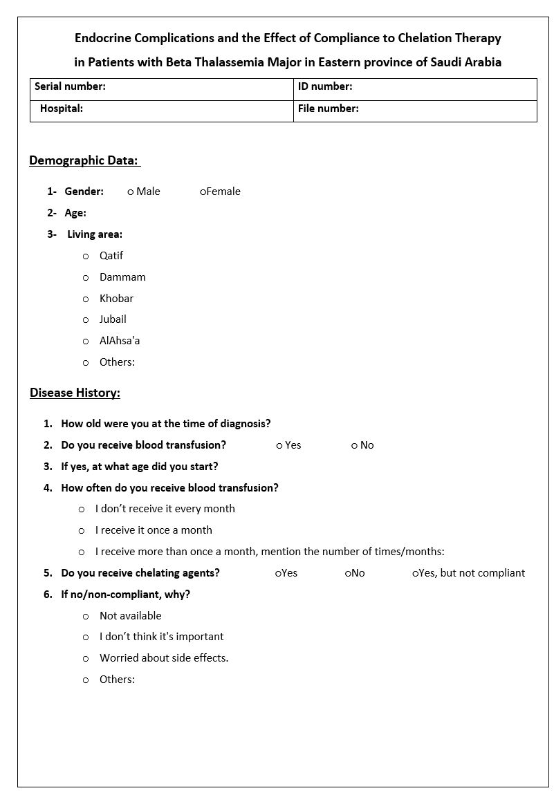
Appendix (10)
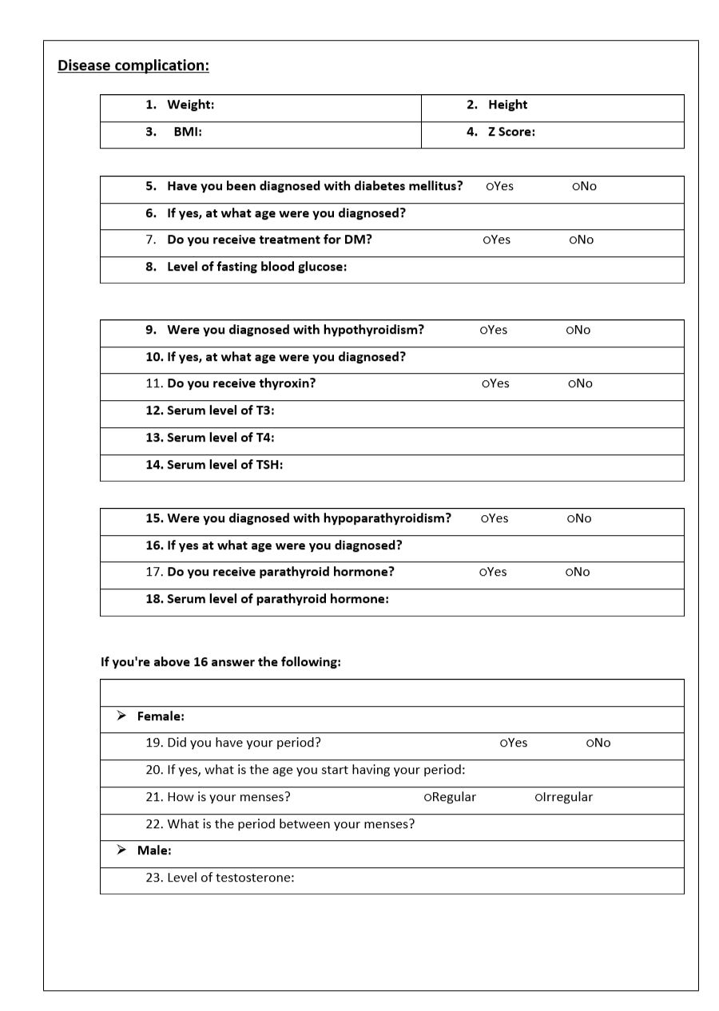
Appendix (11)
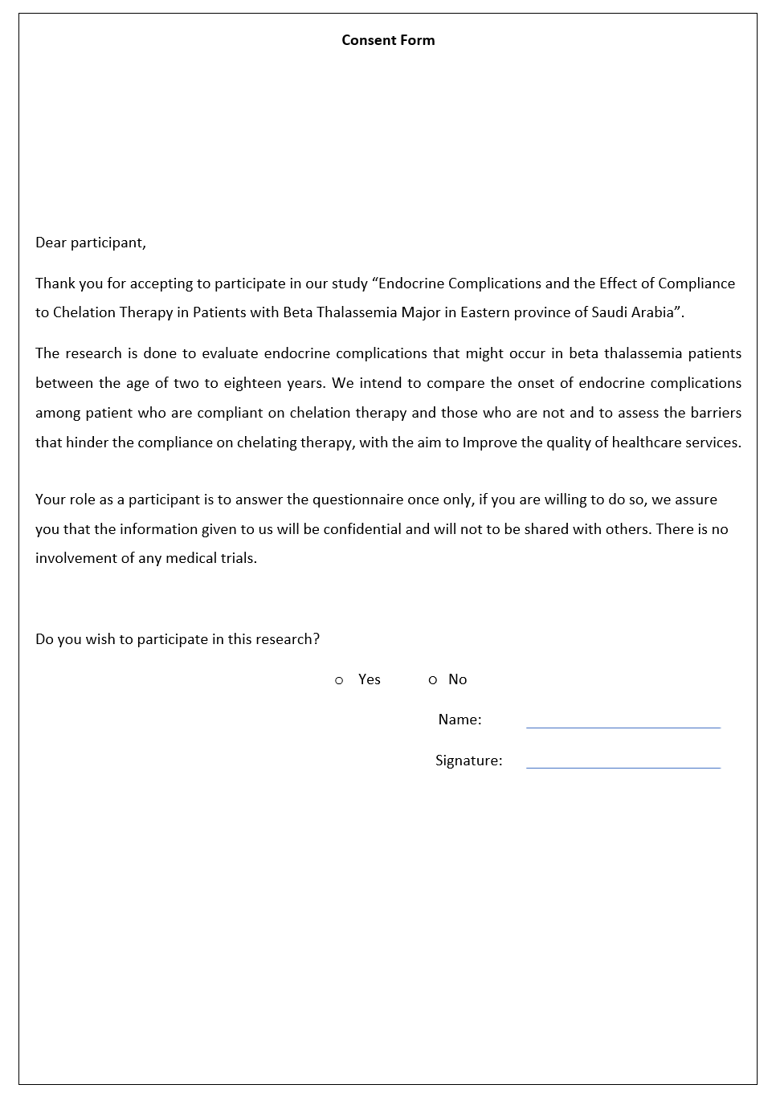
Appendix (12)

