Supplementary materials for

Biodistribution and toxicological effects of ultra-small Pt nanoparticles deposited on Au nanorods (Au@Pt NRs) in mice with intravenous injection

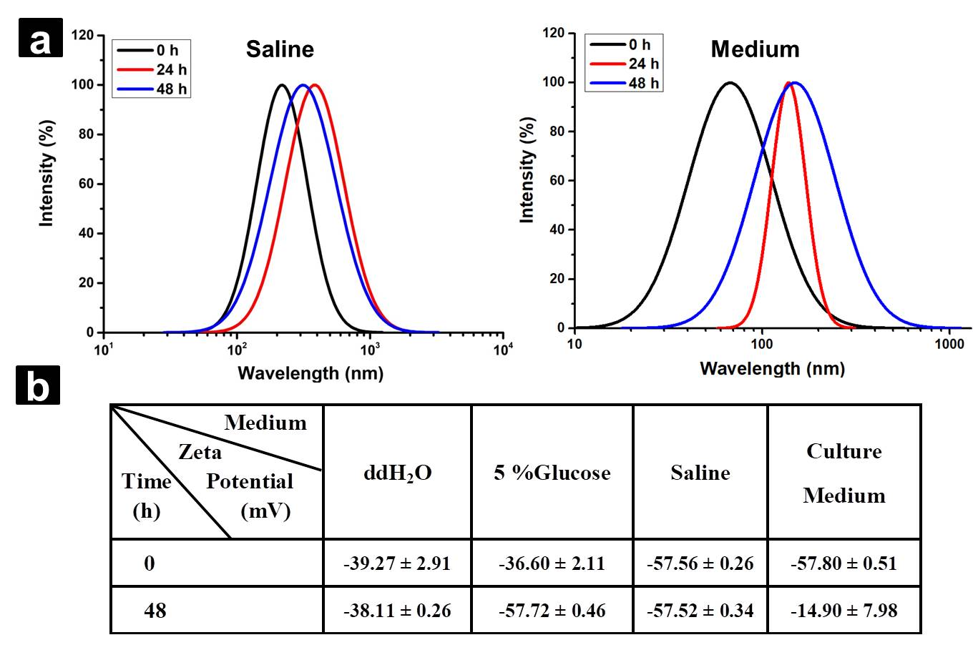
Figure S1. (a) Particle size dispersion of Au@Pt NRs in saline and cell culture medium within 48 h. (b) Zeta potential value of Au@Pt NRs in various medium (ddH₂O, 5 % glucose, saline and cell culture medium) within 48 h. Zeta data represents the mean ± SD (n = 3).

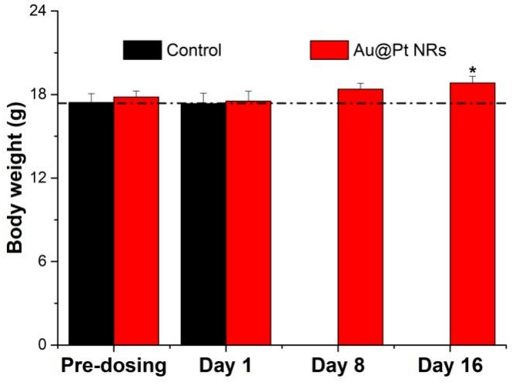
Figure S2. The weight of mice at pre-dosing, Day 1, Day 8 and Day 16 post injection. Each data represents the mean ± SD (n = 4). * represents the significant difference compared with the pre-dosing group. *: 0.01<p<0.05.

Figure S3. The sums of Au and Pt in all the organs at Day 1, Day 8 and Day 16 post injection.

Figure S4. The distribution changes of Pt/Au ratios in the organs at Day 1, Day 8 and Day 16 post injection. (a) Pt/Au ratio. (b) The changes of Pt/Au ratio in the organs compared with control, respectively. Each data represents the mean ± SD (n = 4). * represents the significant difference compared with control. *: 0.01<p<0.05, **: 0.001<p<0.01, ***: p<0.001.

Methods
- Preparation of Au NRs
CTAB (7.5 mL, 0.1 M) was mixed with HAuCI₄ (100 μL, 25 mM) and diluted with water to 9.4 mL. Then, 0.6 mL 0.01 M of ice-cold NaBH₄ was added. The color of the solution changed to brown, indicating the formation of Au seeds. The growth solution of Au NRs consisted CTAB (10 mL, 0.1 M), HAuCI₄ (200 μL, 25 mM), AgNO₃ (100 μL, 10 mM), H₂SO₄ (100 μL, 1 M), and AA (80 μL, 0.1 M). Then, 24 μL Au seeds were added to the solution to initial the growth of Au NRs. After 12 h at 30 °C, the obtained Au NRs were purified by centrifuging twice (12000 rpm, 5 min) and resuspended in ddH₂O.

- Determination of Au@Pt NRs Concentration
The nanoparticle concentration of Au@Pt NRs is estimated based on the concentration of Au NRs. Generally, Inductively Coupled Plasma-Mass Spectrometry (ICP-MS) is employed to determine the total concentration of Au atoms in a given Au NRs suspension. According to the molar volume of a gold atom (10.2 cm³/mol), the total volume (V) of all AuNRs in the suspension was obtained. From the TEM images, the diameters and lengths of Au NRs can be measured and the mean volume of a single Au NRs (V₀) can be calculated by assuming a cylindrical shape with two half-sphere end-caps. The Au NRs molar concentration in the suspension can be estimated as V/AV₀, where A is Avogadro’s constant. The spectrum of Au@Pt NRs at the same particle concentration can be obtained during the process of syntheses. The atom concentrations of Pt and Au were measured by ICP-MS and the ratio was 0.3. Therefore, the particle concentration of Au@Pt NRs can be estimated according to the Lambert-Beer law that the concentration is proportional to the extinction value of spectrum.

