Real-world clinical and patient-reported outcomes from the longitudinal telotristat ethyl treatment registry of patients with neuroendocrine tumors
Daneng Li¹, Christina Darden², Noran Osman³, Salma Sayeed³, Laurin Jackson², Diana Garbinsky², Aman Chauhan⁴
¹City of Hope Comprehensive Cancer Center and Beckman Research Institute, Duarte, CA, USA; ²RTI Health Solutions, Research Triangle Park, NC, USA; ³TerSera Therapeutics, Deerfield, IL, USA; ⁴Markey Cancer Center, University of Kentucky, Lexington, KY, USA

SUPPLEMENTARY INFORMATION
Figure S1. PGIC: 6-month changes in CS symptoms
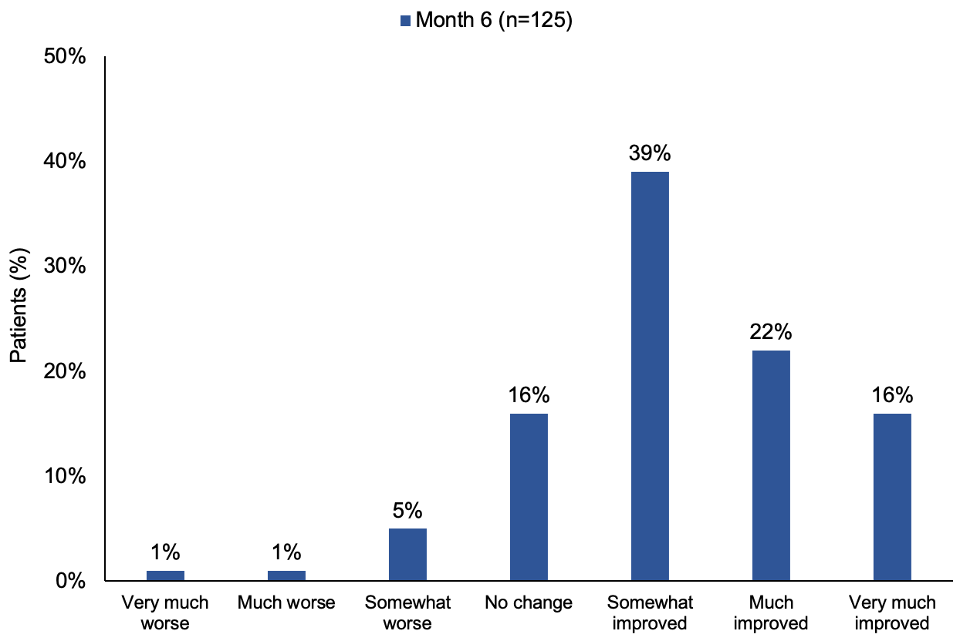

Figure S2. Patient-reported use of SSAs
A) Long-acting monthly SSA use
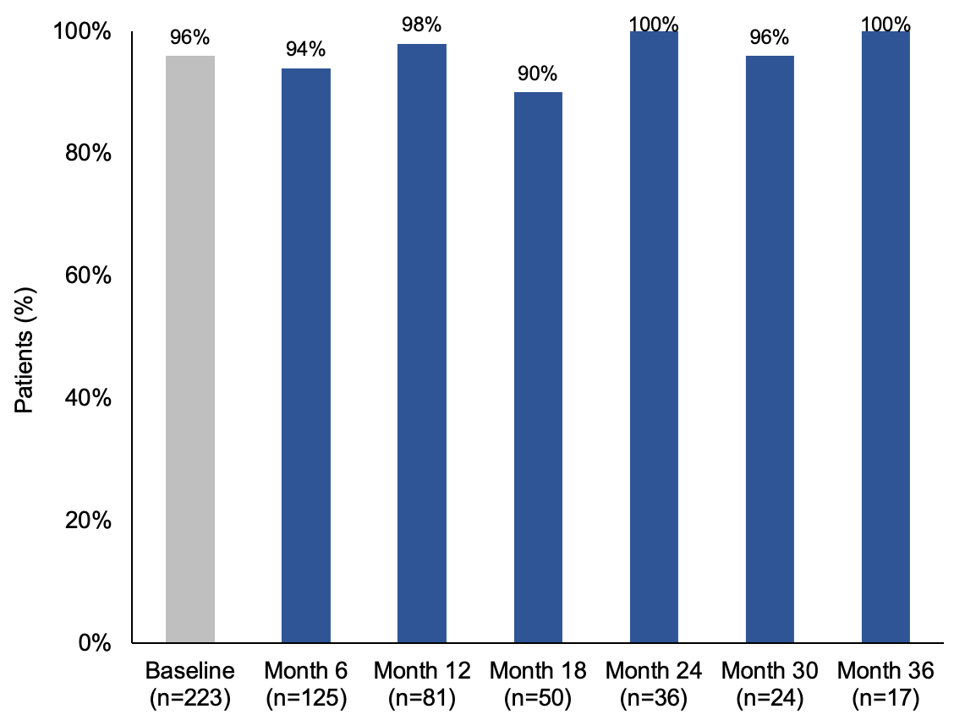
Figure S2. Patient-reported use of SSAs
B) Short-acting rescue SSA therapy
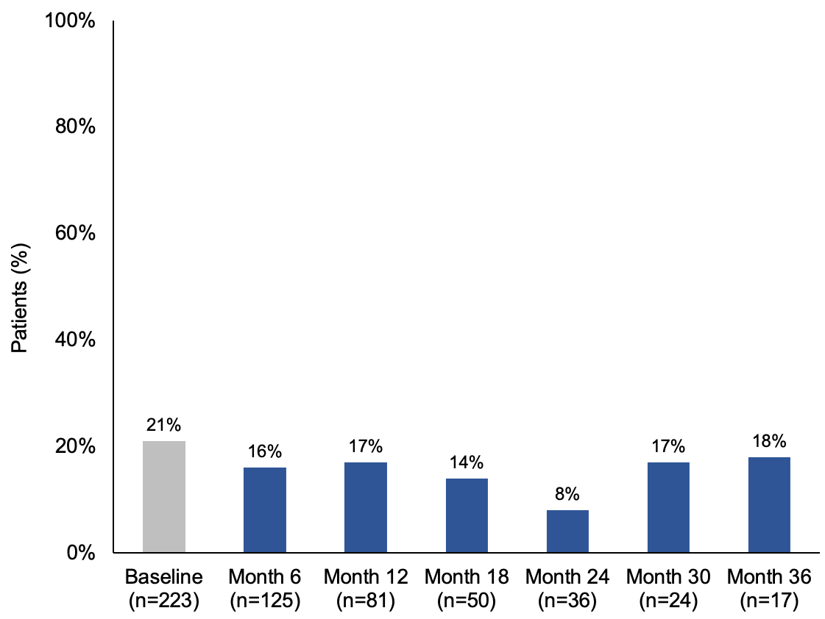
Note: At baseline, patients reported SSA use for the past 1 month; at each post-baseline timepoint, patients reported SSA use for the previous 6 months.
Figure S3. Patient-reported dosing and frequency of long-acting SSAs
A) Changes in dosing of long-acting monthly SSAs
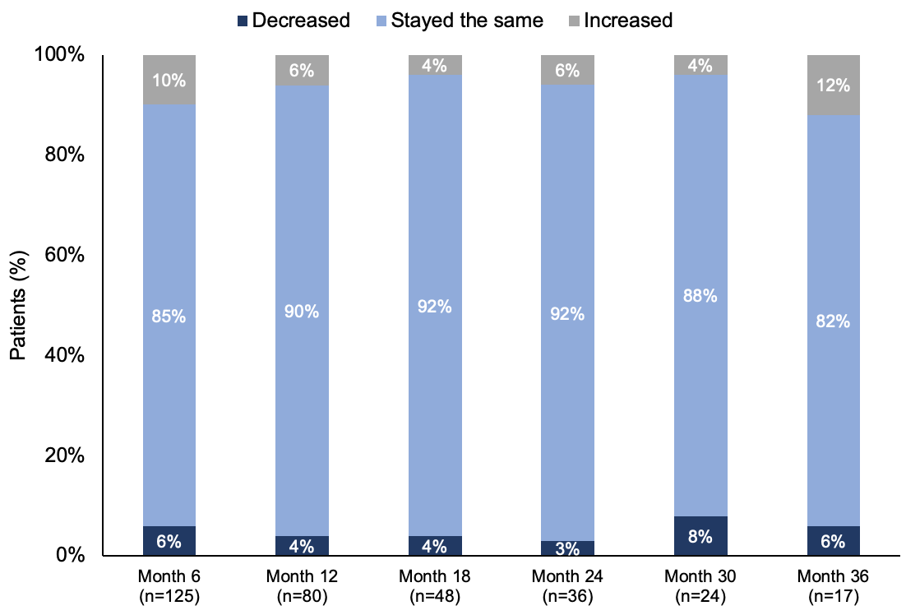
Figure S3. Patient-reported dosing and frequency of long-acting SSAs
B) Changes in frequency of long-acting monthly SSAs
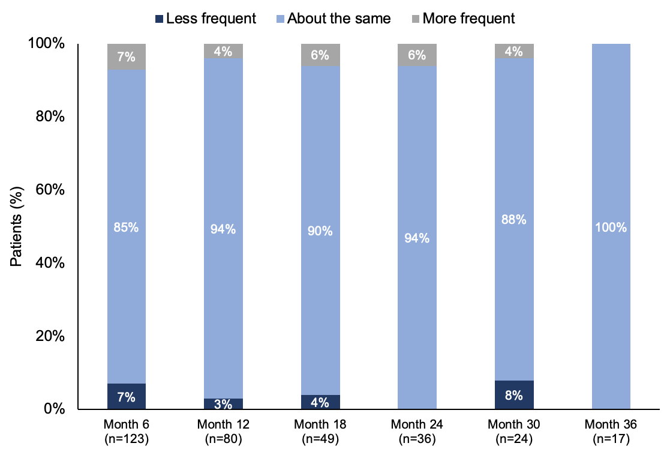
Proportions may not sum to 100% due to rounding.

Figure S4. Patient-reported CS-related ED visits and hospitalizations
A) Patients with ≥1 CS-related ED visit in the previous 6 months
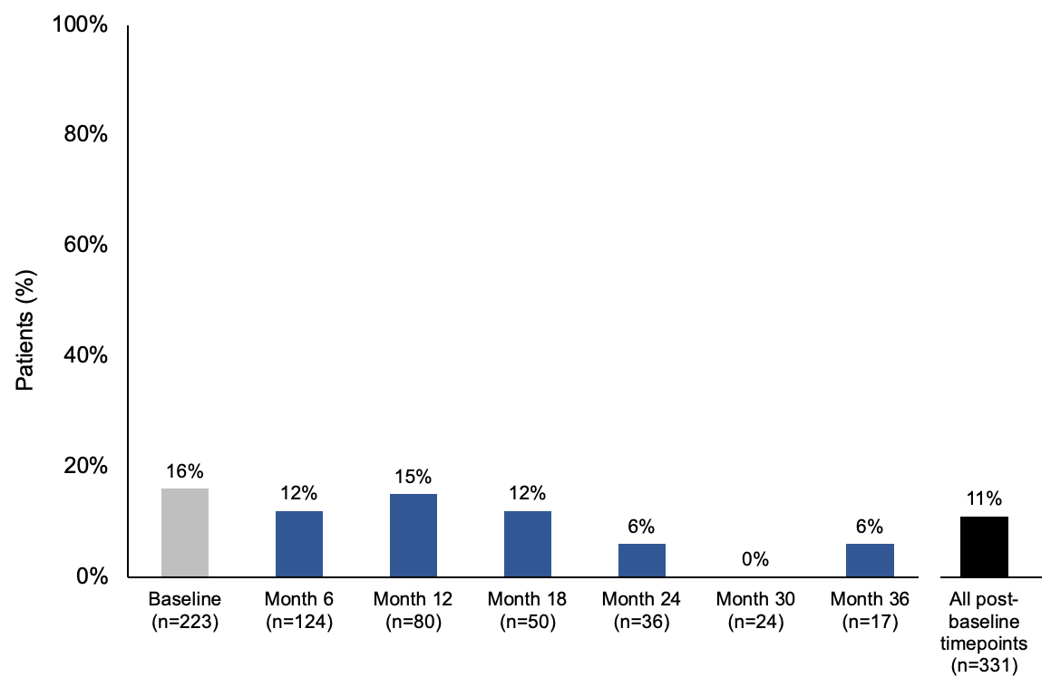
Figure S4. Patient-reported CS-related ED visits and hospitalizations
B) Patients with ≥1 CS-related hospitalization in the previous 6 months
