Supporting Information

Gallium Metal−Organic Nanoparticles with Albumin-Stabilized and Loaded Graphene for Enhanced Delivery to HCT116 cells
Yuan-yuan Wu¹, Wen-Hui Liao¹, Zong-ling Niu¹, Si-Han Zhou¹, Tian-Tian Wu¹, Zhe Li², Qi-Hua Zhao¹, Jing-Yuan Xu², Ming-jin Xie^{1,*}
¹ School of Chemical Science and Technology, Yunnan University, Kunming, People’s Republic of China.
² Department of Chemical Biology and Tianjin Key Laboratory on Technologies Enabling Development of Clinical Therapeutics and Diagnostics (Theranostics), School of Pharmacy, Tianjin Medical University, Tianjin, People’s Republic of China.
*Corresponding author： Ming-jin Xie. Email: mjxie@ynu.edu.cn

Figures 3
Figure S1. Size distributions of Ga/HBrQ NPs on GO. 3
Figure S2. Zeta potential of BSA/Ga/HBrQ NP, GO/Ga/HBrQ NP, BSA, GO and Ga(III) + HBrQ complex. 3
Figure S3. Standard curve of Ga³⁺ in ultrapure water. 4
Figure S4. Scanning electron microscope-energy scattering spectrum of BSA/Ga/HBrQ NP (a) SEM image, (b), (c), (d), (e), (f), (g) espectively Elemental distribution of Ga, C, O, N, Br, S on the surface of nano-drugs. 4
Figure S5. Scanning electron microscope-energy scattering spectrum of GO/Ga/HBrQ NP (a) SEM image, (b), (c), (d), (e), (f) respectively Elemental distribution of Ga, C, O, N, Br on the surface of nano-drugs. 5
Figure S6. Variation of DLS average particle size of (a) BSA/Ga/HBrQ NP and (b) GO/Ga/HBr Q NP in PBS with different pH. 5
Figure S7. Pictures of Ga(III) + HBrQ complex dissolved in pH=7.2-7.4 PBS buffer different time points. 6
Figure S8. Fluorescence spectra of BSA/Ga/HBrQ NP, GO/Ga/HBrQ NP and Ga(III) + HBrQ complex. 6
Figure S9. Fluorescence lifetimes of (a) Ga(III) + HBrQ complex, (b) BSA/Ga/HBrQ NP and (c) GO/Ga/HBrQ NP in air. 7
Figure S10. Cell experiment of Ga(III) +HBrQ complex. (a) IC₅₀ (μM) values of compounds toward HCT116 cells and LO2 cells after 72 hours; (b) cell cycle distribution of HCT116 cells after treatment with 10μM compounds for 24 hours; (c) apoptosis ratio of HCT116 cells after treatment with 10 μM compounds for 24 hours; (d) Confocal laser scanning microscope images of Intracellular ROS detection in HCT116 cells incubated with PBS or compounds (10 μM) treatment. 7

Figures
Figure S1. Size distributions of Ga/HBrQ NPs on GO.

Figure S2. Zeta potential of BSA/Ga/HBrQ NP, GO/Ga/HBrQ NP, BSA, GO and Ga(III) + HBrQ complex.

Figure S3. Standard curve of Ga³⁺ in ultrapure water.

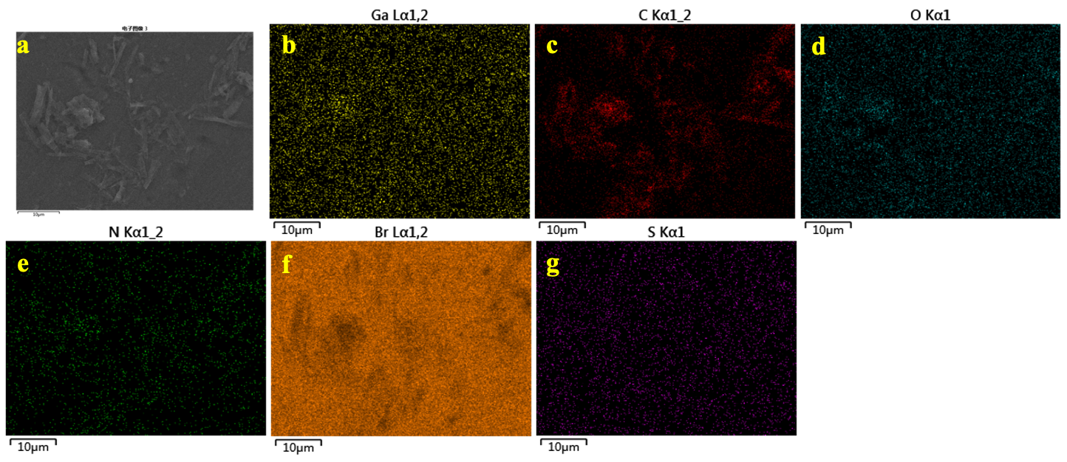
Figure S4. Scanning electron microscope-energy scattering spectrum of BSA/Ga/HBrQ NP (a) SEM image, (b), (c), (d), (e), (f), (g) espectively Elemental distribution of Ga, C, O, N, Br, S on the surface of nano-drugs.

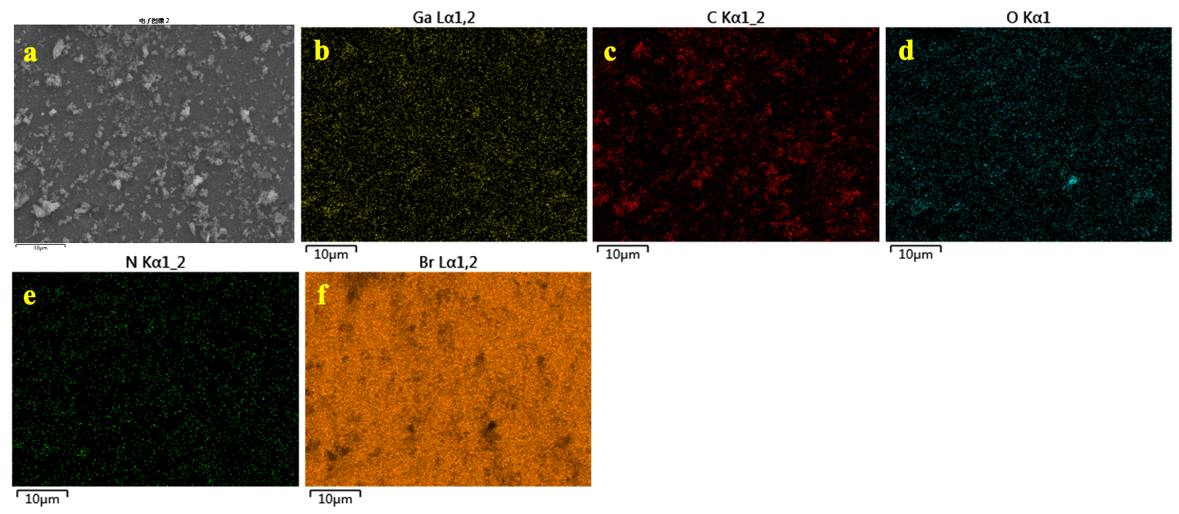
Figure S5. Scanning electron microscope-energy scattering spectrum of GO/Ga/HBrQ NP (a) SEM image, (b), (c), (d), (e), (f) respectively Elemental distribution of Ga, C, O, N, Br on the surface of nano-drugs.

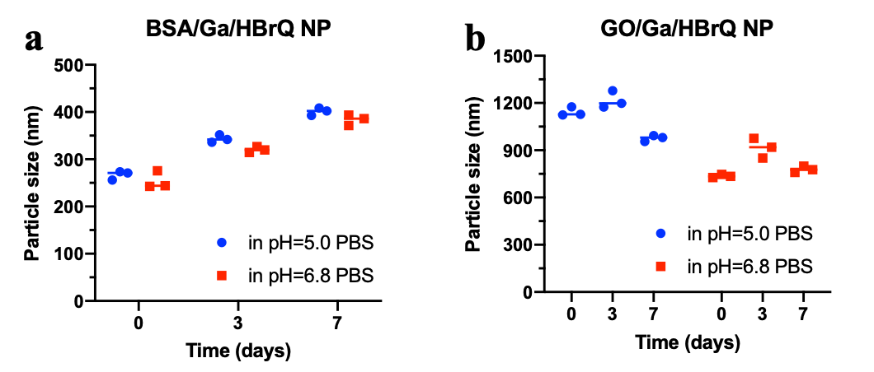
Figure S6. Variation of DLS average particle size of (a) BSA/Ga/HBrQ NP and (b) GO/Ga/HBr Q NP in PBS with different pH.

Figure S7. Pictures of Ga(III) + HBrQ complex dissolved in pH=7.2-7.4 PBS buffer different time points.
Figure S8. Cell experiment of Ga(III) +HBrQ complex. (a) IC₅₀ (μM) values of compounds toward HCT116 cells and LO2 cells after 72 hours; (b) cell cycle distribution of HCT116 cells after treatment with 10μM compounds for 24 hours; (c) apoptosis ratio of HCT116 cells after treatment with 10 μM compounds for 24 hours; (d) Confocal laser scanning microscope images of Intracellular ROS detection in HCT116 cells incubated with PBS or compounds (10 μM) treatment.

Figure S9. Fluorescence spectra of BSA/Ga/HBrQ NP, GO/Ga/HBrQ NP and Ga(III) + HBrQ complex.

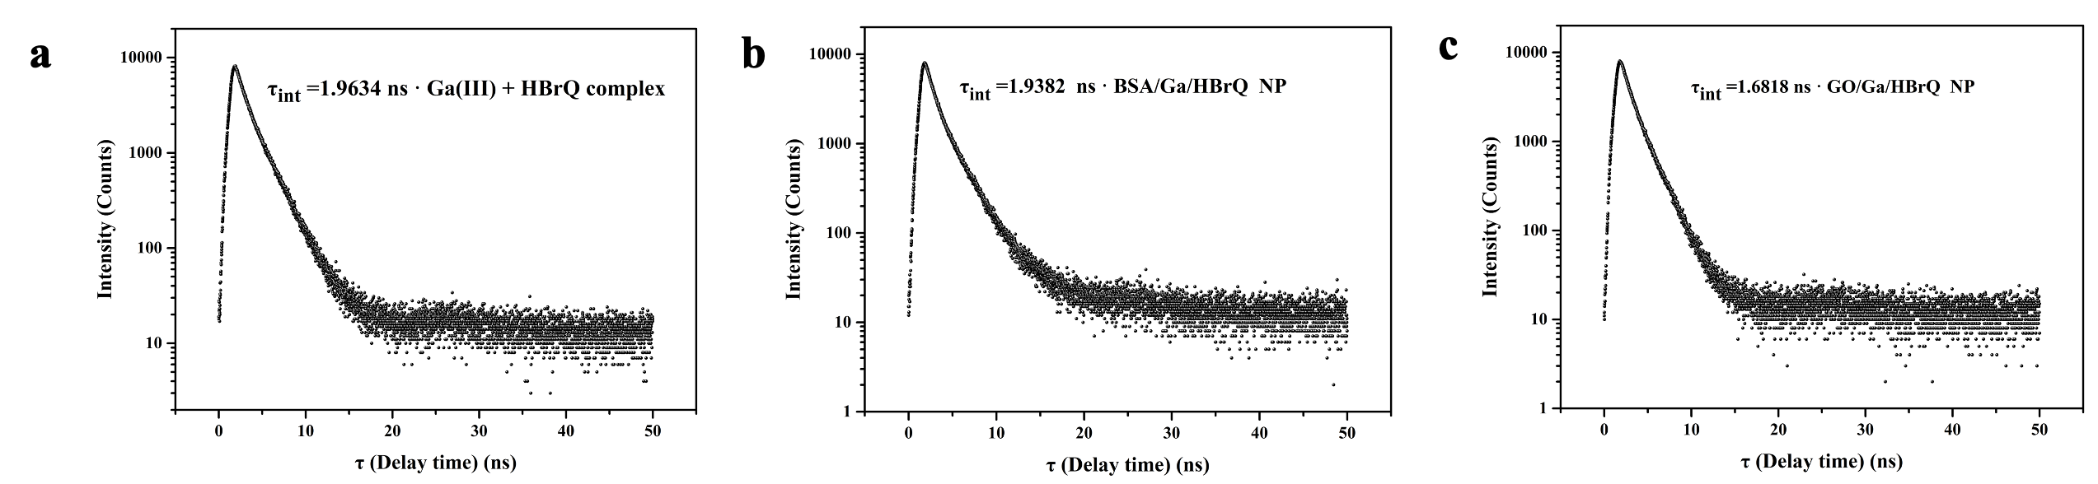
Figure S10. Fluorescence lifetimes of (a) Ga(III) + HBrQ complex, (b) BSA/Ga/HBrQ NP and (c) GO/Ga/HBrQ NP in air.

