Supplementary Data

Functionalized Prussian Blue Nanozyme as Dual-Responsive Drug Therapeutic Nanoplatform against Periodontal Disease via Macrophage Polarization

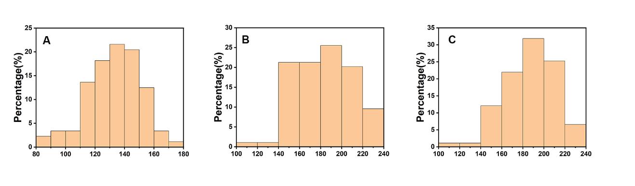
Figure S1. Particle size distribution diagram of HMPB, HMPB@PDA and HMPB@Cur@PDA (A-C).

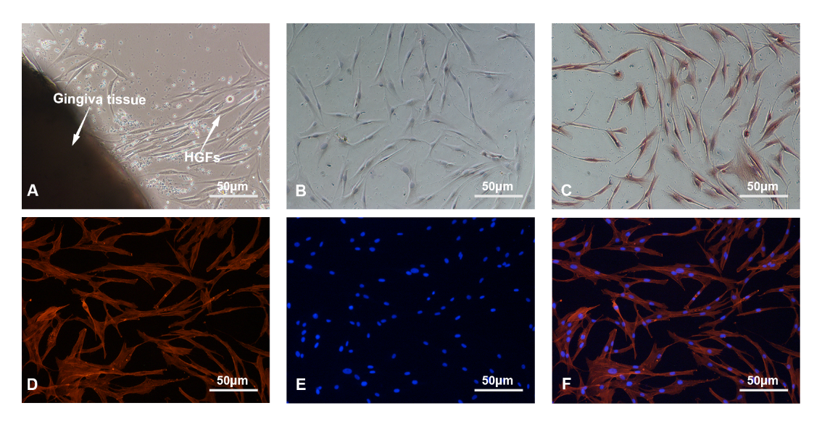
Figure S2. The extraction and identification of HGFs. (A)The cells after 6 days of tissue culture. Cell characterization with negative cytokeratin 8 (B) and positive vimentin (C). Phalloidin staining (D), nuclear staining (E) and merge images of HGFs.

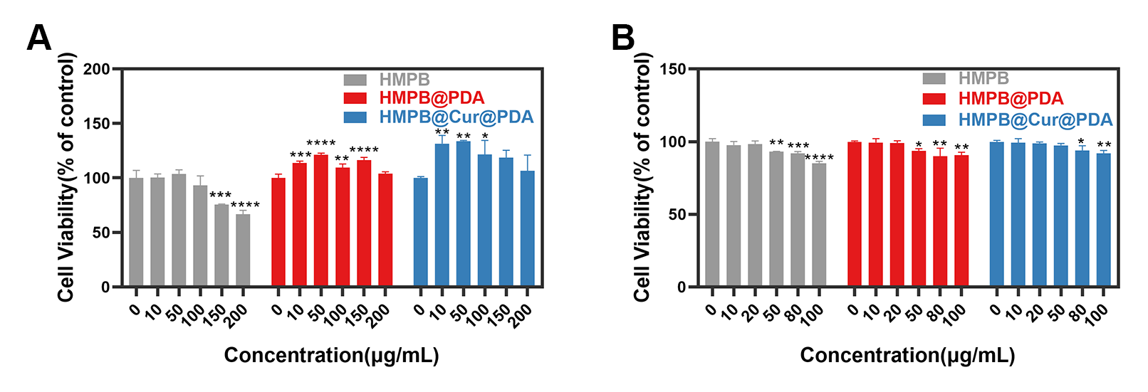
Figure S3. The viability of RAW264.7 cells (A) and HGFs (B) incubated with different concentrations of various NPs for 5 days.

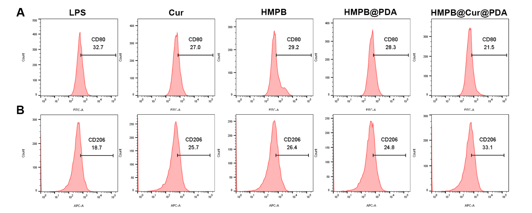
Figure S4. The proportion of pretreated macrophage cells measured by flow cytometry after LPS stimulation. (A) The CD80 (FITC channel) and (B) CD206 (APC channel) were employed to specifically label M1 and M2 macrophages, respectively.

Table S1. The primer sequences for RT-qPCR.
Organisms | Gene | Forward sequence | Reverse sequence
Mus musculus | TNF-α | CAGGCGGTGCCTATGTCTC | CGATCACCCCGAAGTTCAGTAG
Mus musculus | IL-1β | GAAATGCCACCTTTTGACAGTG | TGGATGCTCTCATCAGGACAG
Mus musculus | iNOS | GTTCTCAGCCCAACAATACAAGA | GTGGACGGGTCGATGTCAC
Mus musculus | Arg-1 | CTCCAAGCCAAAGTCCTTAGAG | GGAGCTGTCATTAGGGACATCA
Mus musculus | TGF-β | CCACCTGCAAGACCATCGAC | CTGGCGAGCCTTAGTTTGGAC
Mus musculus | IL-10 | CTTACTGACTGGCATGAGGATCA | GCAGCTCTAGGAGCATGTGG
Mus musculus | β-Actin | CATCCGTAAAGACCTCTATGCCAAC | ATGGAGCCACCGATCCACA
Homo sapiens | TNF-α | CCTCTCTCTAATCAGCCCTCTG | GAGGACCTGGGAGTAGATGAG
Homo sapiens | IL-1β | ATGATGGCTTATTACAGTGGCAA | GTCGGAGATTCGTAGCTGGA
Homo sapiens | β-Actin | CATGTACGTTGCTATCCAGGC | CTCCTTAATGTCACGCACGAT

