APPENDIX/Supplemental material

Appendix A: Figure 1. Study Design Figure - Primary Objective
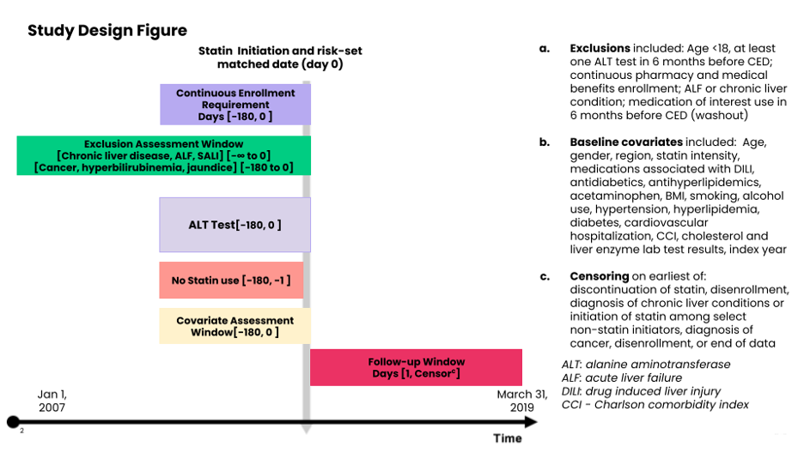

Appendix B: List of Statins
List of Statins | Source
- Atorvastatin  - Fluvastatin  - Lovastatin  - Pravastatin  - Rosuvastatin  - Simvastatin  - Pitavastatin | https://www.heart.org/-/media/files/health-topics/cholesterol/chlstrmngmntgd_181110.pdf

Appendix C: Claims-based algorithm using ICD-9 CM, and ICD-10 CM Codes for identification of severe acute liver injury with hospitalization or ED visit

CODE | TYPE | DESCRIPTION
572.2 | ICD 9 | Hepatic encephalopathy
573.3 | ICD 9 | Hepatitis unspecified
570 | ICD 9 | Acute and subacute necrosis of liver
782.4 | ICD 9 | Jaundice unspecified not of newborn
573.8 | ICD 9 | Other specified disorders of liver
573.9 | ICD 9 | Unspecified disorder of liver
V42.7 | ICD 9 | Liver replaced by transplant
K71.0 | ICD 10 | Toxic liver disease with cholestasis
K71.1 | ICD 10 | Toxic liver disease with hepatic necrosis
K71.10 | ICD 10 | Toxic liver disease with hepatic necrosis, without coma
K71.11 | ICD 10 | Toxic liver disease with hepatic necrosis, with coma
K71.2 | ICD 10 | Toxic liver disease with acute hepatitis
K71.6 | ICD 10 | Toxic liver disease with hepatitis, not elsewhere classified
K71.9 | ICD 10 | Toxic liver disease, unspecified
K72.0 | ICD 10 | Acute and subacute hepatic failure
K72.00 | ICD 10 | Acute and subacute hepatic failure without coma
K72.01 | ICD 10 | Acute and subacute hepatic failure with coma
K72.9 | ICD 10 | Hepatic failure, unspecified
K72.90 | ICD 10 | Hepatic failure, unspecified without coma
K72.91 | ICD 10 | Hepatic failure, unspecified with coma
K75.9 | ICD 10 | Inflammatory liver disease, unspecified
K76.2 | ICD 10 | Central hemorrhagic necrosis of liver
K76.8 | ICD 10 | Other specified diseases of liver
K76.89 | ICD 10 | Other specified diseases of liver
K76.9 | ICD 10 | Liver disease, unspecified
R17 | ICD 10 | Unspecified jaundice
Z94.4 | ICD 10 | Liver transplant status

Note: Data from these studies.¹³⁻¹⁵

Appendix D: Standardized Differences for Primary Objective
Appendix D1: Primary Objective - Standardized differences comparing statin initiators with Normal Baseline ALT value to Statin Initiators with Abnormal Baseline ALT Value in Optum
 | ALT <=35 U/L  (n=740,396) | ALT >35 U/L  (n=136,908) | Unmatched Std. Difference | Matched Std. Difference
Age |  |  | 0.724 | 0.008
Age on index date (mean, SD) | 60.17 (12.80) | 51.34 (11.55) | - | -
Gender |  |  | 0.591 | 0.005
Females (n, %) | 404,348 (54.6%) | 36,632 (26.8%) | - | -
Region |  |  | 0.071 | 0.022
Region - Northeast | 64,034 (8.6%) | 10,733 (7.8%) | - | -
Region - Midwest | 65,968 (8.9%) | 14,116 (10.3%) | - | -
Region - South | 445,886 (60.2%) | 83,857 (61.3%) | - | -
Region - West | 161,570 (21.8%) | 27,904 (20.4%) | - | -
Region - Other | 2,938 (0.4%) | 298 (0.2%) | - | -
Medications
Statin Intensity |  |  | - | -
...Low (n, %) | 110,596 (14.9%) | 17,148 (12.5%) | - | -
...Moderate (n, %) | 490,211 (66.2%) | 91,727 (67.0%) | - | -
...High (n, %) | 101,080 (13.7%) | 19,243 (14.1%) | 0.012 | 0.011
...Missing; n (%) | 38,509 (5.2%) | 8,790 (6.4%) | - | -
Medications associated with drug-induced liver injury (n,%) | 219,372 (29.6%) | 39,681 (29.0%) | 0.014 | 0.016
Antidiabetic medication - Oral (n, %) | 160,019 (21.6%) | 34,569 (25.2%) | 0.086 | 0.016
Antidiabetic medication - Insulin (n, %) | 44,887 (6.1%) | 6,505 (4.8%) | 0.058 | 0.01
Antidiabetic medication - GLP-1 (n, %) | 8,621 (1.2%) | 2,300 (1.7%) | 0.044 | 0.003
Non-statin antihyperlipidemic medications (n, %) | 45,255 (6.1%) | 11,818 (8.6%) | 0.097 | 0.009
Pharmacy-dispensed acetaminophen (n, %) | 134,470 (18.2%) | 23,044 (16.8%) | 0.035 | 0.022
Comorbidity
BMI >30 or obesity surgery (n, %) | 89,148 (12.0%) | 20,724 (15.1%) | 0.09 | 0.018
Smoking history (n, %) | 68,701 (9.3%) | 10,170 (7.4%) | 0.067 | 0.022
Alcohol consumption (n, %) | 6,145 (0.8%) | 1,708 (1.2%) | 0.041 | 0.003
Hypertension diagnosis (n, %) | 456,436 (61.6%) | 78,267 (57.2%) | 0.091 | 0.008
Hyperlipidemia diagnosis (n, %) | 573,973 (77.5%) | 107,151 (78.3%) | 0.018 | 0.007
Diabetes (Type 1 or Type 2) diagnosis (n, %) | 207,475 (28.0%) | 36,708 (26.8%) | 0.027 | 0.017
Cardiovascular hospitalization (n, %) | 57,062 (7.7%) | 6,932 (5.1%) | 0.108 | 0.018
Charlson Comorbidity Index (CCI) (mean, SD) | 0.93 (1.32) | 0.66 (1.05) | 0.222 | 0.034
Results of most recent laboratory tests in baseline period
Had most recent LDL test value in baseline (n, %) | 642,410 (86.8%) | 114,558 (83.7%) | - | -
...LDL>130 mg/dl (n, %) | 360,497 (56.1%) | 68,403 (59.7%) | 0.025 | 0.016
...Mean (SD, Min, Max) | 135.39 (41.59, 1.00, 772.00) | 139.57 (42.55, 2.00, 510.00) | - | -
...Median [IQR] | 137.00 [107.00, 162.00] | 141.00 [111.00, 167.00] | - | -
Had most recent HDL test value in baseline (n, %) | 664,820 (89.8%) | 124,676 (91.1%) | - | -
...HDL<40 mg/dl (n, %) | 137,548 (20.7%) | 45,076 (36.2%) | 0.333 | 0.015
...Mean (SD, Min, Max) | 52.13 (15.68, 2.00, 319.00) | 45.47 (13.65, 3.00, 267.00) | - | -
...Median [IQR] | 50.00 [41.00, 60.00] | 43.00 [36.00, 52.00] | - | -
Had most recent Triglycerides test value in baseline (n, %) | 665,113 (89.8%) | 124,753 (91.1%) | - | -
...Triglycerides >150 mg/dl (n, %) | 284,194 (42.7%) | 78,232 (62.7%) | 0.382 | 0.000
...Mean (SD, Min, Max) | 165.62 (146.16, 11.00, 21,400.00) | 225.92 (240.04, 5.00, 16,740.00) | - | -
...Median [IQR] | 137.00 [98.00, 195.00] | 177.00 [126.00, 255.00] | - | -
Had most recent AST test value in baseline (n, %) | 727,823 (98.3%) | 134,624 (98.3%) | - | -
...AST>40 U/L (n, %) | 4,424 (0.6%) | 28,954 (21.5%) | - | -
...Mean (SD, Min, Max) | 20.08 (5.75, 1.00, 361.00) | 40.83 (1,907.84, 3.00, 700,006.00) | - | -
...Median [IQR] | 19.00 [16.00, 23.00] | 31.00 [26.00, 39.00] | - | -
Others
Year of Index date |  |  | 0.199 | 0.013
2007 | 34,029 (4.6%) | 9,605 (7.0%) | - | -
2008 | 51,691 (7.0%) | 12,460 (9.1%) | - | -
2009 | 66,745 (9.0%) | 14,593 (10.7%) | - | -
2010 | 58,529 (7.9%) | 12,544 (9.2%) | - | -
2011 | 48,457 (6.5%) | 10,658 (7.8%) | - | -
2012 | 49,467 (6.7%) | 9,824 (7.2%) | - | -
2013 | 76,111 (10.3%) | 12,411 (9.1%) | - | -
2014 | 71,070 (9.6%) | 11,519 (8.4%) | - | -
2015 | 81,455 (11.0%) | 12,194 (8.9%) | - | -
2016 | 97,467 (13.2%) | 15,118 (11.0%) | - | -
2017 | 105,375 (14.2%) | 15,982 (11.7%) | - | -
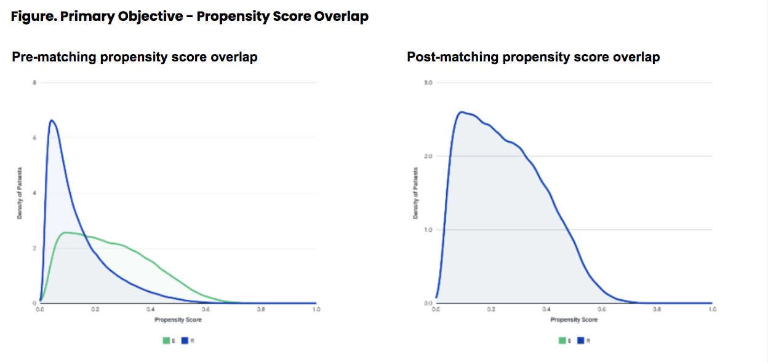
Appendix D2. Primary Objective - Standardized differences comparing statin initiators with Normal Baseline ALT value to Statin Initiators with Abnormal Baseline ALT Value in Marketscan
 | ALT <=35 U/L  (n=528,578) | ALT >35 U/L  (n=98,063) | Unmatched Std. Difference | Matched Std. Difference
Age |  |  | 0.549 | 0.005
Age on index date (mean, SD) | 56.72 (11.33) | 50.77 (10.30) | - | -
Gender |  |  | 0.559 | 0.008
Females (n, %) | 284,954 (53.9%) | 26,930 (27.5%) | - | -
Region |  |  | 0.096 | 0.016
Region - Northeast | 98,604 (18.7%) | 16,548 (16.9%) | - | -
Region - Midwest | 67,261 (12.7%) | 11,415 (11.6%) | - | -
Region - South | 320,845 (60.7%) | 59,977 (61.2%) | - | -
Region - West | 41,709 (7.9%) | 10,095 (10.3%) | - | -
Region - Other | 159 (0.0%) | 28 (0.0%) | - | -
Medications
Statin Intensity |  |  | - | -
...Low (n, %) | 79,155 (15.0%) | 13,158 (13.4%) | - | -
...Moderate (n, %) | 356,370 (67.4%) | 66,539 (67.9%) | - | -
...High (n, %) | 73,557 (13.9%) | 14,629 (14.9%) | 0.029 | 0.014
...Missing; n (%) | 19,496 (3.7%) | 3,737 (3.8%) | - | -
Medications associated with drug-induced liver injury (n,%) | 157,805 (29.9%) | 27,851 (28.4%) | 0.032 | 0.022
Antidiabetic medication - Oral (n, %) | 113,023 (21.4%) | 26,334 (26.9%) | 0.128 | 0.026
Antidiabetic medication - Insulin (n, %) | 31,256 (5.9%) | 4,906 (5.0%) | 0.04 | 0.016
Antidiabetic medication - GLP-1 (n, %) | 8,169 (1.5%) | 1,951 (2.0%) | 0.034 | 0.007
Non-statin antihyperlipidemic medications (n, %) | 29,996 (5.7%) | 8,195 (8.4%) | 0.105 | 0.016
Pharmacy-dispensed acetaminophen (n, %) | 90,798 (17.2%) | 16,020 (16.3%) | 0.023 | 0.026
Comorbidity
BMI >30 or obesity surgery (n, %) | 50,763 (9.6%) | 11,600 (11.8%) | 0.072 | 0.022
Smoking history (n, %) | 32,626 (6.2%) | 5,392 (5.5%) | 0.029 | 0.027
Alcohol consumption (n, %) | 3,145 (0.6%) | 979 (1.0%) | 0.045 | 0.004
Hypertension diagnosis (n, %) | 287,651 (54.4%) | 53,150 (54.2%) | 0.004 | 0.01
Hyperlipidemia diagnosis (n, %) | 355,117 (67.2%) | 67,216 (68.5%) | 0.029 | 0.005
Diabetes (Type 1 or Type 2) diagnosis (n, %) | 131,715 (24.9%) | 25,708 (26.2%) | 0.03 | 0.023
Cardiovascular hospitalization (n, %) | 14,782 (2.8%) | 2,078 (2.1%) | 0.044 | 0.014
Charlson Comorbidity Index (CCI) (mean, SD) | 0.68 (1.09) | 0.58 (0.96) | 0.095 | 0.042
Results of most recent laboratory tests in baseline period
Had most recent LDL test value in baseline (n, %) | 461,727 (87.4%) | 82,926 (84.6%) | - | -
...LDL>130 mg/dl (n, %) | 264,647 (57.3%) | 48,781 (58.8%) | 0.006 | 0.013
...Mean (SD, Min, Max) | 136.16 (41.73, 1.00, 546.00) | 138.24 (43.11, 1.08, 1,262.00) | - | -
...Median [IQR] | 138.00 [107.00, 163.00] | 140.00 [109.00, 166.00] | - | -
Had most recent HDL test value in baseline (n, %) | 474,753 (89.8%) | 88,711 (90.5%) | - | -
...HDL<40 mg/dl (n, %) | 95,462 (20.1%) | 31,639 (35.7%) | 0.332 | 0.014
...Mean (SD, Min, Max) | 52.39 (15.67, 2.00, 262.00) | 45.74 (13.84, 4.00, 239.00) | - | -
...Median [IQR] | 50.00 [41.00, 61.00] | 44.00 [37.00, 52.00] | - | -
Had most recent Triglycerides test value in baseline (n, %) | 475,896 (90.0%) | 89,082 (90.8%) | - | -
...Triglycerides >150 mg/dl (n, %) | 198,137 (41.6%) | 55,193 (61.9%) | 0.384 | 0.001
...Mean (SD, Min, Max) | 164.56 (147.98, 1.06, 9,602.00) | 223.33 (227.59, 1.12, 9,060.00) | - | -
...Median [IQR] | 134.00 [96.00, 193.00] | 176.00 [124.00, 253.00] | - | -
Had most recent AST test value in baseline (n, %) | 155,434 (29.4%) | 34,131 (34.8%) | - | -
...AST>40 U/L (n, %) | 881 (0.5%) | 6,816 (19.9%) | - | -
...Mean (SD, Min, Max) | 19.81 (10.98, 1.00, 3,680.00) | 34.92 (18.02, 1.25, 511.00) | - | -
...Median [IQR] | 19.00 [16.00, 23.00] | 31.00 [26.00, 38.00] | - | -
Change in ALT result | 9,850 (1.9%) | 7,970 (8.1%) | - | -
Others
Year of Index date |  |  | 0.133 | 0.006
2007 | 0 (0.0%) | 0 (0.0%) | - | -
2008 | 3,936 (0.7%) | 908 (0.9%) | - | -
2009 | 26,057 (4.9%) | 6,610 (6.7%) | - | -
2010 | 24,039 (4.5%) | 5,879 (6.0%) | - | -
2011 | 25,179 (4.8%) | 5,740 (5.9%) | - | -
2012 | 78,519 (14.9%) | 14,080 (14.4%) | - | -
2013 | 80,207 (15.2%) | 13,420 (13.7%) | - | -
2014 | 82,323 (15.6%) | 14,080 (14.4%) | - | -
2015 | 82,015 (15.5%) | 13,481 (13.7%) | - | -
2016 | 68,347 (12.9%) | 12,396 (12.6%) | - | -
2017 | 57,956 (11.0%) | 11,469 (11.7%) | - | -

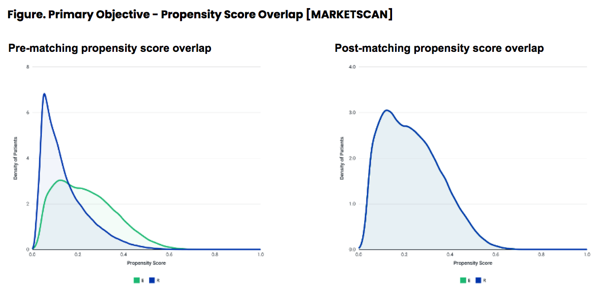
Appendix E: Standardized Differences for Secondary Objective
Appendix E1. Secondary Objective - Standardized differences comparing statin initiators with non initiators in Optum
 | Statin Non-Initiators  (N = 335,955) | Statin Initiators  (N = 84,231) | Unmatched Std. Difference | Matched Std. Difference
Age | 53.74 (11.39) | 54.09 (11.15) | 0.031 | 0.012
Age on index date (mean, SD) | 53.00 [46.00, 61.00] | 53.00 [46.00, 62.00] | - | -
Gender |  |  | 0.113 | 0.025
Females (n, %) | 117,980 (35.1%) | 25,144 (29.9%) | - | -
Region |  |  | 0.057 | 0.015
Region - Northeast | 31,639 (9.4%) | 6,694 (7.9%) | - | -
Region - Midwest | 31,569 (9.4%) | 8,592 (10.2%) | - | -
Region - South | 200,290 (59.6%) | 50,927 (60.5%) | - | -
Region - West | 71,542 (21.3%) | 17,785 (21.1%) | - | -
Region - Other | 915 (0.3%) | 233 (0.3%) | - | -
Medications
Medications associated with drug-induced liver injury (n,%) | 86,500 (25.7%) | 24,251 (28.8%) | 0.068 | 0.026
Antidiabetic medication - Oral (n, %) | 76,471 (22.8%) | 19,210 (22.8%) | 0.001 | 0.005
Antidiabetic medication - Insulin (n, %) | 12,890 (3.8%) | 4,091 (4.9%) | 0.05 | 0.022
Antidiabetic medication - GLP-1 (n, %) | 4,576 (1.4%) | 1,299 (1.5%) | 0.015 | 0.007
Non-statin antihyperlipidemic medications (n, %) | 27,503 (8.2%) | 6,107 (7.3%) | 0.035 | 0.009
Pharmacy-dispensed acetaminophen (n, %) | 53,512 (15.9%) | 14,023 (16.6%) | 0.019 | 0.009
Comorbidity
BMI >30 or obesity surgery (n, %) | 53,071 (15.8%) | 12,270 (14.6%) | 0.034 | 0.005
Smoking history (n, %) | 20,896 (6.2%) | 6,287 (7.5%) | 0.049 | 0.021
Alcohol consumption (n, %) | 4,017 (1.2%) | 1,011 (1.2%) | 0 | 0.001
Hypertension diagnosis (n, %) | 200,046 (59.5%) | 51,711 (61.4%) | 0.038 | 0.013
Hyperlipidemia diagnosis (n, %) | 255,103 (75.9%) | 63,985 (76.0%) | 0.001 | 0
Diabetes (Type 1 or Type 2) diagnosis (n, %) | 90,055 (26.8%) | 21,918 (26.0%) | 0.018 | 0.001
Cardiovascular hospitalization (n, %) | 12,906 (3.8%) | 3,884 (4.6%) | 0.038 | 0.018
Charlson Comorbidity Index (CCI) (mean, SD) | 0.68 (1.12) | 0.69 (1.11) | 0.006 | 0.008
Results of most recent laboratory tests in baseline period
Had most recent LDL test value in baseline (n, %) | 325,018 (96.7%) | 79,608 (94.5%) | - | -
...LDL>130 mg/dl (n, %) | 171,757 (51.1%) | 41,481 (49.2%) | 0.038 | 0.016
...Mean (SD) | 128.87 (37.02) | 131.91 (41.58) | - | -
...Median [IQR] | 132.00 [102.00, 156.00] | 133.00 [102.00, 165.00] | - | -
Had most recent HDL test value in baseline (n, %) | 324,456 (96.6%) | 81,885 (97.2%) | - | -
...HDL<40 mg/dl (n, %) | 99,538 (29.6%) | 25,708 (30.5%) | 0.019 | 0.004
...Mean (SD) | 46.96 (12.84) | 46.47 (12.36) | - | -
...Median [IQR] | 45.00 [38.00, 54.00] | 45.00 [38.00, 53.00] | - | -
Had most recent Triglycerides test value in baseline (n, %) | 323,789 (96.4%) | 80,817 (95.9%) | - | -
...Triglycerides >150 mg/dl (n, %) | 168,966 (50.3%) | 47,174 (56.0%) | 0.115 | 0.03
...Mean (SD) | 166.48 (72.20) | 177.65 (74.17) | - | -
...Median [IQR] | 155.00 [111.00, 211.00] | 167.00 [120.00, 226.00] | - | -
Had most recent AST test value in baseline (n, %) | 326,200 (97.1%) | 82,239 (97.6%) | - | -
...AST>40 U/L (n, %) | 74,052 (22.0%) | 15,731 (18.7%) | 0.084 | 0.079
...Mean (SD) | 34.80 (13.73) | 33.60 (12.47) | - | -
...Median [IQR] | 31.00 [26.00, 39.00] | 31.00 [26.00, 38.00] | - | -
Others
Year of Index date |  |  | 0.001 | 0.003
2007 | 16,019 (4.8%) | 4,033 (4.8%) | - | -
2008 | 28,404 (8.5%) | 7,113 (8.4%) | - | -
2009 | 33,665 (10.0%) | 8,444 (10.0%) | - | -
2010 | 29,098 (8.7%) | 7,294 (8.7%) | - | -
2011 | 24,615 (7.3%) | 6,171 (7.3%) | - | -
2012 | 23,796 (7.1%) | 5,963 (7.1%) | - | -
2013 | 31,923 (9.5%) | 8,005 (9.5%) | - | -
2014 | 29,569 (8.8%) | 7,412 (8.8%) | - | -
2015 | 33,553 (10.0%) | 8,409 (10.0%) | - | -
2016 | 41,505 (12.4%) | 10,405 (12.4%) | - | -
2017 | 43,808 (13.0%) | 10,982 (13.0%) | - | -

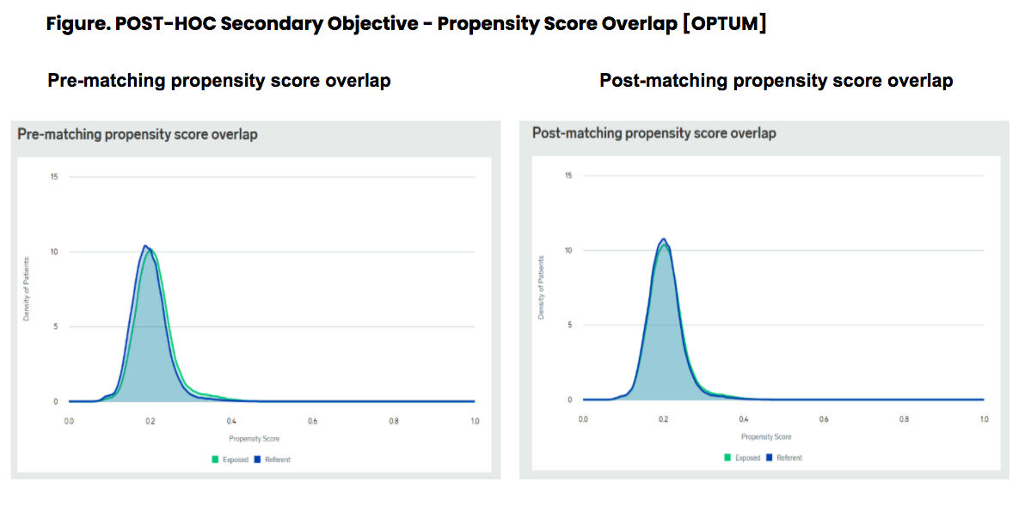
Appendix E2. Secondary Objective - Standardized differences comparing statin initiators with non initiators in MarketScan
 | Statin Non-Initiators  (N = 275,898) | Statin Initiators  (N = 69,103) | Unmatched Std. Difference | Matched Std. Difference
Age | 52.22 (9.29) | 52.95 (9.55) | 0.077 | 0.027
Age on index date (mean, SD) | 52.00 [46.00, 58.00] | 53.00 [47.00, 59.00] | - | -
Gender |  |  | 0.112 | 0.02
Females (n, %) | 97,209 (35.2%) | 20,731 (30.0%) | - | -
Region |  |  | 0.092 | 0.02
Region - Northeast | 61,670 (22.4%) | 12,950 (18.7%) | - | -
Region - Midwest | 29,552 (10.7%) | 8,218 (11.9%) | - | -
Region - South | 157,655 (57.1%) | 40,886 (59.2%) | - | -
Region - West | 26,958 (9.8%) | 7,028 (10.2%) | - | -
Region - Other | 63 (0.0%) | 21 (0.0%) | - | -
Medications
Medications associated with drug-induced liver injury (n,%) | 61,704 (22.4%) | 20,087 (29.1%) | 0.154 | 0.056
Antidiabetic medication - Oral (n, %) | 64,540 (23.4%) | 16,188 (23.4%) | 0.001 | 0.01
Antidiabetic medication - Insulin (n, %) | 9,563 (3.5%) | 3,504 (5.1%) | 0.079 | 0.036
Antidiabetic medication - GLP-1 (n, %) | 4,439 (1.6%) | 1,247 (1.8%) | 0.015 | 0.008
Non-statin antihyperlipidemic medications (n, %) | 19,506 (7.1%) | 5,026 (7.3%) | 0.008 | 0.003
Pharmacy-dispensed acetaminophen (n, %) | 35,571 (12.9%) | 11,402 (16.5%) | 0.102 | 0.04
Comorbidity
BMI >30 or obesity surgery (n, %) | 33,301 (12.1%) | 7,469 (10.8%) | 0.04 | 0.003
Smoking history (n, %) | 11,945 (4.3%) | 3,621 (5.2%) | 0.043 | 0.017
Alcohol consumption (n, %) | 2,589 (0.9%) | 609 (0.9%) | 0.006 | 0.003
Hypertension diagnosis (n, %) | 151,250 (54.8%) | 39,747 (57.5%) | 0.054 | 0.021
Hyperlipidemia diagnosis (n, %) | 183,568 (66.5%) | 45,990 (66.6%) | 0 | 0.002
Diabetes (Type 1 or Type 2) diagnosis (n, %) | 73,958 (26.8%) | 16,910 (24.5%) | 0.054 | 0.006
Cardiovascular hospitalization (n, %) | 1,155 (0.4%) | 1,082 (1.6%) | 0.116 | 0.054
Charlson Comorbidity Index (CCI) (mean, SD) | 0.56 (0.95) | 0.57 (0.95) | 0.006 | 0.021
Results of most recent laboratory tests in baseline period
Had most recent LDL test value in baseline (n, %) | 271,161 (98.3%) | 68,030 (98.4%) | - | -
...LDL>130 mg/dl (n, %) | 142,263 (51.6%) | 37,011 (53.6%) | 0.04 | 0.001
...Mean (SD) | 130.24 (39.11) | 136.94 (45.54) | - | -
...Median [IQR] | 132.00 [102.00, 157.00] | 137.00 [103.00, 169.00] | - | -
Had most recent HDL test value in baseline (n, %) | 270,040 (97.9%) | 67,720 (98.0%) | - | -
...HDL<40 mg/dl (n, %) | 81,138 (29.4%) | 20,839 (30.2%) | 0.016 | 0.003
...Mean (SD) | 47.87 (14.78) | 47.30 (14.13) | - | -
...Median [IQR] | 45.00 [38.00, 55.00] | 45.00 [38.00, 54.00] | - | -
Had most recent Triglycerides test value in baseline (n, %) | 270,895 (98.2%) | 67,938 (98.3%) | - | -
...Triglycerides >150 mg/dl (n, %) | 144,286 (52.3%) | 40,179 (58.1%) | 0.118 | 0.029
...Mean (SD) | 174.66 (101.10) | 187.84 (116.98) | - | -
...Median [IQR] | 157.00 [111.00, 216.00] | 169.00 [120.00, 232.00] | - | -
Had most recent AST test value in baseline (n, %) | 88,424 (32.0%) | 22,754 (32.9%) | - | -
...AST>40 U/L (n, %) | 19,160 (6.9%) | 4,039 (5.8%) | 0.045 | 0.042
...Mean (SD) | 35.78 (23.39) | 33.80 (17.79) | - | -
...Median [IQR] | 30.00 [25.00, 39.00] | 30.00 [25.00, 37.00] | - | -
Others
Year of Index date |  |  | 0.001 | 0.004
2008 | 2,631 (1.0%) | 658 (1.0%) | - | -
2009 | 17,277 (6.3%) | 4,324 (6.3%) | - | -
2010 | 15,781 (5.7%) | 3,952 (5.7%) | - | -
2011 | 14,389 (5.2%) | 3,608 (5.2%) | - | -
2012 | 42,062 (15.2%) | 10,534 (15.2%) | - | -
2013 | 39,900 (14.5%) | 9,988 (14.5%) | - | -
2014 | 39,179 (14.2%) | 9,808 (14.2%) | - | -
2015 | 36,988 (13.4%) | 9,269 (13.4%) | - | -
2016 | 35,487 (12.9%) | 8,888 (12.9%) | - | -
2017 | 32,204 (11.7%) | 8,074 (11.7%) | - | -

