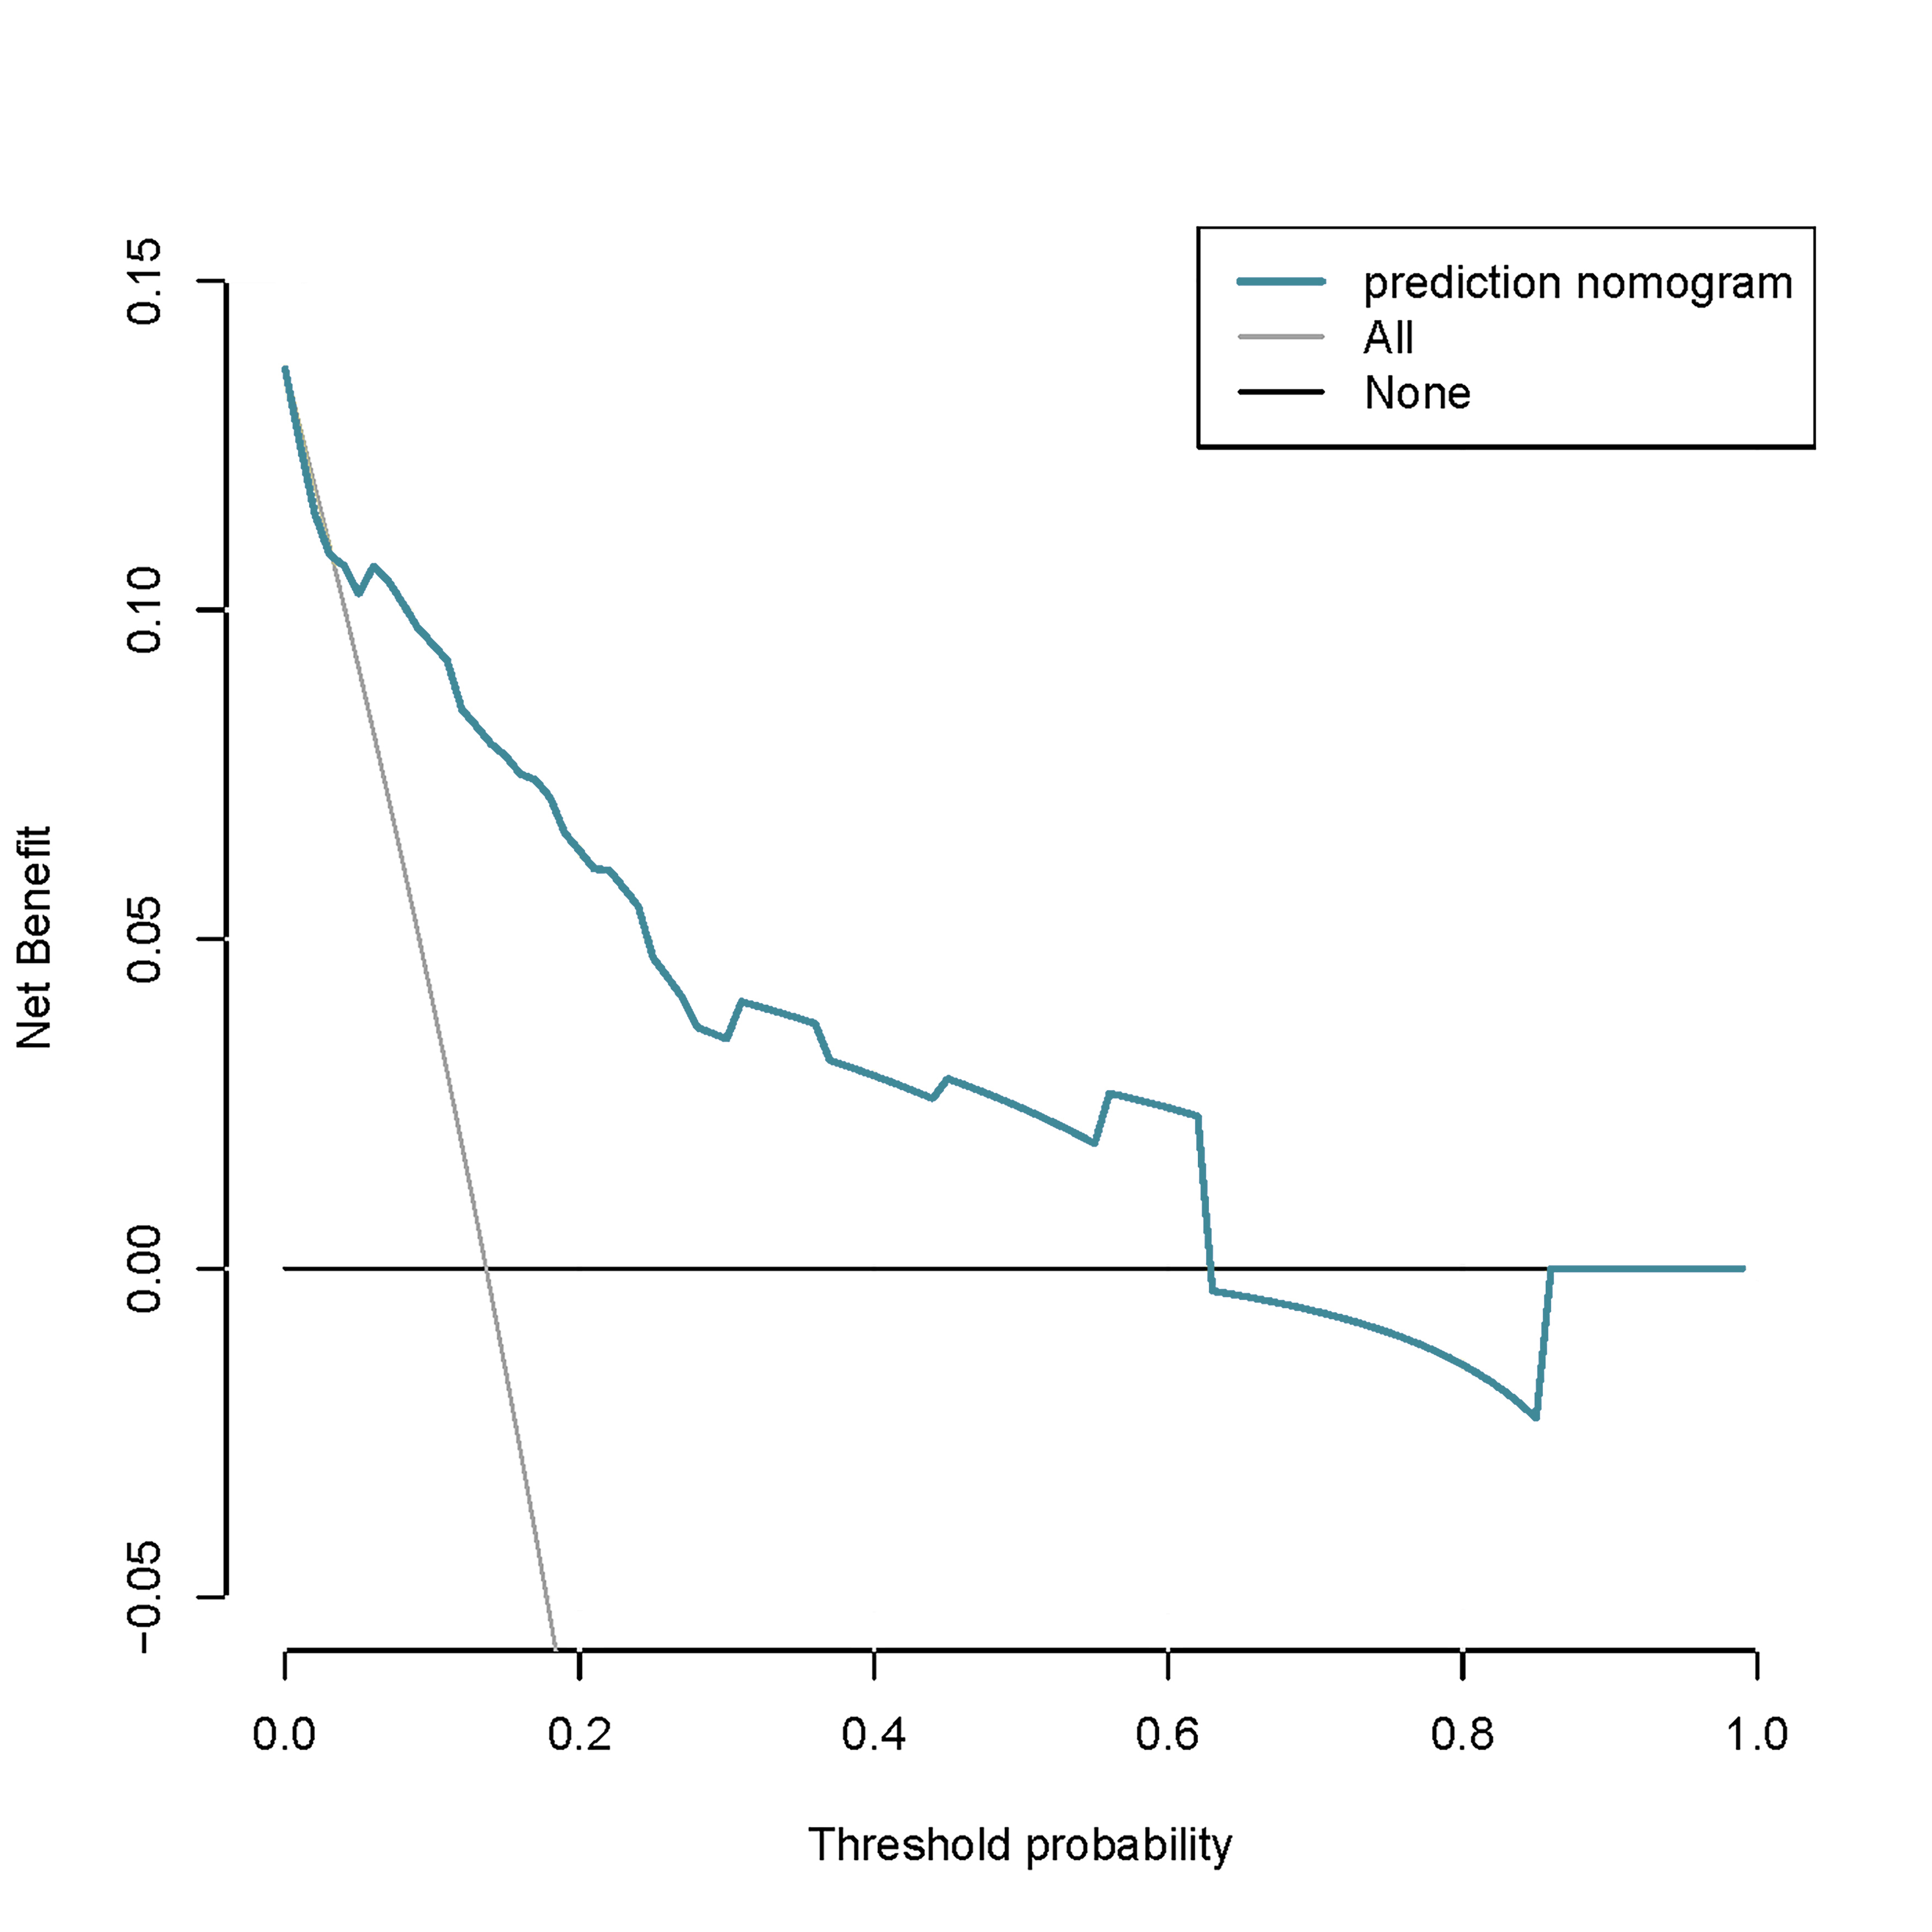
Fig S1: Decision curve analysis for the nomogram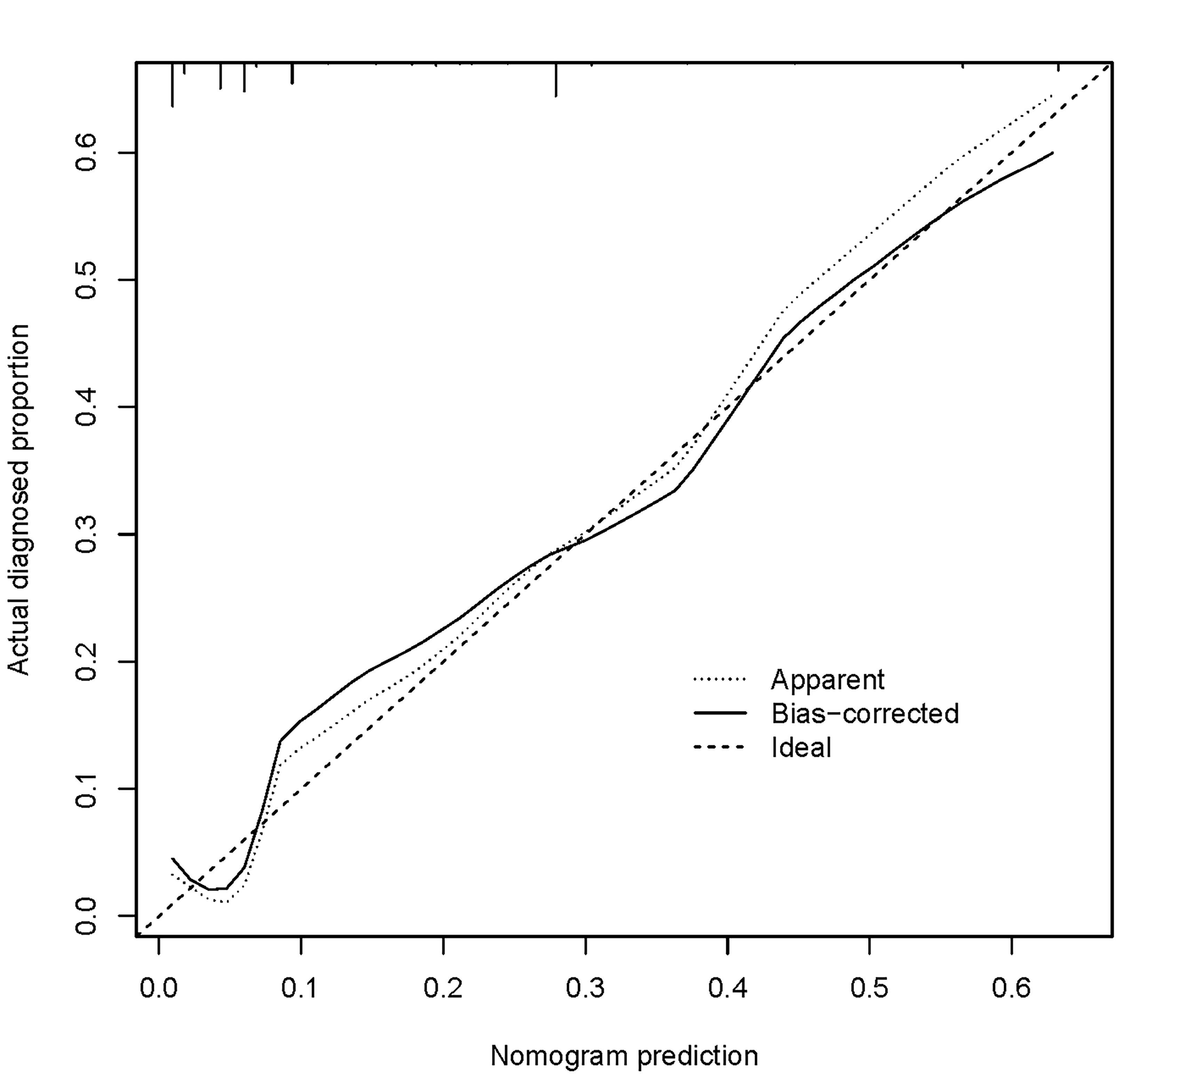 Fig S2 Calibration curve of the nomogram analysis

