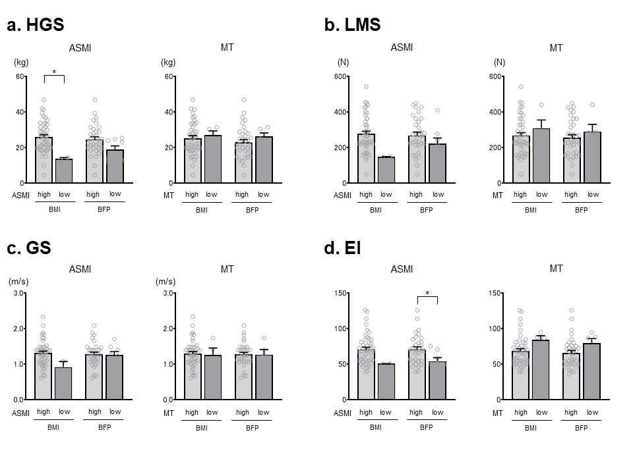

Supplementary figure 1 legends Comparison of HGS, LMS, GS, and US-assessed EI among the BIA/US-assessed high or low ASMI/MT classified by higher BMI or BFP.
Notes: a. Hand grip strength, b. Leg muscle strength, c. Gait speed, d. Echo intensity. The bar graph represents the mean value, and the error bar represents the standard error of the mean. The comparison of muscle strength or physical function with high or low muscle mass (i.e., ASMI or MT) was analyzed in overweight participants, as determined by body index (i.e., higher BMI or BFP), with an unpaired t-test. Light-gray bars have high skeletal muscle mass (ASMI or MT) and higher body mass index (BMI or BFP). Normal-gray bars are the group with low skeletal muscle mass (ASMI or MT) and higher body mass index (BMI or BFP).
*p < 0.05 were as a statistical significance.
* is "less than or equal to 0.05 (5%) probability of significance (p < 0.05)."
Abbreviations: ASMI, appendicular skeletal muscle mass index; BIA, bioelectrical impedance analysis; BFP, body fat percentage; BMI, body mass index; EI, echo intensity; GS, gait speed; HGS, hand grip strength; LMS, leg muscle strength; MT, muscle thickness; US, ultrasonography.

