Photothermal Nanoheaters-Modified Spores for Safe and Controllable Antitumor Therapy

Xin Zhang^{1#}, Yang Zhang^{2#}, Ning Wang¹, Ye-Tong Shen¹, Qing Chen², Lu Han¹, Bo Hu¹*

¹ Department of Biochemistry and Molecular Biology, School of Life Sciences, China Medical University, Shenyang 110122, China
² School of pharmacy, Shenyang Medical College, Shenyang 110034, China

*Corresponding authors. E-mail address: bhu@cmu.edu.cn, 86hubo86@163.com (B. Hu)
# Xin Zhang and Yang Zhang contributed equally to this work.

Supporting Figures

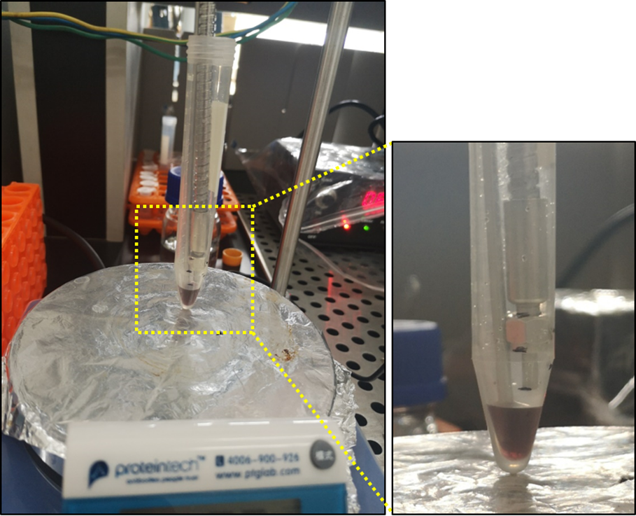

Figure S1. Device diagram for photothermal conversional performance study. (808 nm laser)

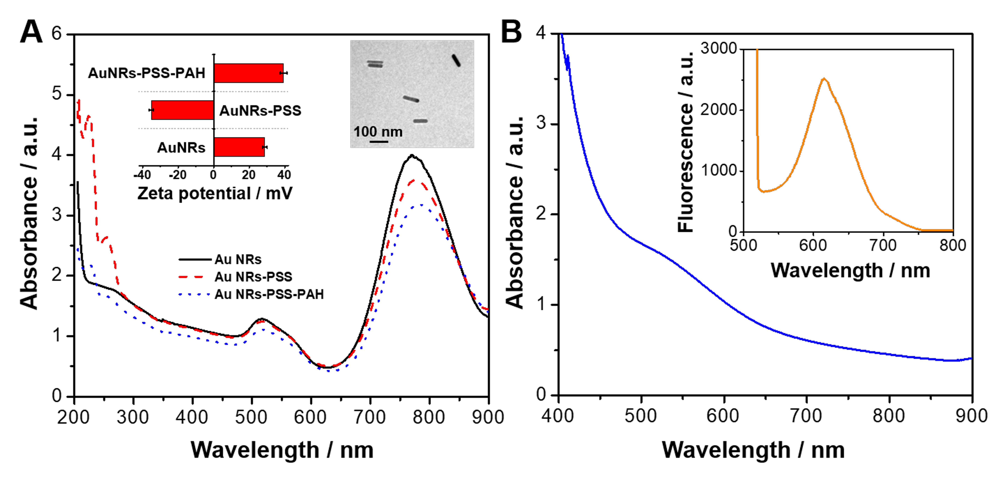

Figure S2. (A) Absorption spectra, zeta potential (inset, left) and TEM images (inset, right) of AuNRs, AuNRs-PSS and AuNRs-PSS-PAH. (B) Absorption and fluorescence emission spectra (inset) of BSA-AuNCs.

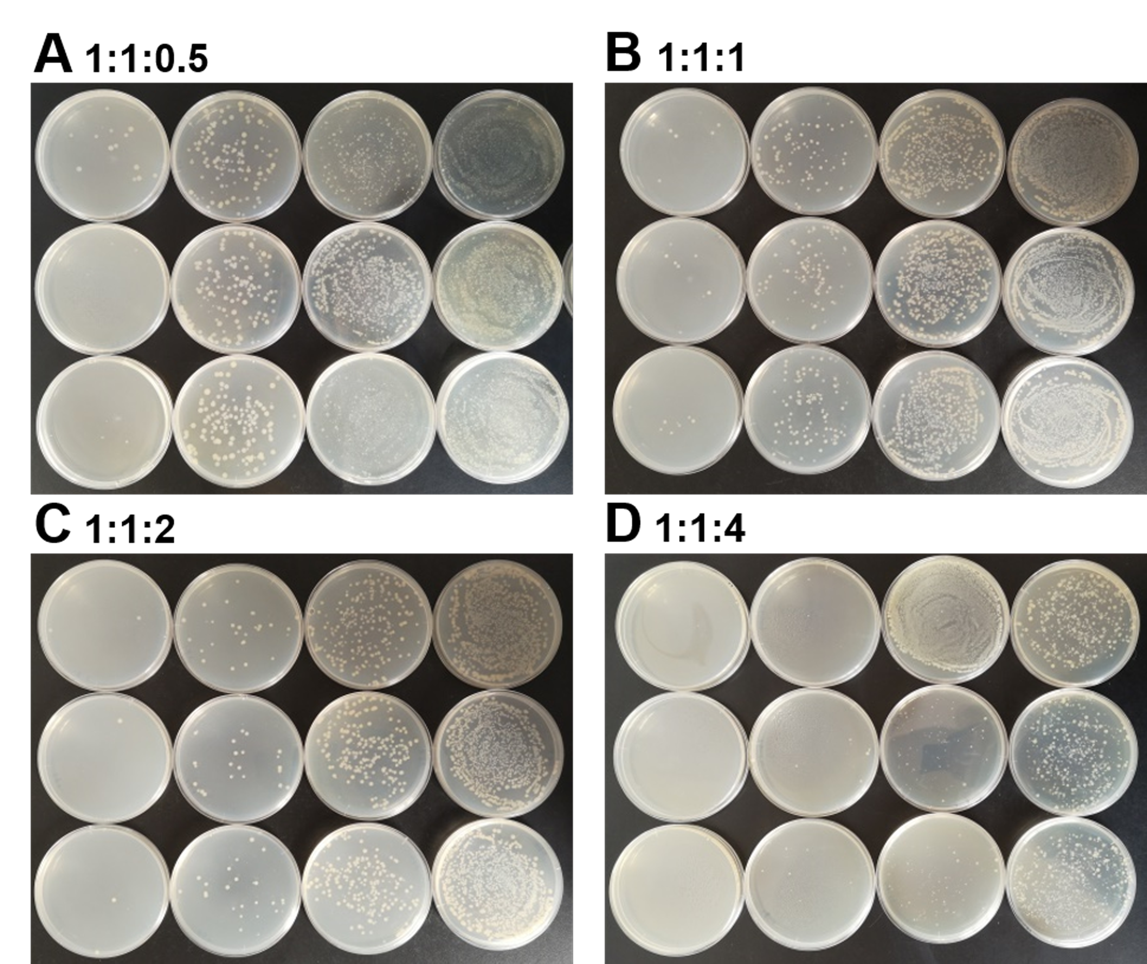

Figure S3. The antibacterial properties of Spore@NRs/NCs at different Spore:NCs:NRs ratio. (NIR irradiation: 808 nm, 900 mW, 20 min)

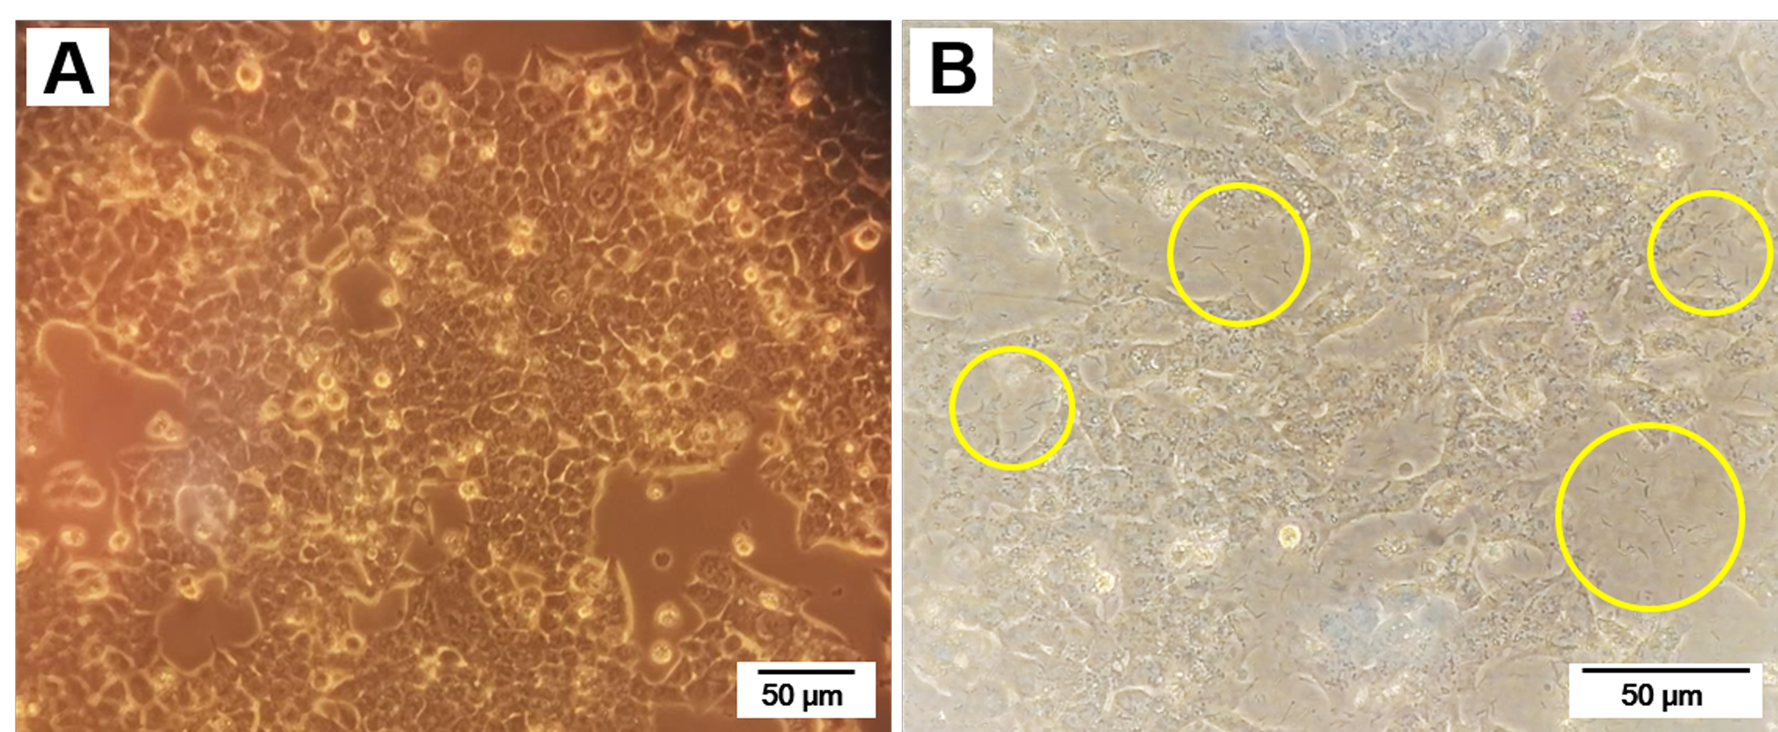

Figure S4. Bright field confocal images of HCT116 cells (A) and HCT116 cells deal with Spore@NRs/NCs (B) (Yellow circles indicate the extracellular vegetative/activated bacteria cell@NRs/NCs).

This information is available free of charge via the Internet at http://****

