Decoding the key functional combined components group and uncovering the molecular mechanism of longdan xiegan decoction in treating uveitis

Supplemental Data:

- Table S1
Table S1. Active components of LXD filtered by ADME.
ID | Component | OB* | DL* | Source
MOL000073 | 5, 2'-Dihydroxy-6, 7, 8-trimethoxyflavone | 31.71 | 0.35 | Huangqin
MOL000098 | Sudan III | 84.07 | 0.59 | Zhizi
MOL000131 | Ent-Epicatechin | 48.96 | 0.24 | Huangqin
MOL000173 | Wogonin | 30.68 | 0.23 | Huangqin
MOL000211 | EIC | 41.9 | 0.14 | Chaihu
MOL000228 | (2R)-7-Hydroxy-5-methoxy-2-phenylchroman-4-one | 55.23 | 0.20 | Huangqin
MOL000239 | Linoleyl acetate | 42.1 | 0.20 | Chaihu
MOL000296 | Sulfoorientalol C | 41.57 | 0.16 | Zexie
MOL000354 | (4aS, 6aR, 6aS, 6bR, 8aR, 10R, 12aR, 14bS)-10-Hydroxy-2, 2, 6a, 6b, 9, 9, 12a-heptamethyl-1, 3, 4, 5, 6, 6a, 7, 8, 8a, 10, 11, 12, 13, 14b-Tetradecahydropicene-4a-carboxylic acid | 32.02 | 0.76 | Cheqianzi
MOL000358 | β-Sitosterol | 36.91 | 0.75 | Huangqin
MOL000359 | Sitosterol | 36.91 | 0.75 | Longdan
MOL000392 | Isoliquiritigenin | 85.32 | 0.15 | Chaihu
MOL000417 | Baicalin | 40.12 | 0.75 | Chaihu
MOL000422 | Kaempferol | 41.88 | 0.24 | Longdan
MOL000449 | EIC | 41.9 | 0.14 | Huangqin
MOL000490 | Stigmasterol | 43.83 | 0.76 | Dihuang
MOL000497 | Stigmasterol | 43.83 | 0.76 | Chaihu
MOL000500 | Isorhamnetin | 49.60 | 0.31 | Chaihu
MOL000525 | Sitosterol | 36.91 | 0.75 | Huangqin
MOL000552 | Norwogonin | 39.40 | 0.21 | Huangqin
MOL000675 | Quercetin | 46.43 | 0.28 | Zhizi
MOL000749 | Jioglutin D | 39.02 | 0.14 | Dihuang
MOL000763 | 16β-Methoxyalisol B monoacetate | 32.43 | 0.77 | Zexie
MOL000830 | Isoimperatorin | 45.46 | 0.23 | Zhizi
MOL000831 | Exceparl M-OL | 31.90 | 0.16 | Zhizi
MOL000832 | Ethyl oleate (NF) | 32.40 | 0.19 | Zhizi
MOL000839 | 5-Hydroxy-7-methoxy-2-(3, 4, 5-trimethoxyphenyl)chromone | 51.96 | 0.41 | Zhizi
MOL000846 | 3-Methylkempferol | 60.16 | 0.26 | Zhizi
MOL000849 | GBGB | 45.58 | 0.83 | Zhizi
MOL000853 | Sitosterol | 36.91 | 0.75 | Zexie
MOL000854 | Alisol B | 34.47 | 0.82 | Zexie
MOL000856 | Alisol B monoacetate | 35.59 | 0.81 | Zexie
MOL000862 | Alisol, b, 23-acetate | 32.52 | 0.82 | Zexie
MOL001406 | Rivularin | 37.94 | 0.37 | Huangqin
MOL001458 | Stigmasterol | 43.83 | 0.76 | Huangqin
MOL001484 | Kaempferol | 41.88 | 0.24 | Chaihu
MOL001490 | Coptisine | 30.67 | 0.86 | Huangqin
MOL001494 | EIC | 41.90 | 0.14 | Zhizi
MOL001506 | Bis[(2S)-2-ethylhexyl] benzene-1, 2-dicarboxylate | 43.59 | 0.35 | Huangqin
MOL001558 | Sesamin | 56.55 | 0.83 | Longdan
MOL001641 | β-Sitosterol | 36.91 | 0.75 | Zhizi
MOL001645 | Aristolochic acid Ⅱ | 37.56 | 0.45 | Mutong
MOL001663 | Crocetin | 35.30 | 0.26 | Zhizi
MOL001689 | Acacetin | 34.97 | 0.24 | Huangqin
MOL001735 | 1-Monolinolein | 37.18 | 0.30 | Zexie
MOL001745 | Kaempferol | 41.88 | 0.24 | Zhizi
MOL001771 | Alisol B | 36.76 | 0.82 | Zexie
MOL001789 | Quercetin | 46.43 | 0.28 | Cheqianzi
MOL001792 | 3, 5, 6, 7-Tetramethoxy-2-(3, 4, 5-trimethoxyphenyl)chromone | 31.97 | 0.59 | Chaihu
MOL001889 | Supraene | 33.55 | 0.42 | Huangqin
MOL001941 | (4aS, 6aR, 6aS, 6bR, 8aR, 10R, 12aR, 14bS)-10-Hydroxy-2, 2, 6a, 6b, 9, 9, 12a-heptamethyl-1, 3, 4, 5, 6, 6a, 7, 8, 8a, 10, 11, 12, 13, 14b-tetradecahydropicene-4a-carboxylic acid | 32.03 | 0.76 | Zhizi
MOL001942 | Stigmasterol | 43.83 | 0.76 | Zhizi
MOL002203 | Oleic acid | 33.13 | 0.14 | Zhizi
MOL002311 | Areapillin | 48.96 | 0.41 | Chaihu
MOL002322 | Isovitexin | 31.29 | 0.72 | Longdan
MOL002464 | Rel-(1R, 3aS, 4S, 7S, 8R, 8aS)-7-isopropyl-1, 4-dimethyldecahydro-4, 7-epoxyazulene-1, 8-diol | 94.43 | 0.15 | Zexie
MOL002565 | Cubebin | 57.13 | 0.64 | Chaihu
MOL002714 | Baicalein | 33.52 | 0.21 | Huangqin
MOL002776 | Sitosterol | 36.91 | 0.75 | Cheqianzi
MOL002844 | Longikaurin A | 47.72 | 0.53 | Chaihu
MOL002879 | Methyl linolelaidate | 41.93 | 0.17 | Huangqin
MOL002883 | Mandenol | 42.00 | 0.19 | Zhizi
MOL002897 | Diop | 43.59 | 0.39 | Huangqin
MOL002908 | 5, 8, 2'-Trihydroxy-7-methoxyflavone | 37.01 | 0.27 | Huangqin
MOL002909 | 5, 7, 2, 5-Tetrahydroxy-8, 6-dimethoxyflavone | 33.82 | 0.45 | Huangqin
MOL002910 | Carthamidin | 41.15 | 0.24 | Huangqin
MOL002911 | 2, 6, 2', 4'-Tetrahydroxy-6'-methoxychaleone | 69.04 | 0.22 | Huangqin
MOL002913 | Dihydrobaicalin_qt | 40.04 | 0.21 | Huangqin
MOL002914 | Eriodyctiol (flavanone) | 41.35 | 0.24 | Huangqin
MOL002915 | Salvigenin | 49.07 | 0.33 | Huangqin
MOL002917 | 5, 2', 6'-Trihydroxy-7, 8-dimethoxyflavone | 45.05 | 0.33 | Huangqin
MOL002925 | 5, 7, 2', 6'-Tetrahydroxyflavone | 37.01 | 0.24 | Huangqin
MOL002926 | Dihydrooroxylin A | 38.72 | 0.23 | Huangqin
MOL002927 | Skullcapflavone II | 69.51 | 0.44 | Huangqin
MOL002928 | Oroxylin A | 41.37 | 0.23 | Huangqin
MOL002932 | Panicolin | 76.26 | 0.29 | Huangqin
MOL002933 | 5, 7, 4'-Trihydroxy-8-methoxyflavone | 36.56 | 0.27 | Huangqin
MOL002934 | Neobaicalein | 104.34 | 0.44 | Huangqin
MOL002937 | Dihydrooroxylin | 66.06 | 0.23 | Huangqin
MOL003095 | Supraene | 33.55 | 0.42 | Zhizi
MOL003137 | Leucanthoside | 32.12 | 0.78 | Longdan
MOL003143 | Gentirigenic acid | 38.78 | 0.78 | Longdan
MOL003152 | Gentisin | 64.06 | 0.21 | Longdan
MOL003155 | Pranferin | 52.14 | 0.28 | Longdan
MOL003169 | Gentiopicroside tetraacetate | 32.44 | 0.7 | Longdan
MOL003170 | Gentisein | 67.57 | 0.19 | Longdan
MOL003656 | Octalupine | 47.82 | 0.28 | Chaihu
MOL003708 | Aristolochic acid A | 62.71 | 0.55 | Mutong
MOL003896 | Sainfuran | 79.91 | 0.23 | Chaihu
MOL004328 | Troxerutin | 31.60 | 0.28 | Chaihu
MOL004561 | Ammidin | 34.55 | 0.22 | Zhizi
MOL004598 | Dinatin | 30.97 | 0.27 | Cheqianzi
MOL004609 | Daucostero_qt | 36.91 | 0.75 | Cheqianzi
MOL004624 | Hypolaetin | 33.24 | 0.28 | Cheqianzi
MOL004628 | Orobanchoside_qt | 55.99 | 0.82 | Cheqianzi
MOL004644 | Plantaginin_qt | 54.04 | 0.24 | Cheqianzi
MOL004648 | β-Sitosterol | 36.91 | 0.75 | Danggui
MOL004653 | Stigmasterol | 43.83 | 0.76 | Danggui
MOL004683 | 2, 6-Di(phenyl)thiopyran-4-thione | 69.13 | 0.15 | Danggui
MOL004702 | EIC | 41.90 | 0.14 | Dihuang
MOL004718 | Sitosterol | 36.91 | 0.75 | Dihuang
MOL004805 | (+)-Anomalin | 46.06 | 0.66 | Chaihu
MOL004806 | Methyl (2E, 4E)-octadeca-2, 4-dienoate | 38.77 | 0.17 | Chaihu
MOL004808 | Saikosaponin c_qt | 30.50 | 0.63 | Chaihu
MOL004810 | α-Spinasterol | 42.98 | 0.76 | Chaihu
MOL004811 | Petunidin | 30.05 | 0.31 | Chaihu
MOL004814 | Oleic acid | 33.13 | 0.14 | Chaihu
MOL004815 | Quercetin | 46.43 | 0.28 | Chaihu
MOL004820 | Linoleic | 41.90 | 0.14 | Chaihu
MOL004824 | Quercetin | 46.43 | 0.28 | Gancao
MOL004827 | Mairin | 55.38 | 0.78 | Gancao
MOL004828 | Jaranol | 50.83 | 0.29 | Gancao
MOL004829 | Isorhamnetin | 49.60 | 0.30 | Gancao
MOL004833 | Sitosterol | 36.91 | 0.75 | Gancao
MOL004835 | Formononetin | 69.67 | 0.21 | Gancao
MOL004836 | Calycosin | 47.75 | 0.24 | Gancao
MOL004838 | Kaempferol | 41.88 | 0.24 | Gancao
MOL004841 | Licochalcone A | 40.79 | 0.29 | Gancao
MOL004848 | Vestitol | 74.66 | 0.21 | Gancao
MOL004849 | Inermine | 75.18 | 0.54 | Gancao
MOL004855 | Isoliquiritigenin | 85.32 | 0.15 | Gancao
MOL004856 | DFV | 32.76 | 0.18 | Gancao
MOL004857 | Glycyrol | 90.78 | 0.67 | Gancao
MOL004860 | Medicarpin | 49.22 | 0.34 | Gancao
MOL004863 | Pinocembrin | 64.72 | 0.18 | Gancao
MOL004864 | Lupiwighteone | 51.64 | 0.37 | Gancao
MOL004866 | 7-Methoxy-2-methyl isoflavone | 42.56 | 0.20 | Gancao
MOL004879 | Naringenin | 59.29 | 0.21 | Gancao
MOL004882 | (2S)-2-[4-Hydroxy-3-(3-methylbut-2-enyl)phenyl]-8, 8-dimethyl-2, 3-dihydropyrano[2, 3-f]chromen-4-one | 31.79 | 0.72 | Gancao
MOL004883 | Euchrenone | 30.29 | 0.57 | Gancao
MOL004884 | Glyasperin B | 65.22 | 0.44 | Gancao
MOL004885 | Glyasperin F | 75.84 | 0.54 | Gancao
MOL004891 | Glyasperin C | 45.56 | 0.40 | Gancao
MOL004898 | Isotrifoliol | 31.94 | 0.42 | Gancao
MOL004903 | (E)-1-(2, 4-Dihydroxyphenyl)-3-(2, 2-dimethylchromen-6-yl)prop-2-en-1-one | 39.62 | 0.35 | Gancao
MOL004904 | Kanzonols W | 50.48 | 0.52 | Gancao
MOL004905 | (2S)-6-(2, 4-Dihydroxyphenyl)  -2-(2-hydroxypropan-2-yl)-4-methoxy-2, 3-dihydrofuro[3, 2-g]chromen-7-one | 60.25 | 0.63 | Gancao
MOL004907 | Semilicoisoflavone B | 48.78 | 0.55 | Gancao
MOL004908 | Glepidotin A | 44.72 | 0.35 | Gancao
MOL004910 | Glepidotin B | 64.46 | 0.34 | Gancao
MOL004911 | Phaseolinisoflavan | 32.01 | 0.45 | Gancao
MOL004912 | Glypallichalcone | 61.60 | 0.19 | Gancao
MOL004913 | Echinatin | 66.58 | 0.17 | Gancao
MOL004914 | 8-(6-Hydroxy-2-benzofuranyl)-2, 2-dimethyl-5-chromenol | 58.44 | 0.38 | Gancao
MOL004915 | Licochalcone B | 76.76 | 0.19 | Gancao
MOL004917 | Licochalcone G | 49.25 | 0.32 | Gancao
MOL004924 | 3-(2, 4-Dihydroxyphenyl)-8-(1, 1-dimethylprop-2-enyl)-7-hydroxy-5-methoxy-coumarin | 59.62 | 0.43 | Gancao
MOL004935 | Licoricone | 63.58 | 0.47 | Gancao
MOL004941 | Gancaonin A | 51.08 | 0.40 | Gancao
MOL004945 | Gancaonin B | 48.79 | 0.45 | Gancao
MOL004948 | Licorice glycoside E | 32.89 | 0.27 | Gancao
MOL004949 | - (3, 4-Dihydroxyphenyl)-5, 7-dihydroxy-8-(3-methylbut-2-enyl)  - chromone | 66.37 | 0.41 | Gancao
MOL004957 | 5, 7-Dihydroxy-3-(4-methoxyphenyl)-8-  (3-methylbut-2-enyl)chromone | 30.49 | 0.41 | Gancao
MOL004959 | 2-(3, 4-Dihydroxyphenyl)-5, 7-dihydroxy-6-(3-methylbut-2-enyl) chromone | 44.15 | 0.41 | Gancao
MOL004961 | Glycyrin | 52.61 | 0.47 | Gancao
MOL004966 | Licocoumarone | 33.21 | 0.36 | Gancao
MOL004974 | Licoisoflavone | 41.61 | 0.42 | Gancao
MOL004978 | Licoisoflavone B | 38.93 | 0.55 | Gancao
MOL004980 | Licoisoflavanone | 52.47 | 0.54 | Gancao
MOL004985 | Shinpterocarpin | 80.30 | 0.73 | Gancao
MOL004988 | (E)-3-[3, 4-Dihydroxy-5-(3-methylbut-2-enyl)phenyl]-1-(2, 4-dihydroxyphenyl)prop-2-en-1-one | 46.27 | 0.31 | Gancao
MOL004989 | Liquiritin | 65.69 | 0.74 | Gancao
MOL004990 | Licopyranocoumarin | 80.36 | 0.65 | Gancao
MOL004991 | 3, 22-Dihydroxy-11-oxo-delta(12)-oleanene-27-alpha-methoxycarbonyl-29-oic acid | 34.32 | 0.55 | Gancao
MOL004993 | Glyzaglabrin | 61.07 | 0.35 | Gancao
MOL004996 | Glabridin | 53.25 | 0.47 | Gancao
MOL005000 | Glabranin | 52.90 | 0.31 | Gancao
MOL005001 | Glabrene | 46.27 | 0.44 | Gancao
MOL005003 | Glabrone | 52.51 | 0.50 | Gancao
MOL005007 | 1, 3-Dihydroxy-9-methoxy-6-benzofurano[3, 2-c]chromenone | 48.14 | 0.43 | Gancao
MOL005008 | 1, 3-Dihydroxy-8, 9-dimethoxy-6-benzofurano[3, 2-c]chromenone | 62.90 | 0.53 | Gancao
MOL005012 | Eurycarpin A | 43.28 | 0.37 | Gancao
MOL005013 | Glycyroside | 37.25 | 0.79 | Gancao
MOL005016 | (-)-Medicocarpin | 40.99 | 0.95 | Gancao
MOL005017 | Sigmoidin-B | 34.88 | 0.41 | Gancao
MOL005018 | (2R)-7-Hydroxy-2-(4-hydroxyphenyl)chroman-4-one | 71.12 | 0.18 | Gancao
MOL005020 | (2S)-7-hydroxy-2-(4-hydroxyphenyl)-8-(3-methylbut-2-enyl)chroman-4-one | 36.57 | 0.32 | Gancao
MOL005869 | Hederagenin | 36.91 | 0.75 | Mutong
MOL007245 | Methyl linoleate | 41.93 | 0.17 | Zhizi
MOL007813 | β-Sitosterol | 36.91 | 0.75 | Mutong
MOL007819 | Stigmasterol | 43.83 | 0.76 | Mutong
MOL007835 | Aristoloside_qt | 40.32 | 0.60 | Mutong
MOL007836 | Poriferast-5-en-3beta-ol | 36.91 | 0.75 | Mutong
MOL008206 | Epiberberine | 43.09 | 0.78 | Huangqin
MOL008259 | Ariskanin A | 109.51 | 0.40 | Mutong
MOL009038 | Methyl vaccenate | 31.90 | 0.17 | Zhizi
MOL010415 | Moslosooflavone | 44.09 | 0.25 | Huangqin
MOL010799 | Alisol C | 32.70 | 0.82 | Zexie
MOL010803 | Alisol C monoacetate | 33.06 | 0.83 | Zexie
MOL010804 | [(1S, 3R)-1-[(2R)-3, 3-Dimethyloxiran-2-yl]-3-[(5R, 8S, 9S, 10S, 11S, 14R)-11-hydroxy-4, 4, 8, 10, 14-pentamethyl-3-oxo-1, 2, 5, 6, 7, 9, 11, 12, 15, 16-decahydrocyclopenta[a]phenanthren-17-yl]butyl] acetate | 35.58 | 0.81 | Zexie
MOL011081 | 11, 13-Eicosadienoic acid, methyl ester | 39.28 | 0.23 | Huangqin
MOL012245 | Linolenic acid methyl ester | 46.15 | 0.17 | Huangqin
MOL012246 | 5, 7, 4'-Trihydroxy-6-methoxyflavanone | 36.63 | 0.27 | Huangqin
MOL012266 | 5, 7, 4'-Trihydroxy-8-methoxyflavanone | 74.24 | 0.26 | Huangqin
MOL013187 | Dihydrotricetin | 58.12 | 0.28 | Cheqianzi
*OB: oral bioavailability, DL: Drug-like

- Table S2
Table S2. The detailed information of network FACs in LXD.
FACs | Gene list | P-value | FDR value
1 | APP, HSP90AA1, ESR1, MYC, ELAVL1, CDK2, TP53, CREBBP, FN1, RB1, HDAC1, CDK1, EP300, RELA, SMARCA4, HSPA4, PCNA, HDAC2, XPO1, SMAD3, JUN, SMARCA2, MDM2, MAPK8, AKT1, NFKB1, HDAC3, VCAM1, CDKN1A, ATF2, MAPK14, STAT3, CCNB1, AR, PRKDC, MTOR, CEBPB, CCNE1, CSNK2A1, PLK1, CDK4, GSK3B, KAT2B, NR3C1, E2F1, CASP3, ETS1, CDC25A, CCND1, ENO1, KAT5, CDKN1B, CHEK1, HSPA5, CDK3, TOP1, MAP2K1, FOS, STUB1, E2F4, MNAT1, RBL1, HSPA1A, HSPD1, TFDP1, TBP, MAPK10, CCNH, HMGB1, VIM, MAPK11, MAPK9, E2F3, TOP2A, BCL2, CDC25B, SMARCB1, CCNA2, RXRA, EEF1A1, CCNE2, RBBP4, CDK9, CDK6, RBL2, SOD1, CDK8, NCOA1, HDAC9, CDKN2A, PPARG, PKN1, CEBPA, POLA1, ENO2, VDR, HSPG2, CSNK2A2, CDK5, SOD2, RARA, MYOD1, CHEK2, CCND3, MCM7, SNCA, NCOA2, CFTR, BCL6, RUNX2, TOP2B, CDC25C, TFDP2, E2F2, E2F5, FEN1, PSMD2, CCND2, GSK3A, SKP2, DNMT1, STAT6, RBBP7, APEX1, NR0B2, REL, NOS2, HMGB2, ERCC5, SUMO4, TAF1, TRAP1, CDK13, CDK15, ARID4A, RXRB, AURKA, ACTA2, PPIA, CDK14, SREBF2, FAF1, MDM4, LDHA, MAK, EPAS1, SSB, CCNG1, RXRG, HNF4A, PPARD, EIF4A1, SUV39H1, CDK17, KDM4C, AIRE, CCNT1, CDK5R1, POLI, SREBF1, PSTPIP1, BRCA2, UCHL1, CAMKK1, PHLPP2, ICK, RRM1, SPI1, UBTF, SIRT5, NEK2, APPL1, THRA, VRK2, RBBP6, CDK18, PGR, POLR3A, THRB, EIF4A3, UBA2, TKT, DKC1, AICDA, IMPDH2, EIF4A2, RELB, BCL2L11, RBBP5, STK35, PDK1, MCL1, FUS, MYCN, LPIN2, RARB, GSR, MAPKAPK2, DEK, SENP1, SAE1, KIF11, FABP4, PYGM, DDX1, ARID4B, SPP1, GAPDHS, LIN54, S100A8, CEP290, TNNT2, PIM1, CREM, ICAM1, S100A9, MAPKAPK3, KLF5, PYGL, HSD17B10, OGT, KDM5B, ELF1, PPM1A, MAPK15, METAP2, UBLCP1, FOXP3, TBX21, TRIM39, NR1I2, KDM2A, MTFMT, AKT3, TNFSF11, GLUL, PTP4A3, SOX9, KIF4A, USP5, MAPKAPK5, NLRP3, ESRRG, RARG, PBK, IL16, PRDM2, NEK7, EID1, PTPN3, PSMB9, ARFGAP1, ATF1, DCLK3, SENP6, KDM4B, PNMA2, PTPRD, IFI16, ALDH5A1, DAPK3, RBBP8, IKZF1, QPCTL, SRP72, MBTPS1, CDKN2C, CCNK, KDM2B, GFPT1, KIF14, CDKN2B, SLC2A1, PHF8, GALK1, BLOC1S1, NR1I3, FABP1, DHFR, UBR4, PPIG, SRSF6, GLI1, TRIB2, SP100, TNFRSF18, UHRF1, PADI4, SH2D1A, RBP4, PTPN7, DYRK4, PDE5A, RBBP9, KRT7, CRYAA, MBTPS2, KYNU, ALPP, LAP3, KDM4D, CBX7, DNPEP, RBP3, NLRP12, TYMS, USP50, GTF2IRD1, MX1, MTCP1, TRIP11, AHI1, PRODH, DYRK3, PARP14, DUSP5, NELFCD, ARFGAP3, AMY1C, CRX, TCN2, AGBL2, SLC17A5, ARFGAP2, NLRP7, FOXP1, RLBP1, CFHR2, NAT2, GIMAP4, GNLY, HCP5, CD58, NARF, DHPS, TOR1A, CD69, SLC12A1, DNASE1L3, AMY1B, NT5C, FST, SULT2A1, EPO, EPCAM, SERPINF1, RPE65, UACA, IL36RN, GPER1, P2RX4, CC2D2A | 0.0001 | 0.000717
2 | MAPT, CALM1, ABCG2, ESR2, CYP1B1, TDP1, ODC1, CREB1, CBR1, ABCB1, ALOX5, CYP19A1, HIF1A, ALOX12, PTPRS, CA7, P4HB, ABCC1, VEGFA, AKR1B1, ALOX15, IL2, AKR1B10, XDH, DYRK1A, TYR, KCND3, MAOA, NQO1, PTGS1, ACP1, TERT, PTGS2, CYP1A1, MAOB, GLO1, CA4, MPG, CA13, PGF, HSD17B3, ERAP1, TTR, ALOX15B, NOX4, CA3, ABCC2, ALDH2, DAPK1, MIF, ERN1, GRK6, AMY1B, AMY1C, AMY1A, AKR1B15, ESRRA, CA12, TUBB3, CTSV, TNKS, ALDH1B1, CYP1A2TCF4, CYP2C8, ST6GAL1, NFE2L2, PDK3, TUBB1, ALOXE3, MBNL1, AHR, KLK2, HSD17B1, ESRRB, ALDH1A2, ALPI, DLAT, CA2, PDK4, NR4A2, MPO, ALOX12B, TNKS2, RDH8, MBNL2, NUAK1, CA9, PLAA, CELA1, CA1, MBNL3, MDH1, PIP5K1C, HSD11B2, CA5A, ACVR2B, ACVR2A, ALDH1A1, BACE1, ST3GAL3, CAMK4, CA14, CA6, GPR35, KDM4E, P29474, PON1, CA5B, IL6, P29475, P35228, SENP7, HSD17B2, SLC16A3, AKR1A1, SLCO2B1, CDC42BPB, COMT, CSNK1A1L, FUT7, CBR3, CHRNA7, KLK7, CDKL5, FUT4, STK32A, CRYZ, NQO2, ALDH1A3, ALDH1L1, TNNI3, GUSB, PLA2G1B, SLC37A4, SLC9A1, AKR1E2, ALPL, GFER, MMP26, QDPR, ABAT, AOX1, BACE2, TNNC1, DBH, TPMT, STK17B, LRP6, CISD1, DSTYK, PCSK7, MUC5AC, AQP1, ALDH1L2, TSSK2, ABCB4, AKR1C1, AKR1C2, AKR1C3, KCNN2, CYP11B2, CYP11B1, KCNB1, Q9HCR9, ANGPT2, MMP15, KCNN1, PLA2G2E, KCNK9, TMIGD3, KCNN4, HDAC11, MTTP, BRD9, GZMK, CDK5R1, CDK5, SLC22A12, SAE1, UBA2, TCN1, CETP, CSNK2A3, EWS-Fli1, GPR183, KLK14, MRP3, SLC16A7, TRPM2, AZU1, CCNE2, CDK2, CCNE1 | 0.0001 | 0.000614
3 | GNG2, GNB1, PIK3CG, NMUR2, LPAR5, POMC, TAS2R31, LPAR2, C3, LPAR3, LPAR1, CCR5, CXCR6, ADRA2C, CXCR3, CCR1, MCHR1, GNAI3, CCR7, OXER1, CCR6, GNAI1, ADORA2A, CXCL2, ADORA1, S1PR1, ADCY1, CCL5, S1PR3, CXCL13, ADCY6, ADCY5, CXCL10, S1PR4, CXCL9, CXCL5, GABBR1, TAS2R9, CCL25, S1PR5, TAS2R7, S1PR2, CCR4, CXCR2, CXCR1, GABBR2, MTNR1A, CNR1, TAS2R19, TAS2R20, TAS2R43, OPRD1, ADORA2B, TAS2R46, TAS2R14, OPRM1, TAS2R10, TAS2R13, TAS2R50, MTNR1B, CNR2, CXCL12, PTGER3, ADORA3, DRD2, NPBWR1, DRD4, P2RY14, OPRL1, CCR2, CXCR5, OPRK1, DRD3, ADRA2A, CHRM4, CHRM2, ADRA2B, CCR9, ADM, GPBAR1, AVPR2, GNAO1, LHCGR, DRD1, ADCYAP1R1, PTGER2, PTGER4, DRD5, PTGIR, PTGDR, SCTR, DPP4, PTH, ADA, PDE1B, CCL3, CCL4, CCL11, PIR, MRAP, GLRA1, GLRA2, GLRA3, GLRA4 | 0.0001 | 0.000614
4 | SRC, PIK3R1, HRAS, FYN, EGFR, ABL1, KRAS, PTPN1, PTPN11, NRAS, PLCG1, PDPK1, JAK2, PTPN6, YES1, ERBB2, STAT1, PTPN2, JAK1, ERBB3, RAF1, PTK2, ERBB4, CD4, CD247, CAMK2A, PTPRC, FLT1, MET, BRAF, KDR, FGFR1, FGFR2, SOCS1, CAMK2B, ZAP70, PDGFRB, RPS6KA3, INSR, FGFR3, FGF2, RPS6KA2, AKT2, KIT, CISH, ACVR1, HLA-DRB1, LAT, FGR, HLA-DQB1, HLA-DQA1, ARF1, CD28, CNTN2, IGF1R, FLT4, HLA-DPB1, FBN1, HCK, FGFR4, FGF19, IFNGR2, IL2RA, IL2RB, FRK, CTLA4, IL3, CD79B, CSF1, FGF1, PD, GFRA, IFNG, TXK, CD19, ALK, FCGR2A, CD80, CD86, PTPRJ, LRBA, IL5, AZIN1, CTSL1, CSF1R, IFNA17, RASGRP1, CTSK, INS, CD22, TRPV4, IL6R, PDCD1, PTPN22, IFNB1, MATK, IFNA2, ADC, AXL, , KCNMA1, LAT2, DUSP3, FLT3, KIR2DS1, IDO1, DYNLT1, CTSL2, KIR3DS1, LTK, PTPRF, IL15, FCRL3, CCL18, IL13, ITGAL, SIT1, CD68, P2RX7, SEPSECS, AFF2, VEGFB, PCCA, IL1RAPL2 | 0.0001 | 0.00086
5 | MT-CYB, NDUFA4, ATP5A1, MT-ND4L, NDUFA11, ATP5B, NDUFC2, NDUFB10, NDUFA9, MT-ND4, MDH2, NDUFB7, NDUFB6, NDUFB11, NDUFA8, NDUFA5, NDUFA10, NDUFB1, NDUFB4, NDUFB3, NDUFB9, MT-ND5, NDUFA1, NDUFB2, NDUFS1, NDUFB5, NDUFS5, MT-ND3, MT-ND2, MT-ND6, MT-ND1, NDUFB8, NDUFA2, ATP5C1, NDUFA3, NDUFA6, NDUFC1, NDUFA7, NDUFA13, NDUFS3, NDUFS2, NDUFS4, NDUFA12, NDUFAB1, NDUFV1, NDUFV2, NDUFS6, NDUFS7, NDUFS8, NDUFV3, NDUFAF3, CPT1A, NDUFAF1, MT-CO1, NDUFAF4, TGM1, NDUFAF2 | 0.0001 | 0.00215
6 | POLH, PLA2G4A, PPARA, TLR2, SPHK1, KDM5A, CES2, PLA2G2A, DNM1, POLB, TRPV1, FAAH, EPHX2, MGLL, PAFAH1B2, DAGLA, IARS, PLA2G4C, SPHK2, PDCD4, POLK, PAM, SMPD2, PLA2G4B, SLC25A20, ENPP2, CES1, POLL, KDM4A, COL4A3BP, HAO1, SELP, FABP3, PLA2G5, ADH1B, EPHX1, SPTLC1, GPR174, GPR34, PLA2G10, NAAA, HSD11B1, PLA2G2C, GSTK1, CYP4F2, POLM, SOAT2, ACER2, HSD11B1L, ADH7, SPTLC2, SLC22A8, GSTA1, SLC22A6, LCN2, SLCO2A1, ENPEP, FFAR4, TBXAS1, ASAH1, ADH1A, ADH1C, GSTM1, PTGES, UGCG, BHMT, PMP2, BBOX1, GABRQ, KDM7A, MPEG1, SLC6A11, MGST1, FABP12, FABP9, P05413, P15090, Q01469, CPT1B, CYP2C9, P07148, FABP2, GLTP, PTPMT1, FABP7, PLA2G2D, Q969P6 | 0.0001 | 0.001433
7 | F2, P2RY11, LPAR4, HTR2C, LPAR6, HTR2A, P2RY10, F2RL3, HTR2B, LTB4R, TACR1, PTAFR, EDNRA, FFAR1, EDNRB, PTGFR, TBXA2R, CHRM3, MLNR, GHSR, LTB4R2, NTSR1, PTGER1, CYSLTR1, ADRA1B, TAC1, CHRM5, CHRM1, ADRA1A, ADRA1D | 0.0001 | 0.001075
8 | CD44, MMP2, MMP3, THBS1, COL1A1, MMP9, TGFB1, PLG, MMP1, COL2A1, VTN, LRP2, COL1A2, ACAN, BGN, MMP13, VCAN, SDC1, GFAP, CCL2, IGFBP3, SPARC, S100B, HAPLN1, SERPINE1, TGFB2, HGF, MMP10, MMP12, SELL, PRSS1, COL9A3, SERPING1, S100A1, IGFBP5, COL11A1, TIMP1, COL11A2, COL5A2, COL27A1, COL5A3, COMP, COL9A1, COL9A2, SELE, TIMP2, MMP8, SLC35B2, S100A12, MMP20, MMP27, TGFBR3, TNFRSF11B, JAG1, AKR1C4, COCH, MADCAM1, MATN1, SPINK5, SCGB1A1, SLC9A3, MATN3 | 0.002703 | 0.012916

- Table S3
Table S3. Key components group in LXD.
 | ID | Component |  | OB* | DL* |  |  | Structure
MOL000098 |  | Quercetin | 46.43 |  |  | 0.28 | 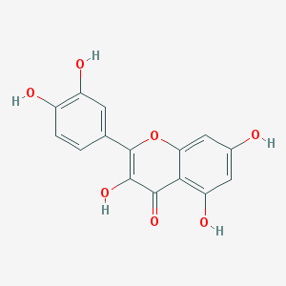
MOL000525 |  | Sitosterol | 36.91 |  |  | 0.75 | 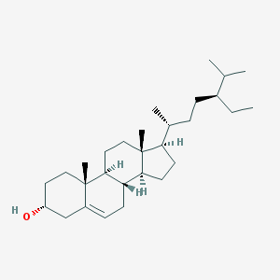
MOL001689 |  | Acacetin | 34.97 |  |  | 0.24 | 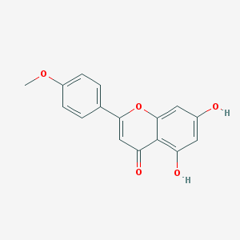
MOL007819 |  | Stigmasterol | 43.83 |  |  | 0.76 | 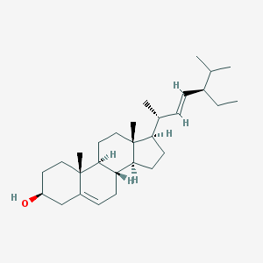
MOL008206 |  | Epiberberine | 30.74 |  |  | 0.55 | 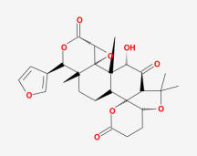
MOL000173 |  | Wogonin | 30.68 |  |  | 0.23 | 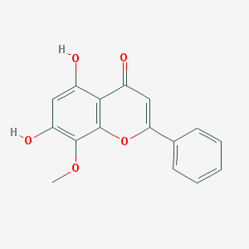
MOL002932 |  | Panicolin | 76.26 |  |  | 0.29 | 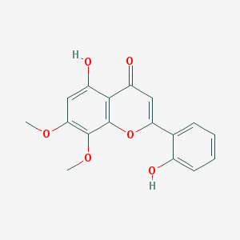
MOL004961 |  | Glycyrin | 52.61 |  |  | 0.47 | 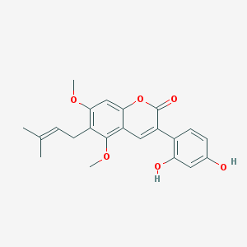
MOL003896 |  | Sainfuran | 79.91 |  |  | 0.23 | 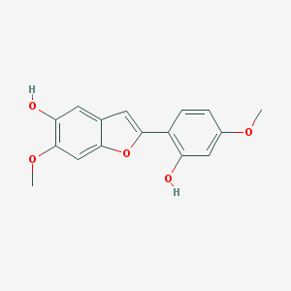
MOL000131 |  | ent-Epicatechin | 48.96 |  |  | 0.24 | 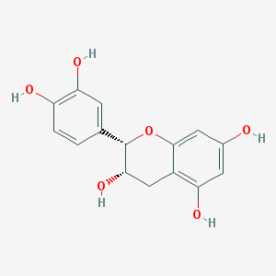
MOL001494 |  | EIC | 41.90 |  |  | 0.14 | 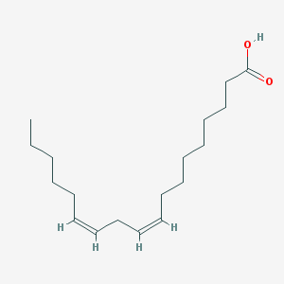
MOL001745 |  | Kaempferol | 41.88 |  |  | 0.24 | 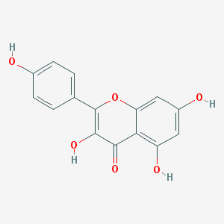
MOL003170 |  | Gentisein | 67.57 |  |  | 0.19 | 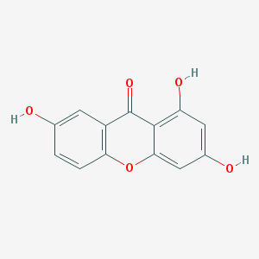
MOL013187 |  | Dihydrotricetin | 58.12 |  |  | 0.28 | 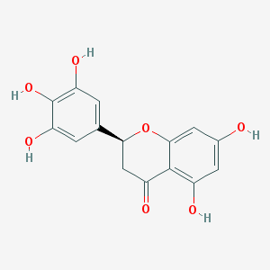
MOL000675 |  | Quercetin | 49.60 |  |  | 0.31
MOL004985 |  | Shinpterocarpin | 80.30 |  |  | 0.73 | 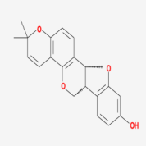
MOL000239 |  | Linoleyl acetate | 42.10 |  |  | 0.20 | 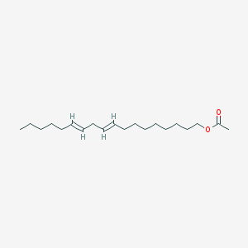
MOL001789 |  | Quercetin | 46.43 |  |  | 0.28
MOL002714 |  | Baicalein | 33.52 |  |  | 0.21 | 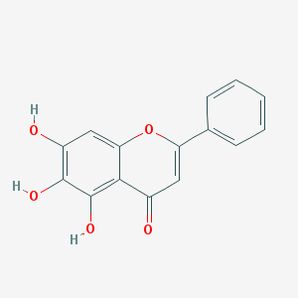
MOL004835 |  | Formononetin | 69.67 |  |  | 0.21 | 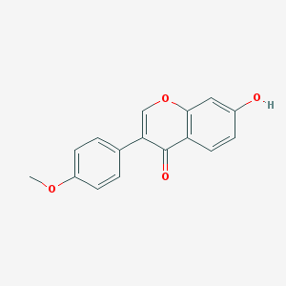
MOL002883 |  | Mandenol | 42.00 |  |  | 0.19 | 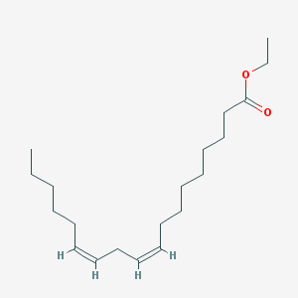
MOL000392 |  | Isoliquiritigenin | 85.32 |  |  | 0.15 | 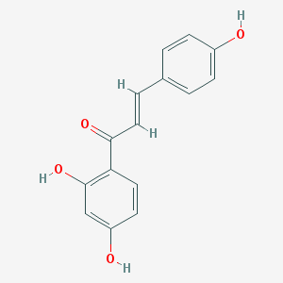
MOL002911 |  | 2, 6, 2', 4'-Tetrahydroxy-6'-methoxychaleone | 69.04 |  |  | 0.22 | 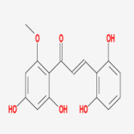
MOL010415 |  | Moslosooflavone | 44.09 |  |  | 0.25 | 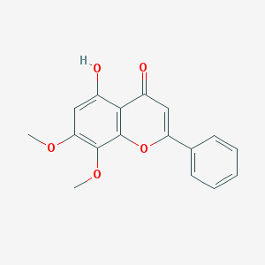
MOL002322 |  | Isovitexin | 31.29 |  |  | 0.72 | 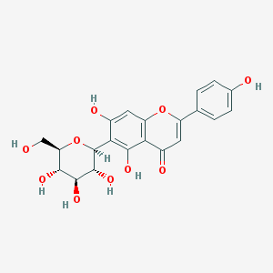
MOL004866 |  | 7-Methoxy-2-methyl isoflavone | 42.56 |  |  | 0.20 | 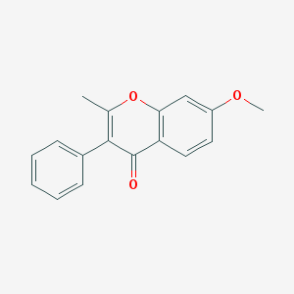
MOL002928 |  | Oroxylin A | 41.37 |  |  | 0.23 | 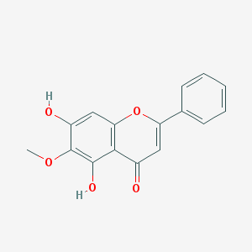
MOL002464 |  | Rel-(1R, 3aS, 4S, 7S, 8R, 8aS)-7-isopropyl-1, 4-dimethyldecahydro-4, 7-epoxyazulene-1, 8-diol | 94.43 |  |  | 0.15 | 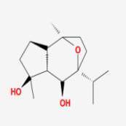
MOL002925 |  | 5, 7, 2', 6'-Tetrahydroxyflavone | 37.01 |  |  | 0.24 | 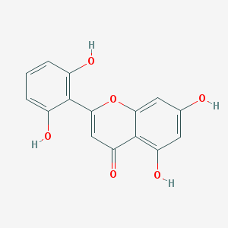
MOL004991 |  | 3, 22-Dihydroxy-11-oxo-delta(12)-oleanene-27-alpha-methoxycarbonyl-29-oic acid | 34.32 |  |  | 0.55 | 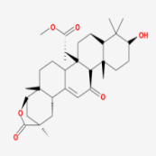
MOL004841 |  | Licochalcone A | 40.79 |  |  | 0.29 | 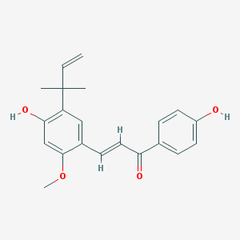
MOL004883 |  | Euchrenone | 30.29 |  |  | 0.57 | 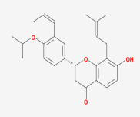
MOL004914 |  | 8-(6-hydroxy-2-benzofuranyl)-2, 2-Dimethyl-5-chromenol | 58.44 |  |  | 0.38 | 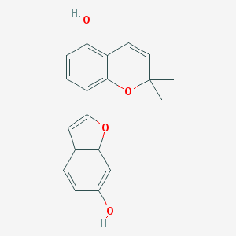
MOL001645 |  | Aristolochic acid Ⅱ | 37.56 |  |  | 0.45 | 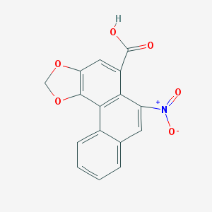
MOL004683 |  | 2, 6-Di(phenyl)thiopyran-4-thione | 69.13 |  |  | 0.15 | 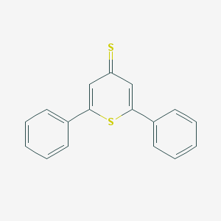
MOL005008 |  | 1, 3-Dihydroxy-8, 9-dimethoxy-6-benzofurano[3, 2-c]chromenone | 62.90 |  |  | 0.53 | 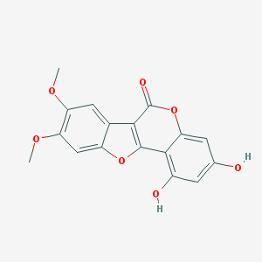
MOL005017 |  | Sigmoidin-B | 34.88 |  |  | 0.41 | 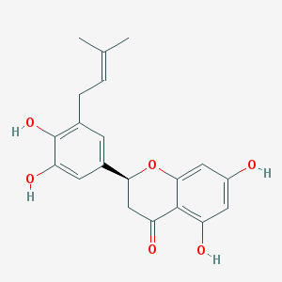
MOL004855 |  | Isoliquiritigenin | 85.32 |  |  | 0.15
MOL003137 |  | Leucanthoside | 32.12 |  |  | 0.78 | 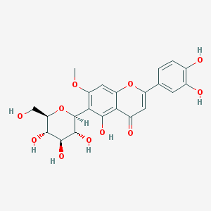
MOL003656 |  | Octalupine | 47.82 |  |  | 0.28 | 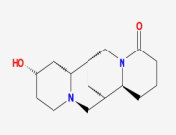
MOL001942 |  | Stigmasterol | 43.83 |  |  | 0.76
MOL004980 |  | Licoisoflavanone | 52.47 |  |  | 0.54 | 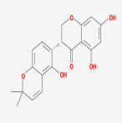
MOL004598 |  | Dinatin | 30.97 |  |  | 0.27 | 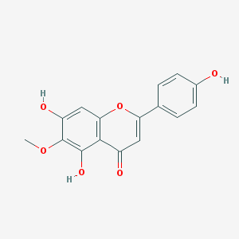
MOL002937 |  | Dihydrooroxylin | 66.06 |  |  | 0.23 | 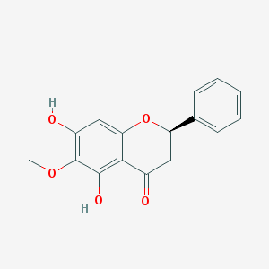
MOL004948 |  | Licorice glycoside E | 32.89 |  |  | 0.27 | 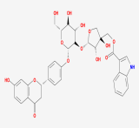
MOL008259 |  | Ariskanin A | 109.51 |  |  | 0.40 | 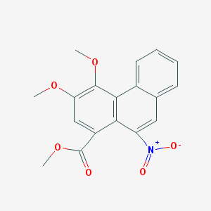
MOL004838 |  | Kaempferol | 41.88 |  |  | 0.24
MOL004848 |  | Vestitol | 74.66 |  |  | 0.21 | 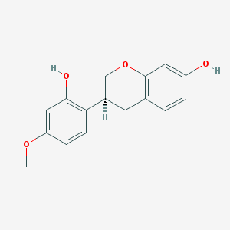
MOL005003 |  | Glabrone | 52.51 |  |  | 0.50 | 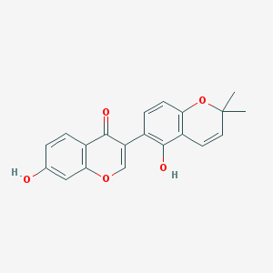
MOL007835 |  | Aristoloside_qt | 40.32 |  |  | 0.60 | 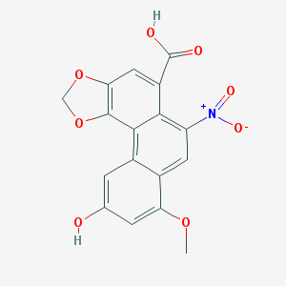
MOL000211 |  | EIC | 41.90 |  |  | 0.14
MOL000500 |  | Isorhamnetin | 49.60 |  |  | 0.31 | 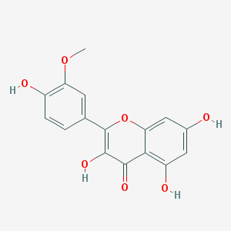
MOL004815 |  | Quercetin | 46.43 |  |  | 0.28
MOL004648 |  | β-Sitosterol | 15.00 |  |  | 0.81 | 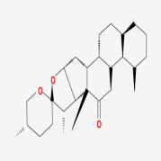
MOL002913 |  | Dihydrobaicalin_qt | 40.04 |  |  | 0.21 | 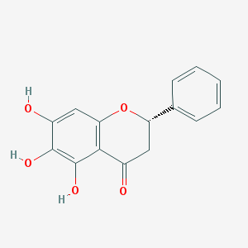
MOL004833 |  | Sitosterol | 36.91 |  |  | 0.75
*OB: oral bioavailability, DL: Drug-like

4. Supplemental Experimental Procedures:
4.1 Reagents
Quercetin and sitosterol (≥ 98% purity by HPLC) were obtained from Jingzhu Biotechnology Co. Ltd.(Nanjing, China), and LPS (purity ≥ 98%) was purchased from TCI Shanghai (Shanghai, China). LPS was purchased from Sigma-Aldrich Co.(St. Louis, United States). The commercial kits for measuring the tumor necrosis factor alpha (TNF-α) and interferon-gamma (IFN-γ) were purchased from Nanjing Jiancheng Biotechnology Co. Ltd.(Nanjing, China). DMEM medium, fetal bovine serum (FBS), 0.25% trypsin, and 3-(4, 5-dimethylthiazol-2-yl)-2, 5-diphenyltetrazolium bromide (MTT) were purchased from Shanghai Sangon Biotechnology Co. Ltd. (Shanghai, China).
4.2 Cell Culture and Treatment
RAW264.7 cells were obtained from the cell bank of the Chinese Academy of Sciences (Shanghai, China). The cells were cultured in DMEM with 10% FBS, and incubated at 37°C under 5% CO₂ . When RAW264.7 cells reached 80% confluency, the cells were treated with quercetin and sitosterol for 2 h, then the cells were treated with LPS (1 μg/mL) for 24 h.
4.3 Cell Viability Assay
MTT assay was utilized to measure cell viability. RAW264.7 cells (6×10⁴ per/well) were seeded in 96-well plates. After 24 h incubation, RAW264.7 cells were treated with 10, 20, 30, 40 and 50 μM quercetin and sitosterol for 24 h. 10 μL of MTT were added to reach a final concentration of 0.5 mg/mL, and incubated for a further 4 h. The absorbance was measured at 570 nm with a microplate reader (BioTek, USA).

