Supplementary materials
Table S1 - Formula of model evaluation metrics and for the concept of ARM.
Terminologies: | Formula:
Precision (PPV) | $$precision=\frac{TP}{TP+FP}$$
Recall (Sensitivity) | $$recall=\frac{TP}{TP+FN}$$
F-score | $$F-score=2\frac{precision×recall}{precision+recall}$$
(weighted) kappa | $$k=1-\frac{\sum_{j=1}^{k}{\sum_{j=1}^{k}{w_{ij}x_{ij}}}}{\sum_{j=1}^{k}{\sum_{j=1}^{k}{w_{ij}m_{ij}}}}$$
Accuracy | $$Acc=\frac{n(correct prediction)}{N}$$
Balanced accuracy | $$bACC=\frac{TPR+TNR}{2}$$
Support | $$supp\left(A→B\right)=\frac{n(AB)}{n}$$
Confidence | $$con\left(A→B\right)=\frac{supp\left(A→B\right)}{supp\left(A\right)}=\frac{n\left(AB\right)}{n\left(A\right)}$$
Lift | $$lift\left(A→B\right)=\frac{con\left(A→B\right)}{supp\left(B\right)}$$

Table S2 - Tree model results by C4.5 algorithm with different settings.
Data for Training Set | M | Leaves | Size | Accuracy | Error(Opti.) | Error(Pessi.)
Original dataset | 2 | 45 | 79 | 90.63% | 6.92% | 7.72%
Original dataset | 3 | 30 | 53 | 90.63% | 7.28% | 7.81%
Original dataset | 4 | 21 | 39 | 90.06% | 7.56% | 7.94%
Original dataset | 5 | 18 | 34 | 90.34% | 7.67% | 7.99%
Original dataset | 6 | 17 | 32 | 90.06% | 7.88% | 8.19%
Original dataset | 7 | 16 | 30 | 90.34% | 8.03% | 8.31%
Original dataset | 8 | 16 | 30 | 90.06% | 8.03% | 8.31%
Original dataset | 9 | 13 | 24 | 90.06% | 8.24% | 8.47%
Original dataset | 10 | 13 | 23 | 90.06% | 8.31% | 8.54%
Original dataset | 11 | 13 | 23 | 90.34% | 8.35% | 8.58%
Original dataset | 12 | 11 | 20 | 90.20% | 8.49% | 8.68%
Original dataset | 13 | 12 | 22 | 90.63% | 8.38% | 8.59%
Original dataset | 14 | 12 | 21 | 90.34% | 8.59% | 8.81%
Original dataset | 15 | 12 | 21 | 90.34% | 8.59% | 8.81%
Over sampling | 2 | 307 | 573 | 81.68% | 1.25% | 3.28%
Over sampling | 3 | 307 | 568 | 81.39% | 1.46% | 3.49%
Over sampling | 4 | 277 | 512 | 81.68% | 2.02% | 3.85%
Over sampling | 5 | 256 | 474 | 80.97% | 2.61% | 4.30%
Over sampling | 6 | 230 | 428 | 78.41% | 3.55% | 5.07%
Over sampling | 7 | 219 | 406 | 76.70% | 4.19% | 5.64%
Over sampling | 8 | 217 | 402 | 76.28% | 4.33% | 5.76%
Over sampling | 9 | 202 | 374 | 74.57% | 5.03% | 6.36%
Over sampling | 10 | 197 | 365 | 73.72% | 5.26% | 6.56%
Over sampling | 11 | 194 | 358 | 73.58% | 5.47% | 6.75%
Over sampling | 12 | 189 | 348 | 73.30% | 5.86% | 7.10%
Over sampling | 13 | 178 | 326 | 71.31% | 6.64% | 7.81%
Over sampling | 14 | 177 | 322 | 70.88% | 7.00% | 8.17%
Over sampling | 15 | 180 | 326 | 71.59% | 7.66% | 8.85%

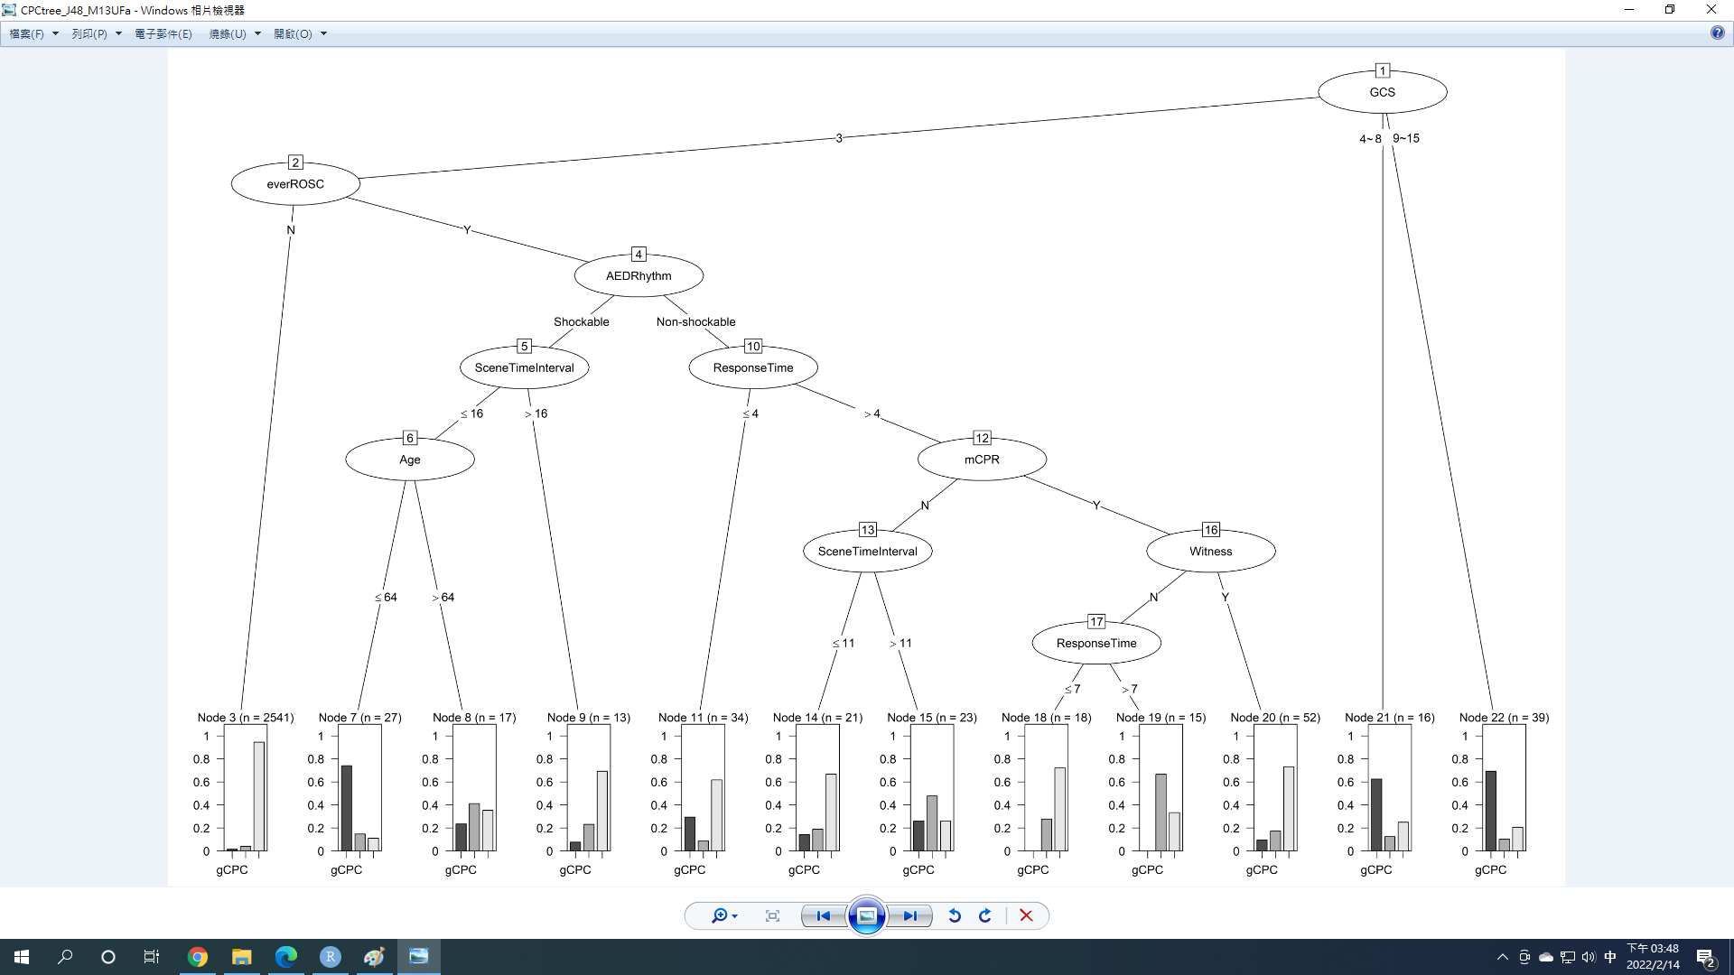
Fig. S1 - Tree plot by C4.5 algorithm with parameters M=13 and C=2.5, pruned. (Accuracy=90.63%)

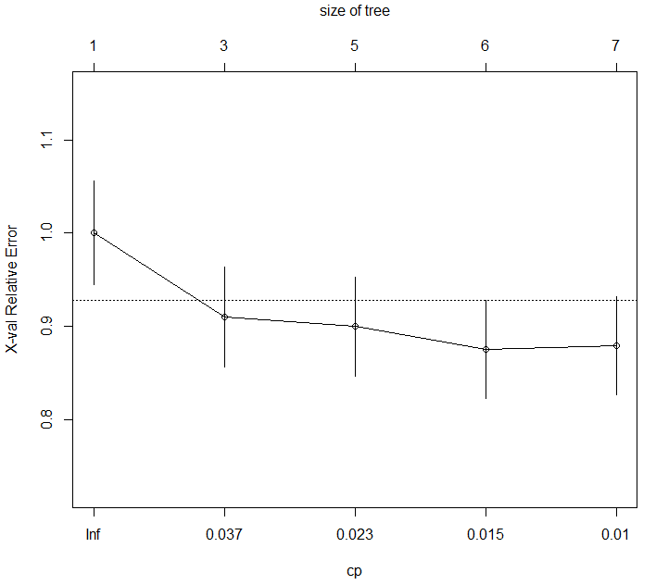
Fig. S2 - Complexity parameter in CART analysis.

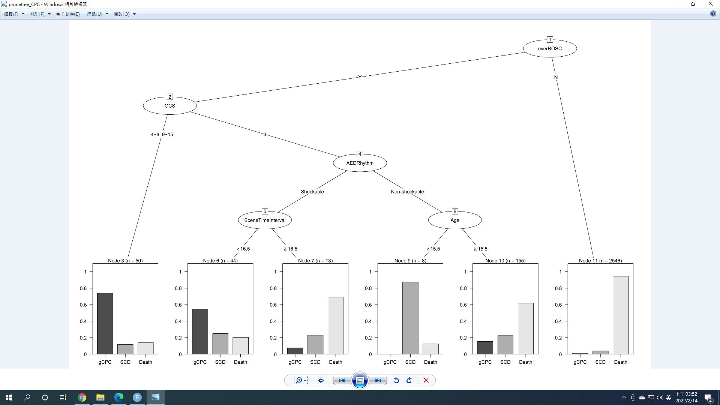
Fig. S3 - Tree model plot by CART (pruned with tree size having six leaves).

Table S3 - Evaluation results for tree-based model performance in the three subgroups and all.
Performance metrics | C4.5 |  | CART |  | RF
 | Original  dataset | Over Sampling | Original  dataset | Over Sampling | Original  Dataset | Over Sampling
Precision (PPV) in gCPC | 53.57% | 40.54% | 42.86% | 71.43% | 65.22% | 70.37%
Recall (Sen) in gCPC | 42.86% | 42.86% | 62.50% | 32.05% | 42.86% | 54.29%
F1 score in gCPC | 0.476 | 0.417 | 0.508 | 0.442 | 0.517 | 0.613
bACC in gCPC | 70.46% | 69.78% | 79.78% | 65.23% | 70.83% | 76.55%
Precision (PPV) in SCD | 55.56% | 8.57% | 7.32% | 31.71% | 50.00% | 38.46%
Recall (Sen) in SCD | 12.20% | 14.63% | 60.00% | 18.31% | 2.44% | 12.20%
F1 score in SCD | 0.200 | 0.108 | 0.130 | 0.232 | 0.047 | 0.185
bACC in SCD | 55.80% | 52.49% | 77.28% | 56.94% | 51.14% | 55.49%
Precision (PPV) in Death | 92.65% | 92.80% | 98.89% | 84.55% | 91.90% | 93.07%
Recall (Sen) in Death | 98.41% | 88.22% | 92.00% | 95.68% | 99.36% | 98.41%
F1 score in Death | 0.954 | 0.905 | 0.953 | 0.898 | 0.955 | 0.957
bACC in Death | 66.97% | 65.82% | 83.93% | 65.29% | 63.50% | 68.94%
Accuracy (Overall) | 90.62% | 81.68% | 90.77% | 80.82% | 90.91% | 91.19%
Kappa (Overall) | 0.384 | 0.221 | 0.353 | 0.328 | 0.341 | 0.434
multi-class AUC | 64.67% | 70.19% | 64.46% | 76.66% | 65.15% | 71.47%
weighted Precision (Overall) | 88.55% | 85.30% | 90.77% | 80.82% | 88.13% | 88.76%
weighted Recall (Overall) | 90.63% | 81.68% | 88.67% | 88.01% | 90.91% | 91.20%
F1 score (Overall) | 0.896 | 0.834 | 0.897 | 0.843 | 0.895 | 0.900

Table S4 - The results of ARM from original dataset (listing in the raw output with original variable names from the dataset), all rules were found to death due to the highly imbalanced outcome classes.
Rules for CPC outcome {conditions} =>{outcome} | support | confidence | coverage | lift
{GCS=3} => {CPC_3=Death} | 0.892 | 0.910 | 0.981 | 1.015
{ever ROSC=N} => {CPC_3=Death} | 0.852 | 0.945 | 0.901 | 1.055
{AED Rhythm=Non-shockable} => {CPC_3=Death} | 0.791 | 0.926 | 0.855 | 1.033
{mechanical CPR =Y} => {CPC_3=Death} | 0.759 | 0.912 | 0.832 | 1.017
{Location=Residential} => {CPC_3=Death} | 0.713 | 0.919 | 0.776 | 1.025
{CAD=N} => {CPC_3=Death} | 0.682 | 0.904 | 0.754 | 1.008
{DM=N} => {CPC_3=Death} | 0.665 | 0.902 | 0.738 | 1.006
{EMT_menbers=3~4} => {CPC_3=Death} | 0.651 | 0.904 | 0.719 | 1.009
{Witness=N} => {CPC_3=Death} | 0.547 | 0.944 | 0.579 | 1.053
{Hospital Level=Non-CAC} => {CPC_3=Death} | 0.494 | 0.906 | 0.545 | 1.010
{Age=65~85 y/o} => {CPC_3=Death} | 0.351 | 0.905 | 0.387 | 1.010
{Gender=F} => {CPC_3=Death} | 0.333 | 0.911 | 0.366 | 1.016
{Transport Time=4~8 mins} => {CPC_3=Death} | 0.329 | 0.908 | 0.362 | 1.013
{Bystander CPR=N, Amiodarone=0} => {CPC_3=Death} | 0.318 | 0.900 | 0.354 | 1.005
{EMT Time=24~30 mins} => {CPC_3=Death} | 0.305 | 0.903 | 0.337 | 1.008

