Supporting Information

A biomimetic smart nanoplatform as “inflammation scavenger” for regenerative therapy of periodontal tissue
Poyu Chen^{1, 2, 3}*, Chuangwei Zhang^{1, 2, 3}*, Ping He⁴, Shengyuan Pan^{1, 2, 3}, Wenjie Zhong^{1, 2, 3}, Yue Wang^{1, 2, 3}, Qingyue Xiao^{1, 2, 3}, Xinyan Wang^{1, 2, 3}, Wenliang Yu^{1, 2, 3}, Zhangmin He^{1, 2, 3}, Xiang Gao^{1, 2, 3#}, Jinlin Song^{1, 2, 3#}

¹College of Stomatology, Chongqing Medical University, Chongqing 401147, People’s Republic of China;
²Chongqing Key Laboratory of Oral Diseases and Biomedical Sciences, Chongqing 401147, People’s Republic of China;
³Chongqing Municipal Key Laboratory of Oral Biomedical Engineering of Higher Education, Chongqing 401147, People’s Republic of China;
⁴Department of Stomatology, Dazhou Central Hospital, Dazhou, SiChuan 635000, People’s Republic of China.

*These authors contributed equally to this work

Correspondence:
#Prof. Xiang Gao, Chongqing Key Laboratory for Oral Diseases and Biomedical Sciences, Chongqing 401147, People’s Republic of China
Tel & Fax: +86 23 88860105.
E-mail: xiangg@hospital.cqmu.edu.cn
#Prof. Jinlin Song, Chongqing Key Laboratory for Oral Diseases and Biomedical Sciences, Chongqing 401147, People’s Republic of China
Tel & Fax: +86 23 88860026.
E-mail: songjinlin@hospital.cqmu.edu.cn

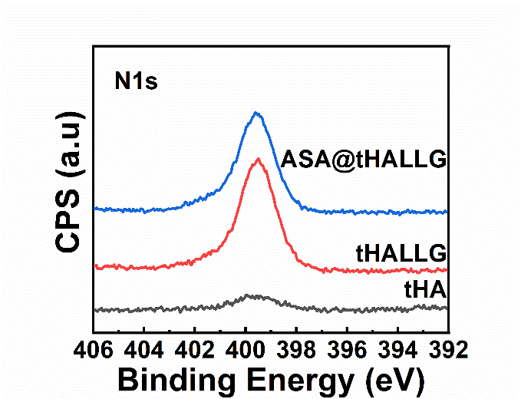
Figure S1. High-resolution nitrogen spectra of tHA, tHALLG and ASA@tHALLG nanocomposites.

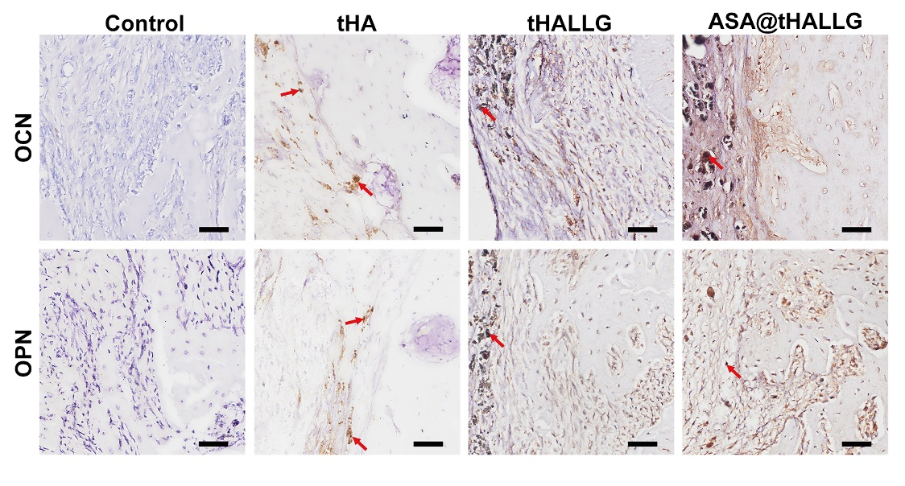
Figure S2. IHC staining of OCN and OPN in defects treated by tHA, tHALLG and ASA@tHALLG nanocomposites. Red arrows indicate the implanted materials.

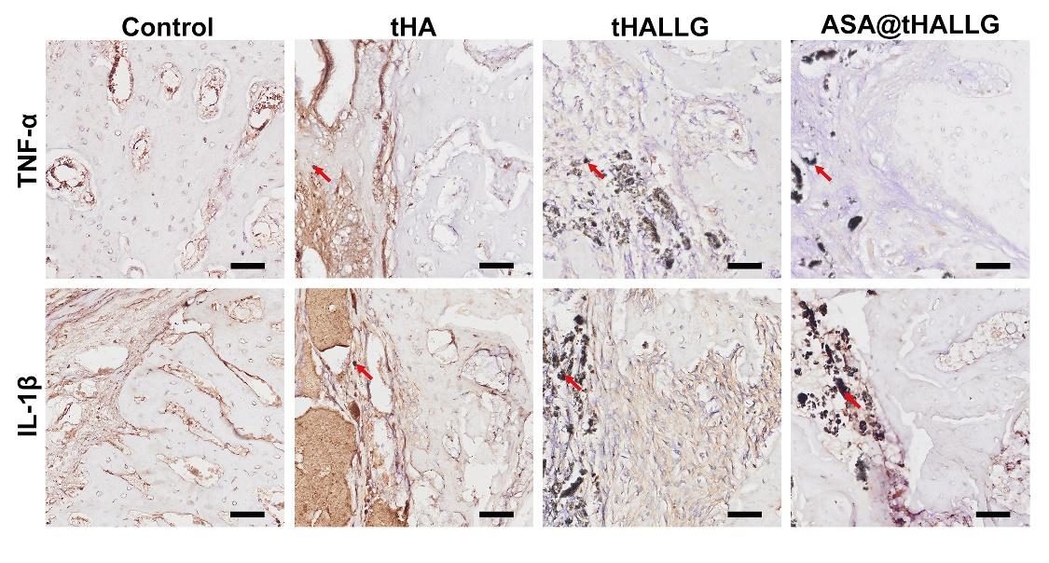
Figure S3. IHC staining of TNF-α and IL-1β in defects treated by tHA, tHALLG and ASA@tHALLG nanocomposites. Red arrows indicate the implanted materials.

Table S1. The primers used in this study
Gene | Primer sequence (5'→3')
GAPDH | (F) CGACAGTCAGCCGCATCTT  (R) CCAATACGACCAAATCCGTTG
Runx2 | (F) AGGAATGCGCCCTAAATCACT  (R)ACCCAGAAGGCACAGACAGAAG
COL1A1 | (F) AGACACTGGTGCTAAGGGAGAG  (R) GACCAGCAACACCATCTGCG
ALP | (F) GAACGTGGTCACCTCCATCCT  (R) TCTCGTGGTCACAATGC
TNF-α | (F) TCTTCTCCTTCCTGATCGTGG  (R) AGGGCTGATTAGAGAGAGGTCC
IL-1β | (F) GAAATGATGGCTTATTACAGTGGC  (R) TTGCTGTAGTGGTGGTCGGAG
IL-6 | (F) GAGTAGTGAGGAACAAGCCAGAG  (R) GGTCAGGGGTGGTTATTGC

