Supporting Information for
Short-Wavelength Aggregation-Induced Emission Photosensitizers for Solid Tumor Therapy: Enhanced with White-light Fiber Optic
Zijuan Mengª, Zhaojun Chenª, Guangwen Luª, Xiaoqi Dongª, Jun Dai^{b*}, Xiaoding Louª, Xia Fanª

ª Faculty of Materials Science and Chemistry, China University of Geosciences, Wuhan 430074, China.
^{b} Department of Obstetrics and Gynecology, Tongji Hospital, Tongji Medical College, Huazhong University of Science and Technology, Wuhan 430034, China.

Figures and caption
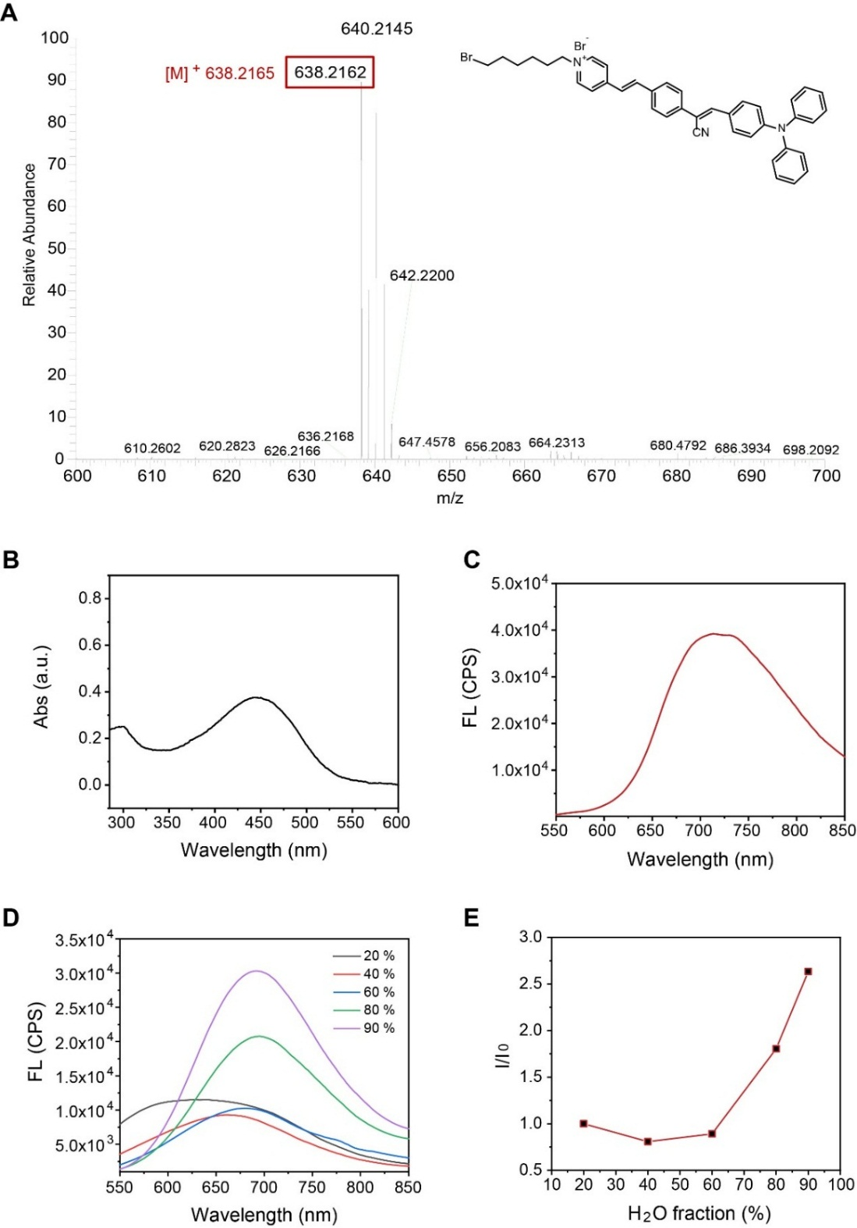
Figure S1. Characterization of PyTPA. (A) High resolution mass spectrum (HRMS) (MALDI-TOF) of PyTPA, [M]⁺ = 638.2162 (calcd 638.2165). (B) UV-vis absorption spectra of PyTPA. The concentration of PyTPA is 10 μM. (C) Fluorescence spectra of PyTPA. (D) Photoluminescence (PL) spectra of PyTPA in DMSO/water mixtures with different water fractions. (E) Plot of I/I₀ values versus the compositions of the aqueous mixtures. I₀ = emission intensity of PyTPA in DMSO. E_{ex} = 450 nm.
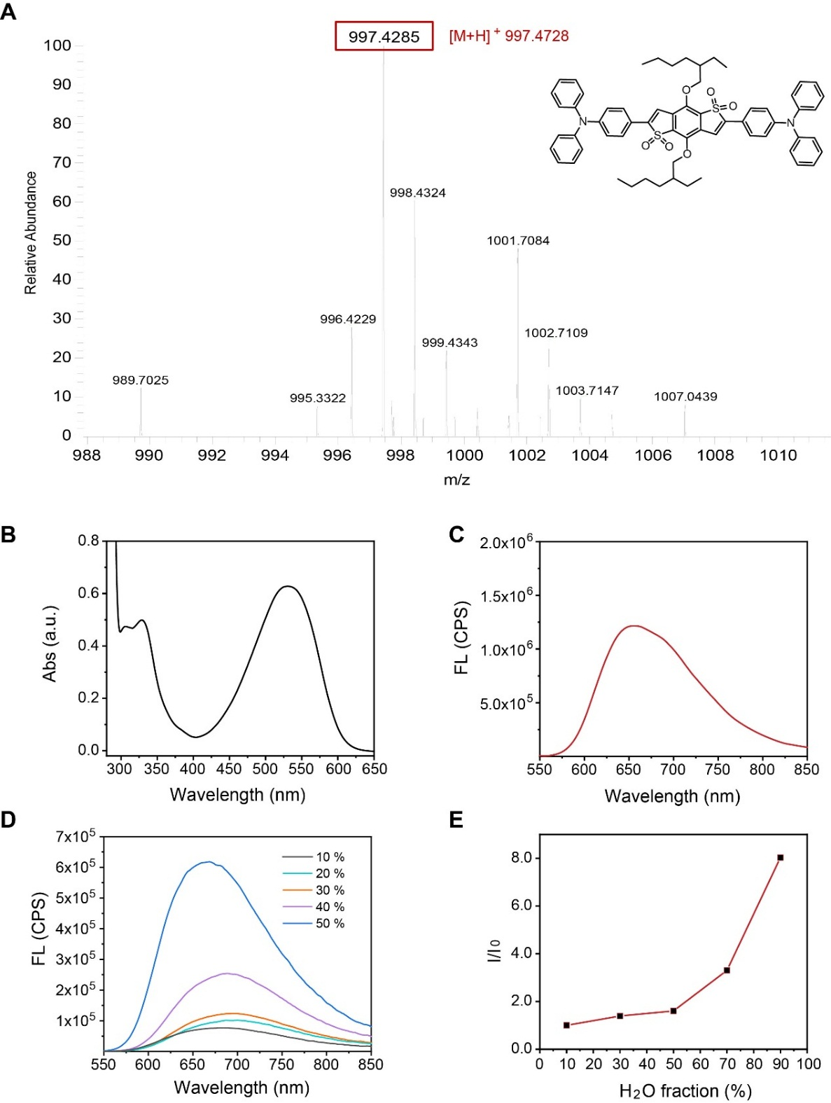
Figure S2. Characterization of TB. (A) High resolution mass spectrum (HRMS) (MALDI-TOF) of TB, [M+H]⁺ = 997.4728 (calcd 997.4285). (B) UV-vis absorption spectra of TB. The concentration of TB is 10 μM. (C) Fluorescence spectra of TB. (D) Photoluminescence (PL) spectra of TB in THF/water mixtures with different water fractions. (E) Plot of I/I₀ values versus the compositions of the aqueous mixtures. I₀ = emission intensity of TB in THF. E_{ex} = 530 nm.

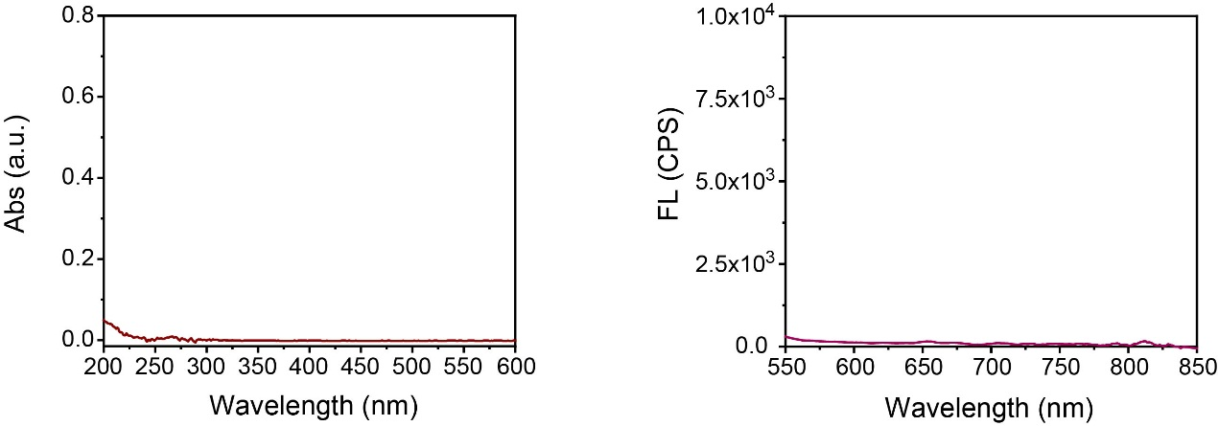
Figure S3. UV-vis absorption spectra of PEG. The concentration of PEG is 10 μM.
Fluorescence spectra of PEG.

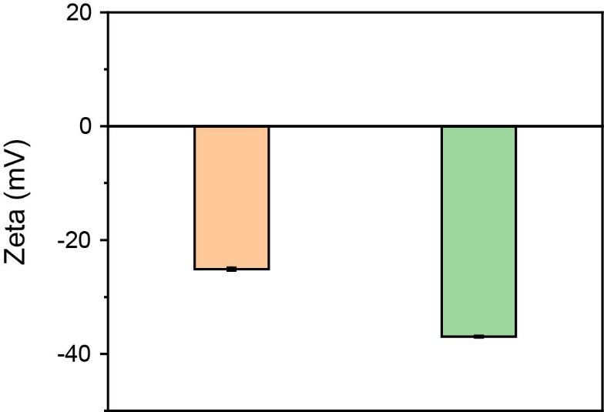
Figure S4. Zeta potential indicating the surface charges of PyTPA@PEG and TB@PEG NPs.
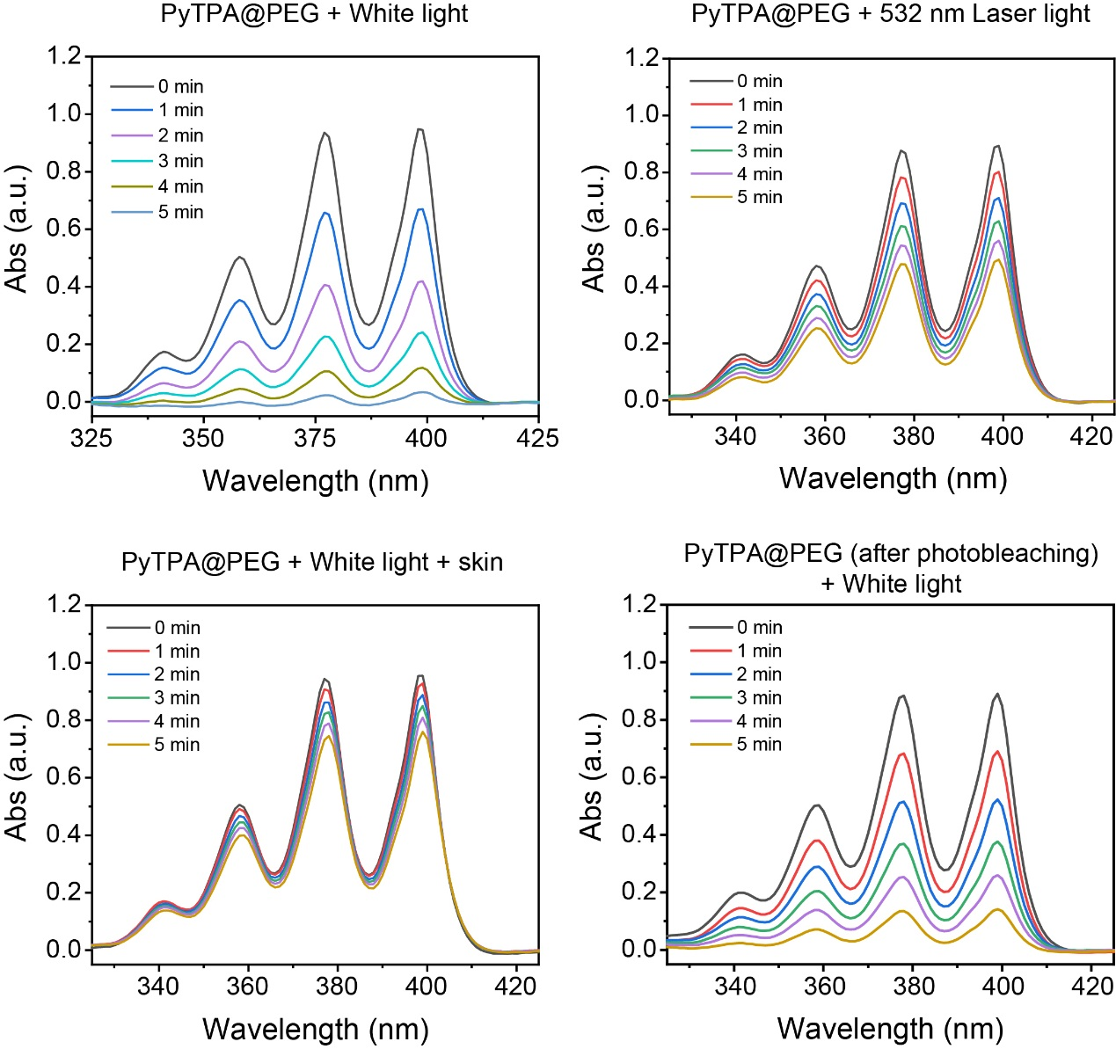
Figure S5. The UV-vis absorption spectrum of the ROS indicator ABDA mixed with PyTPA@PEG upon light irradiation (white light, 80 mW cm⁻², 532 nm laser light, 80 mW cm⁻², white light bleaching of 100mW cm⁻² for 30 minutes).
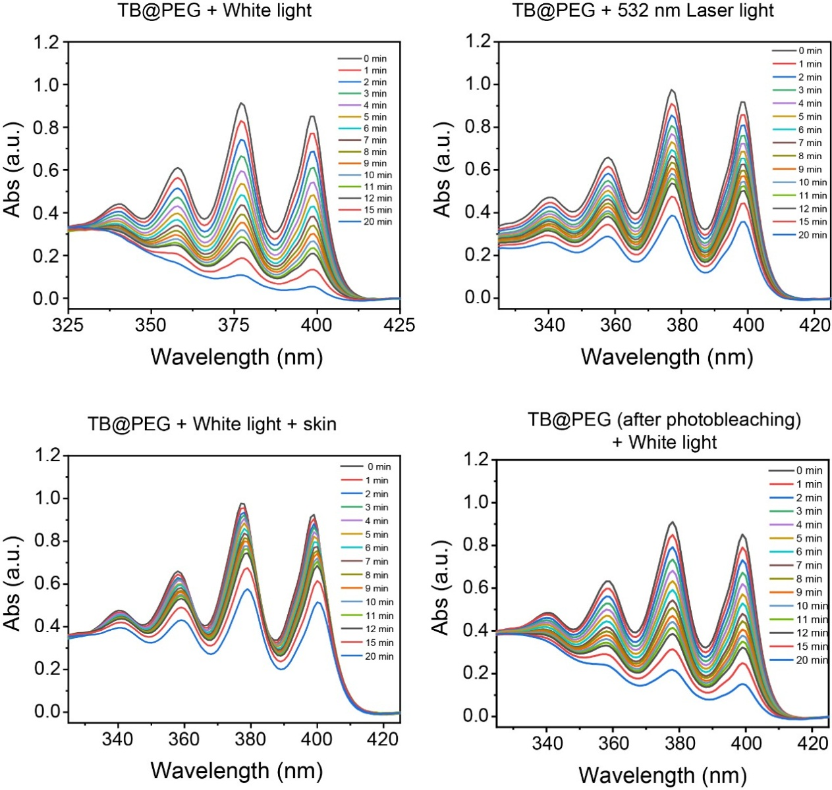 Figure S6. The UV-vis absorption spectrum of the ROS indicator ABDA mixed with TB@PEG upon light irradiation (white light, 80 mW cm⁻², 532 nm laser light, 80 mW cm⁻², white light bleaching of 100mW cm⁻² for 30 minutes).

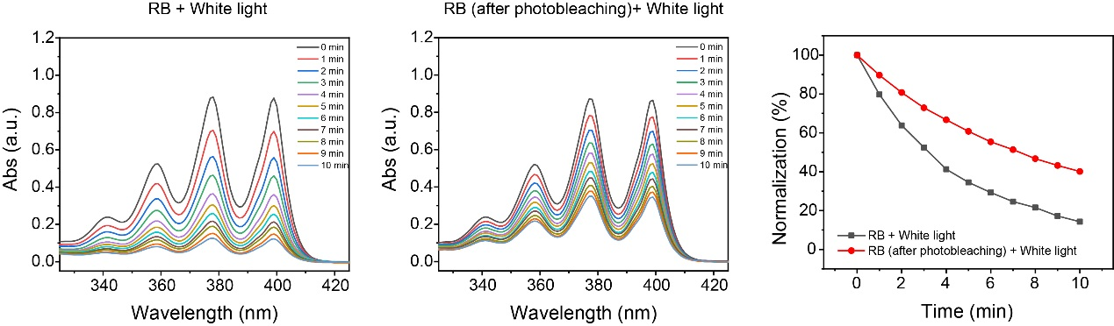 Figure S7. The UV-vis absorption spectrum of the ROS indicator ABDA mixed with RB upon light irradiation (white light, 80 mW cm⁻², white light bleaching of 100mW cm⁻² for 30 minutes).
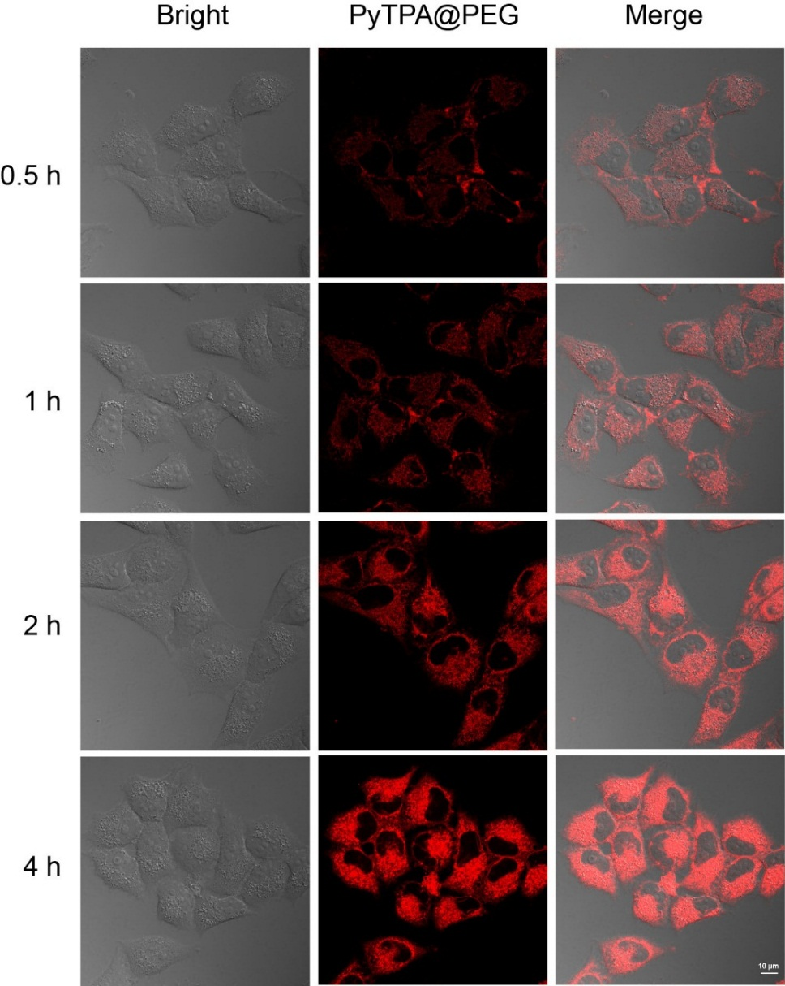
Figure S8. Hela cells were incubated with different time of PyTPA@PEG. CLSM was detected the intracellular fluorescence intensity. The concentration of PyTPA@PEG was 10 μM. PyTPA@PEG: Ex =405 nm, Em = 640-740 nm.
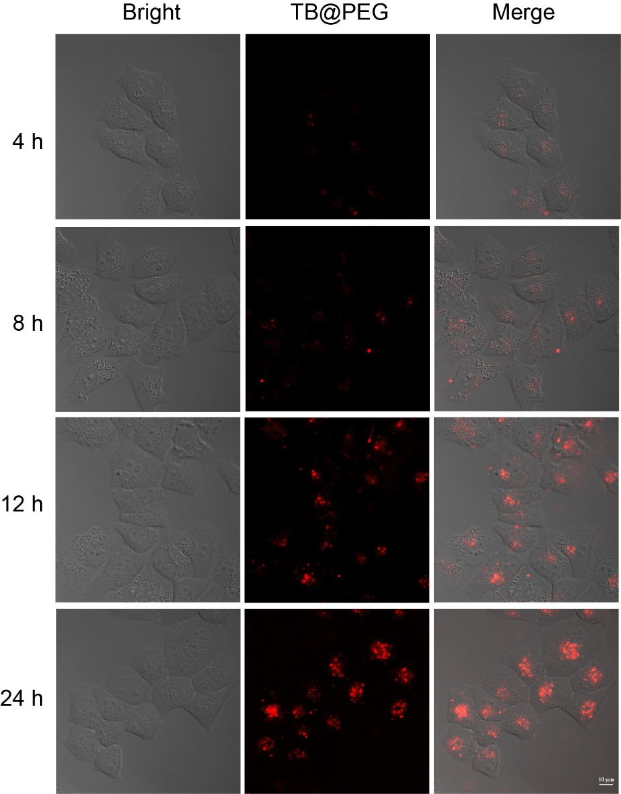
Figure S9. After incubation of Hela cells with TB@PEG NPs for 4 h, 8 h, 12 h and 24 h. CLSM assayed the NPs taken up by the cells. The concentration of TB@PEG NPs was 10 μM. TB@PEG: Ex = 543 nm, Em = 620-740 nm.

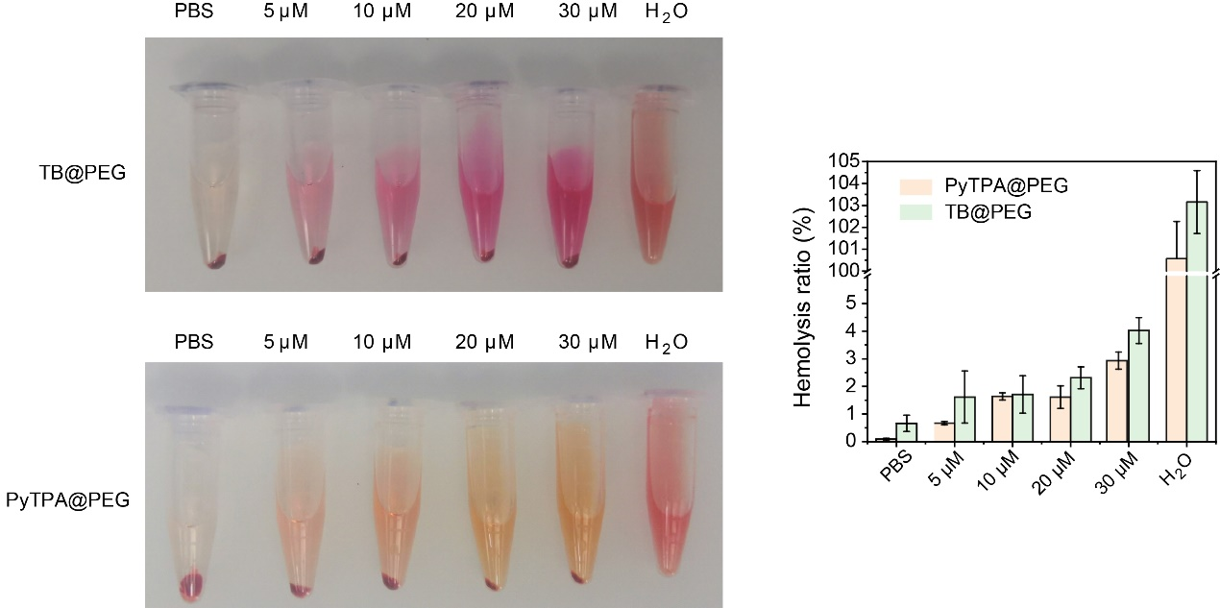
Figure S10. Hemolysis test after incubated with PBS (negative control), PyTPA@PEG, TB@PEG, and ultrapure water (positive control). The concentration of nanoparticles was 5μM, 10 μM, 20 μM and 30 μM, respectively. The results were presented as the mean ±SD (n = 3).

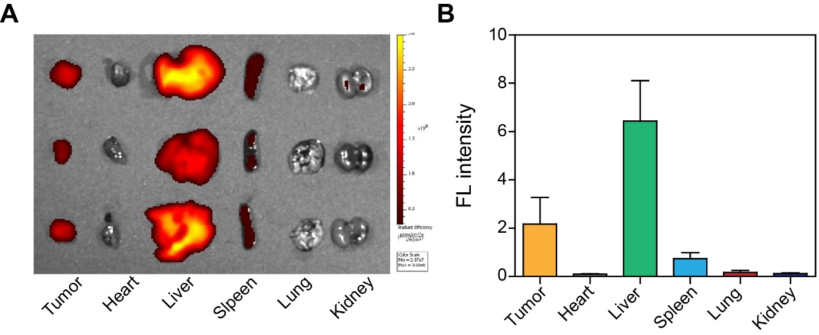
Figure S11. (A) Fluorescence images of TB@PEG in different organs and tumors 48 h after the tail vein injection. TB@PEG: Ex = 535 nm, Em = 680 nm. (B) Relative fluorescence intensity of TB@PEG in tumor, heart, liver, spleen, lung and kidney.

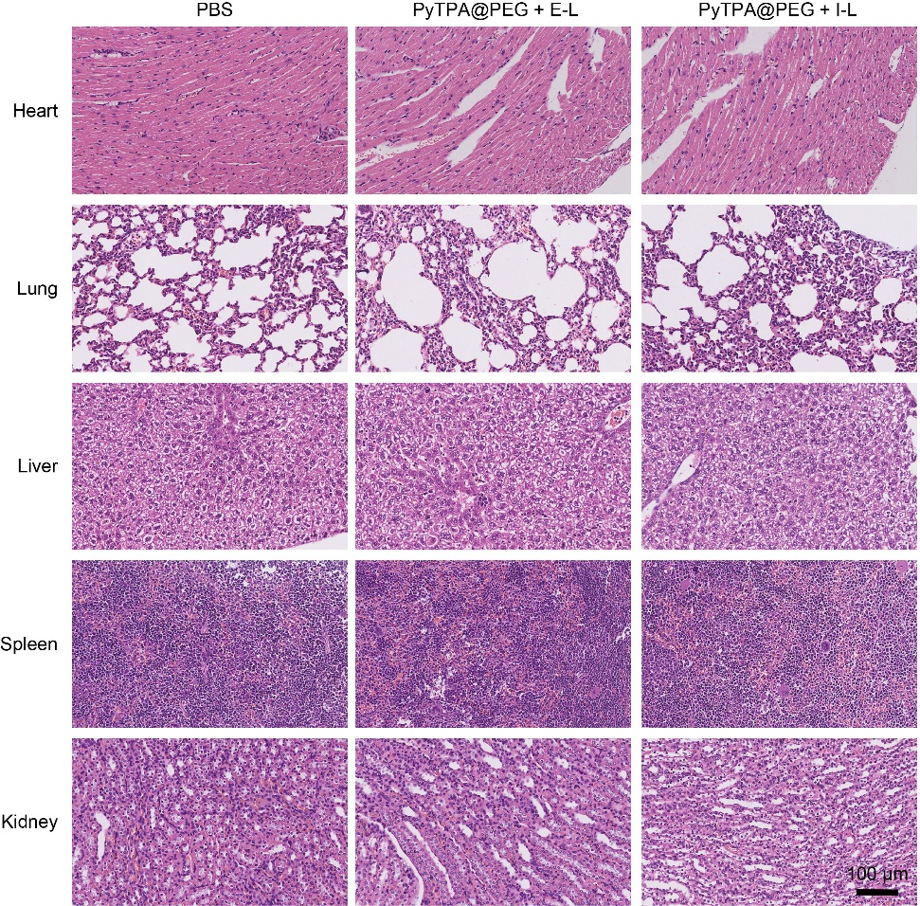 Figure S12. The histological changes of heart, lung, liver, spleen and kidney were observed by H&E staining.
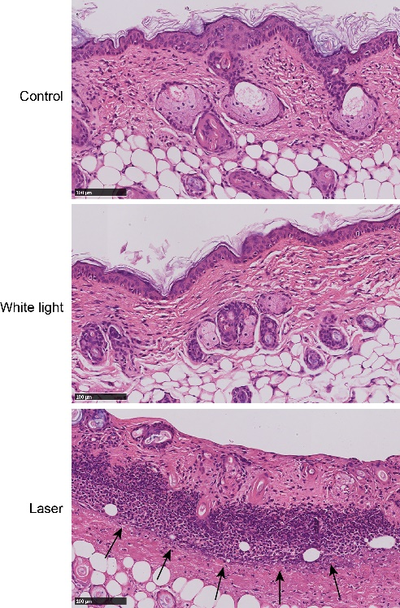
Figure S13. The histological changes of skin after white light (200 mW cm⁻², 10 min) and laser irradiation (200 mW cm⁻², 10 min) were observed by H&E staining. The black arrow indicated inflammatory cell infiltration.

