SUPPLEMENTARY FIGURES

Figure S1 AF4-DLS analysis of investigated liposomes: A. liposome F10103; B. Liposome F10102; C. Liposome F20104A Continuous blue line: liposomes in PBS; continuous red line: liposomes in diluted in PBS; black dotted line: z-average [d, nm] of liposomes in PBS; green dotted line: z-average [d, nm] of liposomes in diluted PBS

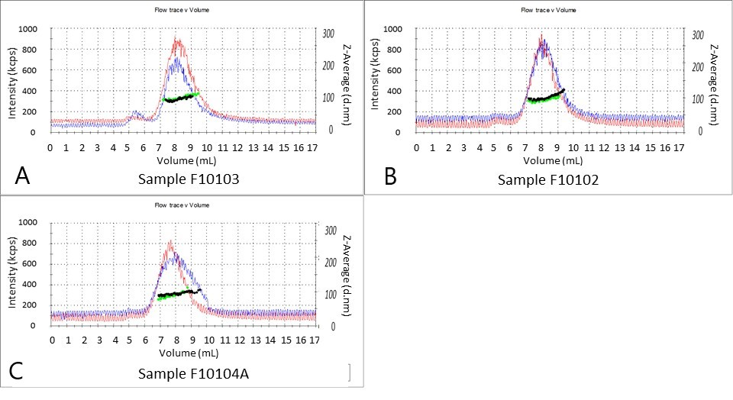

Figure S2 iC3b variability in serum from healthy donors as response to CV based on: (a) Gender, (b) Rhesus factor (RH+ and RH-) and (c) RH-gender
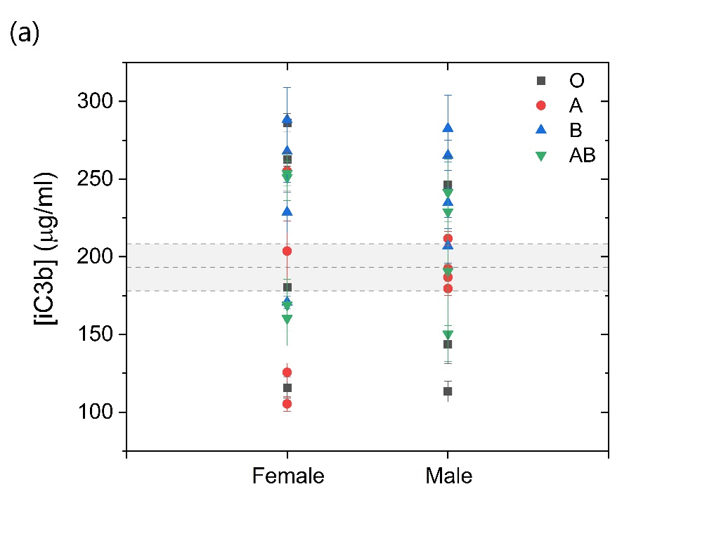
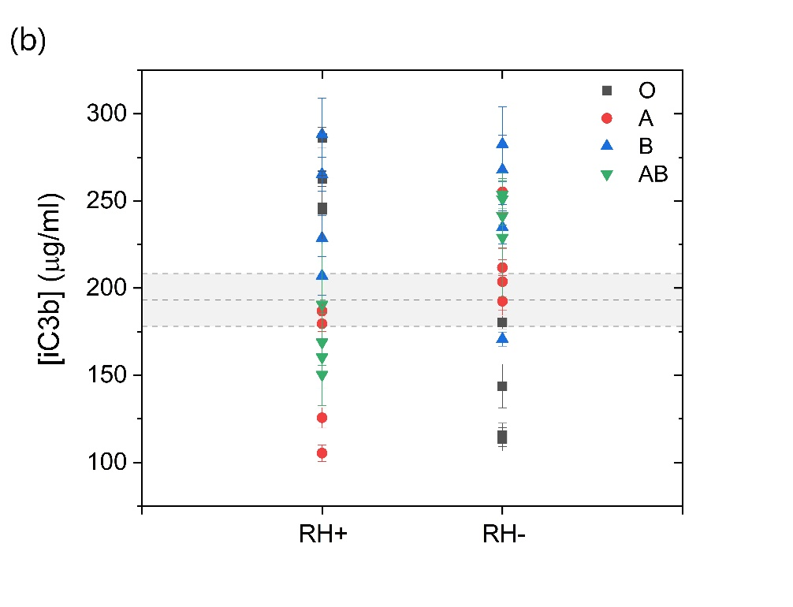
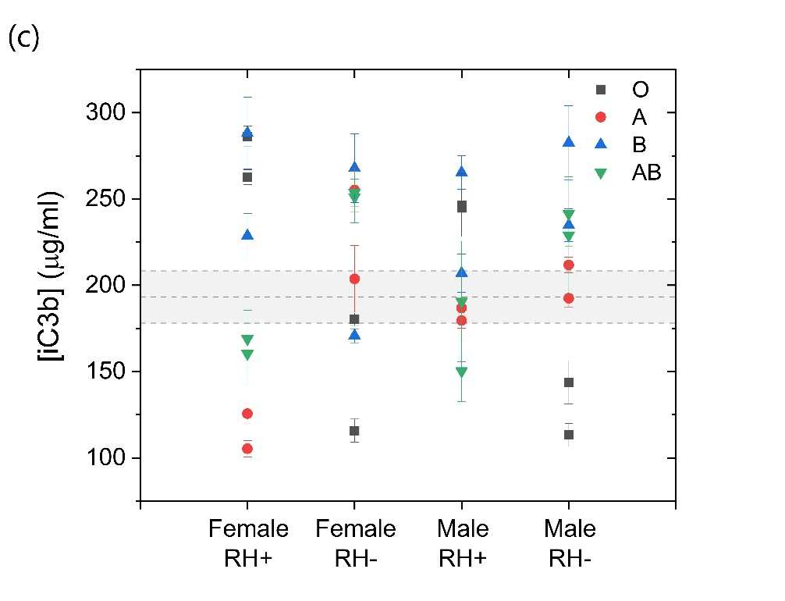

Figure S3 iC3b variability in serum from healthy donors as response to liposome (F20104) based on: (a) Gender, (b) Rhesus factor (RH) and (c) RH-gender
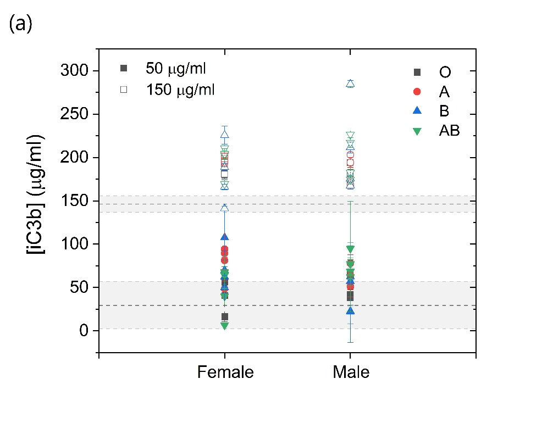
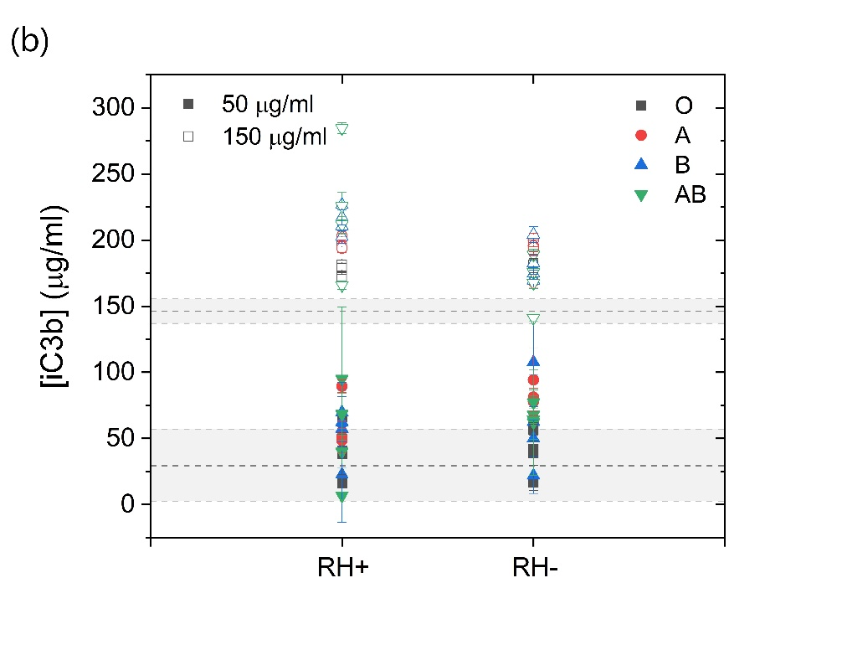
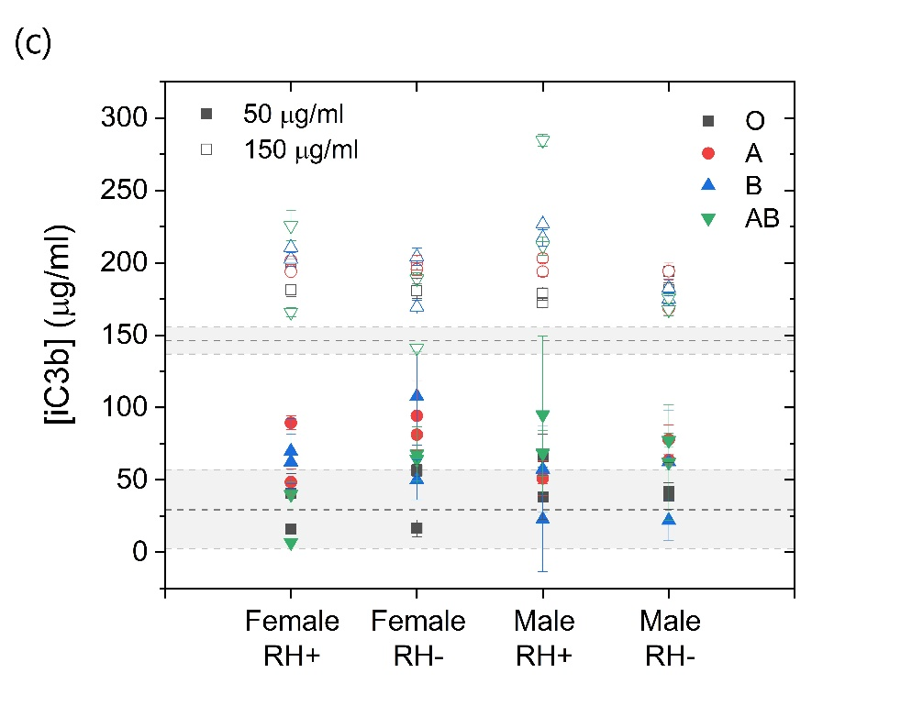
Table S1 Liposomes investigated in the study

Catalogue nr. | Mean particle size | Lipid Stock  concentration [mg/ml] | Lipid composition | Hydration buffer (loading battery)
F20104A | 100 nm  (95-120 nm) | 36.3 | HSPC/CHOL (55:45 mol/mol) | 250 mM ammonium sulfate External solution: 10% sucrose, 20mM NaPO4, pH 6.5 +/- 0.2
F20103A | 100 nm  (95-120 nm) | 36.5 | DSPC/CHOL (55:45 mol/mol) | 250 mM ammonium sulfate External solution: 10% sucrose, 20mM NaPO4, pH 6.5 +/- 0.2
F10102 | 100 nm  (95-120 nm) | 34.6 | DPPC/CHOL (55:45 mol/mol) | Internal/External solution: 10% sucrose, 20 mM HEPES, pH 7.0 - 7.5

Table S2 Information on clinical parameters of human serum obtained from both healthy donors (S2A) and patients (S2B) with pre-existing conditions

(S2A)

Health status | Donors | Blood type | Rhesus (Rh) | Gender | Age | Ig G | Ig M
Healthy | 1 | A | + | female | 59 | 806 | 107
Healthy | 2 | A | + | female | 41 | 1125 | 95
Healthy | 3 | A | + | male | 59 | 945 | 49
Healthy | 4 | A | + | male | 48 | 1087 | 82
Healthy | 5 | A | - | female | 31 | 1126 | 88
Healthy | 6 | A | - | female | 50 | 1423 | 97
Healthy | 7 | A | - | male | 52 | 730 | 77
Healthy | 8 | A | - | male | 23 | 775 | 94
Healthy | 9 | O | + | female | 55 | 885 | 299
Healthy | 10 | O | + | female | 58 | 594 | 74
Healthy | 11 | O | + | male | 56 | 750 | 91
Healthy | 12 | O | + | male | 54 | 616 | 60
Healthy | 13 | O | - | female | 55 | 1113 | 137
Healthy | 14 | O | - | female | 54 | 937 | 28
Healthy | 15 | O | - | male | 50 | 1081 | 58
Healthy | 16 | O | - | male | 57 | 833 | 72
Healthy | 17 | B | + | female | 51 | n.a. | n.a.
Healthy | 18 | B | + | female | 56 | n.a. | n.a.
Healthy | 19 | B | + | male | 54 | 1127 | 38
Healthy | 20 | B | + | male | 52 | 645 | 25
Healthy | 21 | B | - | female | 57 | 808 | 60
Healthy | 22 | B | - | female | 27 | 1153 | 68
Healthy | 23 | B | - | male | 24 | 1085 | 74
Healthy | 24 | B | - | male | 47 | n.a. | n.a.
Healthy | 25 | AB | + | female | 50 | 758 | 88
Healthy | 26 | AB | + | female | 59 | 694 | 38
Healthy | 27 | AB | + | male | 54 | 985 | 84
Healthy | 28 | AB | + | male | 58 | 844 | 128
Healthy | 29 | AB | - | female | 32 | 721 | 90
Healthy | 30 | AB | - | female | 60 | 1201 | 51
Healthy | 31 | AB | - | male | 28 | 902 | 85
Healthy | 32 | AB | - | male | 24 | 809 | 58

(S2B)

Patients with pre-existing conditions | Donors | Blood type | Rhesus (Rh) | Gender | Age | Ig G | Ig M | Allergy type
Allergy | 1 | A | + | female | 52 | 771 | 91 | t4, f17, f94, f49 (G3), t3, poplar (G4)
Allergy | 2 | A | + | female | 56 | 1061 | 63 | t2 (G4), t4 (G3), t3 (G5), w6 (G2), f13 (G2), f17, f94, chroma, nickel, cobalt
Allergy | 3 | A | + | male | 59 | 950 | 46 | pollen unspecified (G3)
Allergy | 4 | A | + | male | 50 | 932 | 89 | pollen (grass), pollen (trees)
Allergy | 5 | A | - | female | 44 | 1278 | 93 | f44 (G1), nickel
Allergy | 6 | A | - | female | 53 | 1164 | 101 | t4, t3, w6, m01, sticking plaster, chicken/pigeon (feahthers) (G4), d01, d0, f02, f04, sun (G3)
Allergy | 7 | A | - | male | 31 | 1282 | 120 | pollen, cereals
Allergy | 8 | A | - | male | 39 | 1001 | 99 | pollen (grass), pollen (early and middle flowering plants and trees), i3 (G3)
Allergy | 9 | O | + | female | 45 | 957 | 155 | t2, t4, t3 (G3), e1 (G1), stone fruit, apple, cherry
Allergy | 10 | O | + | female | 71 | 1258 | 64 | t2, sticking plaster (G3), t4, t3, f84 (G2)
Allergy | 11 | O | + | male | 36 | 947 | 65 | t2, t4, d01, d02, f49 (G3), t3 (G4), f85(G1)
Allergy | 12 | O | + | male | 34 | n.a. | n.a. | e1 (G3)
Allergy | 13 | O | - | female | 70 | 799 | 59 | mites, mold, fragrances, nickel
Allergy | 14 | O | - | female | 24 | 1297 | 64 | pollen (G3-G4)
Allergy | 15 | O | - | male | 72 | 1221 | 55 | t2, t4, t3 (G5)
Allergy | 16 | O | - | male | 56 | 1022 | 68 | g6 (G4), g8 (G4), t3 (G3)
Allergy | 17 | B | + | female | 31 | 791 | 80 | w6 (G5), d01, d02, d70, d72, f44
Allergy | 18 | B | + | female | 64 | 1065 | 98 | i1 (g2), i3 (G4), penicillin
Allergy | 19 | B | + | male | 55 | 1186 | 37 | f84 (G4)
Allergy | 20 | B | + | male | 56 | 1074 | 96 | pollen grass (G3), t4, e5, f17 (G4), t3 (G3), e1, e3 (G5)
Allergy | 21 | B | - | female | 51 | 816 | 100 | t4, t3 (G1), f02 (G3)
Allergy | 22 | B | - | female | 57 | 845 | 64 | k82 (G2), nickel, cobalt (G5), fragrances, Perubalsam (G2), benzocaine (G1)
Allergy | 23 | B | - | male | n.a. | n.a. | n.a. | n.a.
Allergy | 24 | B | - | male | n.a. | n.a. | n.a. | n.a.
Allergy | 25 | AB | + | female | 59 | 807 | 70 | m01, m03 (G5), f85 (G2), garlic (G4), w6
Allergy | 26 | AB | + | female | 41 | 872 | 86 | g12 (G4), t2, t4, t3 (G5), w1, w6 (G1), d01, d02 (G5), m03, m06, Cladosporium herbarium (G2), f17, melon, apple, cherry (G4)
Allergy | 27 | AB | + | male | n.a. | n.a. | n.a. | n.a.
Allergy | 28 | AB | + | male | n.a. | n.a. | n.a. | n.a.
Allergy | 29 | AB | - | female | 61 | 1158 | 46 | t4 (G3), e1, d01 (G4)
Allergy | 30 | AB | - | female | 47 | 1082 | 148 | chrome, nickel (G4), pollen, palladium
Allergy | 31 | AB | - | male | n.a. | n.a. | n.a. | n.a.
Allergy | 32 | AB | - | male | n.a. | n.a. | n.a. | n.a.

Patients with pre-existing conditions | Donors | Gender | Age | Ig G | Ig M | Cancer type
Cancer | 1 | female | 66 | 888 | 20 | Breast cancer
Cancer | 2 | female | 67 | 712 | 73 | Breast cancer
Cancer | 3 | female | 66 | 1414 | 117 | Breast cancer
Cancer | 4 | female | 69 | 789 | 93 | Breast cancer
Cancer | 5 | female | 66 | 1562 | 81 | Breast cancer
Cancer | 6 | female | 68 | 1072 | 130 | Breast cancer
Cancer | 7 | female | 68 | 876 | 41 | Breast cancer
Cancer | 8 | female | 73 | 1147 | 116 | Breast cancer
Cancer | 9 | male | 67 | 920 | 97 | Lung cancer
Cancer | 10 | female | 75 | 972 | 49 | Lung cancer
Cancer | 11 | female | 75 | 590 | 163 | Lung cancer
Cancer | 12 | male | 76 | 394 | 96 | Lung cancer
Cancer | 13 | female | 75 | 542 | 151 | Lung cancer
Cancer | 14 | male | 65 | 509 | 69 | Not declared
Cancer | 15 | female | 72 | 681 | 53 | Not declared

Patients with pre-existing conditions | Donors | Blood type | Rhesus (RH) | Gender | Age | Ig G | Ig M | Diagnosis
Immunodeficiency | 1 | A | + | female | 78 | 1289 | 113 | M05.84, M81.99, I45.9
Immunodeficiency | 2 | A | + | female | 74 | 716 | 50 | M06.09, I10.90, E06.3G, E78.0
Immunodeficiency | 3 | A | - | female | 70 | 1669 | 128 | M06.09, E11.90, I10.90
Immunodeficiency | 4 | A | - | female | 71 | 703 | 87 | M05.84G, M81.99G
Immunodeficiency | 5 | O | + | female | 61 | 1387 | 120 | M05.80G, I25.9G, M17.9G
Immunodeficiency | 6 | O | + | female | 68 | 693 | 91 | M05.90G , I10.90G, E21.0G
Immunodeficiency | 7 | O | + | male | 57 | 1133 | 53 | M05.80, M81.99, I10.90
Immunodeficiency | 8 | O | - | female | 45 | n.a. | n.a. | rheumatoid arthritis
Immunodeficiency | 9 |  |  | male | 40 | 1531 | 91 | M05.80, M35.0
Immunodeficiency | 10 | B | + | female | 75 | 1019 | 55 | M05.80G, M80.40G, K29.7G
Immunodeficiency | 11 | B | + | female | 66 | 732 | 99 | M06.09G, I10.90G, F31.9G
Immunodeficiency | 12 | B | + | male | 37 | n.a. | n.a. | rheumatoid arthritis
Immunodeficiency | 13 | B | - | female | 64 | 1014 | 70 | M06.09G
Immunodeficiency | 14 | B |  | female | 63 | n.a. | n.a. | M05.84G , M85.89G, M35.3G
Immunodeficiency | 15 | AB | + | female | 86 | 869 | 37 | M80.99G
Immunodeficiency | 16 |  |  | female | 71 | 1385 | 77 | M05.80, I10.90, E78.0

Table S3 Settings of the Asymetrical Flow Field-Flow Fractionation used to characterise Liposomes

Step | Time  [min] | Detector Flow  [mL min-1] | Cross-Flow  [mL min-1] | Focus Flow  [mL min-1]
Elution | 0-2 | 0.3 | 0.3 | 0
Focus | 2-3 |  |  | 1
Focus + Inject | 3-5 |  |  | 1
Focus | 5-7 |  |  | 1
Elution | 7-37 | 0.3 | 0.3 | 0
Elution | 37-48 | 0 | 0 | 0
Elution | 48-50 | 0.3 | 0.3 | 0

