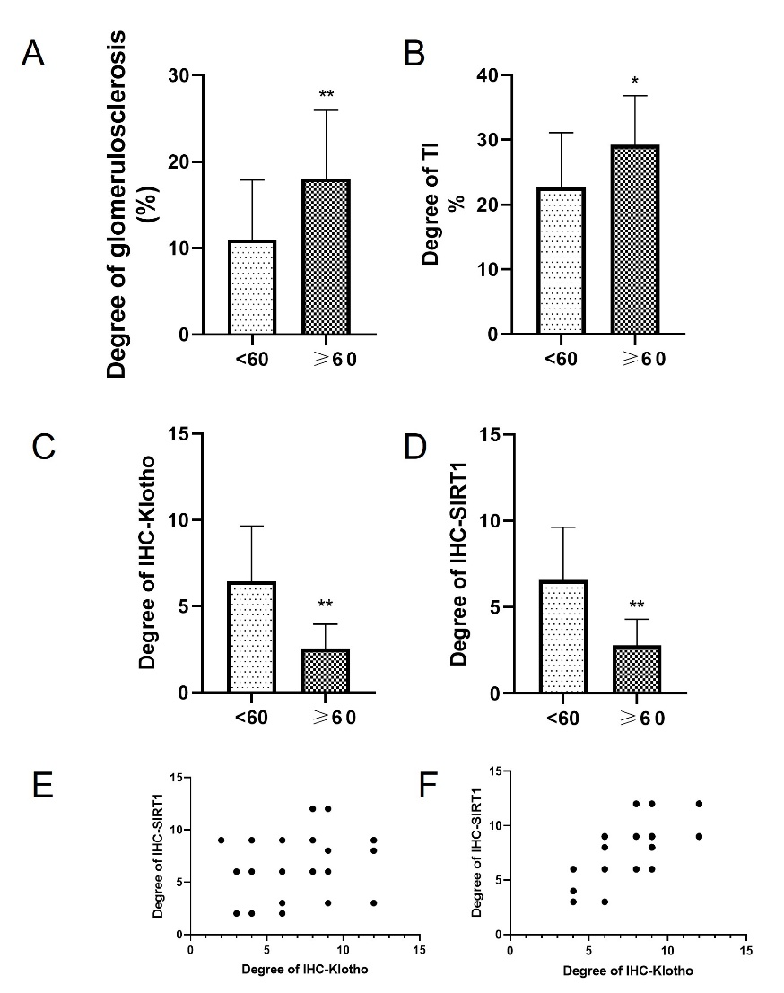
Supplementary Figure 1. Repeated validation grouped by age 60 years. A. HE staining showed a significant difference in the degree of glomerulosclerosis between the age<60 and ≥60. B. HE staining showed a significant difference in the degree of TI between the age<60 and ≥60. C. Klotho protein immunohistochemical staining showed that the expression level of SIRT1 protein was significantly decreased. D. SIRT1 protein immunohistochemical staining showed that the expression level of SIRT1 protein was significantly decreased. E. There was a significant positive correlation between Klotho and SIRT1 expression in the group of age <60. F. There was a significant positive correlation between Klotho and SIRT1 expression in the group of age ≥60. (*P<0.05, **P <0.01)

