Development of controlled-release nanoniosomes for improved delivery and anticancer activity of letrozole for breast cancer treatment

Saeedeh Ahmadiª, Mahmoud Seraj^{b}, Mohsen Chiani^{a,} *, Seyedayin Hosseini^{c}, Saba Bazzazan^{d}, Iman Akbarzadehª, Samaneh Saffar^{d}, Ebrahim Mostafavi^{e, f,} *

ªDepartment of Nano Biotechnology, New Technology Research Group, Pasteur Institute of Iran, Tehran, Iran
^{b}Integrative Research Laboratory, Islamic Azad University of Medical Sciences, Tehran, Iran
^{c} School of Medicine, Shahid Beheshti University of Medical Sciences, Tehran, Iran
^{d}Core Facility Lab, Pasteur Institute of Iran, Tehran, Iran
^{e}Stanford Cardiovascular Institute, Stanford University School of Medicine, Stanford, CA 94305, USA
^{f}Department of Medicine, Stanford University School of Medicine, Stanford, CA 94305, USA
*Correspondence: ebimsv@stanford.edu (E. Mostafavi); chiani@pasteur.ac.ir (M. Chiani)

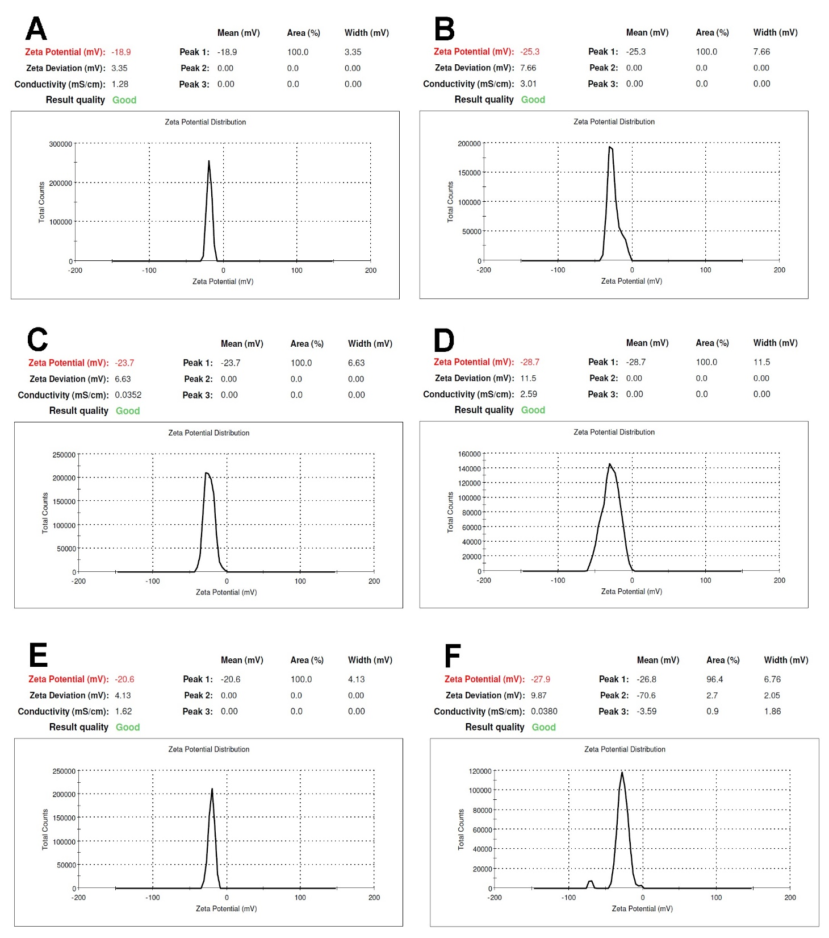
Figure S1. A-F) demonstrated the Zeta potential of L₁ (A), L_{1B} (B), L₂ (C), L_{2B} (D), L₃ (E), and L_{3B} (F).
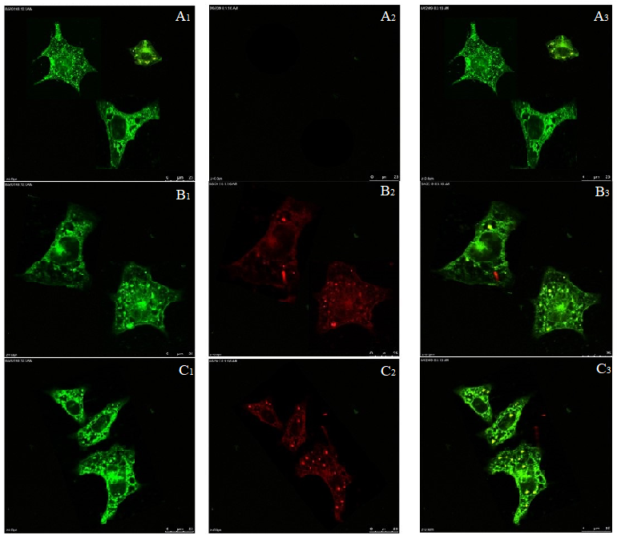
Figure S2. Cell uptake of niosomes was investigated by confocal microscopy. MDA-MB-231 cells stained with coumarin 6 (green points in A1, B1 and C1), MDA-MB-231 cells treated with Nile-red loaded niosomes (red points in A2, B2 and C1), and Localization of Nile red loaded niosome into MDA-MB-231 cells (yellow points in A3, B3 and C3).

