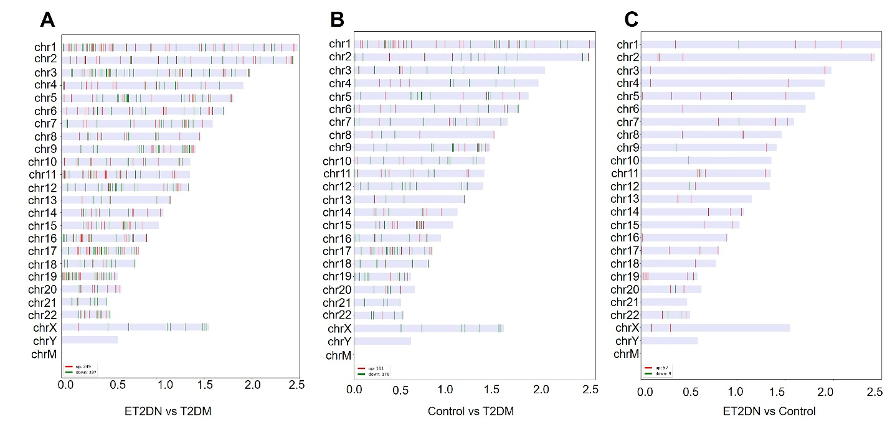
Supplementary figure 1 The distribution in human chromosomes of DECs. (A) ET2DN vs T2DM group; (B) Control vs T2DM group; (C) ET2DN vs control group.

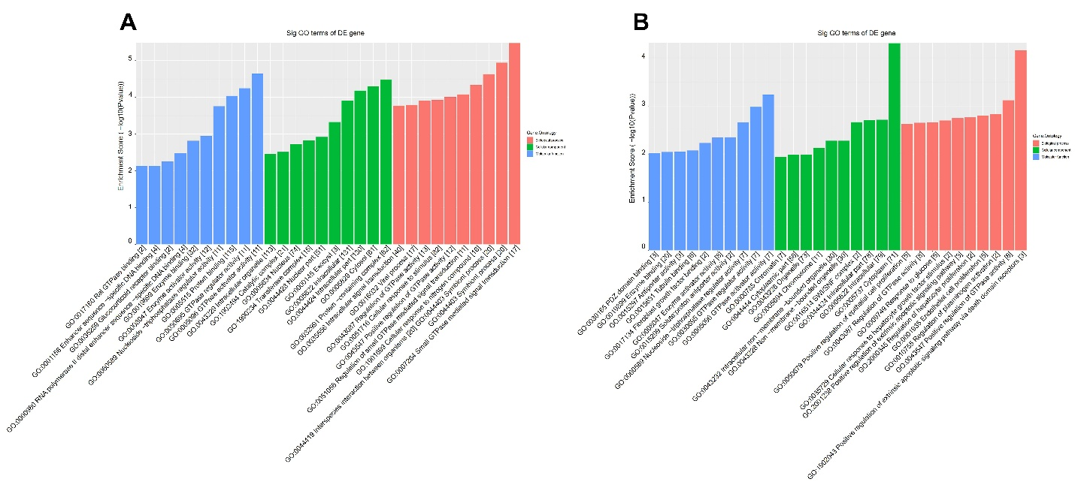
Supplementary figure 2 GO analysis of DECs for their host genes in T2DM vs control group. GO analysis of upregulated (A) and downregulated (B) DECs in T2DM vs control group.
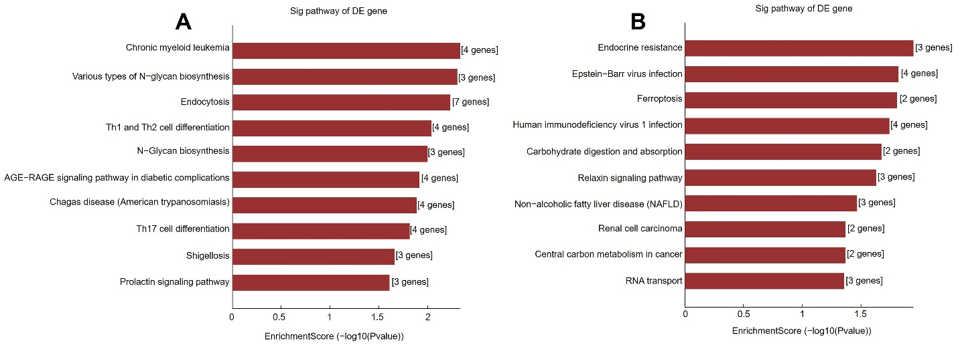
Supplementary figure 3 Pathway analysis of DECs for their host genes in T2DM vs control group. Pathway analysis of upregulated (A) and downregulated (B) DECs in T2DM vs control group.
Supplementary table 1 Primer sequences used for qRT-PCR
circRNA | Primer sequence (5’-3’)
hsa_circ_0001831 | 5’- CCTGTGTTCCACACCACACAC-3’
hsa_circ_0001831 | 5’- CTAAAGGTAGACCAGAATCGGCT-3’
hsa_circ_0044235 | 5’- GCAGAAAAGCCATGATGATATTGT-3’
hsa_circ_0044235 | 5’- CCTTTCCTGAGCGGTAATAACA-3’
hsa_circ_0061260 | 5’- AAACAATCGGGAGAAGATAGCAA-3’
hsa_circ_0061260 | 5’- GCTGTATCCAGGCACATTCCAT-3’
hsa_circ_0000658 | 5’-GTGGTATTTTGTTATAGTCGCCTGA -3’
hsa_circ_0000658 | 5’- GTTCACCGACTGGAAGGGCT-3’
hsa_circ_0063503 | 5’-GACATGAGACCAACGAAAACTGC-3’
hsa_circ_0063503 | 5’- GGCTGGCGTCATTTTCAAAG -3’
hsa_circ_0000867 | 5’- AGGGGAGAGGCTTCTGGTCGA-3’
hsa_circ_0000867 | 5’- CCTCCGAAGCCGAGTCCCAT-3’
Supplementary table 2 Upregulated of circRNAs in T2DM vs control group
circRNA | P-value | FDR | FC | Best  transcript | Gene  Symbol
hsa_circ_0044235 | 0.032357596 | 0.526539281 | 4.4313975 | NM_001114091 | CDC27
hsa_circ_0061251 | 0.01999 | 0.526539281 | 4.377259 | NM_182482 | BAGE2
hsa_circ_0070739 | 0.039279843 | 0.526539281 | 3.981572 | TCONS_000  08208 | TCONS_000  08208
hsa_circ_0048148 | 0.037599 | 0.526539281 | 3.6544073 | NM_004368 | CNN2
hsa_circ_0086490 | 0.015811052 | 0.526539281 | 3.4920225 | NM_004529 | MLLT3
hsa_circ_0002145 | 0.007594378 | 0.526539281 | 3.4261515 | NM_203458 | NOTCH2NL
hsa_circ_0039557 | 0.015060774 | 0.526539281 | 3.4246704 | NM_133368 | RSPRY1
hsa_circ_0004097 | 0.031098301 | 0.526539281 | 3.414459 | NM_031912 | SYT15
hsa_circ_0008223 | 0.031751196 | 0.526539281 | 3.4022939 | NM_015171 | XPO6
hsa_circ_0000858 | 0.026250781 | 0.526539281 | 3.3598811 | None | None
Abbreviations: FDR, false discovery rate; FC, fold change.

Supplementary table 3 Downregulated of circRNAs in T2DM vs control group
circRNA | P-value | FDR | FC | Best  transcript | Gene  Symbol
hsa_circ_0001831 | 0.037868861 | 0.526539281 | 20.5788141 | NM_015356 | SCRIB
hsa_circ_0008389 | 0.003750463 | 0.526539281 | 8.1200459 | NM_018198 | DNAJC11
hsa_circ_0000520 | 0.020232377 | 0.526539281 | 5.7184052 | NR_002312 | RPPH1
hsa_circ_0011377 | 0.00672601 | 0.526539281 | 5.0355047 | NM_003757 | EIF3I
hsa_circ_0001305 | 0.013919219 | 0.526539281 | 4.6557042 | NM_005778 | RBM5
hsa_circ_0000102 | 0.005640712 | 0.526539281 | 4.332589 | NM_001048210 | CLCC1
hsa_circ_0000315 | 0.016811664 | 0.526539281 | 4.0763913 | NM_020238 | INCENP
hsa_circ_0000598 | 0.033844897 | 0.526539281 | 4.0266429 | NM_004048 | B2M
hsa_circ_0006359 | 0.0258325 | 0.526539281 | 3.9875218 | NM_015266 | SLC9A8
hsa_circ_0005336 | 0.013817364 | 0.526539281 | 3.7280729 | NM_015626 | WSB1
Abbreviations: FDR, false discovery rate; FC, fold change.
Supplementary table 4 Upregulated of circRNAs in ET2DN vs control group
circRNA | P-value | FDR | FC | Best  transcript | Gene  Symbol
hsa_circ_0000658 | 0.02387408 | 0.995440049 | 4.1967592 | NM_001159643 | MCTP2
hsa_circ_0074598 | 0.006016201 | 0.995440049 | 2.22982 | NM_001155 | ANXA6
hsa_circ_0000867 | 0.040246611 | 0.995440049 | 2.005455 | NM_004152 | OAZ1
hsa_circ_0007919 | 0.002663876 | 0.995440049 | 1.9564087 | NM_001159746 | ABR
hsa_circ_0007794 | 0.003008632 | 0.995440049 | 1.935202 | TCONS_000  03590 | TCONS_000  03590
hsa_circ_0073379 | 0.02754718 | 0.995440049 | 1.8960691 | NM_024717 | MCTP1
hsa_circ_0022430 | 0.028385534 | 0.995440049 | 1.7946911 | NM_001620 | AHNAK
hsa_circ_0000144 | 0.049033517 | 0.995440049 | 1.7942853 | NM_052931 | SLAMF6
hsa_circ_0063812 | 0.032403214 | 0.995440049 | 1.780357 | NM_014246 | CELSR1
hsa_circ_0003423 | 0.013506717 | 0.995440049 | 1.7585713 | NM_018181 | ZNF532
Abbreviations: FDR, false discovery rate; FC, fold change.

Supplementary table 5 Downregulated of circRNAs in ET2DN vs control group
circRNA | P-value | FDR | FC | Best  transcript | Gene  Symbol
hsa_circ_0063503 | 0.010802848 | 0.995440049 | 1.6606151 | NM_031488 | L3MBTL2
hsa_circ_0022249 | 0.013011662 | 0.995440049 | 1.6314168 | NM_152718 | VWCE
hsa_circ_0062688 | 0.049670399 | 0.995440049 | 1.6188951 | NM_012399 | PITPNB
hsa_circ_0009035 | 0.006205066 | 0.995440049 | 1.551232 | NM_001126103 | RACGAP1
hsa_circ_0002968 | 0.030414707 | 0.995440049 | 1.5403324 | NM_002750 | MAPK8
Abbreviations: FDR, false discovery rate; FC, fold change.

