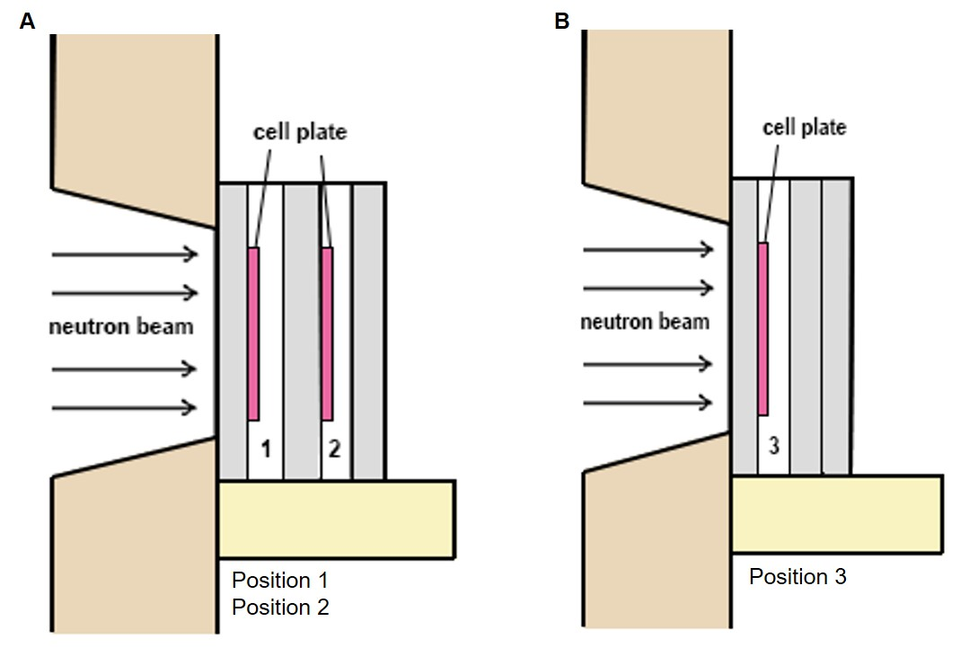

Supplemental Figure 1 Neutron irradiation setup position of cell plates and holders.
The neutron irradiation setup was adapted from the boron neutron capture therapy setup position provided by Dr. Hong-Ming Liu. (A) The setup position for the colony formation assay. (B) The setup position for immunocytochemistry, cell cycle analysis, caspase-3 apoptosis, and Western blot assays.

