Supplementary Information for
Combined self-assembled iRGD polymersomes for effective targeted siRNA anti-tumor therapy

Dongying Li,^{a,b,1}, Jiarun Li,^{a,b,1} Siwei Wang,^{a,b} Wei Teng,^{b, *} Qinmei Wang ^{a,*}

ª Laboratory of Biomaterials, Key Laboratory on Assisted Circulation, Ministry of Health, Cardiovascular Division, First Affiliated Hospital, Sun Yat-sen University, Guangzhou, China
^{b} Hospital of Stomatology, Guangdong Provincial Key Laboratory of Stomatology, Institute of Stomatological Research, Guanghua School of Stomatology, Sun Yat-sen University, Guangzhou, China
¹ The first two authors contributed equally to this work.
* Corresponding authors:
Wei Teng
Email: tengwei@mail.sysu.edu.cn
Qinmei Wang
Email: wangqinm@mail.sysu.edu.cn

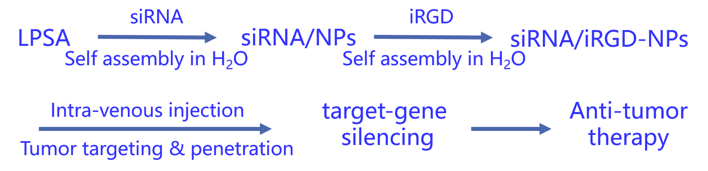
A
B

Figure S1 (A) Flow chart for preparation of siRNA-loaded lipopolysaccharide-amine nanopolymersomes functionalized with iRGD (siRNA/iRGD-NPs) for anti-tumor therapy enhanced by iRGD-mediated tumor target and penetration. (B) Proposed scheme of preparation of siRNA-loaded lipopolysaccharide-amine nanopolymersomes functionalized with iRGD (siRNA/iRGD-NPs).

Table S1 Primer sequences
Gene | 5ʹ-3ʹ Sequence
VEGFR-2 (zebrafish) | Forward-GCUCAGCACACAGAAAGACdTdT
VEGFR-2 (zebrafish) | Reverse- dTdTGACUUUUGUUACAACACUU
VEGFR-2 (mice) | Forward-CGGAGAAGAAUGUGGUUAAdTdT
VEGFR-2 (mice) | Reverse-dTdTGCCUCUUCUUACACCAAUU
GAPDH | Forward-AAGAAGGTGGTGAAGCAGG
GAPDH | Reverse-GAAGGTGGAAGAGTGGGAGT
Cy5-labeled siRNA | Cat No. siT0000003S-1-5 (RiboBio, Guangzhou, China)

Figure S2 Loading capacity of siRNA by LPSA nanopolymers (NPs). (A) Loading capacity of NPs to siRNA (analyzed by gel electrophoresis), where siRNA can be completely retarded by NPs at NPs/siRNA ≥ 1.25 g/g (weight ratio, W/W). (B,C) Effects of incubation time on loading of NPs to siRNA at NPs/siRNA = 1.25/1 (W/W), where 15 min of incubation time is enough for siRNA/NPs complexes formation when mixing equal volume of NPs and siRNA. Data in (B) and (C) were analyzed by gel electrophoresis and micro-BCA assay kit, respectively. These results suggest that siRNA can be quickly complexed by NPs at NPs/siRNA ≥ 1.25 g/g with 100% encapsulation efficiency.

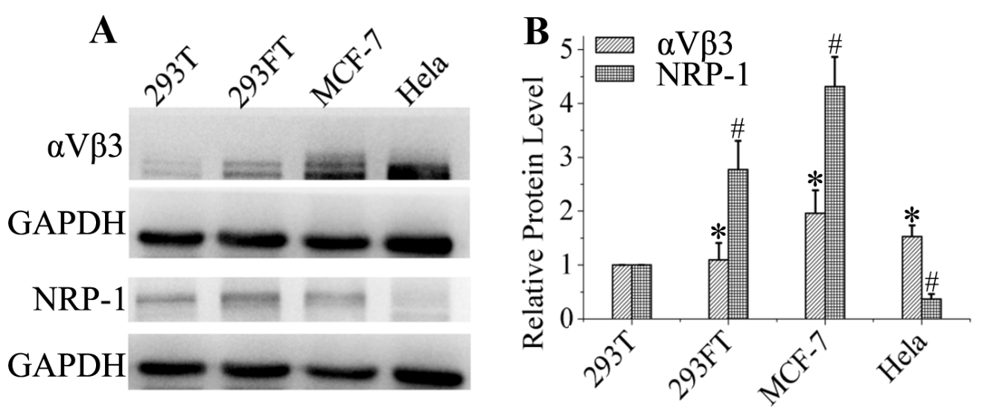
Figure S3 Tumor cell selection for iRGD target by analyzing receptor expression of α_{V}β₃ integrin and NPR-1 in 393T, 293FT, MCF-7, and Hela cells. (A) WesternBlot analysis. (B) Relative protein level, where * ^{OR #}P < 0.05 vs 293T cells. Results show that MCF-7 expresses the maximum protein of α_{V}β₃ and NRP-1. Thus, MCF-7 was chosen as model cell for siRNA-target delivery experiments in this study.

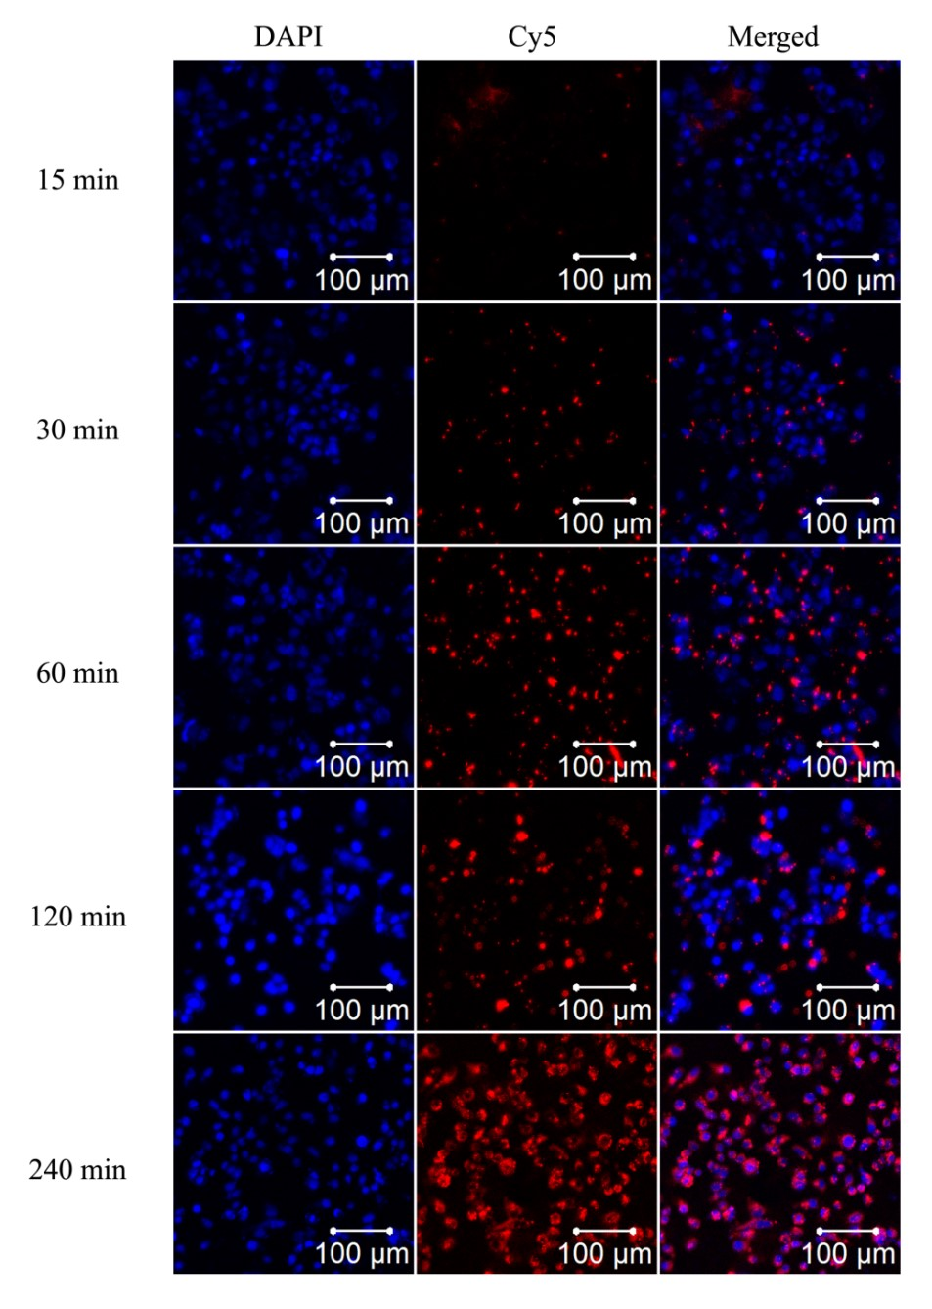
Figure S4 Effects of incubation time on transfection efficiency of siRNA/iRGD-NPs in MCF-7. Images taken by laser confocal scanning microscope. Blue: cell nucleus stained by DAPI, Red: siRNA labeled by Cy5.
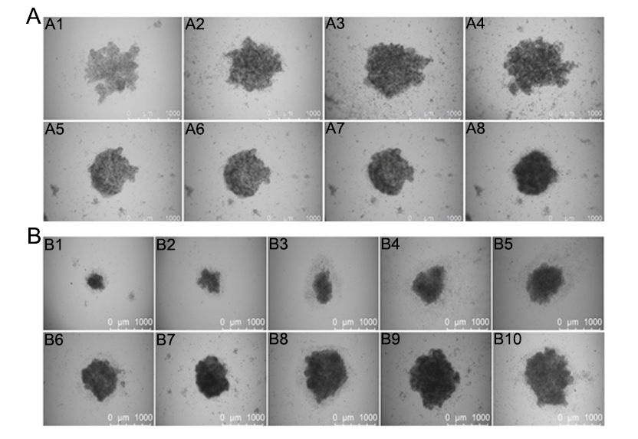
Figure S5 MCF-7 spheroid preparation by hanging drop method. (A) Effects of culture time on inverted lids and on agar on the formation of tumor spheroids at 50k cells/hanging drop. A1-A4: culture on inverted lids for 1, 2, 3, and 4 days, respectively; A5-A8: culture on agar-coated plates for 1, 2, 3, and 4 days, respectively, after culture on inverted lids for 2 days. (B) Effects of cell number in hanging drops on the formation of tumor spheroids, where the cell number for B1-B10 was 5k, 10k, 15k, 20k, 25k, 30k, 35k, 40k, 45k, and 50k, respectively, and the culture time on inverted lids and on agar are 48 and 96 hours, respectively.

Figure S6 The optimal concentration of NPs for in vivo siVEGF delivery in Zebrafish. Images (A), Survival rate (B), and vessel length (C) and area (D) of zebrafish treated by siRNA/NPs with different NPs concentration and 50 nM siRNA in culture media. *P < 0.05 vs blank.

