eFigure S1. Summary of socio-demographic related risk factors by (1) OCS ≥2, ED ≥1, and Hosp ≥1; (2) OCS ≥3, ED ≥2, and Hosp ≥1; and (3) OCS ≥3, ED ≥1, and Hosp ≥1
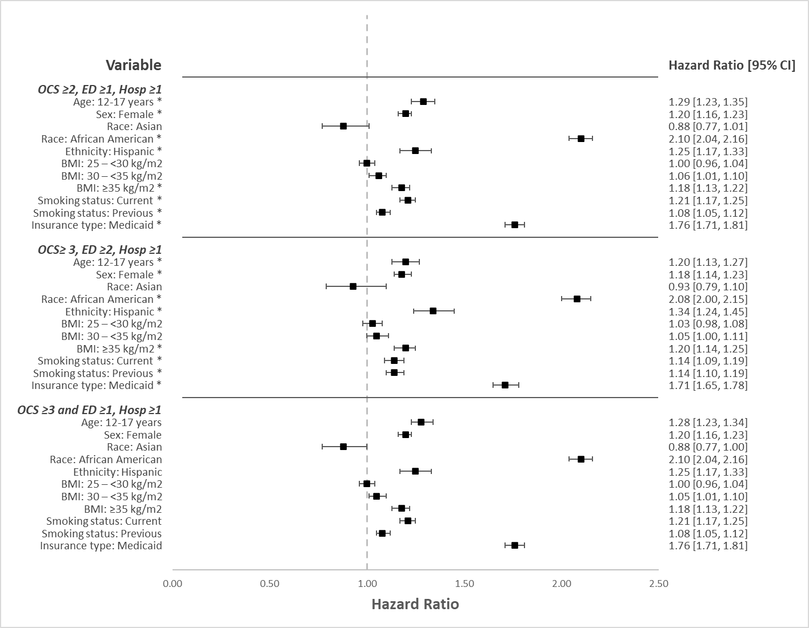
BMI, body mass index; CI, confidence interval; ED, emergency department; Hosp, hospitalization; HR, hazard ratio; OCS, oral corticosteroids
HR >1 indicates an increased risk; HR <1 indicates a decreased risk.
*Statistically significant (P< 0.001).
Note: Caucasian/White was used as the reference point for race. BMI <25 was used as the reference point.

eFigure S2. Summary of risk factors related to healthcare resource utilization by (1) OCS ≥2, ED≥1, and Hosp ≥1 (2) OCS≥3, ED≥2, and Hosp ≥1; and (3) OCS ≥3, ED ≥1, and Hosp ≥1
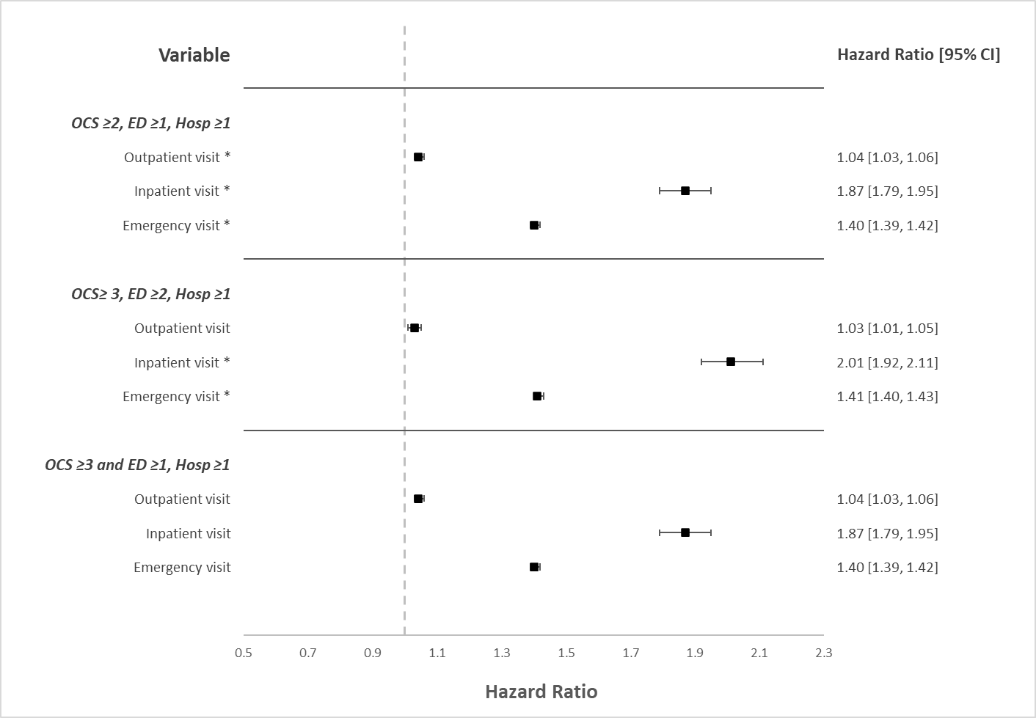
CI, confidence interval; ED, emergency department; Hosp, hospitalization; HR, hazard ratio; OCS, oral corticosteroids
HR >1 indicates an increased risk; HR <1 indicates a decreased risk.
*Statistically significant (P < 0.001).

eFigure S3. Summary of risk factors related to eosinophil count by (1) OCS ≥2, ED≥1, and Hosp ≥1; (2) OCS≥3, ED≥2, and Hosp ≥1; and (3) OCS ≥3, ED ≥1, and Hosp ≥1
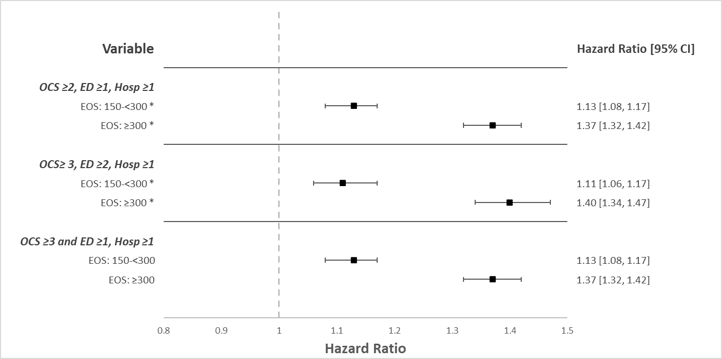
CI, confidence interval; ED, emergency department; EOS, eosinophil; Hosp, hospitalization; HR, hazard ratio; OCS, oral corticosteroids.
EOS < 150/μL was used as the reference point.
HR >1 indicates an increased risk; HR <1 indicates a decreased risk.
*Statistically significant (P < 0.001).

eFigure S4. Summary of risk factors related to comorbidities by (1) OCS ≥2, ED≥1, and Hosp ≥1; (2) OCS≥3, ED≥2, and Hosp ≥1; and (3) OCS ≥3, ED ≥1, and Hosp ≥1
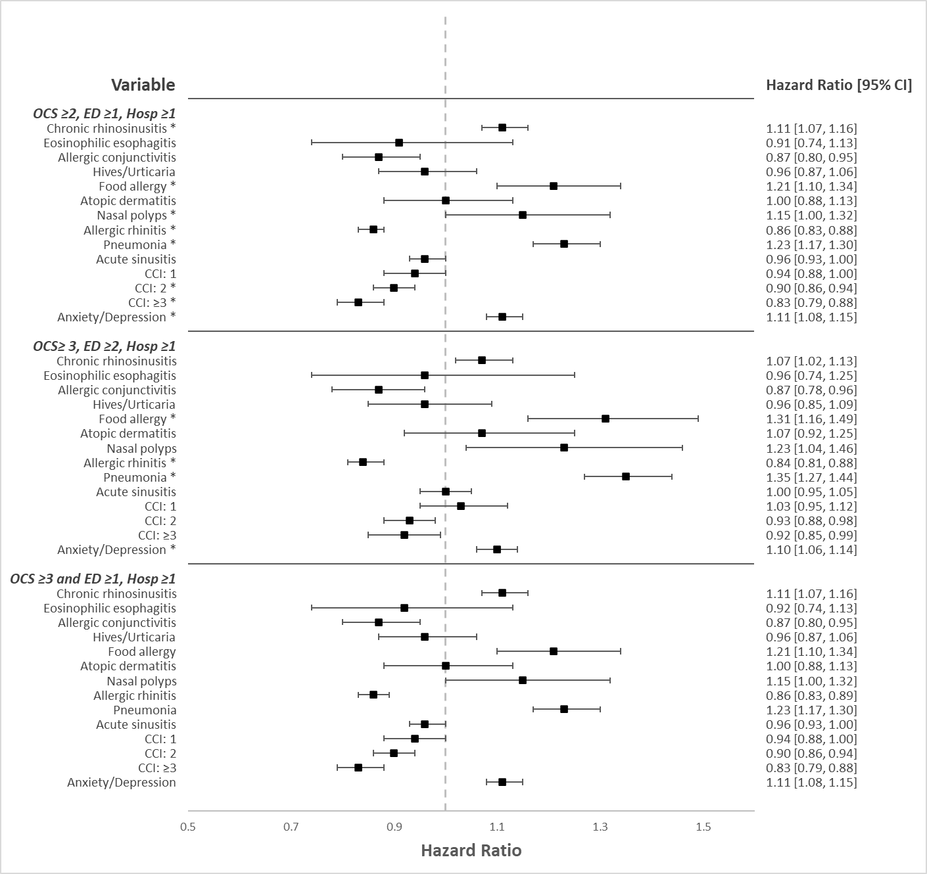
BMI, body mass index; CI, confidence interval; CCI, Charlson comorbidity index; ED, emergency department; Hosp, hospitalization; HR, hazard ratio; OCS, oral corticosteroids
HR >1 indicates an increased risk; HR <1 indicates a decreased risk.
*Statistically significant (P < 0.001).

eFigure S5. Summary of risk factors related to baseline medication by (1) OCS ≥2, ED≥1, and Hosp ≥1; (2) OCS≥3, ED≥2, and Hosp ≥1; and (3) OCS ≥3, ED ≥1, and Hosp ≥1
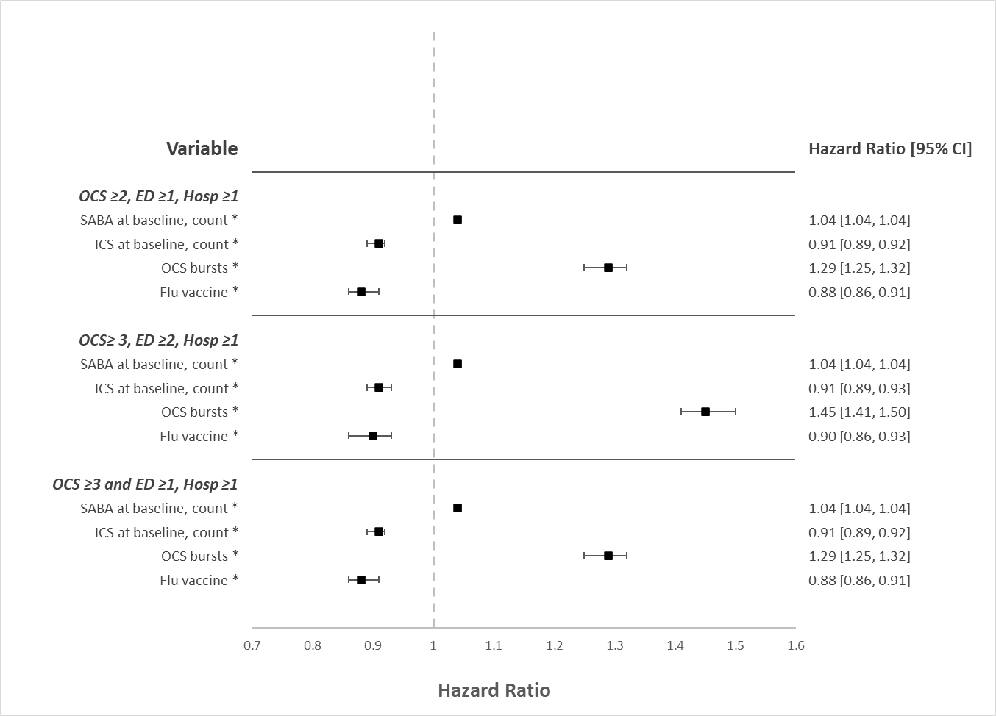
BMI, body mass index; CI, confidence interval; ED, emergency department; Hosp, hospitalization; HR, hazard ratio; ICS, inhaled corticosteroid; OCS, oral corticosteroids; SABA, short-acting beta agonists
Hazard ratio >1 indicates an increased risk; hazard ratio <1 indicates a decreased risk.
*Statistically significant (P < 0.001).

