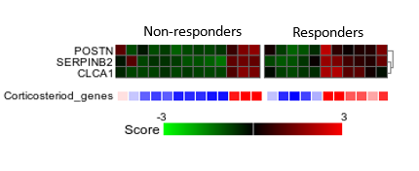
A

B

Supplementary Figure 1. Corticosteroid genes
A. Heatmaps of corticosteroid genes are higher in responders. B. Z-scores from corticosteroid genes showing no significant difference between responders and non-responders. ns = non-significant.
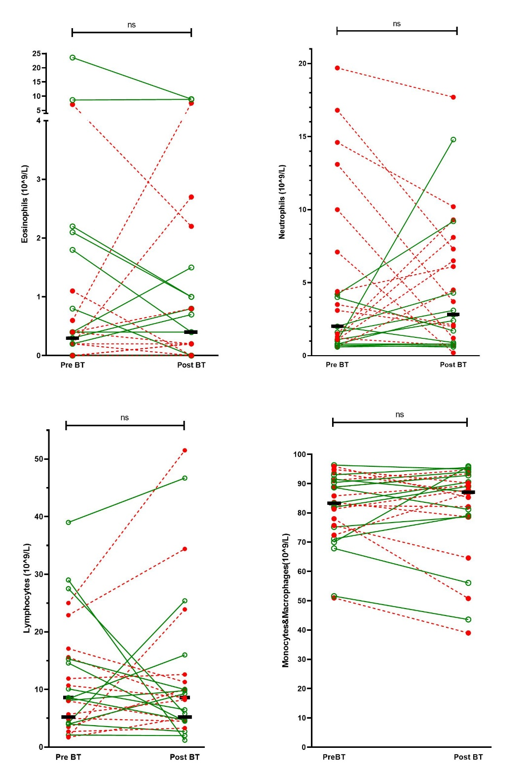
Supplementary Figure 2. Cell counts in bronchoalveolar lavage before bronchial thermoplasty (pre BT) and after bronchial thermoplasty (post BT). The green lines represent responders (based on AQLQ improvement >0,5) and the red lines non-responders. The black stripe represents the median. No significant differences were found using the Wilcoxon test for paired non-parametric analyses (Eosinophils p=0.87, Neutrophils p=0.98, Lymphocytes p=0.76, Monocytes and macrophages p=0.72). ns = non-significant; BT = bronchial thermoplasty.

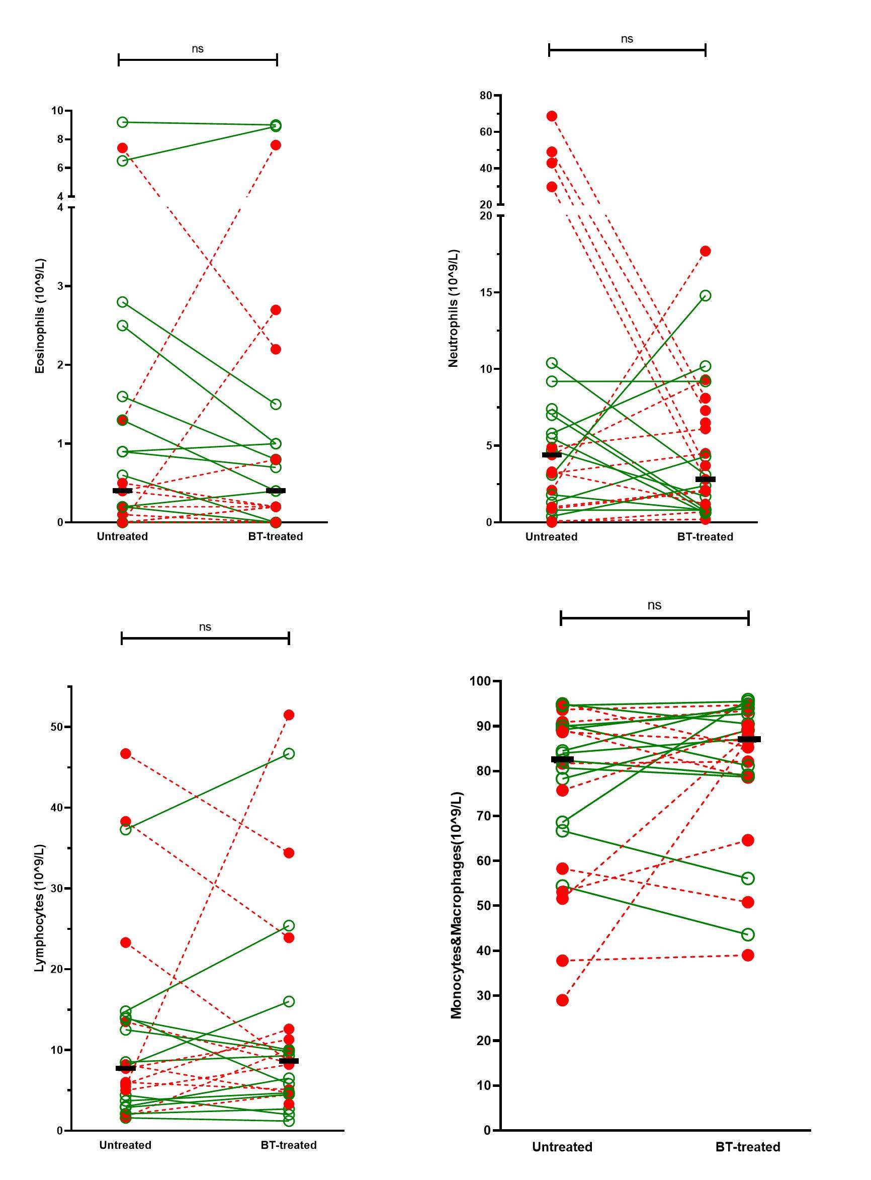
Supplementary Figure 3. Cell counts in bronchoalveolar lavage after bronchial thermoplasty (same time point) in the middle lobe (untreated) and lingula (BT-treated). The green lines represent responders (based on AQLQ improvement >0,5) and the red lines non-responders. The black stripe represents the median. No significant differences were found using the Wilcoxon test for paired non-parametric analyses (Eosinophils p=0.48, Neutrophils p=0.34, Lymphocytes p=0.72, Monocytes and macrophages p=0.37). ns = non-significant;
BT = bronchial thermoplasty.

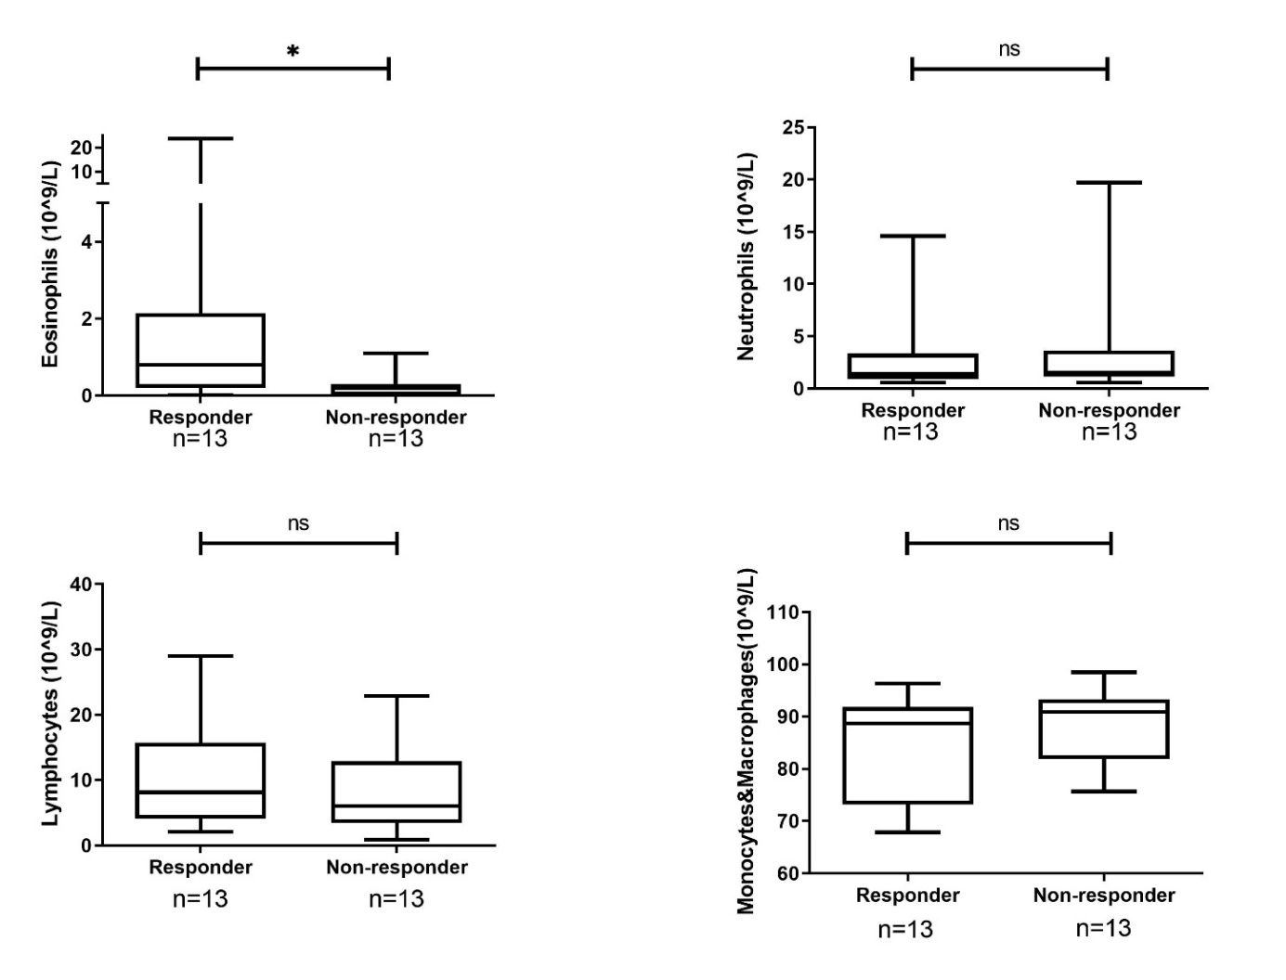

Supplementary Figure 4. Cell counts in bronchoalveolar lavage at baseline between responder and non-responders (based on AQLQ improvement ≥ 0.5). Significant differences were seen in eosinophil counts (p=0.02). Neutrophils (p=0.54), lymphocytes (p=0.46), monocytes and macrophages (p=0.20) did not show any differences (Mann-Whitney U test).
AQLQ = asthma quality of life questionnaire; BT = bronchial thermoplasty; ns = non-significant; * = p < 0,05.

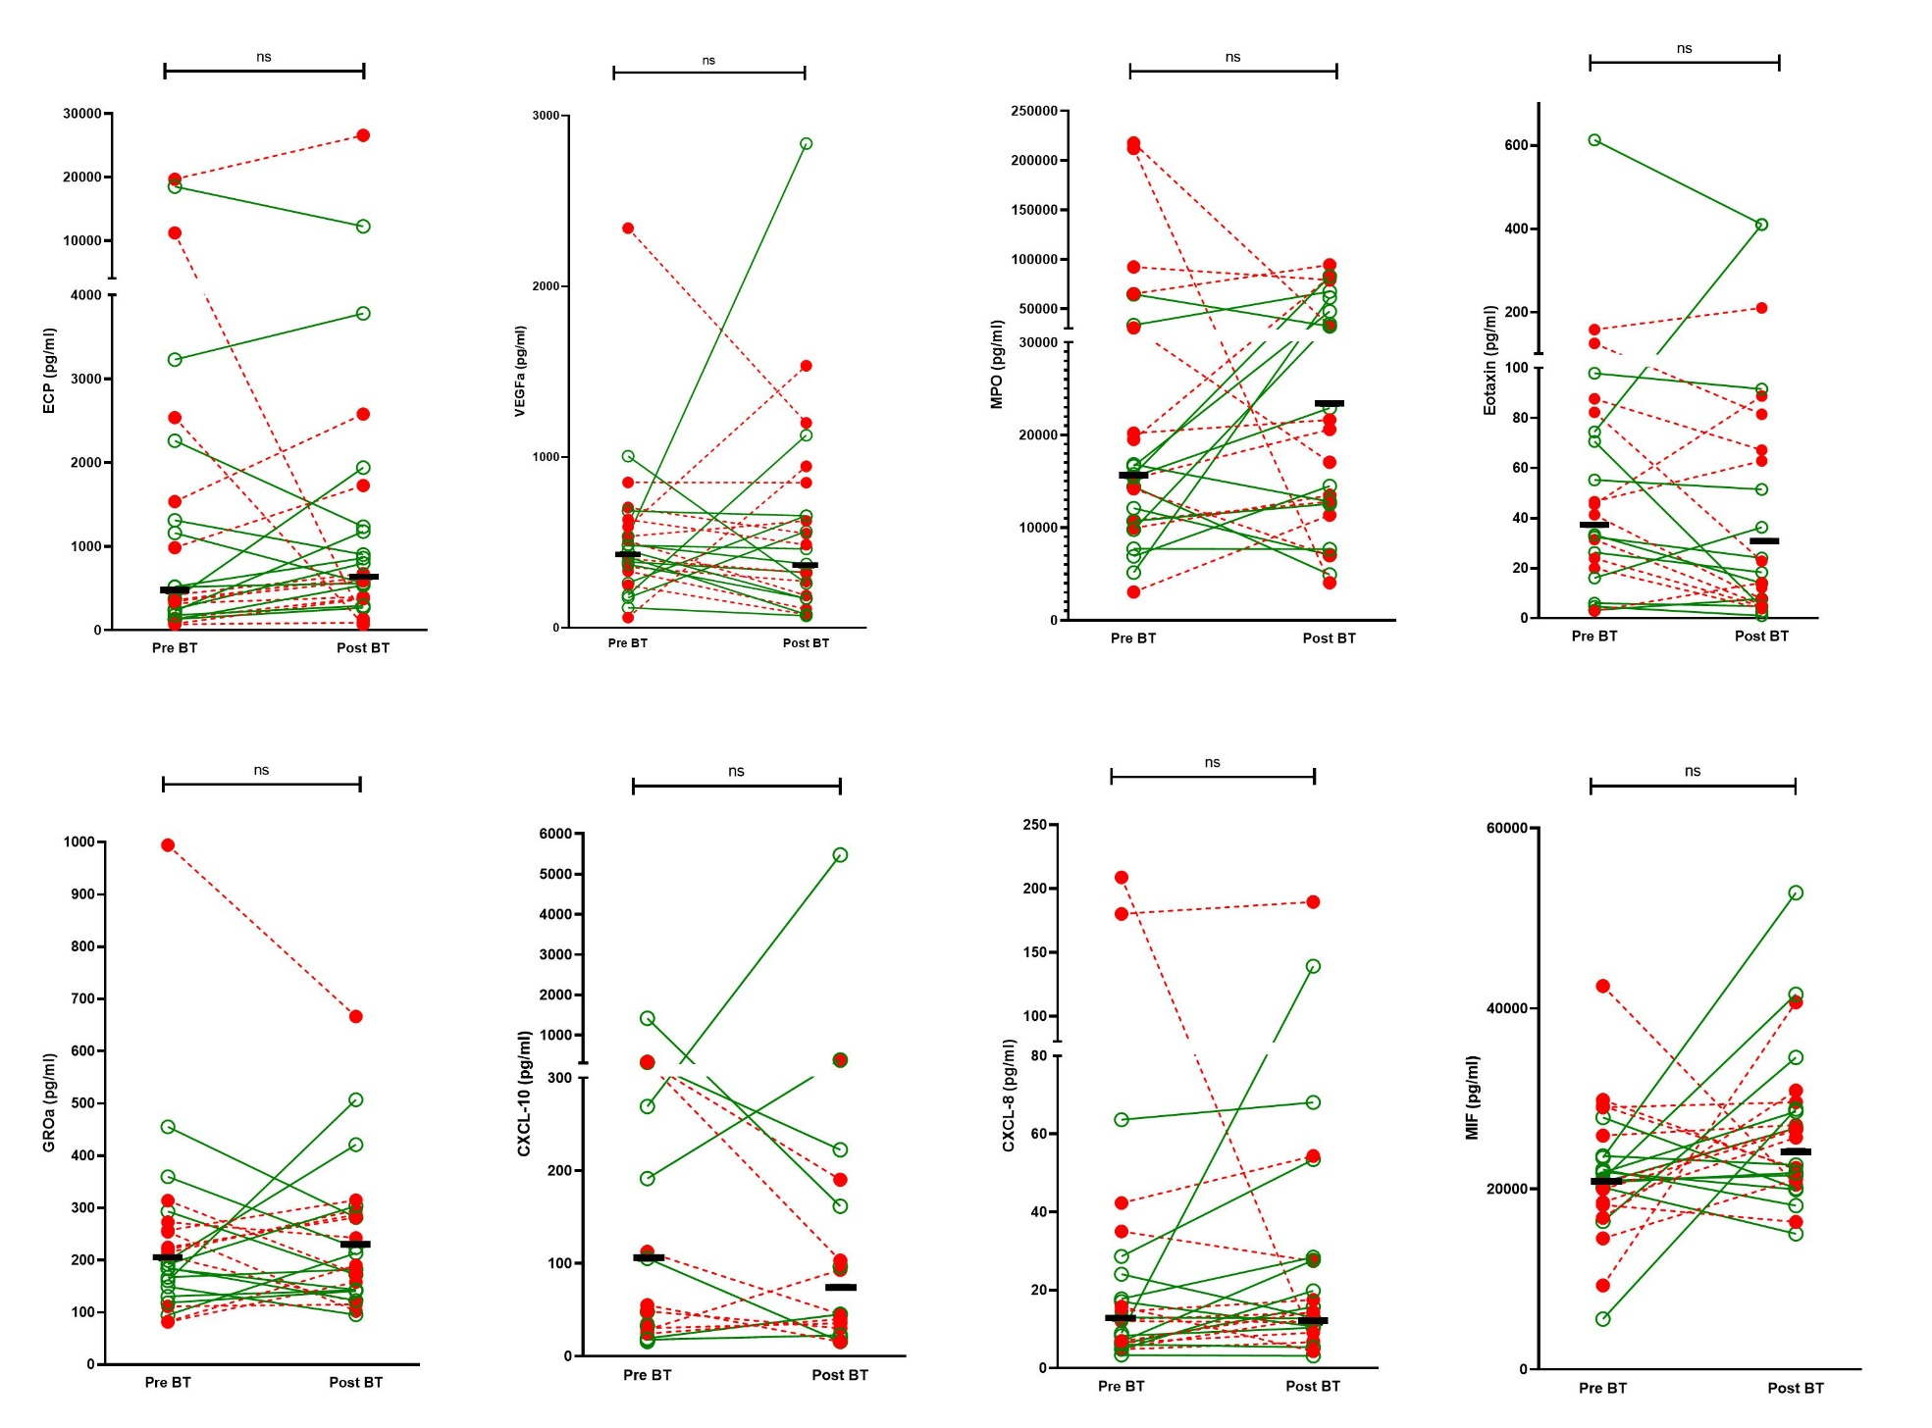

Supplementary Figure 5. Luminex data for 8 cytokines before bronchial thermoplasty (pre BT) and 6 months after bronchial thermoplasty (post BT). The green lines represent responders (based on AQLQ improvement >0,5) and the red lines non-responders. The black stripe represents the median. No significant differences were found using the Wilcoxon test for paired non-parametric analyses (ECP p=0.42, VEGF-a p=0.47, MPO p = 0.69, Eotaxin 2/3 p=0.22, GRO-α p=0.82, CXCL-10 p=0.42, CXCL-8 p=0.42, MIF p=0.10).
ns = non-significant; BT = bronchial thermoplasty.

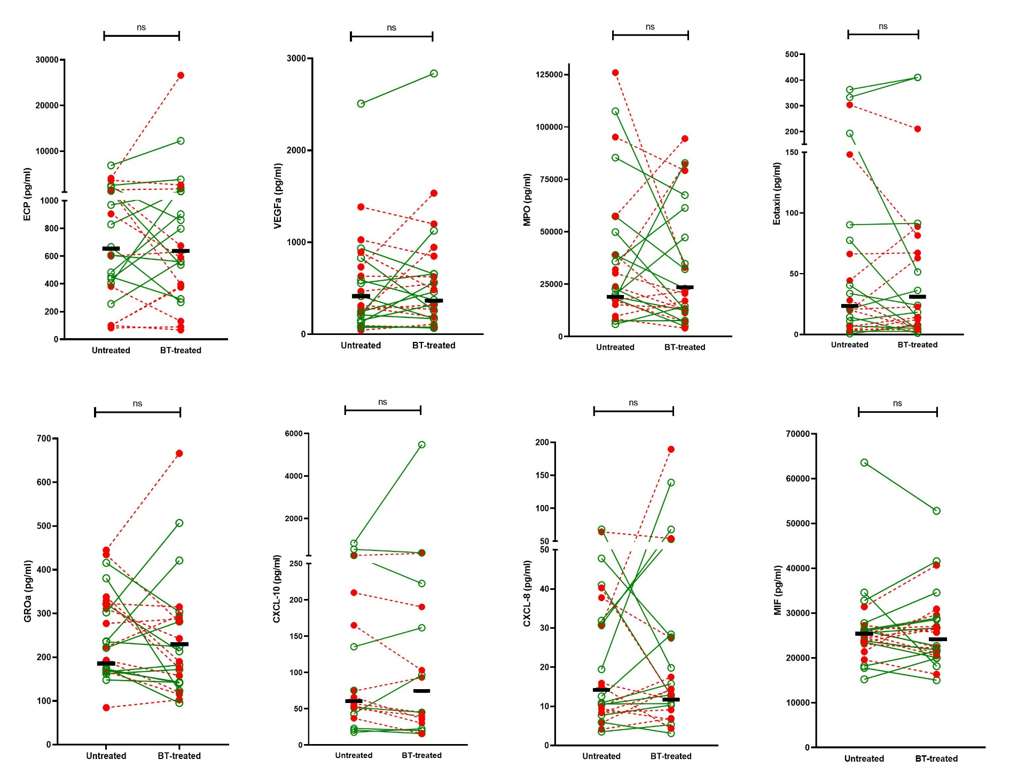

Supplementary Figure 6. Luminex data of 8 cytokines 6 months after bronchial thermoplasty in the middle lobe (untreated) and the lingula (BT-treated). The green lines represent the responders (based on AQLQ improvement ≥0.5) and the red lines non-responders. The black stripe represents the median. No significant differences were found using the Wilcoxon test for paired non-parametric analyses (ECP p=0.50, VEGF-a p=0.90, MPO p = 0.21, Eotaxin 2/3 p=0.56, GRO-α p=0.28, CXCL-10 p=0.15, CXCL-8 p=0.60, MIF p=0.82).
ns = non-significant; BT = bronchial thermoplasty.

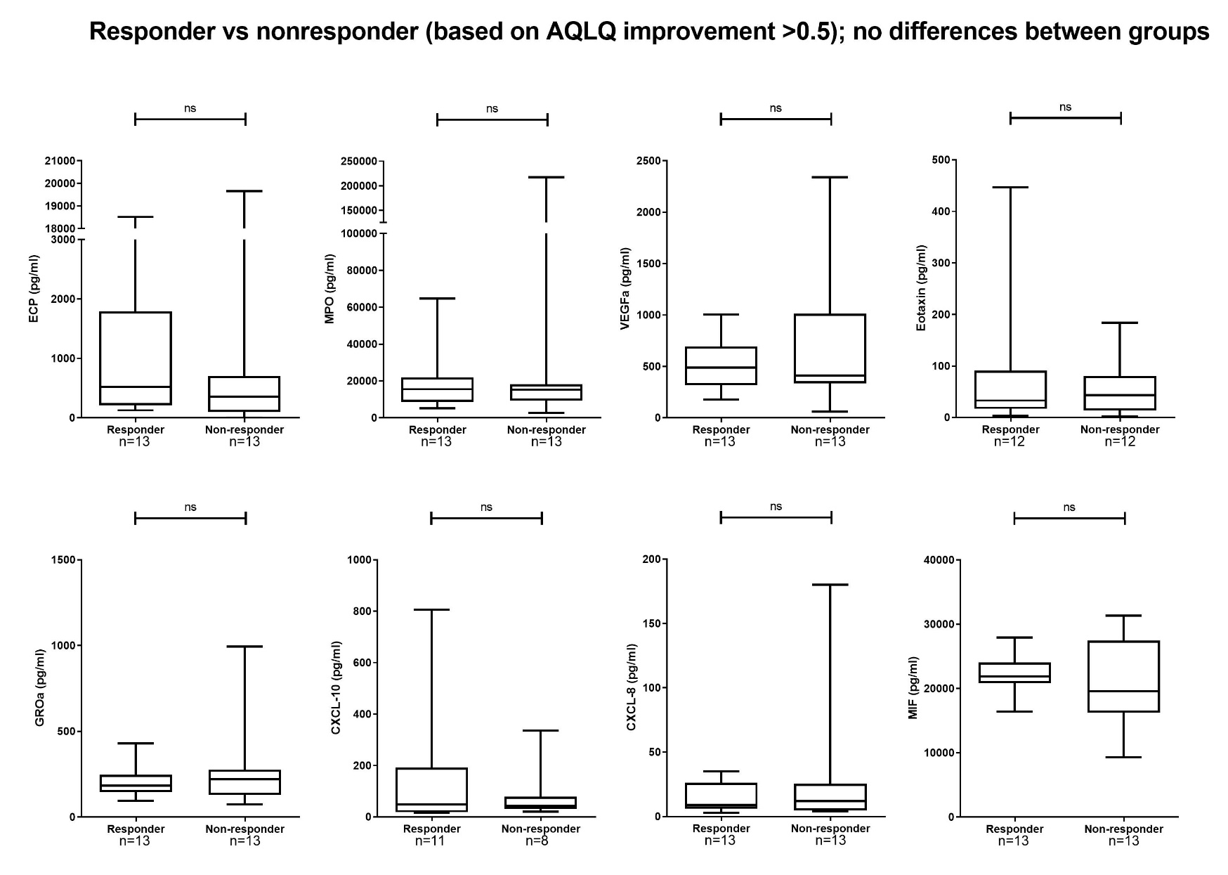

Supplementary Figure 7. Luminex data of 8 cytokines at baseline between responder and non-responders (based on AQLQ improvement ≥ 0.5). No significant differences were seen (ECP (p=0.18), MPO (p=1.0), VEGF-a (p=1.0), Eotaxin 2/3 (p=0.84), GRO-α (p=0.41), CXCL-10 (P=0.90), CXCL-8 (p=0.90), MIF (p=0.44), Mann-Whitney U test). ns = non-significant.

