Supplementary Information for

Greater Plasma Protein Adsorption on Mesoporous Silica Nanoparticles Aggravates Atopic Dermatitis

Jin Kyeong Choi^{1,†}, Jun-Young Park^{2,†}, Soyoung Lee³, Young-Ae Choi⁴, Song Kwon², Min Jun Shin^{2,5}, Hui-Suk Yun⁶, Yong Hyun Jang⁷, Jinjoo Kang⁴, Namkyung Kim⁴, Dongwoo Khang^{2,5,8,}*, Sang-Hyun Kim^{4,}*

¹Department of Immunology, Jeonbuk National University Medical School, Jeonju 54896, Republic of Korea
²Lee Gil Ya Cancer and Diabetes Institute, Gachon University, Incheon 21999, Republic of Korea
³Immunoregulatory Materials Research Center, Korea Research Institute of Bioscience and Biotechnology, Jeongeup 56212, Republic of Korea
⁴CMRI, Department of Pharmacology, School of Medicine, Kyungpook National University, Daegu 41944, Republic of Korea
⁵Department of Health Sciences and Technology, GAIHST, Gachon University, Incheon 21999, Korea
⁶Powder & Ceramics Division, Korea Institute of Materials Science, Changwon 51508, Republic of Korea
⁷Department of Dermatology, School of Medicine, Kyungpook National University, Daegu 41944, Republic of Korea
⁸Department of Physiology, School of Medicine, Gachon University, Incheon 21999, Republic of Korea
†Equally contributed

*Corresponding author:
Prof. Dongwoo Khang, Department of Physiology, College of Medicine, Gachon University, Incheon 21999, Republic of Korea, Tel: +82 32 899 6515, E-mail: dkhang@gachon.ac.kr

Prof. Sang-Hyun Kim, Department of Pharmacology, School of Medicine, Kyungpook National University, Daegu 41944, Republic of Korea, Tel: +82 53 420 4838, E-mail: shkim72@knu.ac.kr
Table S1 Specific surface characteristics (surface area, pore volume, and pore size) values of CSN and MSN analyzed by BET analysis.
Sample name | Test Items | Unit | Result
CSN | Surface Area  BET surface area | m²/g | 44.6530
CSN | Pore volume  Single point adsorption total pore volume of pores  (PP/PP0 = 0.994296090) | cm³/g | 0.295409
CSN | Pore Size  Adsorption average pore diameter (4V/A by BET) | Å | 264.627

Sample name | Test Items | Unit | Result
MSN | Surface Area  BET surface area | m²/g | 884.5656
MSN | Pore volume  Single point adsorption total pore volume of pores  (PP/PP0 = 0.994296090) | cm³/g | 1.094537
MSN | Pore Size  Adsorption average pore diameter (4V/A by BET) | Å | 49.495

Figure S1 Polydispersity index and XPS. (A) XPS full spectra of CSN and MSN. XPS analysis indicated that oxygen and silica show identical atomic weight, which shows that there are no surface chemical changes between CSN and MSN. A slight shift in the XPS spectrum induced by different conductivities between samples (CSN and MSN) is observed. (B) Polydispersity indexes of CSN and MSN indicate identical solubility after 6 h.

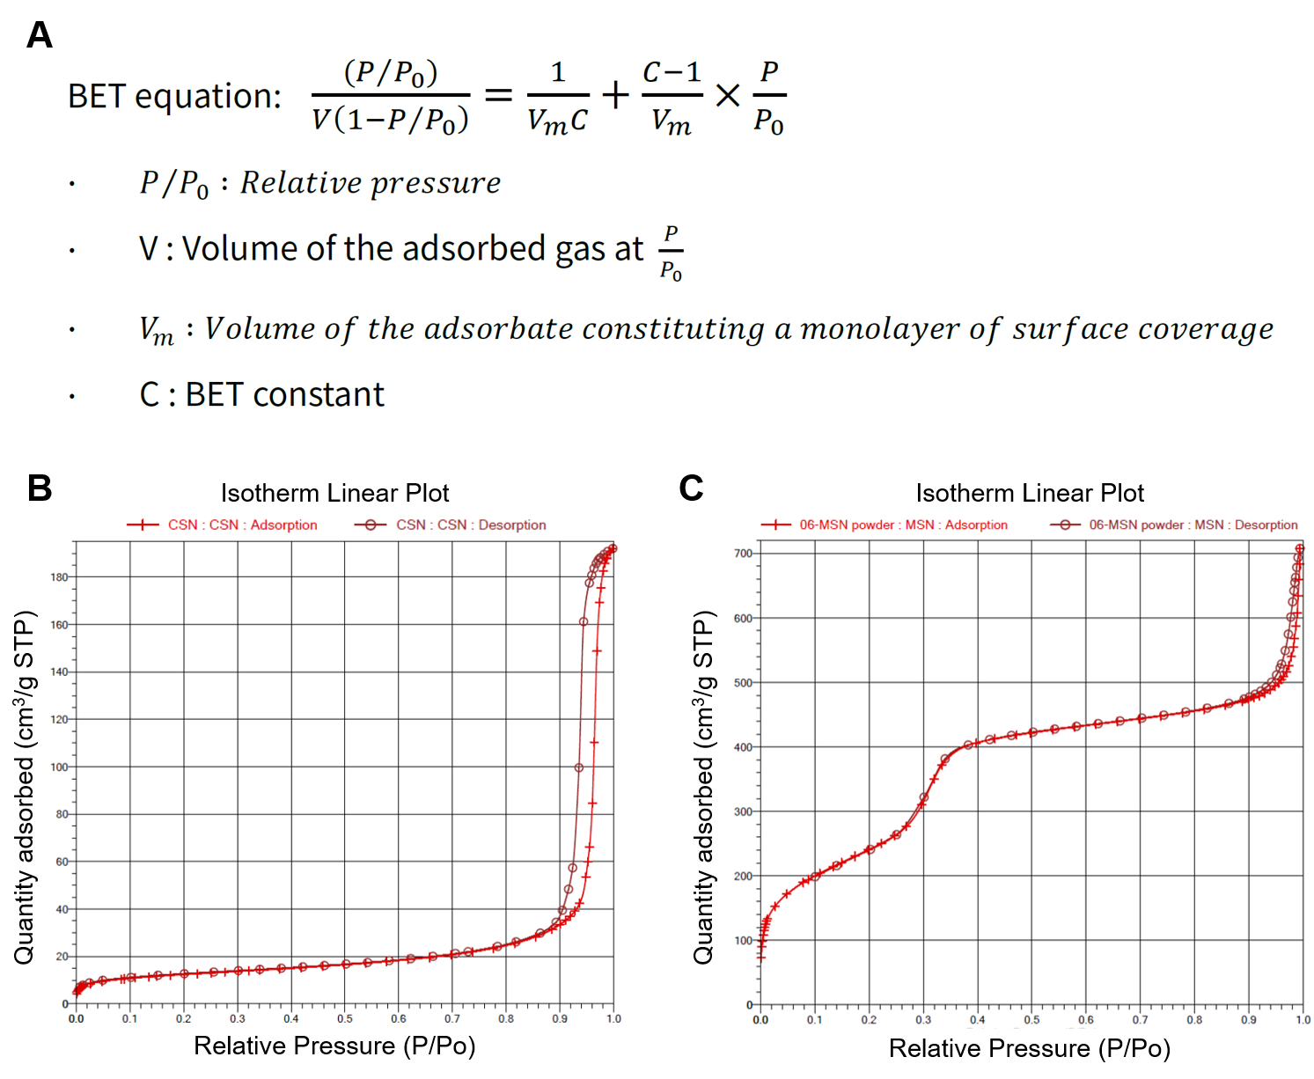
Figure S2 (A) Brunauer-Emmett-Teller (BET) equations for accurate specific surface area evaluation and calculation. N2 adsorption and desorption isotherms, and pore size distributions of (B) CSN and (C) MSN.
Figure S3 MSN-corona induce key AD inflammatory mediators as a response to keratinocytes. Expression of cytokines and chemokines in HaCaT cells. Cells were treated with MSN-corona for 6 h. Expression levels of cytokines and chemokines were determined using qPCR. TNF-α and IFN-γ were used as positive controls. The data are presented as the mean ± SD. *P < 0.05, **P < 0.01 compared with the control. MSN: mesoporous silica nanoparticles.

