Supporting information
Multi-modal imaging monitored M2 macrophage targeting sono-responsive nanoparticles to combat MRSA deep infections
Sijie Chen ^{1,2 #}, Jiahao Wang ^{3,4,5,6 #}, Kui Tang ^{1,2}, Haiqin Liao ^{1,2}, Yan Xu ^{1,2}, Long Wang ^{3,4,5,6}, Chengcheng Niu ^{1,2 *}
^{*1} Department of Ultrasound Diagnosis, The Second Xiangya Hospital, Central South University, Changsha, Hunan 410011, China
^{*2} Research Center of Ultrasonography, The Second Xiangya Hospital, Central South University, Changsha, Hunan 410011, China
³ Department of Orthopedics, Xiangya Hospital, Central South University, Changsha, Hunan 410008, China
⁴ Hunan Engineering Research Center of Biomedical Metal and Ceramic Implants, Xiangya Hospital, Central South University, Changsha, China
⁵ National Clinical Research Center for Geriatric Disorders, Xiangya Hospital, Central South University, Changsha, China
⁶ Hunan key laboratary of aging biology, Xiangya Hospital, Central South University, Changsha, China
Address all correspondence to: Chengcheng Niu, Department of Ultrasound Diagnosis and Research Center of Ultrasonography, The Second Xiangya Hospital, Central South University, Changsha, Hunan, China, 410011; E-mail: niuchengcheng@csu.edu.cn
# These authors have contributed equally to this work.
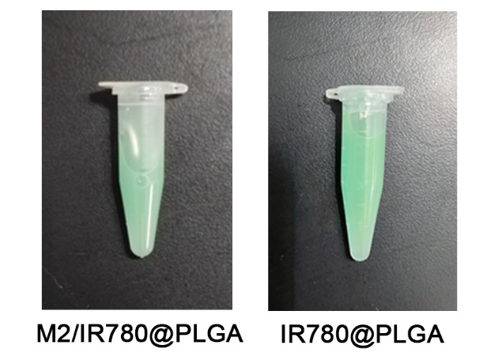
Fig. S1. The appearance of M2/IR780@PLGA nanoparticles and IR780@PLGA nanoparticles.

Fig. S2. UV-vis-NIR absorption spectra of free IR780 and M2/IR780@PLGA nanoparticles.

Fig. S3. The standard curve of IR780.
Fig. S4. (A) Size and (B) zeta potential distributions of M2/IR780@PLGA nanoparticles in 1×PBS or 10% FBS for 7 days.

Fig. S5. (A) Plate counting results of ATCC 43300 strain treated with M2/IR780@PLGA nanoparticles at high concentrations more than 500 μg/mL. (B) MIC tests results of ATCC 43300 strain treated with M2/IR780@PLGA nanoparticles at concentrations lower than 500 μg/mL.

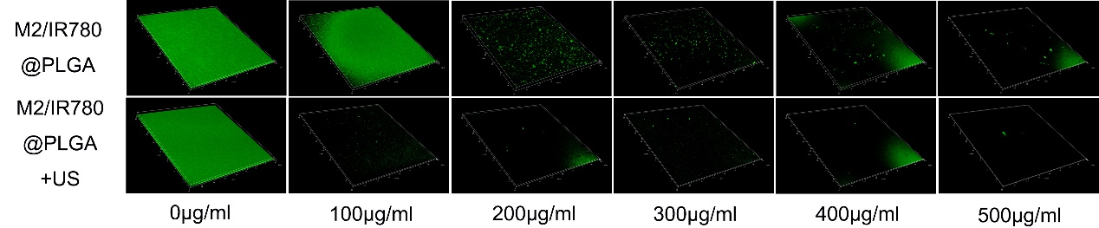
Fig. S6. Live staining images of MRSA after different treatments by CLSM.

Fig. S7. Changes of mice body weight during different treatments.

Fig. S8. Coagulative necrosis in muscle tissue on HE staining (the large areas of red staining without structure), with abundant bacteria on Giemsa staining (red circle).

Fig. S9. Quantification of inflammatory cells in the infection area. Data are expressed as means SD (n = 3). Statistical significances were calculated via ANOVA, *p < 0.05.

Supplementary Table 1. Primers used for quantitative real-time polymerase chain reaction.
IL–10-F | CCAGTACAGCCGGGAAGACA
IL–10-R | GAAGGCAGTCCGCAGCTCTA
CD206-F | CCTATGAAAATTGGGCTTACGG
CD206-R | CTGACAAATCCAGTTGTTGAGG

