ORIGINAL RESEARCH
Kongratanapasert et al
Pharmacological Activities of Fingerroot Extract and Its Phytoconstituents Against SARS-CoV-2 Infection in Golden Syrian Hamsters
Teetat Kongratanapasert^{1*}
Supasek Kongsomros^{2*}
Nlin Arya³,
Kripitch Sutummaporn³
Witthawat Wiriyarat³
Yada Akkhawattanangkul⁴
Tussapon Boonyarattanasoonthorn⁵
Nithi Asavapanumas⁵
Phongthon Kanjanasirirat⁶
Ampa Suksatu²
Khanit Sa-ngiamsuntorn⁷
Suparerk Borwornpinyo^{6,8}
Pornpun Vivithanaporn⁵
Somchai Chutipongtanate^{5,9}
Suradej Hongeng^{6,9}
Boonsong Ongphiphadhanakul¹⁰
Arunee Thitithanyanont²
Phisit Khemawoot⁵
Piyamitr Sritara¹⁰
*These authors contributed equally to this work

¹ Program in Translational Medicine, Faculty of Medicine Ramathibodi Hospital, Mahidol University, Bangkok, 10400, Thailand; ² Department of Microbiology, Faculty of Science, Mahidol University, Bangkok, Thailand; ³ Department of Preclinic and Applied Animal Science, Faculty of Veterinary Science, Mahidol University, Nakhonpathom, 73170, Thailand; ⁴ Department of Clinical Medicine and Public Health, Faculty of Veterinary Science, Mahidol University, Nakhonpathom, 73170, Thailand; ⁵ Chakri Naruebodindra Medical Institute, Faculty of Medicine Ramathibodi Hospital, Mahidol University, Samutprakarn, 10540, Thailand; ⁶ Excellence Center for Drug Discovery, Faculty of Science, Mahidol University, Bangkok 10400, Thailand; ⁷ Department of Biochemistry, Faculty of Pharmacy, Mahidol University, Bangkok 10400, Thailand; ⁸ Department of Biotechnology, Faculty of Science, Mahidol University, Bangkok 10400, Thailand; ⁹ Department of Pediatrics, Faculty of Medicine Ramathibodi Hospital, Mahidol University, Bangkok 10400, Thailand; ¹⁰ Department of Medicine, Faculty of Medicine Ramathibodi Hospital, Mahidol University, Bangkok 10400, Thailand;

Corresponding author: Phisit Khemawoot.
Chakri Naruebodindra Medical Institute, Faculty of Medicine Ramathibodi Hospital, Mahidol University, Bang Phli, Samut Prakarn 10540, Thailand
Tel +66 28395161
Fax +66 28395161
E-mail phisit.khe@mahidol.ac.th

Contents
Figure S1. LCMS chromatograms. (A) Chromatogram of fingerroot extract. (B) Chromatogram of panduratin A. (C) LCMS mass spectra of panduratin A.
Table S1. Bioanalytical method validation of LCMS for panduratin A.
Table S2. The criteria of histopathological scoring of lung tissues.

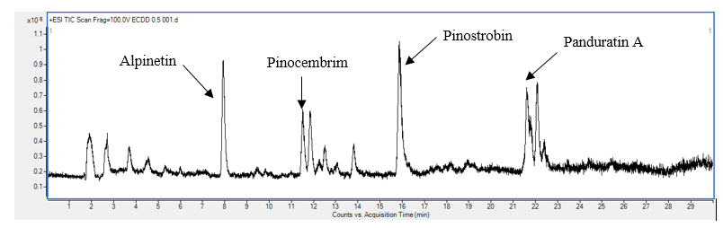
A
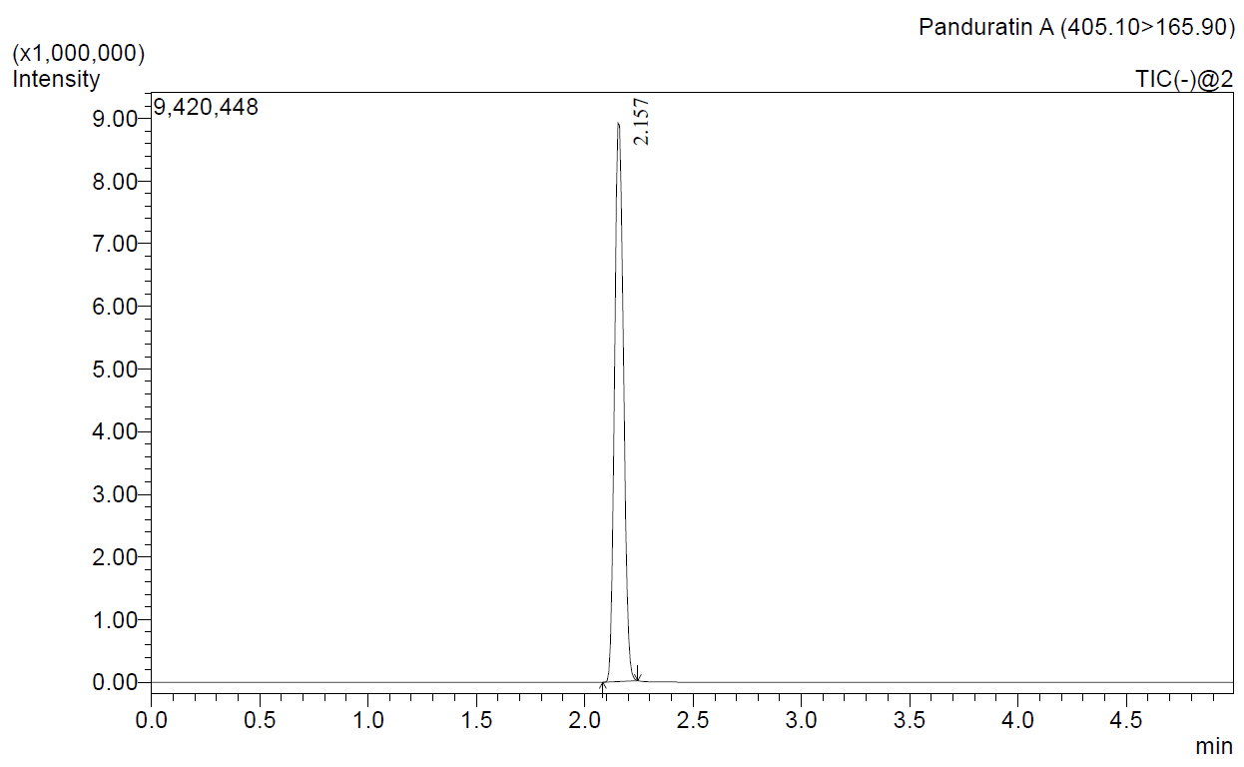
C
B

Figure S1. LCMS chromatograms. (A) Chromatogram of fingerroot extract. (B) Chromatogram of panduratin A. (C) LCMS mass spectra of panduratin A.
 | conditions | Concentration (µg/L) | Mean | SD | Accuracy (%RE) | Precision (%CV) | Absolute recovery  (%)
Panduratin A | Intra-day | 600 | 620.16 | 14.08 | 3.36 | 2.39 | N/A
 |  | 150 | 163.25 | 3.46 | 8.83 | 2.12 | N/A
 |  | 10 | 11.21 | 1.03 | 12.13 | 9.18 | N/A
 | Inter-day | 600 | 629.03 | 51.01 | 4.84 | 8.11 | N/A
 |  | 150 | 163.44 | 9.73 | 8.96 | 5.95 | N/A
 |  | 10 | 11.22 | 1.30 | 12.24 | 11.55 | N/A
 | Room temperature (12 h) | 600 | 652.70 | 21.51 | 8.78 | 3.30 | N/A
 | Room temperature (12 h) | 150 | 161.74 | 7.80 | 7.82 | 4.82 | N/A
 | Room temperature (12 h) | 10 | 10.89 | 0.63 | 8.94 | 5.74 | N/A
 | 3 freeze-thaw cycles | 600 | 668.96 | 14.41 | 11.49 | 2.15 | N/A
 | 3 freeze-thaw cycles | 150 | 166.51 | 8.28 | 11.00 | 4.97 | N/A
 | 3 freeze-thaw cycles | 10 | 10.37 | 0.82 | 3.66 | 7.93 | N/A
 | Storage at  -20°C | 600 | 580.72 | 35.16 | -3.21 | 6.05 | N/A
 | Storage at  -20°C | 150 | 152.78 | 17.30 | 1.86 | 11.33 | N/A
 | Storage at  -20°C | 10 | 10.76 | 1.57 | 7.58 | 14.55 | N/A
 | Autosampler | 600 | 652.86 | 19.59 | 8.81 | 3.00 | N/A
 | Autosampler | 150 | 157.97 | 8.01 | 5.31 | 5.07 | N/A
 | Autosampler | 10 | 11.73 | 0.68 | 11.73 | 6.13 | N/A
 | Recovery | 600 | 635.70 | 40.94 | 5.95 | 6.44 | 97.09
 | extract | 150 | 159.09 | 15.22 | 6.06 | 9.57 | 102.58
 |  | 10 | 11.14 | 1.34 | 11.40 | 12.04 | 101.76
 | Recovery | 600 | 654.75 | 20.35 | 9.13 | 3.11 | N/A
 | un-extract | 150 | 155.08 | 3.88 | 3.39 | 2.50 | N/A
 |  | 10 | 10.95 | 0.38 | 9.47 | 3.49 | N/A
Table S1. Bioanalytical method validation of LCMS for panduratin A.

RE: relative error; CV: coefficient of variation.

Table S2. The criteria of histopathological scoring of lung tissues.

Score | Interstitial pneumonia | Bronchiole and alveolar lesion | Cellular lesions | Vascular lesions | Immunohistochemistry
0 | absent | absent | absent | absent | absent
1 | minimal <10% | minimal  <10% | present | minimal  <10% | airway or alveoli
2 | mild  10-50% | mild  10-50% |  | mild  10-50% | airway and alveoli
3 | moderate  50-70% | moderate  50-70% |  | moderate  50-70%
4 | severe  >70% | severe  >70% |  | severe  >70%

