SUPPLEMENTAL MATERIAL

To: Functional predictors discriminating asthma–COPD overlap (ACO) from chronic obstructive pulmonary disease (COPD)
Kraemer R. et al.

- Assessment of Airway Dynamics by the Integral Method
The assessment of changes in airway caliber to estimate airway function in human subjects and patients with lung disease is best performed by measuring airway resistance using a whole-body plethysmograph, originally introduced by Dubois et al. ^{54,55}. This technique was further adapted by Jaeger and Otis to reach body temperature, ambient pressure and water saturation (BTPS) conditions. Changes in in the calibre of the large, conducting airways are represented by the recording of specific airway loops (sR_{aw}-loops), consisting of the shift volume (V_{pleth}) and the tidal flow (V’) plot. The lung volume, and hence the resting level of end-expiratory lung volume (EELV) at functional residual capacity (FRC_{pleth}) is logically altered in the presence of marked peripheral airway obstruction or pulmonary hyperinflation. It follows that plethysmography offers measurements of airway dynamics in close relationship to FRC_{pleth}, and hence the EELV, which has considerable advantages in the detection of functional deficits compared to measurements of simple spirometry, impulse oscillometric (IOS) or interrupter resistance (R_{int}) measurements.
Until recently, and still used in many plethysmographs, sR_{aw}-loops are approximated routinely by two point analyses creating a straight line throughout the loop.

$${sR}_{aw}=\frac{{∆V}_{pleth}}{V'}∙(P_{amb}-P_{H2O})$$

Absolute lung volume FRC_{pleth} is measured by applying a shutter maneuvre and analysing the occlusion-pressure curve.

$${FRC}_{pleth}=\frac{{∆V}_{pleth}}{P_{m}}∙\left(P_{amb}-P_{H2O}\right)$$

Finally R_{aw} can be calculated from the ration of sR_{aw} and FRC_{pleth}.

$$R_{aw}=\frac{{sR}_{aw}}{{FRC}_{pleth}}=\frac{{∆V}_{pleth}∙P_{m}}{V'∙{∆V}_{pleth}}∙\frac{\left(P_{amb}-P_{H2O}\right)}{\left(P_{amb}-P_{H2O}\right)}=\frac{P_{m}}{V'}$$

The term (P_{amb}-P_{H2O}) reflects the dry air pressure. It follows that R_{aw} is inevitably linked to the value of FRC_{pleth} as a fixed parameter in the equation, and is computed misleadingly low, if a pulmonary hyperinflation is present, and consistently high, if the subject breathes under his natural EELV. Noteworthy is that FRC_{pleth} implicates a shutter occlusion manoeuvre, which is sometimes not tolerated by young children or elderly patients, as well as by patients with severe lung involvement. Moreover, R_{aw} consistently ignores the loop-shaping of the sR_{aw}-loop, especially during quiet breathing, and more importantly, if ventilation inhomogeneities are present.
Although numerous parameters of airway resistances can be calculated from plethysmographic measurements ⁵⁷, the most promising approach was proposed by Matthys H. and Orth U. ⁵⁸, defining the so called “effective specific resistance” (sR_{eff}) as a ratio of the area of the plethysmographic shift-volume versus tidal volume ($\oint{V_{pleth}}dV_{T}$), to the area of the flow/volume loop ($\oint{V^{'}}{dV}_{T}$) throughout the entire respiratory cycle. Noteworthy, the integral $\oint{{∆V}_{pleth}{dV}_{T}}$ multiplied by the dry air pressure (P_{amb}-P_{H2O}) embodies the specific, aerodynamic work of breathing (sWOB) at rest ⁵⁸. Only advanced computer technology made it possible to assess the two integrals presented for infants, children ^{59,60}, as well as for adults ^{58,61}. The mathematical background computing sR_{eff}, sG_{eff} and sWOB, has been presented previously ^{32,33}, showing the following equations:

$$sR_{eff}= P_{amb}-P_{H_{2}O}* \frac{\oint{∆V_{pleth}}dV_{T}}{\oint{V'dV_{T}}}= \frac{1}{{sG}_{eff}}$$

where (P_{amb}-P_{H2O}) is the dry air pressure, the integral $\oint{V_{pleth}}dV_{T}$ the equivalent to the area enclosed by sWOB and the integral $\oint{V^{'}{dV}_{T}}$ the equivalent to the area of the flow-volume loop. Figure S1 synoptically represents a print-screen from a plethysmographic measurement of a healthy infants obtained in an infant whole-body plethysmograph. ⁵⁹ It shows a BTPS-compensated plethysmographic loop, which is the flow dependence (V’) from the shift volume (∆V_{pleth}), derived from two further loops. The first loop (Figure S1; A) represents the tidal flow-volume curve, and its area as integral $\oint{∆V'{dV}_{T}}$ of the Figure S1. Print-screen from a plethysmographic measurement of a healthy infant synoptically representing the interaction of two loops, (A) the tidal flow-volume loop and its area as integral $\oint{∆V'{dV}_{T}}$, and (B) the plethysmographic shift volume-tidal volume, incorporating the area $\oint{{∆V}_{pleth}{dV}_{T}}$, and hence the sWOB, from which (C) the BTPS-compensated plethysmographic loop, (shift volume (∆V_{pleth}) against tidal flow (V’) can be derived, and sR_{eff}, be computed.
$${sR}_{eff}=\left(P_{amb}-P_{H_{2}O}\right)* \frac{\oint{{∆V}_{pleth}dV_{T}}}{\oint{∆V'dV_{T}}}$$

breathing cycle. The second loop (Figure S1; B) characterises the tidal volume in relation to the plethysmographic shift volume and incorporates the area $\oint{{∆V}_{pleth}{dV}_{T}}$, and hence the sWOB. The determination of the sWOB is a prerequisite and part of the computation of sR_{eff}, sG_{eff}, respecively (Figure S1; C), as soon as the subject breathes regularly at resting end-expiratory lung volume (EELV). Importantly however, any extended breathing manoeuvre prior to spontaneous resting breathing has to be avoided, ensuring airway dynamics are assessed under natural breathing conditions e.g., no panting, no breathing against a shutter, no change in the “volume history” ⁶²⁻⁶⁴. Normal spontaneous resting breathing is provided, if the subject breaths naturally and regularly at a constant breathing frequency and constant tidal volume (V_{T}) at EELV, and hence with lowest individual sWOB.

2. Defining predictive Equations of Airway Dynamics
(including confounding parameters influencing the actual breathing pattern and timing)
Predictive equations defining reference values of lung function in infants, children and adults are usually based on algorithms of the subject’s anthropometric measurements, such as age, body weight, body height or a combination of them, as independent variables ^{73,74}. Most of these regressions include linear, but also power- or quadric- function relationships ⁷². This may be suitable for some predictions of static lung volumes ^{42,71,73,75}, volume-time or flow-volume parameters ^{42,72,73}, and indices of intrapulmonary gas distribution ^{20-2276,77,135}. A specific new approach to describe reference ranges more accurately has been developed by Stanojevic et al ⁷⁸, describing the relationship between spirometric lung function and height, age respectively within the pediatric age range, allowing a seamless transition to adulthood. An extension of the so called “LMS (lambda, mu, sigma) method” ⁷⁹ was applied. To our knowledge, however, prediction models using LMS-statistics incorporating age and height of the subjects as independent variables have only been formulated for spirometric parameters ⁷⁵. There is a relative dearth of normative reference values measuring parameters of airway dynamics transitionally from infancy into adulthood. Doershuk et al ⁸⁰ first presented data of specific airway resistance (sR_{aw}), showing gender differences in infants and children (sR_{aw} males < sR_{aw} females). Measuring airway resistance throughout the whole respiratory cycle in infants was performed by Beardsmore et al ⁸¹ demonstrating a dynamic performance of the respiratory circuit in relation to the breathing pattern and suggesting that expiratory looping of the resistance slope could well be due to small airway closure as previously observed by Matthys in adults ²⁷⁴⁸.
However, the physiologic approach of Matthys and Orth ⁵⁸ to evaluate airway dynamics by the integral method putting sWOB ($\oint{V_{pleth}}{dV}_{T}$) in relation to the tidal flow – volume loop ($\oint{∆V'{dV}_{T}}$) for sR_{eff}, its reciprocal ratio for sG_{eff} respectively, has not yet received scientific attention, although this technology has been implemented since years in each Jaeger plethysmograph. Furthermore, based on previous work ^{29,81} regarding airway patency, but also based on previous work dealing with multiple breath-out techniques ⁸², the hypothesis was formed that determinants of airway dynamics, EELV, breathing pattern and timing of breathing should be included into the evaluation of parameter prediction of airway dynamics ³⁴. It turned out, that in the approach of defining airway dynamics (sR_{eff}, sG_{eff} resp.), the most important factor is sWOB. Therefore, predicting equations must be defined for sWOB, from which in a second step sR_{eff} and sG_{eff} can be defined. By a multidimential approach the following regression could be defined ³⁴:

sWOB = EXP(-.300+.017*gender+.138*ln(age)+.836*ln(FRC_{pleth})
+.744*ln(V_{T}/FRC_{pleth})+.387*ln(V_{T}/T_{I}) ± .109083)) (SEE)
*gender: male=0; female=1

sG_{eff} = EXP(.816-.050*gender-.423*ln(sWOB)+.415*ln(FRC_{pleth})
+.603*ln(V_{T}/FRC_{pleth})) ± .12781 (SEE)
*gender: male=0; female=1

sR_{eff} = EXP(-.816+.050*gender+.423*ln(sWOB)-.415*ln(FRC_{pleth})
-.603*ln(V_{T}/FRC_{pleth}) ± .12781 (SEE)
*gender: male=0; female=1

3. Linear discriminant analysis
(including 17 potentially discriminating lung function parameters)
The 17 predictors were grouped within 5 parameter categories (spirometry: FEV₁, FEV₁/FVC, FEF₂₅₋₇₅; airway dynamics: sR_{eff}, sR_{tot}, sWOB; static lung volumes: TLC, FRCpleth, RV, IC/TLC, FRC/TLC, RV/TLC; trapped gases: V_{TG}^{TLC}, V_{TG}^{FRC}, V_{TG}^{RV}, and CO-diffusion: DL_{CO}, K_{CO}), potentially suitable to discriminate between the 3 diagnostic classes (asthma, ACO and COPD). From the 17 parameters 12 could be selected within the drop-levels by linear discriminant analysis, synoptically presented in Figure S2 and showing the following calculated values in each step of the selection procedure:

 | Parameter | Wilks lambda | F-statistics  overall | p-value  overall | F-statistics  diff | p-value  diff
1 | DL_{CO} | 0.4886032 | 281.02564 | 3.053336e-840 | 281.025639 | 3.053336e-84
2 | FEV1/FVC | 0.3278789 | 200.03469 | 3.741968e-128 | 131.372016 | 0.000000e+00
3 | sR_{tot} | 0.2669838 | 166.80249 | 1.297182e-149 | 61.012797 | 0.000000e+00
4 | sWOB | 0.2436810 | 136.93971 | 6.404126e-158 | 25.532860 | 2.564460e-11
5 | FEF₂₅₋₇₅ | 0.2269760 | 117.15218 | 6.058325e-164 | 19.613894 | 6.027593e-09
6 | V_{TG}^{FRC} | 0.2141793 | 102.92278 | 1.598207e-168 | 15.892758 | 1.976218e-07
7 | sR_{eff} | 0.2041393 | 92.03610 | 5.412915e-172 | 13.057964 | 2.909371e-06
8 | RV | 0.1966462 | 83.14742 | 2.755107e-174 | 10.097598 | 4.965985e-05
9 | TLC | 0.1896632 | 76.18737 | 1.804708e-176 | 9.738379 | 7.023176e-05
10 | IC/TLC | 0.1872110 | 69.23045 | 4.638256e-176 | 3.457972 | 3.220727e-02
11 | V_{TG}^{RV} | 0.1857499 | 63.25222 | 4.202608e-175 | 2.072762 | 1.268605e-01
12 | FRC/TLC | 0.1844740 | 58.22229 | 4.470651e-174 | 1.818993 | 1.632059e-01
FEV₁, FRC_{pleth}, RV/TLC V_{TG}^{TLC} and K_{CO} excluded by cross-validated correctness rate

By stepwise classification, using 10-fold cross-validated correctness rate of the R-method “lda”, based on 540 observations with 17 variables in 3 classes with the stop criterion: improvement less than 5%, and according to the Wilks’s lambda statistics (Λ) on each of the discriminant function FEV₁, FRC_{pleth}, RV/TLC, V_{TG}^{TLC} and K_{CO} were excluded from the model, giving a correctness rate of 0.8111.

Accordingly, the final overall statistics including these 12 discriminating lung function parameters, presented with the following results:

Accuracy: 0.8981
95% CI: (0.8695, 0.9223)
No Information Rate: 0.6981
P-Value [Acc > NIR]: < 2.2e-16

Kappa: 0. 767
McNamara’s Test P-Value: 0.0004755

Statistics by Class:

 | Asthma | ACO | COPD
Sensitivity | 0.9708 | 0.52113 | 0.8913
Specificity | 0.7607 | 0.97655 | 0.9888
Pos. pred. value | 0.9037 | 0.77083 | 0.9425
Neg. pred. value | 0.9185 | 0.93089 | 0.9779
Prevalence | 0.6981 | 0.13148 | 0.1704
Detection rate | 0.6778 | 0.06852 | 0.1519
Detection prevalence | 0.7500 | 0.08889 | 0.1611
Balanced Accuracy | 0.8658 | 0.74884 | 0.9401

REFERENCES
(numbered according to the numbering in the main manuscript)

29. Stocks J, Godfrey S, Beardsmore C, Bar-Yishay E, Castile R. Plethysmographic measurements of lung volume and airway resistance. ERS/ATS Task Force on Standards for Infant Respiratory Function Testing. European Respiratory Society/ American Thoracic Society. Eur Respir J. 2001;17(2):302-12. doi: 10.1183/09031936.01.17203020
32. Kraemer R, Blum A, Schibler A, Ammann RA, Gallati S. Ventilation inhomogeneities in relation to standard lung function in patients with cystic fibrosis. Am J Respir Crit Care Med. 2005;171(4):371-8. doi:10.1164/rccm.200407-948OC
33. Kraemer R, Delosea N, Ballinari P, Gallati S, Crameri R. Effect of allergic bronchopulmonary aspergillosis on lung function in children with cystic fibrosis. Am J Respir Crit Care Med. 2006;174(11):1211-20. doi:10.1164/rccm.200603-423OC
34. Kraemer R, Smith HJ, Matthys H. Normative reference equations of airway dynamics assessed by whole-body plethysmography during spontaneous breathing evaluated in infants, children, and adults. Physiol Rep. 2021;9(17): e15027. doi:10.14814/phy2.15027
48. Matthys H. The assessment of airways obstruction. Bull Physiopathol Respir (Nancy). 1973;9(4):961-78.
54. Dubois AB, Botelho SY, Bedell GN, Marshall R, Comroe JH, Jr. A rapid plethysmographic method for measuring thoracic gas volume: a comparison with a nitrogen washout method for measuring functional residual capacity in normal subjects. J Clin Invest. 1956;35(3):322-6.
55. Dubois AB, Botelho SY, Comroe JH, Jr. A new method for measuring airway resistance in man using a body plethysmograph: values in normal subjects and in patients with respiratory disease. J Clin Invest. 1956;35(3):327-35.
56. Jaeger MJ, Otis AB. Measurement of Airway Resistance with a Volume Displacement Body Plethysmograph. J Appl Physiol. 1964;19:813-20.
57. Ulmer WT, Marek W, Rasche K. [Airway resistance curves in obstructive respiratory tract diseases. 8 types of airway resistance curves in spontaneous respiration]. Fortschr Med. 1988;106(33):663-4, 665-6, 667.
58. Matthys H, Orth U. Comparative measurements of airway resistance. Respiration. 1975;32(2):121-34.
59. Kraemer R. Whole-body plethysmography in the clinical assessment of infants with bronchopulmonary diseases. Respiration. 1993;60(1):1-8.
60. Kusenbach G, Pott H, Breuer A, et al. Evaluation of a commercial infant body plethysmography. Eur Respir J. 1998;11(5):1211-3.
61. Zaiss AW, Matthys H. A multiuser system for whole body plethysmographic measurements and interpretation. Lung. 1990;168 Suppl:1185-92.
62. Agostoni E, Mead, J. Statics of the respiratory system. In: Fenn WO, Rahn, H. , ed. Handbook of Physiology. American Physiological Society, Washington D.C. ed. 1964:411-427:chap 14.
63. Mead J, Turner JM, Macklem PT, Little JB. Significance of the relationship between lung recoil and maximum expiratory flow. J Appl Physiol. 1967;22(1):95-108.
64. Duggan CJ, Castle WD, Berend N. Effects of continuous positive airway pressure breathing on lung volume and distensibility. J Appl Physiol (1985). 1990;68(3):1121-6.
71. Stocks J, Quanjer PH. Reference values for residual volume, functional residual capacity and total lung capacity. ATS Workshop on Lung Volume Measurements. Official Statement of The European Respiratory Society. Eur Respir J. 1995;8(3):492-506.
72. Hankinson JL, Odencrantz JR, Fedan KB. Spirometric reference values from a sample of the general U.S. population. Am J Respir Crit Care Med. 1999;159(1):179-87. doi:10.1164/ajrccm.159.1.9712108
73. Zapletal A, Samanek M, Paul T. Lung function in children and adolescents. Karger; 1987.
74. Quanjer PH, Stocks J, Polgar G, Wise M, Karlberg J, Borsboom G. Compilation of reference values for lung function measurements in children. Eur Respir J Suppl. 1989;4:184S-261S.
75. Quanjer PH, Stanojevic S, Cole TJ, et al. Multi-ethnic reference values for spirometry for the 3-95-yr age range: the global lung function 2012 equations. Eur Respir J. 2012;40(6):1324-43. doi:10.1183/09031936.00080312
76. Kraemer R, Meister B. Fast real-time moment-ratio analysis of multibreath nitrogen washout in children. J Appl Physiol. 1985;59(4):1137-44. doi: 10.1152/jappl.1985.59.4.1137
77. Lum S, Stocks J, Stanojevic S, et al. Age and height dependence of lung clearance index and functional residual capacity. Research Support, Non-U.S. Gov't. Eur Respir J. 2013;41(6):1371-7. doi:10.1183/09031936.00005512
78. Stanojevic S, Wade A, Stocks J, et al. Reference ranges for spirometry across all ages: a new approach. Am J Respir Crit Care Med. 2008;177(3):253-60. doi:200708-1248OC [pii]
10.1164/rccm.200708-1248OC
79. Cole TJ, Stanojevic S, Stocks J, Coates AL, Hankinson JL, Wade AM. Age- and size-related reference ranges: a case study of spirometry through childhood and adulthood. Stat Med. 2009;28(5):880-98. doi:10.1002/sim.3504
80. Doershuk CF, Fisher BJ, Matthews LW. Specific airway resistance from the perinatal period into adulthood. Alterations in childhood pulmonary disease. Am Rev Respir Dis. 1974;109(4):452-7.
81. Beardsmore CS, Godfrey S, Shani N, Maayan C, Bar-Yishay E. Airway resistance measurements throughout the respiratory cycle in infants. Respiration. 1986;49(2):81-93.
82. Yammine S, Singer F, Gustafsson P, Latzin P. Impact of different breathing protocols on multiple-breath washout outcomes in children. J Cyst Fibrosis. 2014;13(2):190-7. doi:10.1016/j.jcf.2013.08.01

Figure legends
Figure S1. Print-screen from a plethysmographic measurement of a healthy infant synoptically representing the interaction of two loops, (A) the tidal flow-volume loop and its area as integral $\oint{∆V'{dV}_{T}}$, and (B) the plethysmographic shift volume-tidal volume, incorporating the area $\oint{{∆V}_{pleth}{dV}_{T}}$, and hence the sWOB, from which (C) the BTPS-compensated plethysmographic loop, (shift volume (∆V_{pleth}) against tidal flow (V’) can be derived, and sR_{eff}, be computed.

Figure S2. Predictors potentially suitable to discriminate between the 3 diagnostic classes (asthma, ACO and COPD), assessed by linear discriminant analysis (LDA) using R-statistics.

Figures

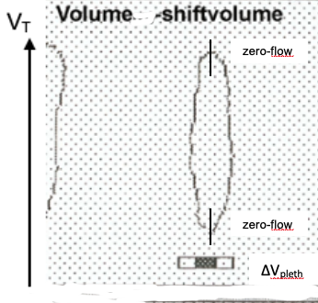
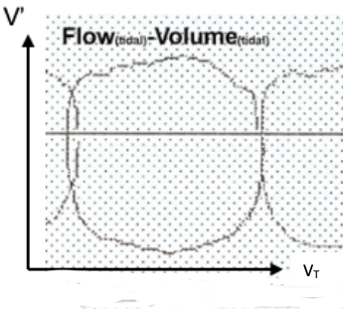
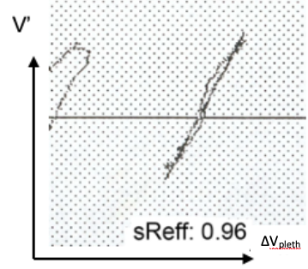
Figure S1
The work of breathing loop
$$sWOB=\oint{V_{pleth}{dV}_{T}}$$

The breathing cycle
Tidal flow-tidal volume loop
$$\oint{∆V'{dV}_{T}}$$
The plethysmographic
tidal flow – shift volume loop
A
B
C
zero-flow
zero-flow
∆V_{pleth}
Volume - shift volume
Flow_{(tidal)} – Volume_{(tidal)}
sR_{eff}: 0.96 kPa*s
∆V_{pleth}

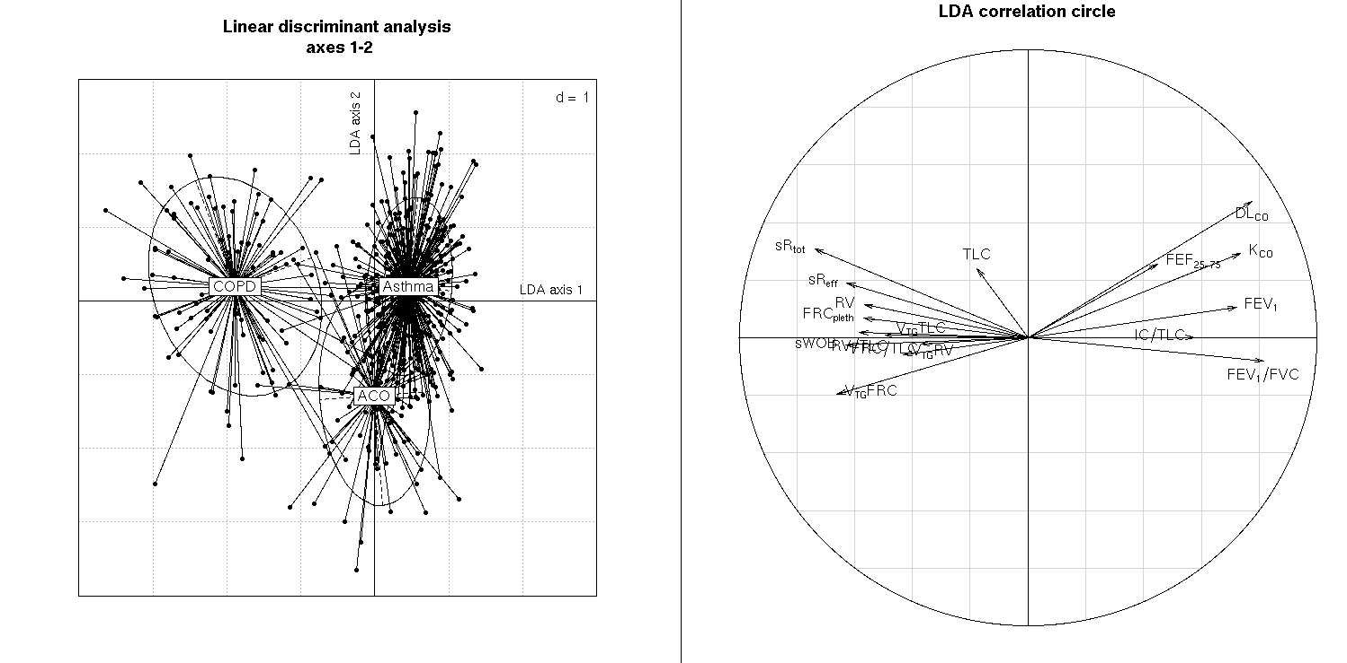
Figure S2

