Supporting Information

Cascade-enhanced catalytic nanocomposite with glutathione depletion and respiration inhibition for effective starving-chemodynamic therapy against hypoxic tumor

Yiran Zhang^{1,2,3,6*}, Hongzhi Hu^{4*}, Xiangtian Deng^{5*}, Qingcheng Song², Xin Xing^{2,3}, Weijian Liu^{4#}, Yingze Zhang^{1,2,3#}

¹School of Medicine, Nankai University, Tianjin, 300071, China.
²Department of Orthopaedic Surgery, Third Hospital of Hebei Medical University, Shijiazhuang, 050051, Hebei, China
³NHC Key Laboratory of Intelligent Orthopaedic Equipment, Third Hospital of Hebei Medical University, Shijiazhuang, Hebei, China.
⁴Department of Orthopaedics, Union Hospital, Tongji Medical College, Huazhong University of Science and Technology, Wuhan 430022, China
⁵Orthopaedics Research Institute, Department of Orthopaedics, West China Hospital, Sichuan University
⁶HeBei Ex&Invivo Biotechnology Co. Ltd, Shijiazhuang, 050051, Hebei, China

*These authors contributed equally to this work.
#Correspondence:
Yingze Zhang, E-mail: yzling_liu@163.com
(First Corresponding author);
Weijian Liu, E-mail: xh_liuweijian@hust.edu.cn

m(GC): m(KMnO₄) | Hydrodynamic size | PDI
1:0.4 | 294.6 ± 42.1 nm | 0.46
1:0.8 | 173.9 ± 22.7 nm | 0.27
1:1.2 | 253.1 ± 37.3 nm | 0.39
1:1.6 | 365.4 ± 53.2 nm | 0.61
Table S1 DLS results of GOx-CuCaP@MnO₂(GCM) at different mass ratios.

Figure S1 XPS spectrum of as-prepared GCMMR NPs. (A) Full scan; (B) Mn2p spectra; (C) Cu2p spectra

Figure S2 Thermogravimetric analysis of GCMMR NPs

Figure S3 Hydrodynamic size of GCMMR NPs in various media over 7 days.

Figure S4 Absorbance of MB at 664 nm after 5 h incubation with different concentrations of GSH. (A) [GCMR] = 1 mg mL⁻¹, [glucose] = 0 μg mL⁻¹. (B) [GCMR] = 1 mg mL⁻¹, [glucose] = 400 μg mL⁻¹

Figure S5 The •OH generation ability of GCMR. (A) HPF (10μM) fluorescence response after 1h incubation in different reaction systems ([GCMR] = 1 mg mL⁻¹, [glucose] = 800 μg mL⁻¹). (B) HPF (10μM) fluorescence response after 1h incubation with GCMR in the presence of GSH (12 mM), glucose (800 μg mL⁻¹) and various concentrations of thiourea (scavenger for •OH).

Figure S6 Standard curve of metformin according to the UV-vis absorption.

Figure S7 Metformin released from GCMMR NPs in PBS with different pH values (7.4 and 5.0) with or without GSH added.

Figure S8 Cell viabilities of MNNG/HOS cells after 24 h incubation with GC (A), GCM (B), GCMR (C) or GCMMR (D) at equivalent concentration of GC in DMEM containing various levels of glucose (0, 200, 400 and 800 μg mL⁻¹).

Figure S9 Cell viability of human bone marrow stromal cells (hBMSCs) after incubation with GC, GCM or GCMR at equivalent concentration of GC for 24 h in the presence of glucose (400 μg mL⁻¹)

Figure S10 Mitochondrial complex I activity of MNNG/HOS cells after 6 h incubation with PBS, MET, GCMR and GCMMR NPs.

Figure S11 Cell viabilities of human bone marrow stromal cells (hBMSCs) after 24 h incubation with different concentrations of GCMMR (at equivalent concentration of GC).

Figure S12 Hemolysis analysis of GCMMR NPs.

Figure S13 Biosafety evaluation by biochemical indexes of the healthy mice as control (A, B) and the mice after treatment of GCMMR (C, D). The aminotransferase (ALT) and aminotransferase (AST) reflect the liver function of the mice. The blood urea nitrogen (BUN) and creatinine (CREA) reflect the kidney function of the mice.

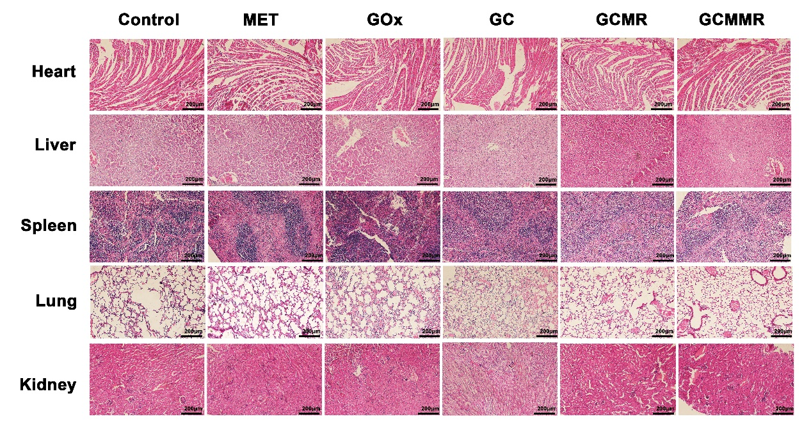

Figure S14 H&E staining images of dissected major organs (heart, liver, spleen, lung, kidney) of MNNG/HOS tumor-bearing mice after corresponding treatments.

