Photodynamic therapy and antibacterial activities of a novel synthesized quaternary Zn-Cu-In-S/ZnS QDs- mTHPP Porphyrin conjugate.
Ncediwe Tsolekile ^{1,2,3}, Sundararajan Parani ^{2,3}, Erenilda Ferreira de Macedo ⁴, Thabang Calvin Lebepe ^{2,3}, Rodney Maluleke ^{2,3}, Vuyelwa Ncapayi ^{2,3}, Mangaka Clara Matoetoe ¹, Sandile Phinda Songca ⁵, Katia Conceição ⁶, Dayane Batista Tada ⁴, and Oluwatobi Samual Oluwafemi ^{2,3}

¹Department of Chemistry, Cape Peninsula University of Technology, PO Box 652, Cape Town 2000, South Africa.
²Department of Chemical Sciences, University of Johannesburg, P. O. Box 17011, Doornfontein 2028, Johannesburg, South Africa.
³Centre for Nanomaterials Science Research, University of Johannesburg, Johannesburg, South Africa.
⁴Laboratory of Nanomaterials and Nanotoxicology, Institute of Science and Technology, Federal University of São Paulo, SP, Brazil.
⁵Department of Chemistry, University of KwaZulu-Natal, Private Bag X 54001, Durban, 4000, South Africa.
⁶Laboratory of Peptide Biochemistry, Institute of Science and Technology, Federal University of São Paulo, SP, Brazil.

Correspondence: [Oluwatobi Samual Oluwafemi]
Department of Chemical Sciences, University of Johannesburg, P. O. Box 17011, Doornfontein 2028, Johannesburg, South Africa.]
Tel [+27 011 559 9060]
Email : oluwafemi.oluwatobi@gmail.com

Correspondence: [Dayane Batista Tada], Laboratório de Nanomateriais e Nanotoxicologia, Universidade Federal de São Paulo, Talim, 330 - Vila Nair, São José dos Campos, SP, 12231-280, Brazil.
Email : day.tada@gmail.com

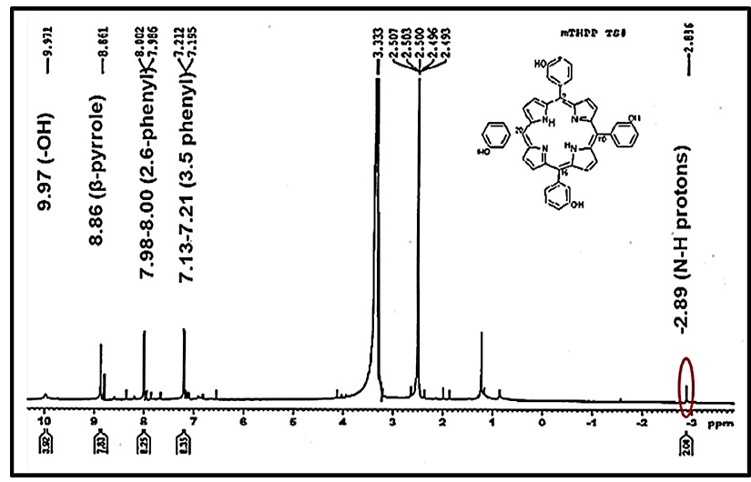
Figure S1: NMR spectrum of mTHPP.

¹HNMR _H(DMSO-d6): 9.99(s, 4H, −OH), 8.85(s, 8H, _-Pyrrole), 7.97(d, 8H, 2,6- phenyl), 7.18(d, 8H, 3,5-Phenyl), −2.92(s, 2H, NH-pyrrole). λmax(MeOH): 418 nm (Soret), 516, 555, 595, 650 nm.

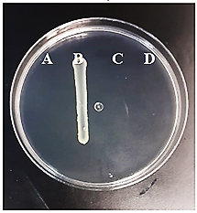

Figure S2: (A) Seeding of E. coli incubated with antibiotic (B) E. coli incubated with culture medium (C) culture medium and autoclaved water without bacteria (D) culture medium without bacteria.

