ORIGINAL RESEARCH
Li et al

A multifunctional nano-delivery system against rheumatoid arthritis by combined phototherapy, hypoxia-activated chemotherapy, and RNA interference
Xiangyu Li¹*
Shixin Zhang¹*
Miaomiao Zhang¹
Ge Li¹
Bo Yang¹
Xinyue Lu¹
Lesheng Teng¹
Youxin Li¹
Fengying Sun¹
*These authors contributed equally to this work

¹School of Life Sciences, Jilin University, Changchun, Jilin, China

Correspondence: Fengying Sun
School of Life Sciences, Jilin University, 2699 Qianjin Street, Changchun, Jilin 130012, China.
Tel +86-431-85155320
Fax +86-431-85155320
Email sunfengying@jlu.edu.cn

Table S1. PDI of HNs and PFHNs.
NPs | PDI | SD
CTAB-SPs | 0.071 | 0.048
HNs | 0.296 | 0.015
PFHNs (HNs:PEI-FA=4:1) | 0.188 | 0.087
PFHNs (HNs:PEI-FA=2:1) | 0.101 | 0.042
PFHNs (HNs:PEI-FA=1:1) | 0.091 | 0.034
PFHNs (HNs:PEI-FA=1:2) | 0.207 | 0.021
PFHNs (HNs:PEI-FA=1:4) | 0.245 | 0.013

Figure S1. (A) ΔT of PFHNs suspension (1 mg/mL) upon NIR irradiation at various power densities, and ΔT-power density curve following 6-min NIR laser irradiation. (B) ΔT of PFHNs suspension at various concentrations upon NIR irradiation (1.0 W/cm²), and ΔT-concentration curve following 6-min NIR laser irradiation. (C) Photothermal stability of PFHNs. (D) ΔT of PBS, HNs, and PFHNs upon NIR irradiation (1.0 W/cm²). (E) In vitro NIR-induced ROS generation by PFHNs.

Figure S2. Nitrogen sorption isotherms of (A) HNs, (B) PFHNs and (C) PFHNs/TM. (D) Pore size distributions of HNs, PFHNs and PFHNs/TM.

Figure S3. Hemolysis assay of free Mcl-1 siRNA (A) and PFHNs/TM (B).

Figure S4. X-ray imaging of hind paws of rats from different groups.

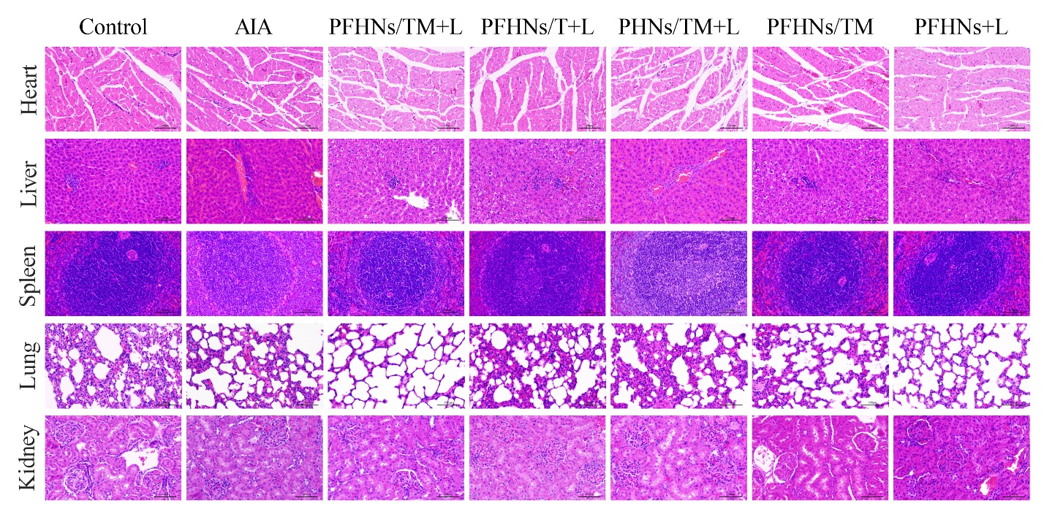
Figure S5. H&E staining of rat major organs from different groups.

