Fig. S1 Size and morphology of Lipo/DOX@ICG a and PDA/DOX@ICG b measured using a Malvern Zetasizer Nano Series instrument and TEM. Scale bar for TEM is 100 nm. c UV-vis-NIR spectra of different concentrations of PDA@ Lipo. d DOX release from PDA/DOX@ICG and Lipo/DOX@ICG in different pH release media (pH = 7.4, 5.0) with or without laser irradiation (2.0 W, 5 min) at 0.5 h (n = 3 per group).

Fig. S2 a The change of particle size of PDA/DOX@ICG and Lipo/DOX@ICG in aqueous solution and FBS. b The appearance comparison of PDA/DOX@ICG and Lipo/DOX@ICG before and after storage. c The content change of PDA/DOX@ICG and Lipo/DOX@ICG in water and FBS.

Fig. S3 In vitro ¹O₂ detection of black DPBF a and free ICG b (containing 10 μg/mL ICG) using ¹O₂ probe DPBF, whose attenuation rate at 417 nm is directly proportional to the generation rate of ¹O₂ under 808 nm laser radiation (1.0 W/cm², 10 min).

Fig. S4 MTT assays of blank carrier PDA a and Lipo b over 24 h in MDA-MB-231 cells with/without irradiation (1.0 W/cm², 2 min).

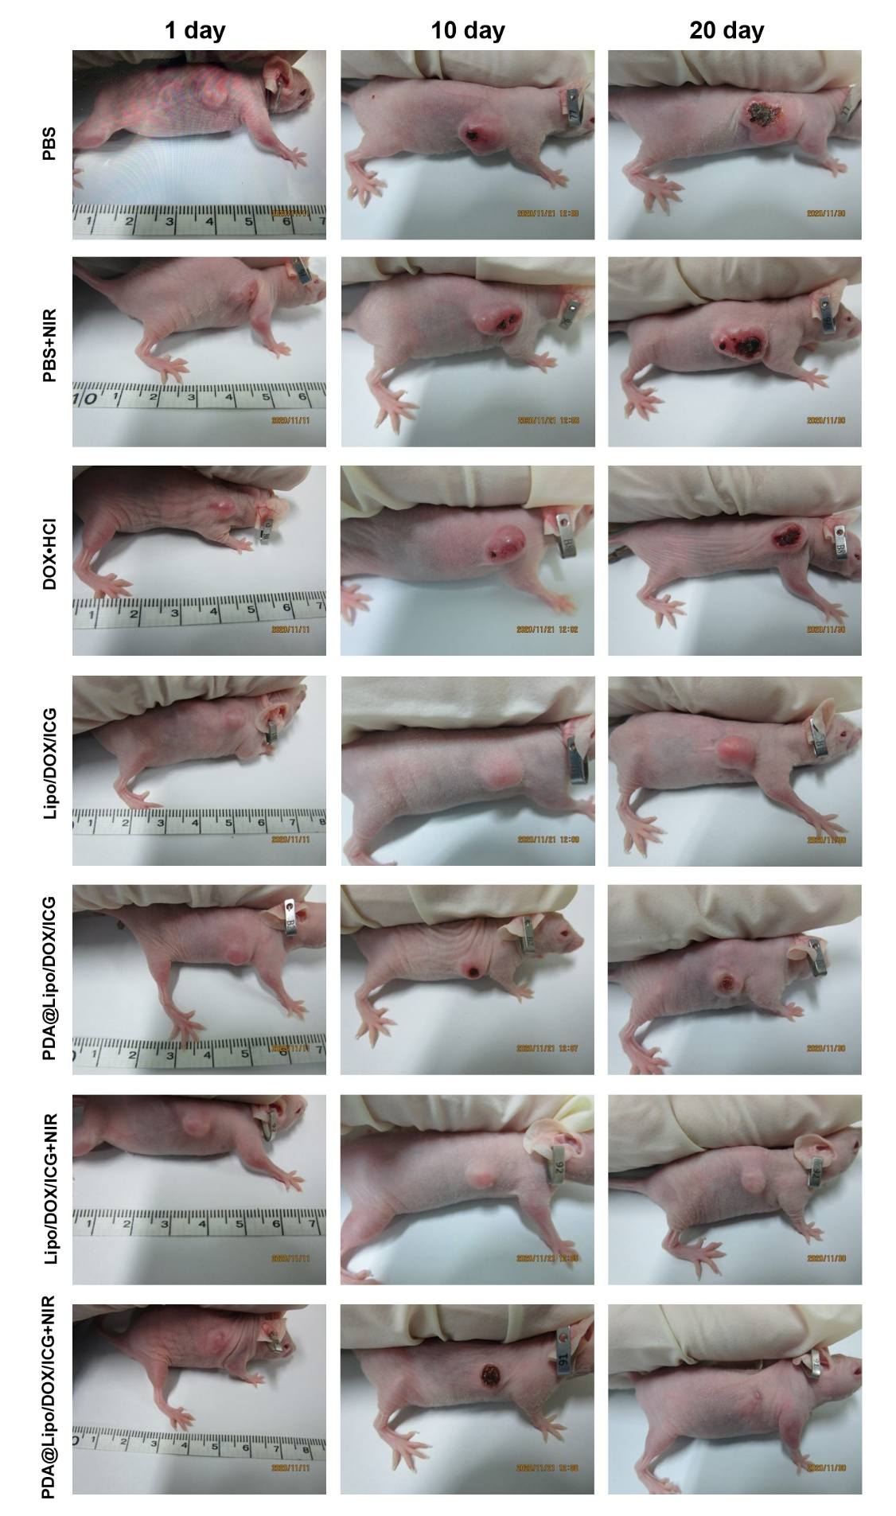
Fig. S5 The pictures of tumor changes after different treatments.

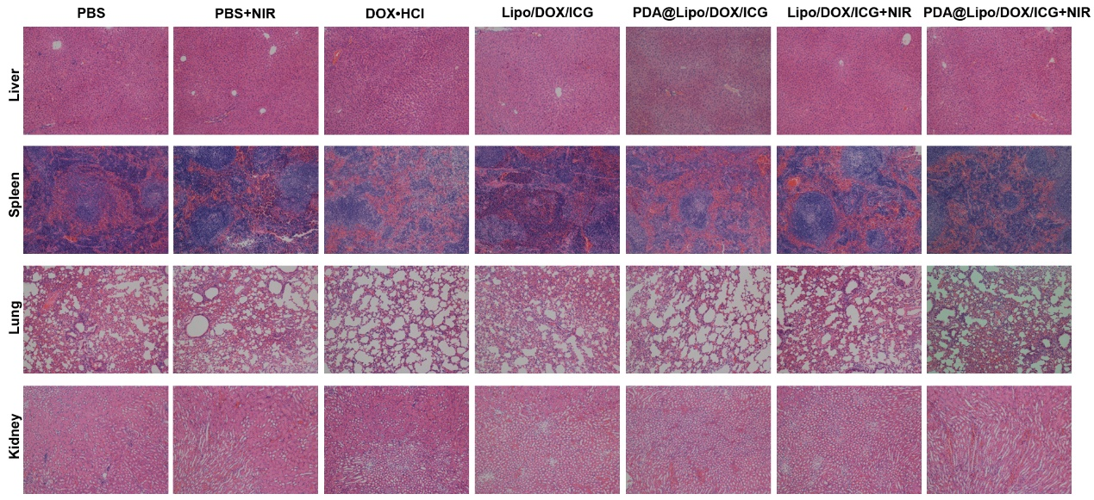
Fig. S6 Representative histological images of liver, spleen, lung and kidney samples from the treated mice. (n = 5 per group).
Conflicts of interest
There are no conflicts to declare.

