Supplementary materials
Flow diagram of participant recruitment
A web-based cross-sectional survey, implemented using the Questionnaire Star platform (https ://www.wjx.cn) and broadcasted through mainstream social-media Wechat was used to collect data. The survey was enabled from April 8 to April 14 (see Figure S1). The inclusion criteria included (1) Willing to accept the investigation; (2) Located in Shanghai; (3) Normal ability of speech, comprehension and expression. A total of 1320 subjects participated in the present study (219 were deleted because of not meeting inclusion criterion or unwilling to accept the investigation). A total of 1,101 were recruited to complete the survey. Figure S1 demonstrated passage of participant selection. All the study participants were entirely voluntary and were provided with written informed consent.

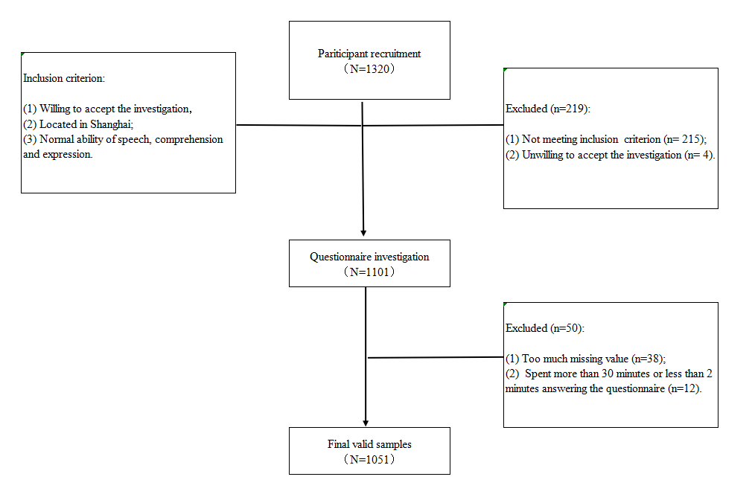
Figure S1. Flow diagram of participant recruitment

The relationship between perceived stress and emotion states
As shown in Figure S2, the scatterplot of perceived stress and emotion states in every participant was showed. There was significant relationship between perceived stress and emotion states, suggesting that individuals with high negative emotions also had high levels of perceived stress.
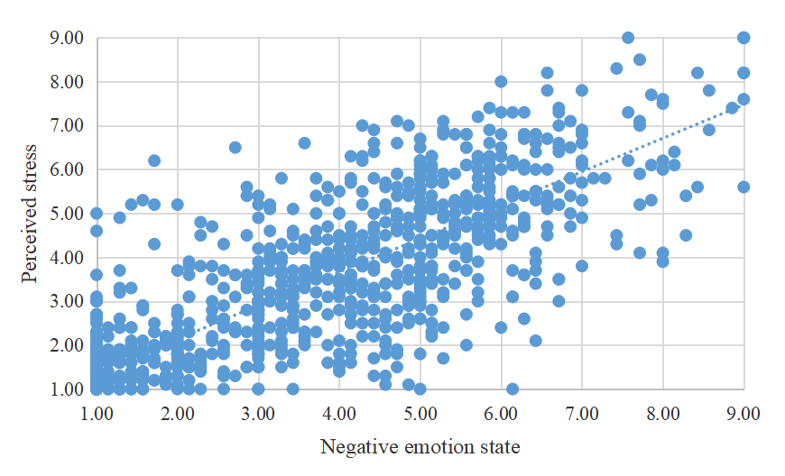

Figure S2. The distribution of emotion state and perceived stress
The change of perceived stress and emotion state over time
Perceived stress on April 11 was significantly higher than on April 9 (p=0.001), meaning individuals’ stress rose as quarantine time increased. The emotion of flustered (p<0.001), jittery (p<0.001), indignant (p<0.001), meaningless (p=0.01) and hopeless (p=0.001) on April 11 was significantly higher than on April 9 (p=0.001). The emotion of bored on April 12 was significantly higher than on April 9 (p=0.022). In conclusion, while overall perceived stress and emotion states were moderate, people's perceived stress and emotion states would increase over time during quarantined at home (Figure S3). This conclusion also supported the results of ANOVA in the manuscript (Those with more quarantined days at home had higher perceived stress (F= 50.494, p<0.001) and emotion state (F= 42.410, p<0.001) than those less).
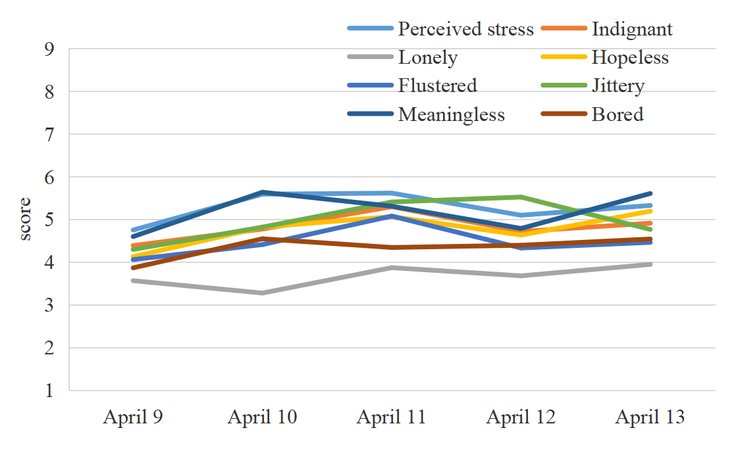
Figure S3. The change of perceived stress and emotion stated over time

The effect of gender on the top three perceived stress and emotion states
We picked out the top three perceived stresses and emotion states to explore the effect of gender on them. As Figure S4 showed, they were stress from living provisions, general stress, stress from COVID-19 infection, meaningless, indignant and jittery. It was revealed that female had higher stress from living provisions, general stress, stress from COVID-19 infection, meaningless, indignant and jittery than male (p<0.001). This result was consistent with the conclusion of ANOVA and hierarchical regression in the manuscript (Female had higher perceived stress (F=215.836, p<0.001) and negative emotion states (F=208.349, p<0.001) than male; Female (β=0.076, p=0.002), living with the elderly (β=0.087, p<0.001), living with children (β=0.121, p<0.001), middle emotion state (β=0.515, p<0.001) and high emotion state (β=0.395, p<0.001) were positively correlated with perceived stress). Female are more vulnerable to stress and negative emotions, deserving more attention.
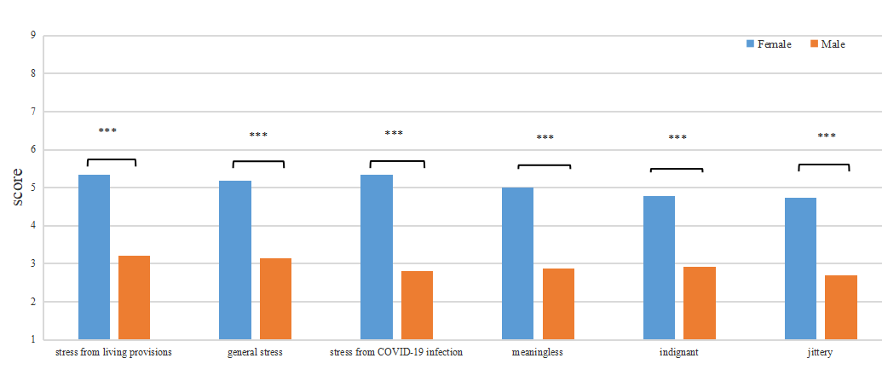
Figure S4. The difference of top three perceived stress and emotion states between female and male
Note: ***, P<0.001.

The effect of living with the elderly on the top three perceived stress and emotion states
Similarly, we picked out the top three perceived stresses and emotion states to explore the effect of living with the elderly on them (Figure S5). Results suggested that living with the elderly during quarantined days had higher stress from living provisions, general stress, stress from COVID-19 infection, meaningless, indignant and jittery than not (p<0.001). This result was consistent with the conclusion of ANOVA and hierarchical regression in the manuscript (Those living with the elderly during quarantined days showed higher perceived stress (F=106.151, p<0.001) and negative emotion state (F=64.069, p<0.001); Female (β=0.076, p=0.002), living with the elderly (β=0.087, p<0.001), living with children (β=0.121, p<0.001), middle emotion state (β=0.515, p<0.001) and high emotion state (β=0.395, p<0.001) were positively correlated with perceived stress). During the outbreak of COVID-19, families with elderly people are more likely to experience psychological and emotional problems.
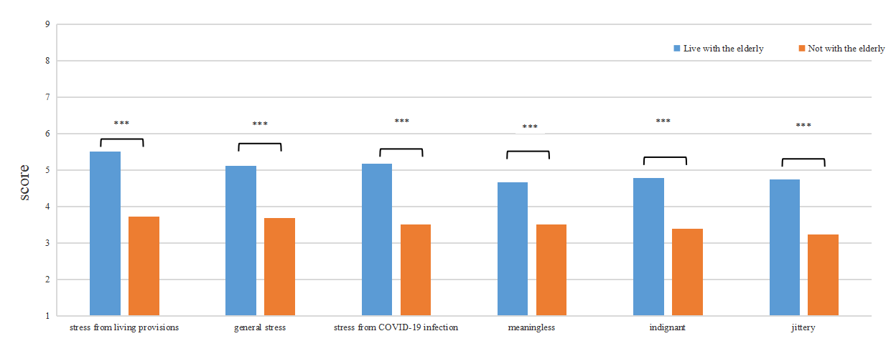
Figure S5. The difference of top three perceived stress and emotion states between live with the elderly or not
Note: ***, P<0.001.

The effect of living with children on the top three perceived stress and emotion states
Lastly, we tested the effect of living with children on the top three perceived stress and emotion states during quarantined days (Figure S6). Results prompted that living with children during quarantined days had higher stress from living provisions, general stress, stress from COVID-19 infection, meaningless, indignant and jittery than not (p<0.001). This result was also consistent with the conclusion of ANOVA and hierarchical regression in the manuscript (Similarly, those living with the children during quarantined days showed higher perceived stress (F=102.778, p<0.001) and negative emotion state (F=78.027, p<0.001), regardless of number of children; Female (β=0.076, p=0.002), living with the elderly (β=0.087, p<0.001), living with children (β=0.121, p<0.001), middle emotion state (β=0.515, p<0.001) and high emotion state (β=0.395, p<0.001) were positively correlated with perceived stress). It was indicated that families with children also need more attention during quarantined at home.
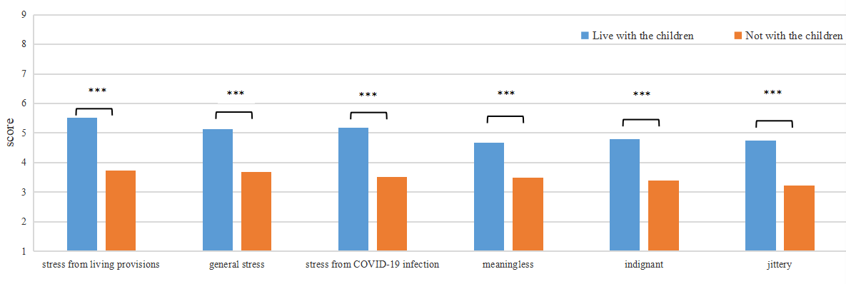
Figure S6. The difference of top three perceived stress and emotion states between live with children or not
Note: ***, P<0.001.

