Supporting information
Cytotoxicity and genotoxicity of polystyrene micro- and nanoplastics with different size and surface modification in A549 human lung cells
Xiaorui Shi¹, Xinan Wang¹, Rong Huang¹, Chu Tang¹, Chong Hu¹, Pengbo Ning^{1*}, Fu Wang^{1, 2, 3*}

- Engineering Research Center of Molecular and Neuro Imaging, Ministry of Education, School of Life Science and Technology, Xidian University, Xi’an 710071, China
- Xianyang Key Laboratory of Molecular Imaging and Drug Synthesis, School of Pharmacy, Shaanxi Institute of International Trade & Commerce, Xianyang 712046, Shaanxi, China
- School of Basic Medical Sciences, Xi’an Jiaotong University, Xi’an 710061, China

*To whom correspondence should be addressed:
Fu Wang, E-mail: fwang@xidian.edu.cn
Pengbo Ning, E-mail: pbning@xidian.edu.cn

Supplemental Table S1. Zeta potential and average particle size characterization of all PS plastics dispersed in water. The size of the particles was expressed as intensity-based average hydrodynamic diameter. PDI: polydispersity index.
MPs type | Water
MPs type | Zeta Potential  (Zp, mV) | Hydrodynamic Size (HDS, nm) | PDI
PS-NPs (80 nm) | -38.50±0.929 | 101.5±0.681 | 0.102±0.017
PS-MPs (2 μm) | -31.23±1.415 | 2145±238.9 | 0.355±0.139
PS | -24.3±0.723 | 104.1±1.514 | 0.0743±0.010
PS-COOH | -20.2±1.430 | 97.2±1.490 | 0.128±0.024
PS-NH₂ | -22.6±2.600 | 91.2±1.450 | 0.0510±0.018

Supplemental Table S2. Zeta potential and average particle size characterization of all PS plastics dispersed in DMEM with or without FBS. The size of the particles was expressed as intensity-based average hydrodynamic diameter. PDI: polydispersity index.
MPs type | DMEM without FBS |  |  | DMEM with FBS
MPs type | Zeta Potential (Zp, mV) | Hydrodynamic Size (HDS, nm) | PDI | Zeta Potential (Zp, mV) | Hydrodynamic Size (HDS, nm) | PDI
PS-NPs (80 nm) | -19.53±1.332 | 203.0±3.959 | 0.178±0.019 | -8.210±0.488 | 123.9±1.852 | 0.280±0.005
PS-MPs (2 μm) | -10.39±0.927 | 3494±406.8 | 1.000±0.000 | -3.623±0.416 | 2423±424.1 | 0.529±0.150
PS | -23.4±1.150 | 169±4.58 | 0.137±0.032 | -7.06±0.933 | 131±4.500 | 0.172±0.016
PS-COOH | -20.3±1.100 | 200±2.65 | 0.164±0.012 | -7.51±0.631 | 114±3.350 | 0.188±0.006
PS-NH₂ | -22.0±0.458 | 160±1.41 | 0.151±0.014 | -7.07±1.350 | 111±4.000 | 0.221±0.006

Supplemental Figure S1. Scanning electron microscopy (SEM) images of 80 nm PS-NPs and 2 μm PS-MPs in ddH₂O.

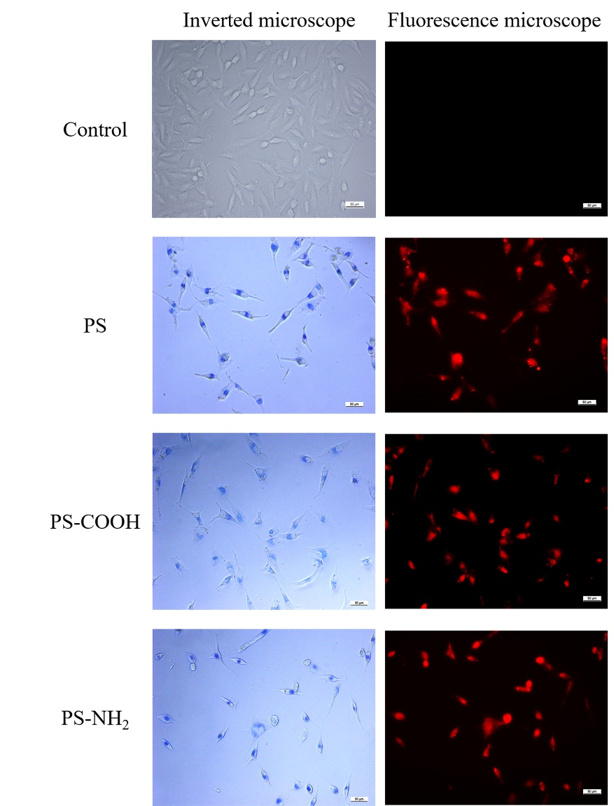
Supplemental Figure S2. Uptake of three kinds of red fluorescent PS-NPs by A549 cells was assessed using inverted fluorescence microscope. A549 cells were seeded in 6-well plates and incubated with three kinds of PS-NPs (200 μg/mL) separately for 24 h. Blue color indicates fluorescent PS-NPs under white light illumination and red color indicates fluorescent PS-NPs excited by green fluorescence. Scale bar, 50 μm for all images.

