Formulae | Zero order | First order | Diffusion
Formulae | R² | R² | R²
TBLs1 | 0.9787 | 0.8976 | 0.99929
TBLs 2 | 0.9782 | 0.8984 | 0.99928
TBLs 3 | 0.9721 | 0.8537 | 0.99918
TBLs 4 | 0.9917 | 0.8740 | 0.99911
TBLs 5 | 0.9832 | 0.8841 | 0.99241
TBLs 6 | 0.9792 | 0.8887 | 0.99932
TBLs 7 | 0.9783 | 0.8938 | 0.9968
TBLs 8 | 0.9848 | 0.9111 | 0.99776
TBLs 9 | 0.9939 | 0.8950 | 0.99302
TBLs 10 | 0.9808 | 0.8998 | 0.99912
TBLs 11 | 0.9864 | 0.9227 | 0.99460
TBLs 12 | 0.9971 | 0.9302 | 0.98777
TBLs 13 | 0.9932 | 0.9288 | 0.99418
TBLs 14 | 0.9820 | 0.9098 | 0.99819
TBLs 15 | 0.9826 | 0.9115 | 0.99543
Supplementary Table 1 [Drug Release Kinetics of CIT Formula
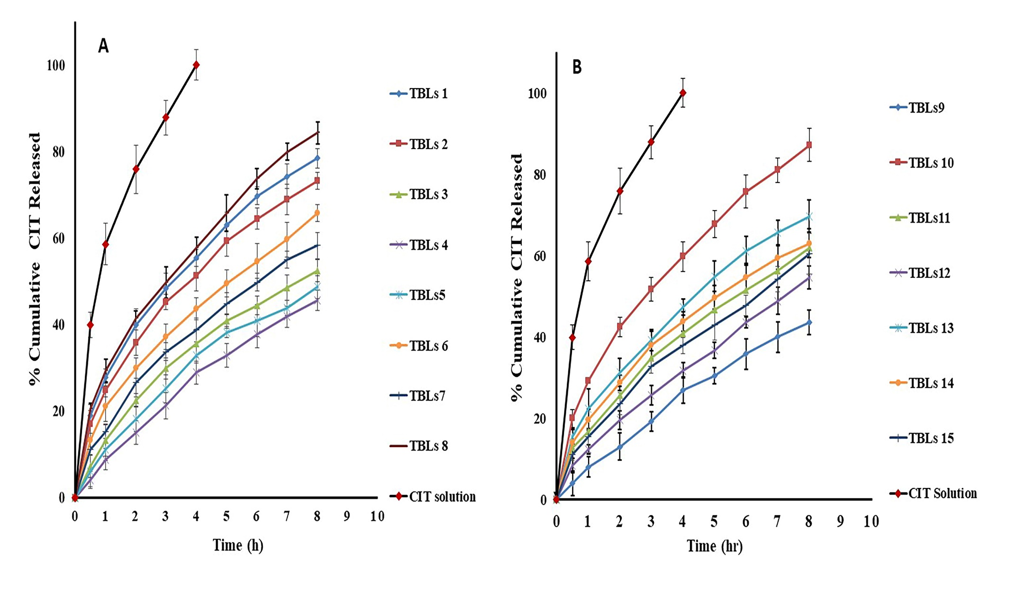
Supplementary Figure 1 [ In -vitro release profile of CIT from drug solution and different TBLs formula: (A) TBLs 1 –TBLs 8,
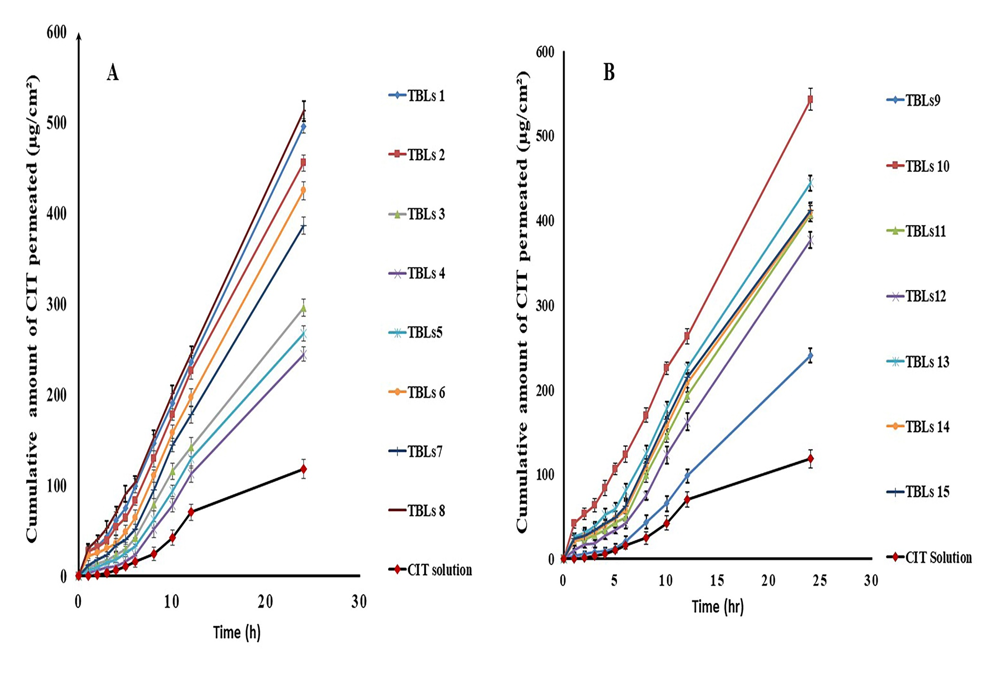
(B) TBLs 9 –TBLs 15]

Supplementary Figure 2 [Permeation profile of CIT from drug solution and different TBLs formula: (A) TBLs 1–TBLs7, (B) TBsL8- BLs15]

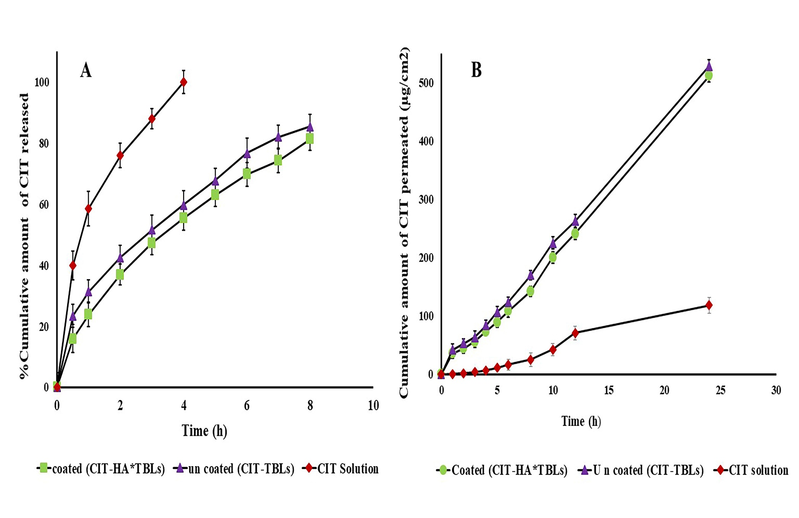
Supplementary Figure 3 [Dissolution profiles (A) and permeation profiles (B) of CIT from the un coated CIT-TBLs and
Coated CIT-HA*TBLs

