Supplementary Material

Micro/Nano-Structured Topography on Titanium Orchestrates Dendritic Cell Adhesion and Activation via β2 Integrin-FAK Signals
Yang Yang^{1, 2*}, Yujing Lin^{1, 2*}, Ruogu Xu^{1,2}, Zhengchuan Zhang^{1, 2}, Wenyi Zeng^{1, 2}, Qiong Xu^{1, 2}, Feilong Deng^{1, 2}

¹Department of Oral Implantology, Guanghua School of Stomatology, Hospital of Stomatology, Sun Yat-Sen University, Guangzhou, PR China
²Guangdong Provincial Key Laboratory of Stomatology, Guangzhou, PR China
*These authors have contributed equally to this work and share first authorship
Correspondence: Qiong Xu, Feilong Deng
Department of Oral Implantology, Hospital of Stomatology, Guanghua School of Stomatology, Sun Yat-Sen University, No. 56, Ling Yuan Xi Road, Guangzhou, 510055, People’s Republic of China
Tel +86 20 83862537
Fax +86 20 83822807
Email xqiong@mail.sysu.edu.cn
dengfl@mail.sysu.edu.cn

Supplementary Table 1. Primer pairs used in the qRT-PCR
Genes | Primer sequences
mIL-10 | Forward: 5’-GGTTGCCAAGCCTTATCGGA-3’  Reverse: 5’-ACCTGCTCCACTGCCTTGCT-3’
mIL-1β | Forward: 5’-TGGAGAGTGTGGATCCCAAG-3’  Reverse: 5’-GGTGCTGATGTACCAGTTGG-3’
mCD83 | Forward: 5’-CGCAGCTCTCCTATGCAGTG-3’  Reverse: 5’-GTGTTTTGGATCGTCAGGGAATA-3’
mMHC-II | Forward: 5’-TGGTGACACTGGGACATTCATC-3’  Forward: 5’-CAGTCTGTCCCCCTGCTAAG-3’
mGAPDH | Forward: 5’-GTGAAGGTCGGTGTGAACGG-3’  Reverse: 5’-TCCTGGAAGATGGTGATGGG-3’

Supplementary Figure 1. Titanium specimen characteristics. EDS spectra showed the main surface elemental compositions for titanium samples.

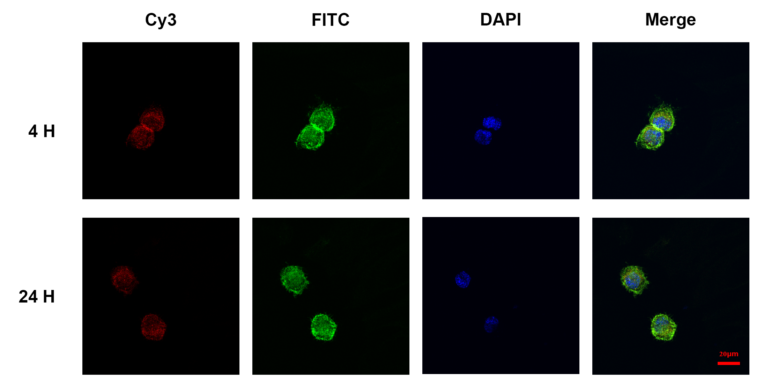
Supplementary Figure 2. The fluorescent staining images of vinculin (Red), F-actin (Green) and nuclei (Blue) showing the DC adhesion states on tissue culture plates at 4 h and 24 h.
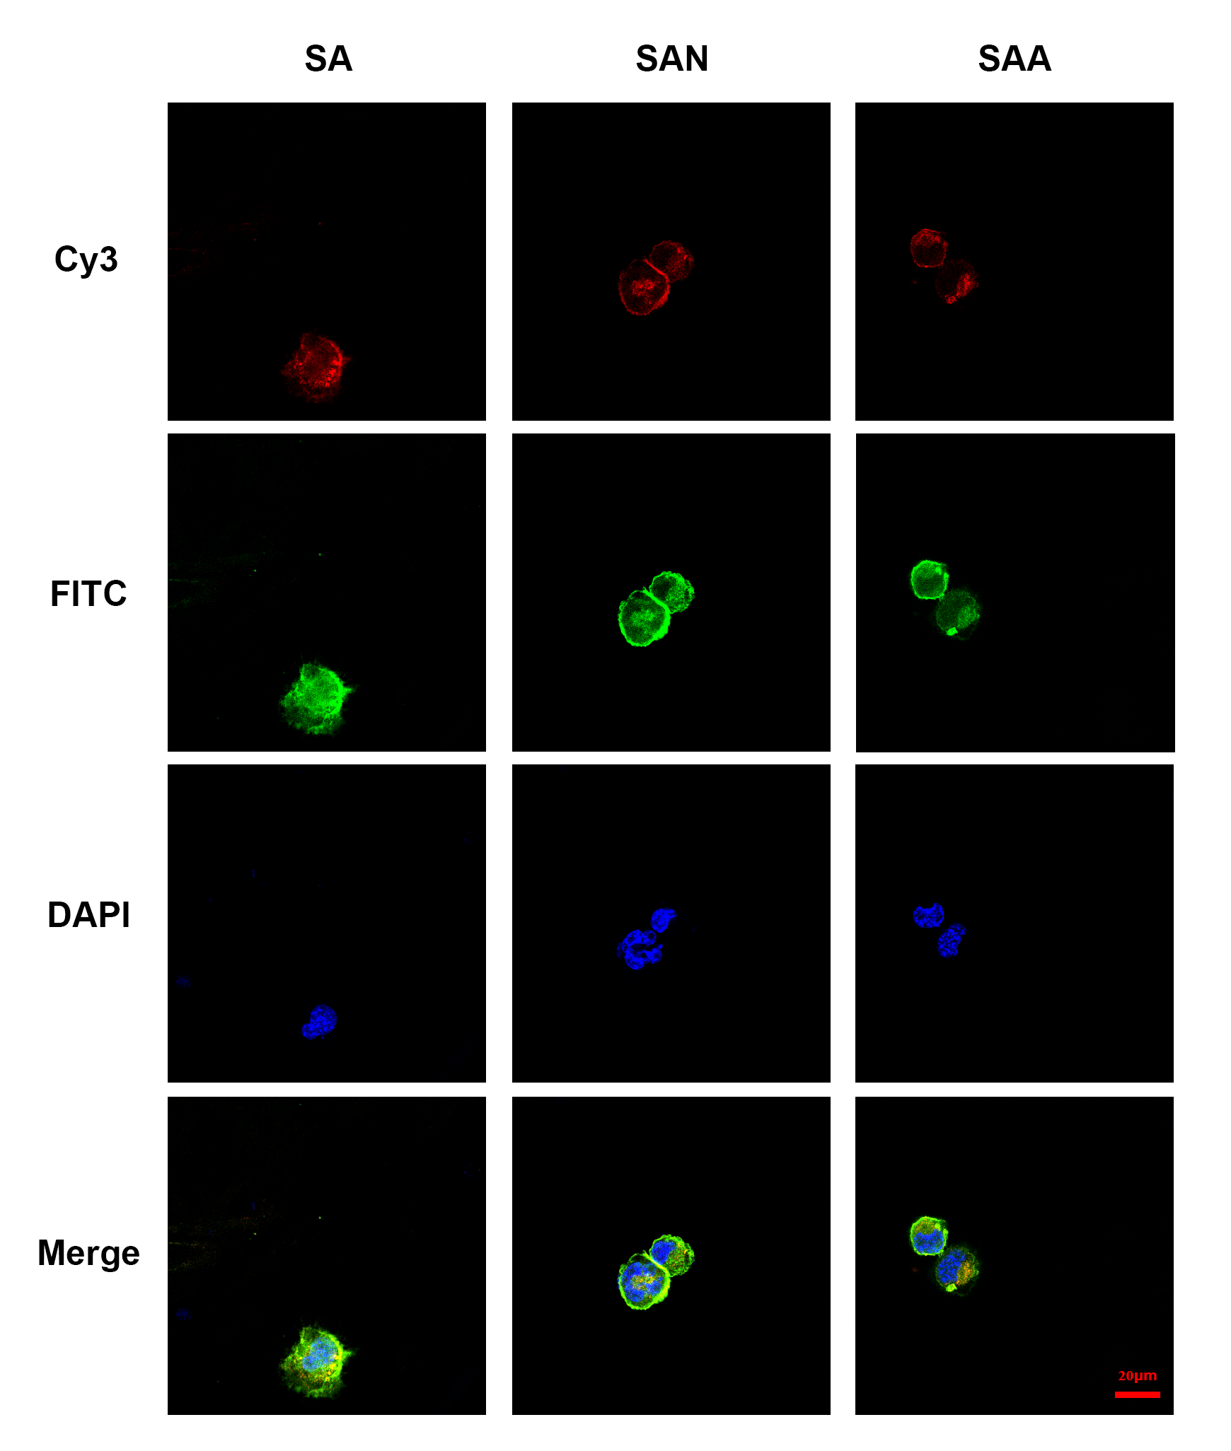
Supplementary Figure 3. The fluorescent staining images of vinculin (Red), F-actin (Green) and nuclei (Blue) showing the DC adhesion states on different titanium surfaces at 4 h.
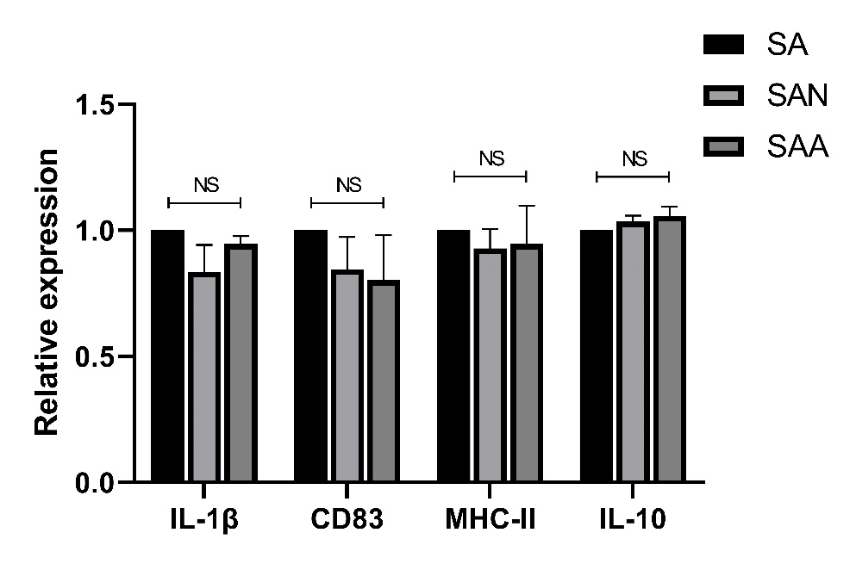
Supplementary Figure 4. The expression of maturation-related genes IL-1β, CD83, MHC-II and IL-10 at 4 h in DCs cultured on different titanium surfaces. NS= not significant.

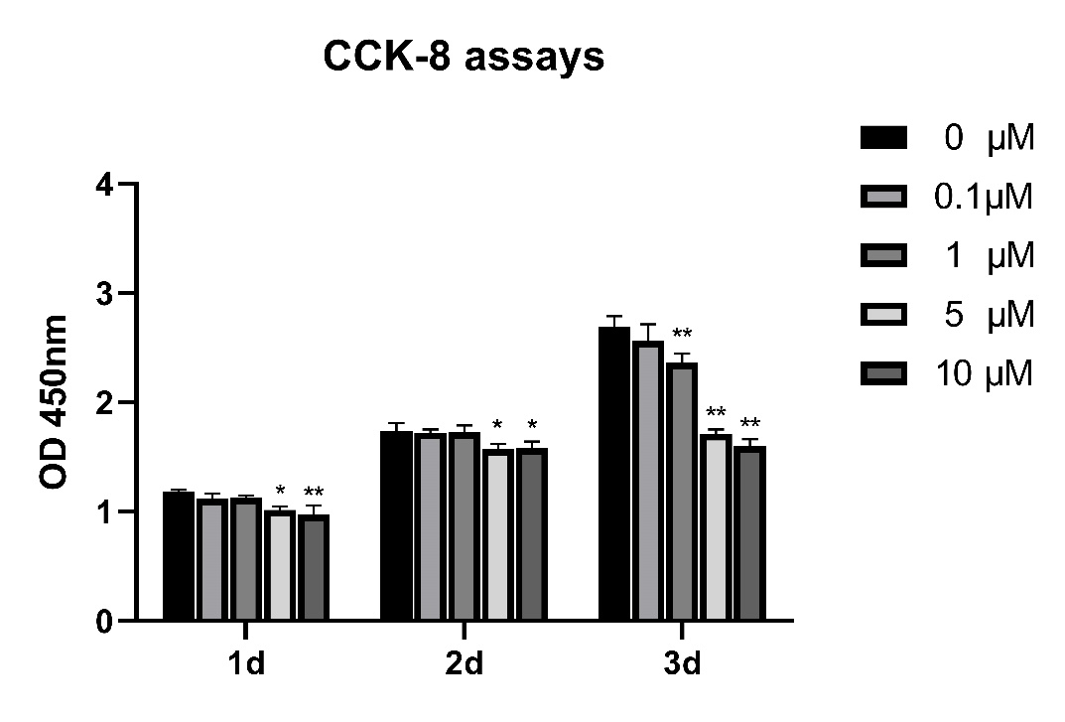
Supplementary Figure 5. Effects of different concentrations of TAE226 on DCs proliferative activity tested by CCK-8 assays at different time points. ⁎P<0.05, ⁎⁎P<0.01 compared with 0μM group.

Supplementary Figure 6. The CD80 expression of DCs at 24h with or without TAE226 analyzed by flow cytometry.

