Supporting information
M1 macrophage derived sono-responsive nanoparticles for sonodynamic anticancer therapy
Sijie Chen ^{1,2}, Jiahao Wang ^{3,4,5,6}, Haiqin Liao ^{1,2}, Kui Tang ^{1,2}, Yan Xu ^{1,2}, Long Wang ^{3,4,5,6}, Chengcheng Niu ^{1,2} *
¹ Department of Ultrasound Diagnosis, The Second Xiangya Hospital, Central South University, Changsha, 410011, China
² Research Center of Ultrasonography, The Second Xiangya Hospital, Central South University, Changsha, 410011, China
³ Department of Orthopedics, Xiangya Hospital, Central South University, Changsha, 410008, China
⁴ Hunan Engineering Research Center of Biomedical Metal and Ceramic Implants, Xiangya Hospital, Central South University, Changsha, China
⁵ National Clinical Research Center for Geriatric Disorders, Xiangya Hospital, Central South University, Changsha, China
⁶ Hunan key laboratary of aging biology, Xiangya Hospital, Central South University, Changsha, China
*Address all correspondence to: Chengcheng Niu, Department of Ultrasound Diagnosis and Research Center of Ultrasonography, The Second Xiangya Hospital, Central South University, Changsha, China, 410011; E-mail: niuchengcheng@csu.edu.cn
Figure S1. UV-vis-NIR absorption spectra of free IR780 and M1/IR780@PLGA nanoparticles.

Figure S2. The standard curve of IR780.

Figure S3. Size distributions of M1/IR780@PLGA nanoparticles in 1×PBS or 10% FBS for 7 days.

Figure S4. Zeta potential distributions of M1/IR780@PLGA nanoparticles in 1×PBS or 10% FBS for 7 days.

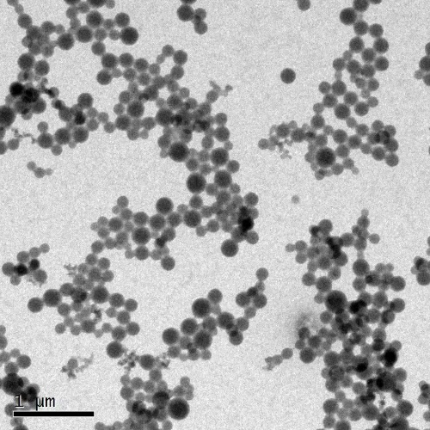
Figure S5. TEM image of nanocarbon labeled nanoparticles.

Figure S6. Changes of mice body weight during different treatments.
Table S1. Primers used for quantitative real-time polymerase chain reaction.
CD86-F | TCTCCACGGAAACAGCATCT
CD86-R | CTTACGGAAGCACCCACGAT
iNOS-F | CAGCTGGGCTGTACAAACCTT
iNOS-R | CATTGGAAGTGAAGCGTTTCG
TNF–α-F | AGCCGATGGGTTGTACCTTG
TNF–α-R | ATAGCAAATCGGCTGACGGT

