APPENDIX
A. Participant Information Sheet
B. Consent form
C. Pre mock OSCE survey
D. Post mock OSCE survey

APPENDIX A.: Participant Information Sheet
Participant Information Sheet For Year 5 Medical Students
Approval ID Number: 20567/001

YOU WILL BE GIVEN A COPY OF THIS INFORMATION SHEET

Title of Study: Assessing the impact of virtual OSCEs on student medical education
__________________________________________________________________________
Department: Medical School

Name and Contact Details of the Researcher(s):

Name and Contact Details of the Principal Researcher:

Rima Chakrabarti
r.chakrabarti@ucl.ac.uk

- Invitation Paragraph

Dear Year 5 students,

You are being invited to take part in a research project, looking at how we can use Virtual Mock OSCEs to aid student learning. Before you decided it is important for you to understand why the research us being done and what participation will involve. Please take time to read the following information carefully and discuss it with others if you wish. Ask us if there is anything that is not clear or if you would like more information. Take time to decide whether or not you wish to take part. Thank you for reading this.’
.

- What is the project’s purpose?

A recent UCL wide survey identified that many of you had felt that your clinical skills had been significantly affected as a result of the pandemic. It was also clear that many felt worried about the impact this may have on your performance at your summative exams. RUMs, Medsoc and Surgsoc have therefore collaborated together to design virtual mock OSCES to provide you with an opportunity to be supervised and gain feedback on certain clinical skills. However, as this is a new format of doing OSCEs, we are conducting a piece of Action Research study to identify how well this works, with the potential for extending this to other clinical years.

The project will gather data through online surveys, which will be anonymised. Your participation is voluntary but as this study is using online surveys, your responses cannot be withdrawn once completed.

There will be two surveys, before and after the mock OSCEs and the links will be live for 2 weeks before and after the OSCEs.

- Why have I been chosen?

All Year 5 students participating in the Virtual Mock OSCEs are eligible for this study.

- Do I have to take part?

Your participation in the study is entirely voluntary and will not affect your ability to take part in the Virtual Mock OSCES or the feedback you receive as part of the session. However, once the online survey is completed, this cannot be withdrawn.

- What will happen to me if I take part?

There should be no effect to you for taking part, as all data is being gathered online through your responses before and after the Virtual mock OSCES.

- What are the possible disadvantages and risks of taking part?

The online surveys will not gather any identifiable or personal data, to ensure anonymity of all participants. We do not anticipate any risks in taking part in this study.

- What are the possible benefits of taking part?

Whilst this format of running OSCEs is novel, your responses in the online survey will help to guide us on whether they can be implemented for all clinical years. It will also enable us to identify how helpful they have been and what we can do in the future to make them even better.

- What if something goes wrong?

If you have any issues regarding the online survey or any aspect of this research study, you can contact the Principal Researcher, Rima Chakrabarti on r.chakrabarti@ucl.ac.uk. In the event that the response you receive is not satisfactory, you can contact the Chair of the UCL Research Ethics Committee – ethics@ucl.ac.uk

- Will my taking part in this project be kept confidential?

All the information that we collect through the online survey during the course of the research study will be kept strictly confidential and will only be available to the Principal Researcher and the research team.

- Limits to confidentiality

Confidentiality will be respected unless there are compelling and legitimate reasons for this to be breached. If this was the case we would inform you of any decisions that might limit your confidentiality.

- What will happen to the results of the research project?
We aim to present the findings of our research to the Medical School with the plan of implementing this resource for following Academic Year 2021-2022. We also will be disseminating our findings in the wider domain through medical education conferences and publication. These findings will be available to all students at UCLMS and may also be used for additional or subsequent research.

- Local Data Protection Privacy Notice

Notice:
The controller for this project will be University College London (UCL). The UCL Data Protection Officer provides oversight of UCL activities involving the processing of personal data, and can be contacted at data-protection@ucl.ac.uk

This ‘local’ privacy notice sets out the information that applies to this particular study. Further information on how UCL uses participant information can be found in our ‘general’ privacy notice:

For participants in research studies, click here

The information that is required to be provided to participants under data protection legislation (GDPR and DPA 2018) is provided across both the ‘local’ and ‘general’ privacy notices.

No categories of personal data used will be collected as part of this study.

- Who is organising and funding the research?

This research has been organised by RUMS, UCL Medical and UCL Surgical Society

This project received £500 of funding from the Student Quality Improvement and Development fund (SQUID) at UCL, which will be evenly distributed among the students/doctors who volunteer to run the stations at the OSCEs only.

You should state the organisation or company that is sponsoring or funding the research.

16. Contact for further information

Rima Chakrabarti
r.chakrabarti@ucl.ac.uk

You should give the participant a contact point for further information. This can be your name,

Thank you for reading this information sheet and for considering to take part in this research study.

APPENDIX B: Consent form
Virtual mock pre-OSCE Survey Consent form
By filling in this form, I agree to take part in a 5th year virtual mock OSCE organised by UCL medical students, written by qualified doctors and approved by the UCLMS Assessment Unit.
Upon completion, I consent to the use of my response data for this survey for the purposes of research, analysis and publication.
Tick Box

Virtual mock post-OSCE Survey Consent form
By filling in this form, I consent to the use of my response data for the purposes of research, analysis and publication.
Tick Box

APPENDIX C: Pre mock OSCE survey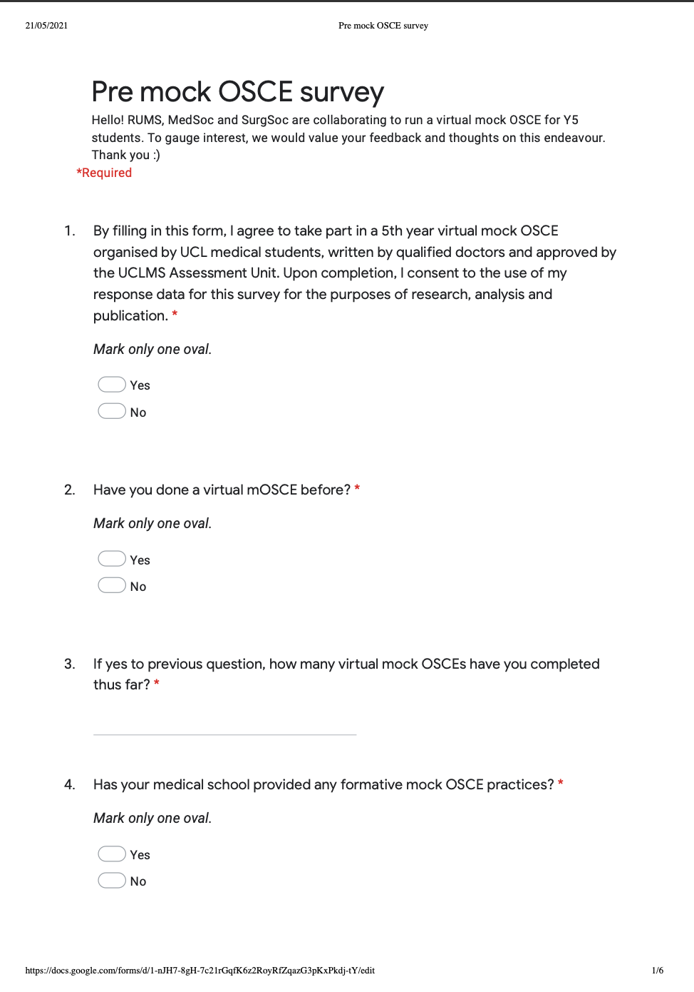
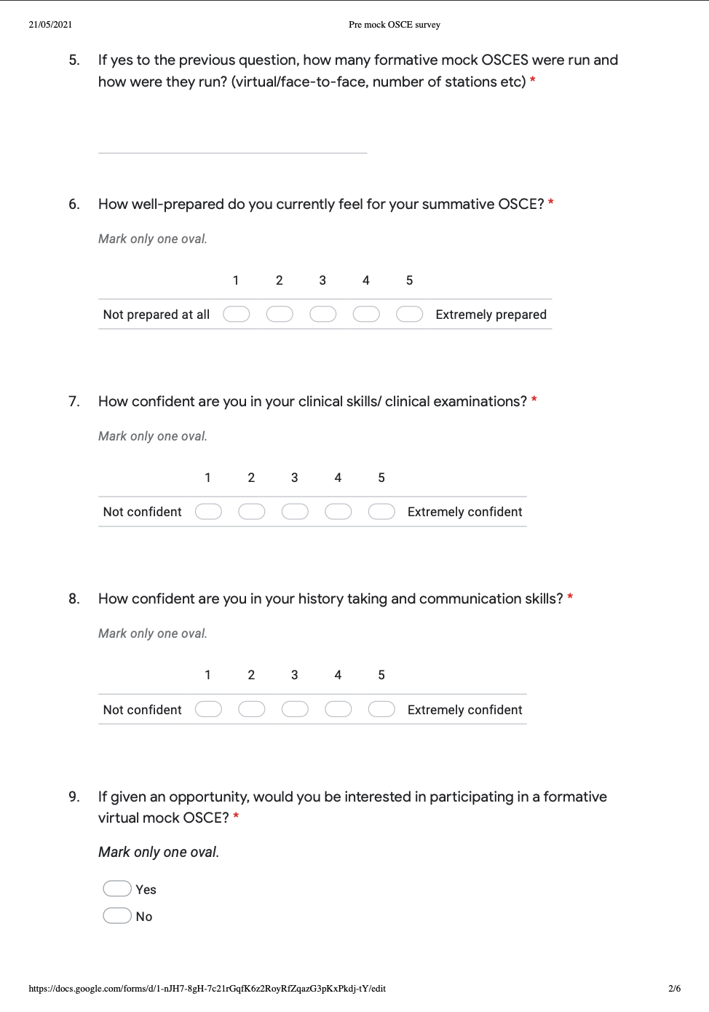
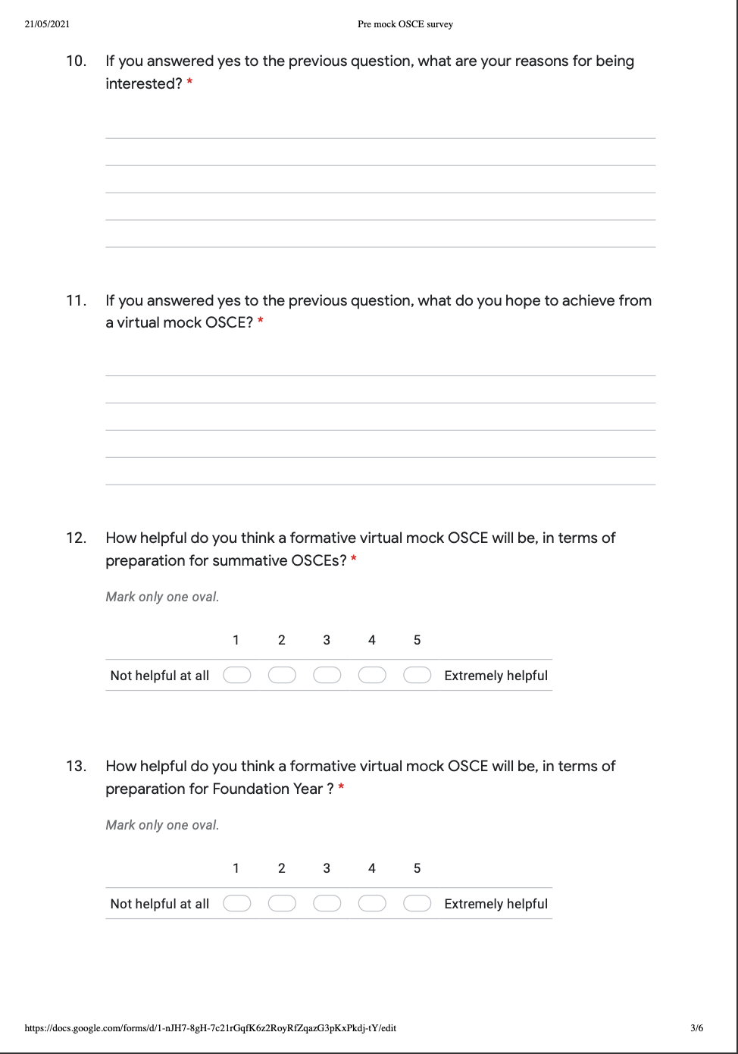
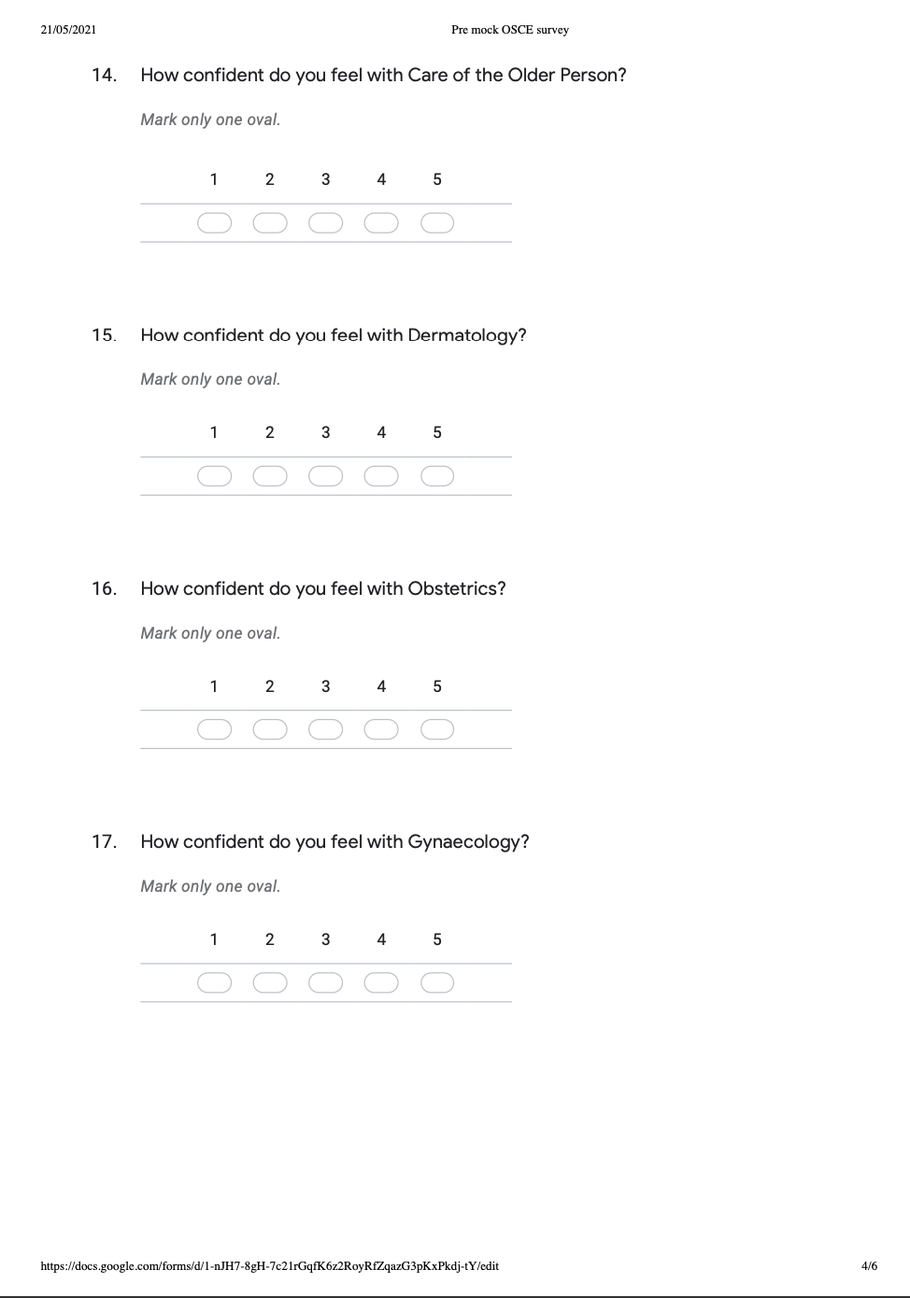
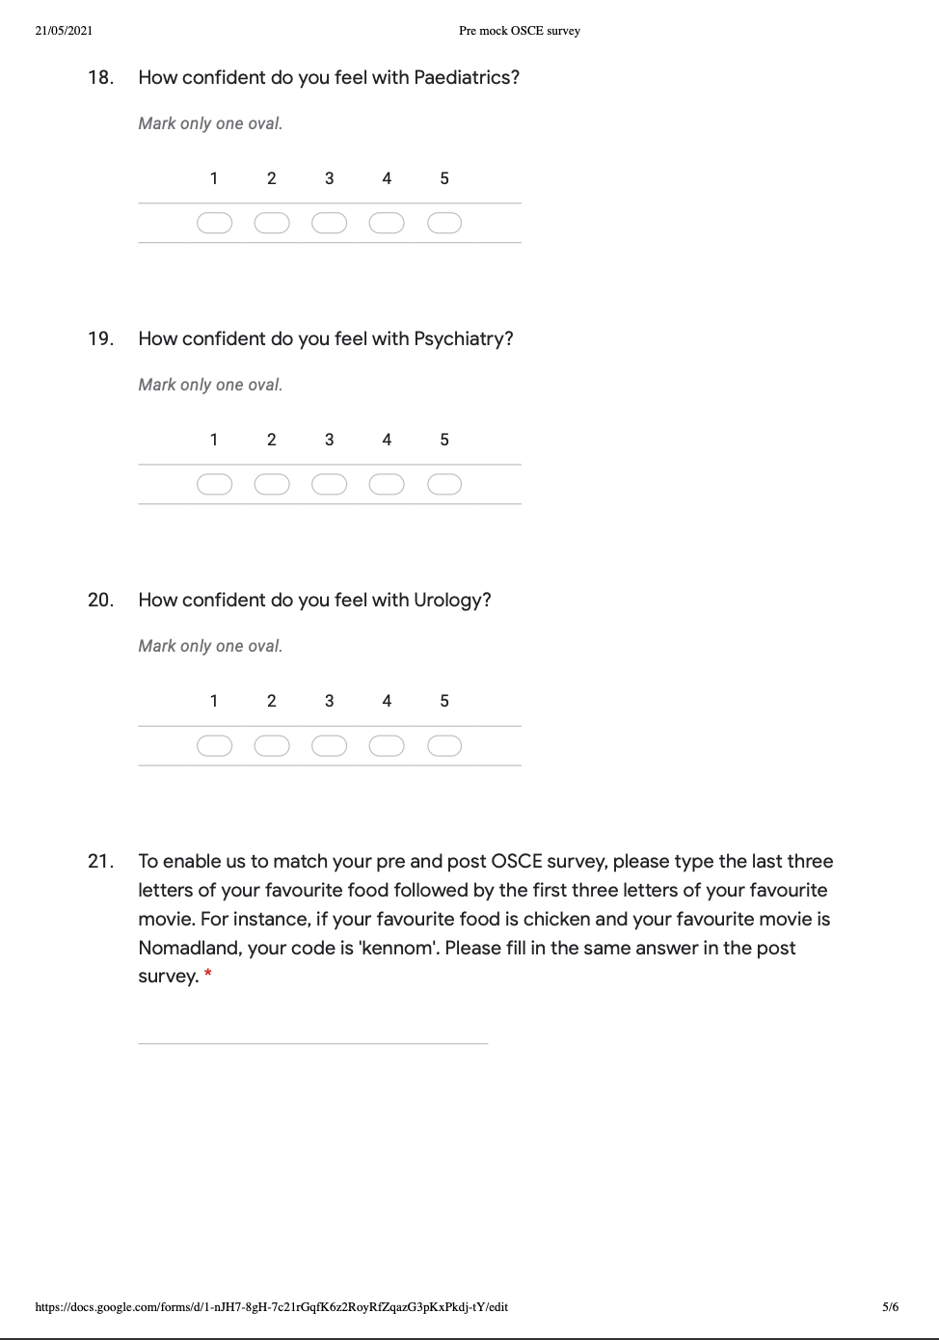
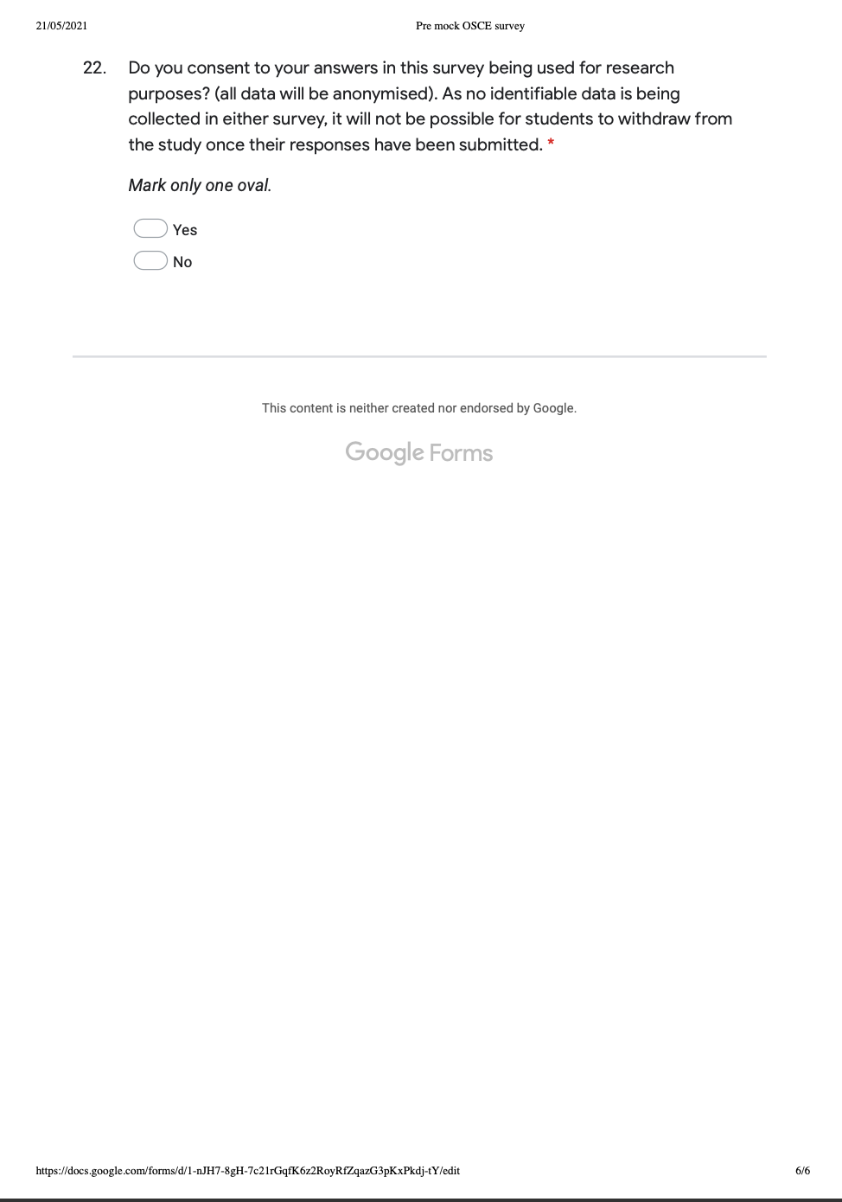
APPENDIX D: Post mock OSCE survey
