ORIGINAL RESEARCH, [Mohammad Golriz] et al
Supplementary Material
Prognostic value of red blood cell distribution width (RDW) in the recurrence of hepatocellular carcinoma following curative resection
Mohammad Golriz^{1,2}, Ali Ramouz¹, Sadeq Ali-Hasan-Al-Saegh¹, Saeed Shafiei¹, Ehsan Aminizadeh¹, Ahmed Hammad¹, Markus Mieth¹, Christian Rupp^{2,3}, Christoph Springfeld^{2,4}, Katrin Hoffmann^{1,2}, Markus Büchler¹, Arianeb Mehrabi^{1,2}

¹ Department of General, Visceral and Transplantation Surgery, Heidelberg University Hospital, Heidelberg, Baden-Württemberg, Germany
² Liver Cancer Center Heidelberg (LCCH), Heidelberg University Hospital, Heidelberg, Baden-Württemberg, Germany
³ Department of Internal Medicine IV, Gastroenterology & Hepatology, Heidelberg University Hospital, Heidelberg, Baden-Württemberg, Germany
⁴ National Center for Tumor Diseases, Department of Medical Oncology, Heidelberg University Hospital, Heidelberg, Baden-Württemberg, Germany

Correspondence to:
Prof. Dr. med. Arianeb Mehrabi, MD, FICS, FEBS, FACS
Head of the Division of Liver Surgery,
Department of General, Visceral, and Transplantation Surgery,
Heidelberg University Hospital, Im Neuenheimer Feld 420,
69120 Heidelberg, Germany
E-Mail: arianeb.mehrabi@med.uni-heidelberg.de
Telephone: 0049 – 6221 – 5636223
Fax: 0049 – 6221 – 567470

Type of article: Original article

Propensity score matching was carried out between two groups of patients based on the RDW levels at different time points. The 3-year RFS was compared between patients considering the above-mentioned cutoff values defined for each checkpoint. Albeit non-significant, the rate of 3-year disease-free survival was higher among patients with RDW levels of ≤14.25% compared to that of patients with RDW levels of >14.25% (P= 0.150) (Figure S1). However, the RFS of patients with RDW ≤16.15% was still significantly higher than that of patients with higher RDW levels (P= 0.033) (Figure S2). Also, at 12th month postoperative, patients with RDW levels of ≤15.85 had significantly higher rate of RFS compared to patients with RDW >15.85 (P= 0.005) (Figure S3).

Figure S1. Kaplan–Meier RFS curves of HCC patients after liver resection after propensity score matching of patients with preoperative level of RDW ≤ 14.25% and preoperative level of RDW > 14.25%.
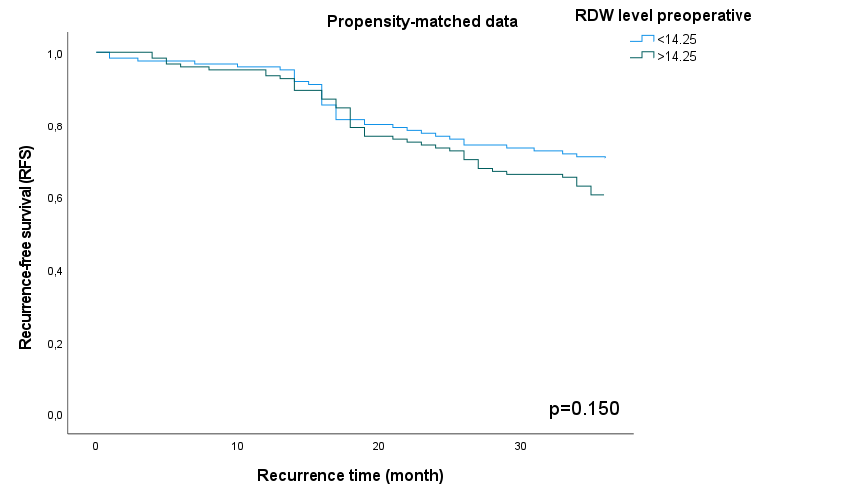

Figure S2. Kaplan–Meier RFS curves of HCC patients after liver resection after propensity score matching of patients with level of RDW ≤ 16.15% and > 16.15%.
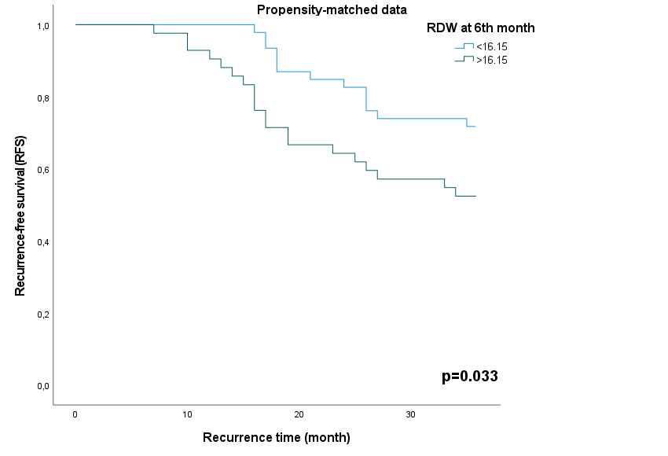

Figure S3. Kaplan–Meier RFS curves of HCC patients after liver resection after propensity score matching of patients with level of RDW ≤ 15.85% and > 15.85%.
