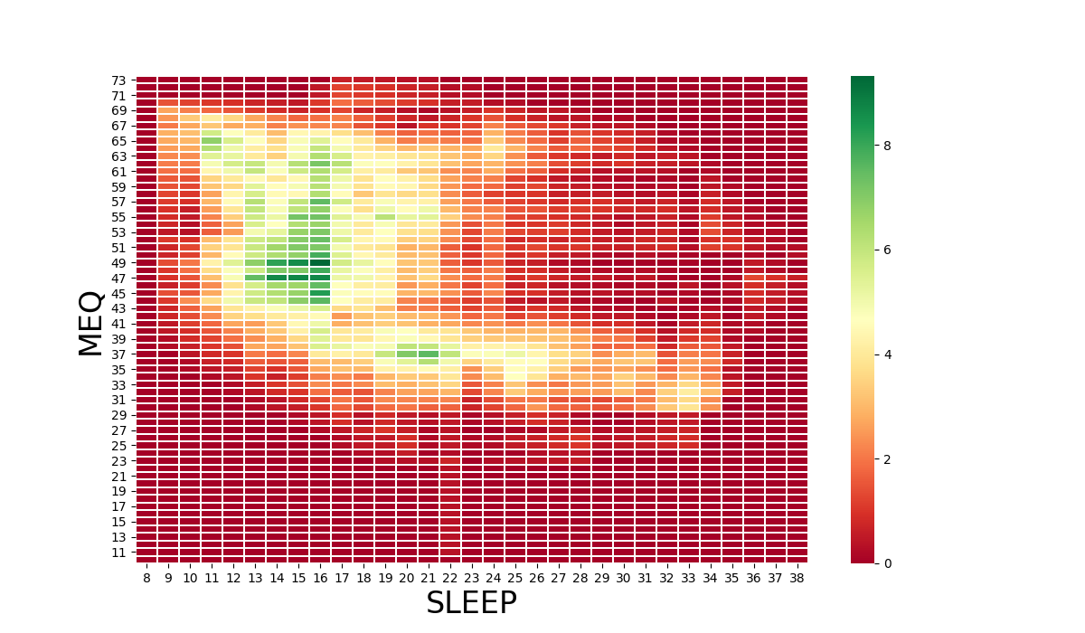
A)

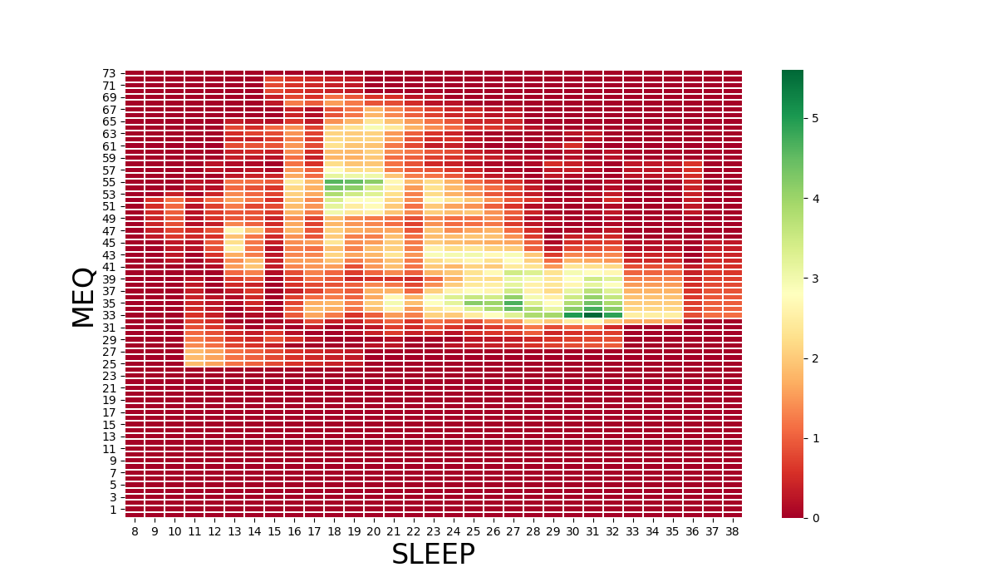
B)

Supplementary Figure 1: Heat Map of Sleep Disturbance Scores and Diurnal Preference (MEQ) by sex. A) Females with higher MEQ scores indicative of morning preference are strongly associated with low sleep disturbance scores. B) Males with lower MEQ scores indicative of evening preference are associated with higher sleep disturbance scores. The heatmaps were made using Fisher’s Exact Test at varying cutoff levels for both dependent and independent variables. Fisher’s Exact Test shows significant association between high sleep disturbance scores (25+) and evening type individuals (MEQ<41). The p-values obtained from the analysis were log-transformed (base 10).

