Title: Using Machine Learning to Predict the Likelihood and Cause of Readmission after Hospitalization for Chronic Obstructive Pulmonary Disease Exacerbation

Running Title: Machine Learning to Predict COPD Readmission

Authors: ¹Bonomo Matthew*, ¹Hermsen Michael*, ¹Kaskovich Samuel, ¹Hemmrich Maximilian, ²Rojas Juan C, ³Carey Kyle, ⁴Venable Laura Ruth, ⁵Churpek Matthew M, ^{3,6}Press Valerie G

*contributed equally

Online Supplement

Supplemental Figure 1. Calibration curve for 90-day readmission risk model
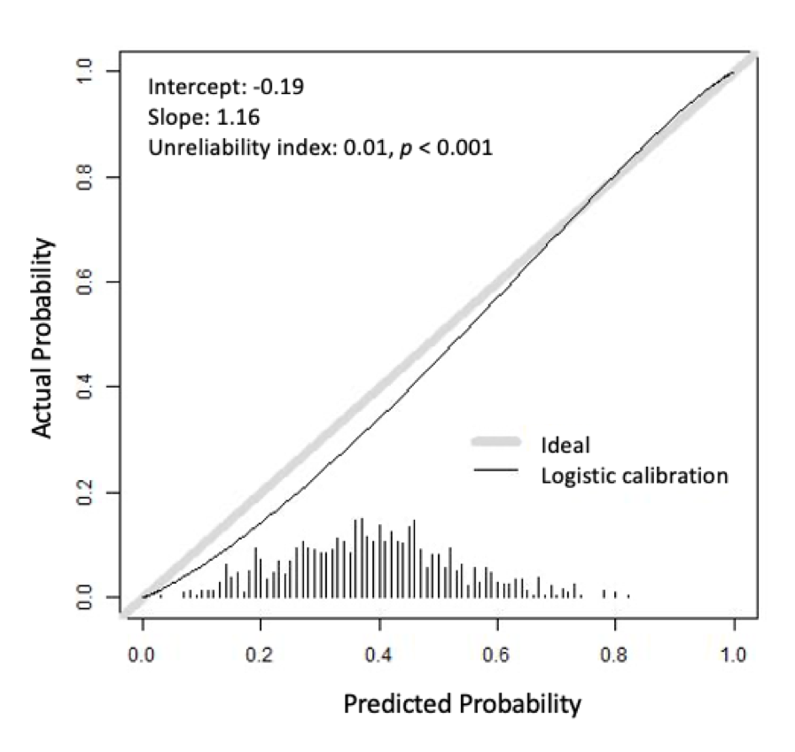

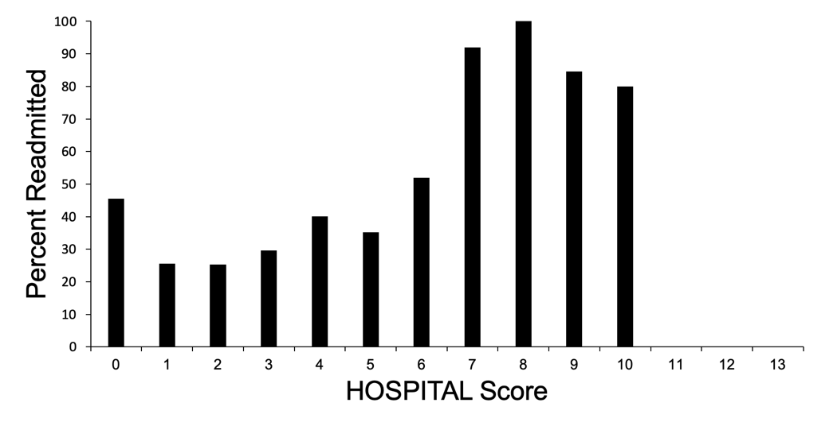
Supplemental Figure 2. Calibration curve for HOSPITAL score in predicting 90-day readmissions

Legend: There were no patients with HOSPITAL scores of 11 or higher.

Supplemental Figure 3. Calibration curve for 90-day readmission cause model
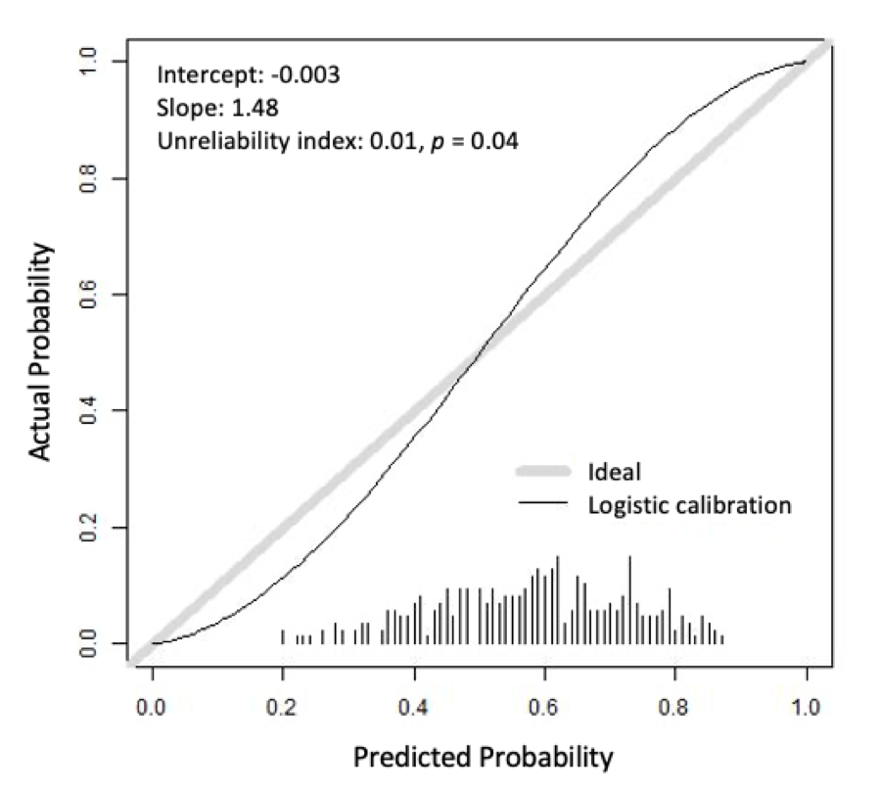

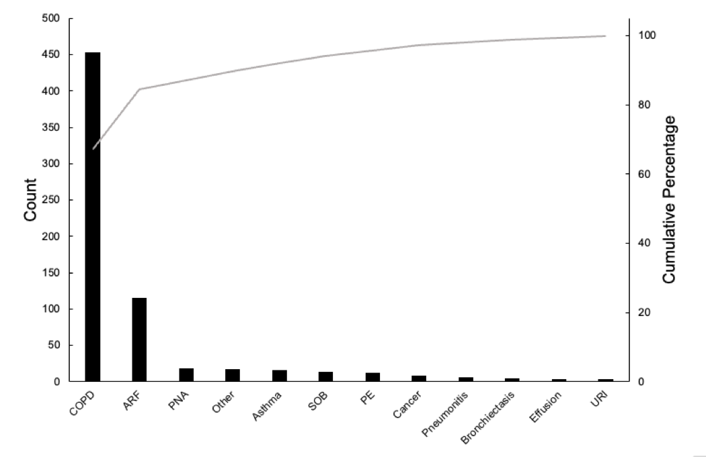
Supplemental Figure 4. Pareto Chart for Respiratory Readmission Diagnoses

Legend: Categories modified from those in similar prior work by Shah, et al.⁶

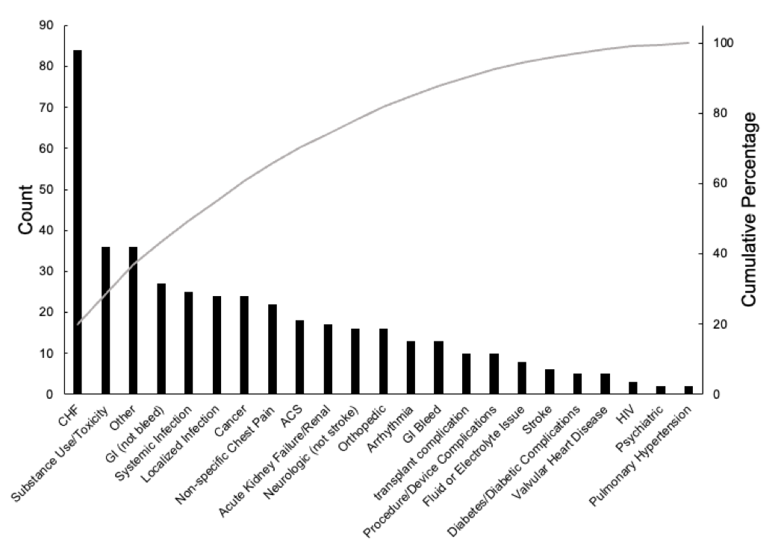
Supplemental Figure 5. Pareto Chart for Non-respiratory Readmission Diagnoses

Legend: Categories modified from those in similar prior work by Shah, et al.⁶

