Supporting Information
Multifunctional nanosnowflakes for T1-T2 double-contrast enhanced MRI and PAI guided Oxygen self-supplementing effective anti-tumor therapy
Yijie Lv¹, Junnan Kan¹, Mingfang Luo², Changfeng Yang¹, Xunrong Luo², Xiaoqian Lin¹, Hao Li¹, Xueming Li¹, Yuping Li¹, Caixia Yang¹, Yan Liu¹*, Xianglin Li¹*
1Author affiliations
School of Medical Imaging, Binzhou Medical University, Yantai, Shandong, 264003, P. R. China.
2Author affiliations
Department of Radiology, Sichuan Provincial People's Hospital, Chengdu, Sichuan, 610072, P. R. China.
Email: xlli@bzmc.edu.cn

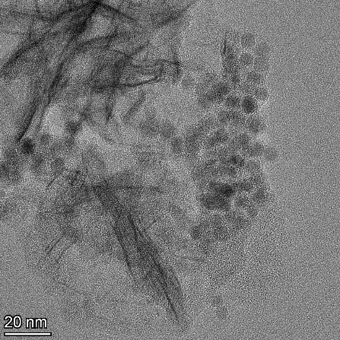

Figure S1. The HRTEM image of UMC.

Figure S2. The EDS analysis of UMC.

Figure S3. Digital image of UMC in different solutions.

Figure S4. The size of UMC dispersed in water, DMEM and FBS.
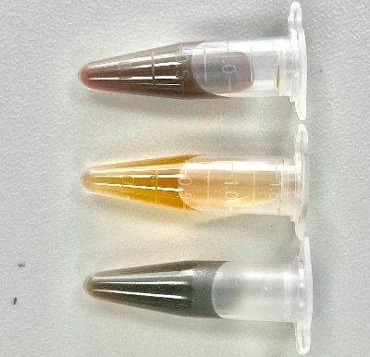
Figure S5. Digital image changes of (a) MnO₂, (b) USPIO, and (c) UMC after reaction with H₂O₂ solution (0 μM), respectively.

Figure S6. Measurement of particle size and PDI changes for UMC within seven days by DLS.
Figure S7. XPS spectrum of UMC: (A) C, (B) N, (C) O, (D) Fe, and (E) Mn.

Figure S8. UV-vis absorption of Ce6 at different concentrations and the standard curve equation of Ce6.
Figure S9. Cell viability inﬂuenced by free Ce6 with laser (20 mW/cm², 3 min) in normal and hypoxic conditions.

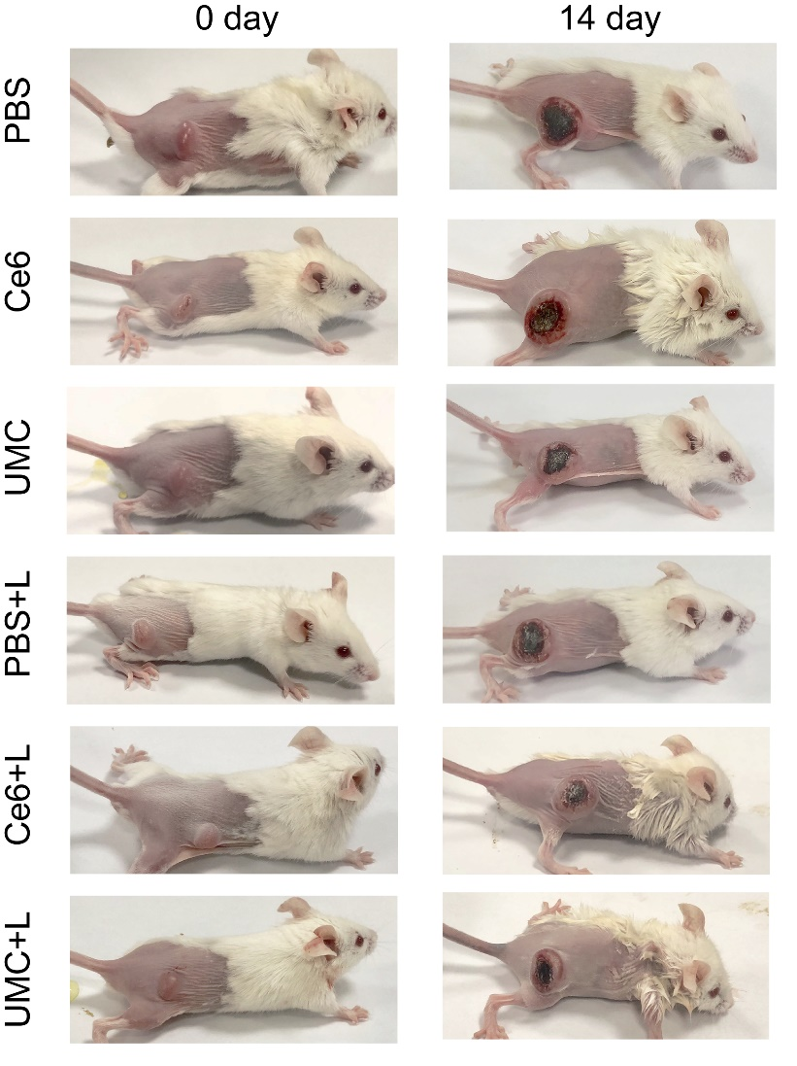
Figure S10. Photographs of mice in different treatment groups before and after treatment.

