Supplementary materials
Antidepressant fill and dose trajectories in pregnant women with depression and/or anxiety: a Norwegian registry linkage study
APPENDICES
Appendix 1. Supplemental information on PRE2DUP method
Appendix 2. Maternal characteristics investigated in the study
Table S1. Characteristics of pregnancies, overall and by antidepressant fill/dose trajectories, Norway, 2009–2018 (8,460 pregnancies)
Table S2. Association (relative risk ratio) between maternal characteristics and antidepressant fill trajectory, Norway, 2009–2018 (7,204 pregnancies)
Figure S1. Trajectories of antidepressant prescription fill in pregnant women with depression/anxiety using longitudinal k-means trajectory modelling on antidepressant exposure by week (2009-2018, n=8,460 pregnancies): grace period = 30 days
Figure S2. Trajectories of antidepressant prescription fill in pregnant women with depression/anxiety using longitudinal k-means trajectory modelling on antidepressant exposure by week (2009-2018, n=8,460 pregnancies): different assumption of daily dose
Figure S3. Trajectories of antidepressant prescription fill in pregnant women with depression/anxiety using longitudinal k-means trajectory modelling on antidepressant exposure by week (2009-2018, n=8,092 pregnancies): analyses restricted to first pregnancy in the cohort
Figure S4. Trajectories of antidepressant prescription fill in pregnant women with depression/anxiety using longitudinal k-means trajectory modelling on antidepressant exposure by week (2009-2018, n=10,317 pregnancies): look-back time window=one year
Figure S5. Trajectories of antidepressant prescription fill in pregnant women with depression/anxiety using group-based trajectory modelling on antidepressant exposure by week (2009-2018, n=8,460 pregnancies)

Appendix 1. Supplemental information on PRE2DUP method
The expected duration of treatment of each dispensation is not available in the registry data and was calculated using a decision procedure based on packaging properties (i.e., dosage form and number of divisible units, e.g., tablet or one millilitre of solution), number of dispensed DDDs, and personal purchasing behaviour. The start and end date of each dispensation is calculated from the dispensing date and the expected duration of treatment.
The expected durations of treatment of all lines, where a line corresponds to the dispensation of a unique medicinal product on a specific date to each individual, were first assigned the number of dispensed DDDs assuming consumption of one DDD per day. Based on a simplified form of the PRE2DUP method, we proceeded as follows: If the unit strength > DDD, the expected duration of treatment was replaced by the number of units. If the unit strength < DDD, the expected duration of treatment remains the number of dispensed DDDs if the potential daily dose cannot be re-defined by (i) reviewing local clinical guidelines, and/or (ii) using packaging parameters, and/or (iii) reviewing leaflet information, and/or (iv) using expected duration of treatment of possible concomitant antidepressant. If the potential daily dose can be defined from one of the above-mentioned strategies, the expected duration of treatment was replaced by number of dispensed DDDs*DDD/potential daily dose (e.g., dispensation of 1 package mianserin (DDD=60mg) 30 tablets 40mg having expected duration of treatment =30 days instead of 20 days). The maximum expected duration of treatment for each dispensation is set to 150 days to avoid possible duplicated dispensations as done in PRE2DUP method.

Appendix 2. Maternal characteristics investigated in the study
We assessed maternal sociodemographic factors (i.e., maternal age at delivery, parity, and marital status), and factors related to pregnancy and reproductive history (i.e., multiple pregnancies, obstetric risk factors before pregnancy, previous pregnancy loss, smoking before pregnancy, and pregnancy planning). Obstetric risk factors were measured by the obstetric comorbidity index adapted from Bateman et al, limited to conditions before pregnancy (e.g. chronic hypertension, chronic renal disease).²³
Co-medications (extracted from NorPD) with opioid analgesics (ATC code N02A), antiepileptics (ATC code N03A), antipsychotics (ATC code N05A), benzodiazepine/z-hypnotics (ATC codes: N05BA, N05CD, N05CF), and psychostimulants (N06B) and comorbidities (extracted from KUHR) with other psychiatric conditions, eating disorders, bipolar disorders, and thyroid disorders in the six months before pregnancy were also investigated. Comorbidities were measured in six months prior to pregnancy using diagnosis with: ICD-10 codes starting with F50 and ICPC-2 codes starting with P86 for eating disorders; ICD-10 codes starting with F31 and ICPC-2 codes starting with P73 for bipolar disorders; ICD-10 codes starting with E039 and ICPC-2 codes starting with T86 thyroid disorders; and ICD-10 codes starting with F and ICPD-2 codes starting with P except for those indicating depression/anxiety for other psychiatric conditions.
Pregnancy planning may be related to medication utilization. Pregnancies classified as potentially planned had at least one of the following proxies:
- reporting use of folic acid before pregnancy (extract from MBRN)
- filling clomiphene (ATC code G03GB02) prescriptions within the six months before pregnancy (extract from NorPD)
- discontinuing hormonal contraception for systemic use (ATC code G03A, excluding contraceptive patches, G03AA13, injections, G03AC06, implants, G03AC08, and emergency contraceptives, G03AD) in the six months before pregnancy (extract from NorPD)
- having preconception encounters in hospital (ICD-10 Z30.432: Encounter for removal of intrauterine contraceptive device, extract from NPR).
Antidepressant treatments are more likely to be discontinued in patients with a lower severity of mental health condition when they enter their course of pregnancy.²⁴ Pregnancies with at least one of the following proxies in the year prior to pregnancy were classified as high severity:
- at least one psychiatric inpatient stay or outpatient specialist encounter with a psychiatric diagnosis (diagnoses with ICD-10: F01-F99 except for F32, F33, F40, F41) or deliberate self-harm diagnoses (ICD-10: X71-X83) as registered in NPR;
- having filled prescriptions for other nervous system drugs (ATC code N except N06 registered in NorPD).

Table S1. Characteristics of pregnancies, overall and by antidepressant dose trajectories, Norway, 2009–2018 (8,460 pregnancies)
 | Study population  N (%) | Antidepressant dose trajectory
Characteristic | Study population  N (%) | Trajectory A  Low dose - discontinuing  N=5,102 | Trajectory B  Medium dose – reducing  N=2,439 | Trajectory C  High dose - continuing  N=919
Year of delivery
2009-2013 | 4,373 (51.7) | 2,701 (52.9) | 1,230 (50.4) | 442 (48.1)
2014-2018 | 4,087 (48.3) | 2,401 (47.1) | 1,209 (49.6) | 477 (51.9)
Maternal age
≤24 years | 1,673 (19.8) | 1,172 (23.0) | 398 (16.3) | 103 (11.2)
25-29 years | 2,587(30.6) | 1,582 (31.0) | 728 (29.9) | 277 (30.1)
30-34 years | 2,521 (29.8) | 1,431 (28.1) | 772 (31.7) | 318 (34.6)
≥35 years | 1,679 (19.9) | 917 (18.0) | 541 (22.2) | 221 (24.1)
Marital status
Married/cohabiting | 7,167 (84.7) | 4,290 (84.1) | 2,073 (85.0) | 804 (87.5)
Other | 1,293 (15.3) | 812 (15.9) | 366 (15.0) | 115 (12.5)
Parity
0 | 3,896 (46.1) | 2,403 (47.1) | 1,106 (45.4) | 387 (42.1)
1 | 4,564 (53.9) | 2,699 (52.9) | 1,333 (54.7) | 532 (57.9)
Plurality
Singleton | 8,338 (98.6) | 5,028 (98.6) | 2,404 (98.6) | 906 (98.6)
Multiple | 122 (1.4) | 74 (1.4) | 45 (1.4) | 13 (1.4)
Obstetric index⸸
0 | 5,342 (63.1) | 3,328 (65.2) | 1,488 (61.0) | 526 (57.2)
1 | 1,997 (23.6) | 1,146 (22.5) | 608 (24.9) | 243 (26.4)
≥ 2 | 1,121 (13.3) | 628 (12.3) | 343 (14.1) | 150 (16.3)
Previous miscarriage or stillbirth
Yes | 2,329 (27.5) | 1,438 (28.2) | 623 (25.5) | 268 (29.2)
No | 6,131 (72.5) | 3,664 (71.8) | 1,816 (74.5) | 651 (70.8)
Smoking before pregnancy
Missing | 1,256 (14.9) | 775 (15.2) | 358 (14.7) | 123 (13.4)
Yes | 2,180 (25.8) | 1,307 (25.6) | 637 (26.1) | 236 (25.7)
No | 5,024 (59.4) | 3,020 (59.2) | 1,444 (59.2) | 560 (60.9)
Pregnancy planning⸸⸸
Potentially yes | 3,063 (36.2) | 1.825 (35.8) | 910 (37.3) | 328 (35.7)
Potentially no | 5,397 (63.8) | 3,277 (64.2) | 1,529 (62.7) | 591 (64.3)
Severity of depression/anxiety in six months before pregnancy⸸⸸⸸
High | 4,696 (55.5) | 2,720 (53.3) | 1,405 (57.6) | 571 (62.1)
Low | 3,764 (44.5) | 2,382 (46.7) | 1,034 (42.4) | 348 (37.9)
Comorbidity in six months before pregnancy
Other psychiatric conditions than depression and/or anxiety | 3,180 (37.6) | 1,879 (36.8) | 924 (37.9) | 377 (41.0)
Eating disorders | 227 (2.7) | 117 (2.3) | 70 (2.9) | 40 (4.4)
Bipolar disorders | 224 (2.7) | 103 (2.0) | 81 (3.3) | 40 (4.4)
Thyroid disorders | 199 (2.3) | 119 (2.3) | 57 (2.3) | 23 (2.5)
Comedication in six months before pregnancy
Opioid analgesic | 1,102 (13.0) | 611 (12.0) | 343 (14.1) | 148 (16.1)
Antiepileptics | 474 (5.6) | 205 (4.0) | 168 (6.9) | 101 (11.0)
Antipsychotics | 784 (9.3) | 366 (7.2) | 286 (11.7) | 132 (14.4)
Psychostimulants | 169 (2.0) | 99 (1.9) | 48 (2.0) | 22 (2.4)
Benzodiazepines | 2,019 (23.9) | 1,105 (21.7) | 632 (25.9) | 282 (30.7)
Thyroid hormones | 365 (4.3) | 187 (3.7) | 118 (4.8) | 60 (6.5)
Treatment regimen in six months before pregnancy
Monotherapy | 7,921 (93.6) | 4,925 (96.5) | 2,212 (90.7) | 784 (85.3)
Polytherapy | 539 (6.4) | 177 (3.5) | 227 (9.3) | 135 (14.7)
Average dose in six months before pregnancy
<= 1 fluoxetine equivalent | 7,387 (87.3) | 5,045 (98.9) | 1,896 (77.7) | 446 (48.5)
>1 fluoxetine equivalent | 1,073 (12.7) | 57 (1.1) | 543 (22.3) | 473 (51.5)
Use of SSRI in the six months prior to pregnancy
Yes | 5,491 (76.2) | 3,200 (73.9) | 1,680 (80.7) | 611 (76.8)
No | 1,713 (23.8) | 1,127 (26.1) | 401 (19.3) | 185 (23.2)
⸸Adapted from Bateman et al., using the variables available in MBRN (age, asthma, pre-gestational diabetes, chronic hypertension, kidney disease, previous caesarean section, multiple gestation) and weighting the variables as done by Bateman et al.
⸸⸸Reporting use of folic acid before pregnancy (extract from MBRN), filling clomiphene (ATC code G03GB02) before pregnancy (extract from NorPD), discontinuing hormonal contraception for systemic use (ATC-code G03A, excluding contraceptive patches, G03AA13, injections, G03AC06, implants, G03AC08, and emergency contraceptives, G03AD) before pregnancy, having preconception encounters in hospital (ICD 10 – Z30: Encounter for contraceptive management).
⸸⸸⸸ Pregnancies with at least one of the following proxies in the year prior to pregnancy were classified as high severity: one or more psychiatric inpatient stay or outpatient specialist encounters with a psychiatric diagnosis (diagnoses with ICD-10: F01-F99 except for F32, F33, F40, F41) or deliberate self-harm diagnoses (ICD-10: X71-X83) as registered in NPR; having filled prescriptions for other nervous system drugs (ATC code N except N06 registered in NorPD)

Table S2. Association (relative risk ratio) between maternal characteristics and antidepressant fill trajectory, Norway, 2009–2018 (7,204 pregnancies)*
 | Multinomial logistic regression (unadjusted)
Characteristic | Late discontinuers  (vs. early discontinuers)  RRR (95% CI) | Continuers  (vs. early discontinuers)  RRR (95% CI) | Interrupters  (vs. early discontinuers)  RRR (95% CI) | Interrupters  (vs. late discontinuers)  RRR (95%CI)
Year of delivery | 1.02 (1.00; 1.04) | 1.05 (1.03; 1.08) | 1.01 (0.99; 1.04) | 0.99 (0.96; 1.01)
Maternal age | 1.01 (1.00; 1.02) | 1.06 (1.05; 1.08) | 1.04 (1.02; 1.05) | 1.03 (1.01; 1.04)
Married or cohabiting | 0.85 (0.72; 0.99) | 1.44 (1.18; 1.75) | 1.47 (1.18; 1.83) | 1.73 (1.40; 2.15)
Non-primiparous | 0.92 (0.82; 1.03) | 1.16 (1.02; 1.33) | 1.31 (1.13; 1.52) | 1.43 (1.23; 1.65)
Multiple birth | 0.64 (0.39; 1.05) | 0.64 (0.36; 1.14) | 0.68 (0.36; 1.28) | 1.06 (0.55; 2.07)
Obstetric index⸸ | 0.99 (0.83; 1.18) | 1.33 (1.10; 1.60) | 0.99 (0.80; 1.24) | 1.01 (0.81; 1.25)
Previous miscarriage or stillbirth | 0.72 (0.63; 0.81) | 0.84 (0.73; 0.97) | 0.82 (0.70; 0.96) | 1.15 (0.98; 1.35)
Smoking before pregnancy | 1.07 (0.94; 1.21) | 0.86 (0.74; 0.99) | 0.96 (0.82; 1.12) | 0.90 (0.77; 1.05)
Pregnancy planning⸸⸸ | 0.79 (0.70; 0.89) | 1.08 (0.95; 1.24) | 1.05 (0.91; 1.22) | 1.33 (1.15; 1.54)
High severity of depression/anxiety in six months before pregnancy⸸⸸⸸ | 1.13 (1.00; 1.27) | 1.15 (1.00; 1.31) | 1.07 (0.92; 1.24) | 0.95 (0.80; 0.99)
Other psychiatric conditions than depression and/or anxiety | 1.11 (0.98; 1.25) | 0.99 (0.86; 1.13) | 0.87 (0.75; 1.02) | 0.79 (0.68; 0.91)
Eating disorders | 1.54 (1.05; 2.27) | 1.57 (1.03; 2.40) | 1.53 (0.96; 2.44) | 0.99 (0.65; 1.52)
Bipolar disorders | 1.10 (0.74; 1.62) | 1.75 (1.18; 2.60) | 1.41 (0.90; 2.22) | 1.29 (0.83; 1.99)
Thyroid disorders | 1.20 (0.82; 1.77) | 1.20 (0.78; 1.86) | 1.00 (0.60; 1.65) | 0.83 (0.51; 1.35)
Opioid analgesic | 1.22 (1.02; 1.46) | 1.36 (1.11; 1.65) | 1.60 (1.30; 1.97) | 1.30 (1.07; 1.59)
Antiepileptics | 1.55 (1.18; 2.05) | 2.21 (1.66; 2.94) | 1.49 (1.06; 2.09) | 0.96 (0.70; 1.31)
Antipsychotics | 1.33 (1.07; 1.64) | 1.54 (1.23; 1.94) | 1.55 (1.21; 1.99) | 1.17 (0.92; 1.48)
Psychostimulants | 1.08 (0.71; 1.66) | 1.24 (0.78; 1.96) | 1.30 (0.79; 2.15) | 1.20 (0.74; 1.95)
Benzodiazepines | 1.16 (1.01; 1.34) | 1.40 (1.20; 1.64) | 1.35 (1.14; 1.60) | 1.16 (0.98; 1.37)
Thyroid hormones | 1.15 (0.84; 1.56) | 1.72 (1.26; 2.35) | 1.19 (0.82; 1.73) | 1.04 (0.72; 1.49)
AD polytherapy | 1.52 (1.15; 2.00) | 2.59 (1.96; 3.41) | 1.61 (1.16; 2.23) | 1.06 (0.79; 1.43)
Higher AD dose prior to pregnancy | 2.77 (2.17; 3.54) | 9.13 (7.20; 11.57) | 3.22 (2.45; 4.25) | 1.16 (0.93; 1.45)
Use of SSRIs in the six months prior to pregnancy | 1.59 (1.39; 1.82) | 1.99 (1.70; 2.34) | 2.65 (1.39; 1.96) | 1.04 (0.87; 1.24)
⸸Adapted from Bateman et al., using the variables available in MBRN (age, asthma, pre-gestational diabetes, chronic hypertension, kidney disease, previous caesarean section, multiple gestation) and weighting the variables as done by Bateman et al.
⸸⸸Reporting use of folic acid before pregnancy (extract from MBRN), filling clomiphene (ATC code G03GB02) before pregnancy (extract from NorPD), discontinuing hormonal contraception for systemic use (ATC-code G03A, excluding contraceptive patches, G03AA13, injections, G03AC06, implants, G03AC08, and emergency contraceptives, G03AD) before pregnancy, having preconception encounters in hospital (ICD 10 – Z30: Encounter for contraceptive management).
⸸⸸⸸ Pregnancies with at least one of the following proxies in the year prior to pregnancy were classified as high severity: one or more psychiatric inpatient stay or outpatient specialist encounters with a psychiatric diagnosis (diagnoses with ICD-10: F01-F99 except for F32, F33, F40, F41) or deliberate self-harm diagnoses (ICD-10: X71-X83) as registered in NPR; having filled prescriptions for other nervous system drugs (ATC code N except N06 registered in NorPD)
*The total number of pregnancies is lower than the total population because of missing values on smoking.
Bold indicates significant association.

Figure S1. Trajectories of antidepressant prescription fill in pregnant women with depression/anxiety using longitudinal k-means trajectory modelling on antidepressant exposure by week (2009-2018, n=8,460 pregnancies): grace period = 30 days
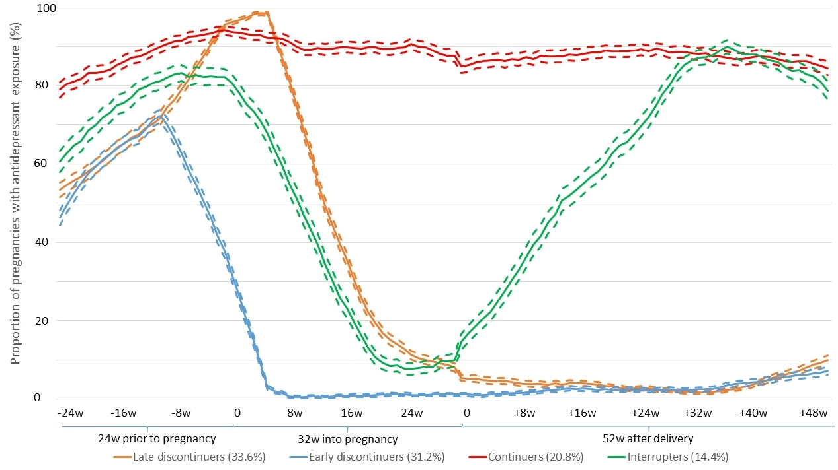

Figure S2. Trajectories of antidepressant prescription fill in pregnant women with depression/anxiety using longitudinal k-means trajectory modelling on antidepressant exposure by week (2009-2018, n=8,460 pregnancies): different assumption of daily dose
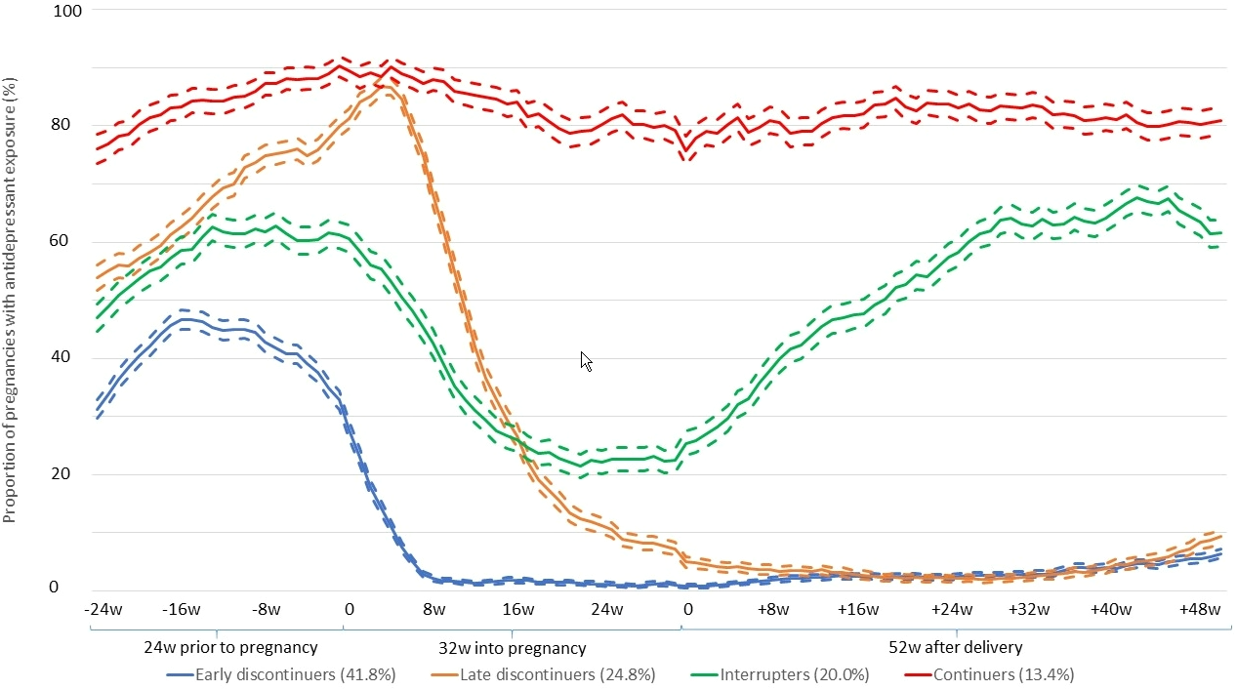

Figure S3. Trajectories of antidepressant prescription fill in pregnant women with depression/anxiety using longitudinal k-means trajectory modelling on antidepressant exposure by week (2009-2018, n=8,092 pregnancies): analyses restricted to first pregnancy in the cohort
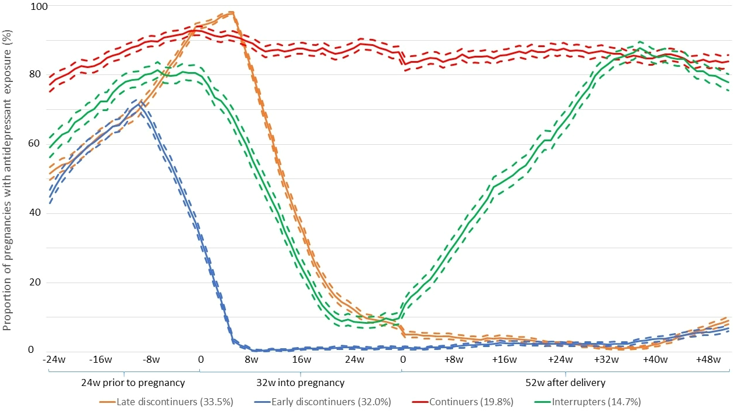

Figure S4. Trajectories of antidepressant prescription fill in pregnant women with depression/anxiety using longitudinal k-means trajectory modelling on antidepressant exposure by week (2009-2018, n=10,317 pregnancies): look-back time window=one year
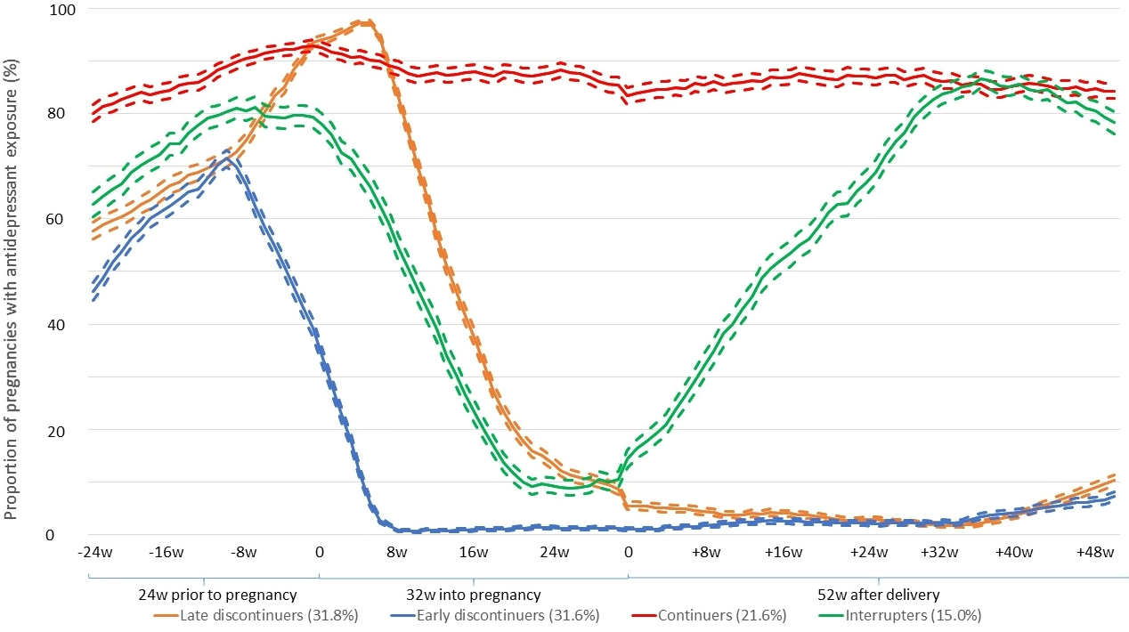

Figure S5. Trajectories of antidepressant prescription fill in pregnant women with depression/anxiety using group-based trajectory modelling on antidepressant exposure by week (2009-2018, n=8,460 pregnancies)
