Supplemental Results
Figure legends
Figure S1 IMQ induced psoriasis-like dermatitis in mice. Mice were topically treated daily on right ear and back skin with 5% IMQ cream for 5 days. A, Ear thickness was measured daily. B, Representative macroscopic appearance of IMQ-induced mice. C, H&E staining of the back skin in mice, scale bar, 50 µm. Data are shown as the mean ± SEM. *P < 0.05, **P < 0.01, ***P <0.001, and ****P <0.0001.
Figure S2 Marker genes in each cell cluster were show in violin plots.
Figure S3 A, Marker genes in each macrophage cluster were show in heatmap. B, Violin plots of marker genes in each macrophage cluster.
Figure S4 Differential gene expression profile of different cell types in control vs psoriatic mice skin.
Figure S5 A, Marker genes in each NK/T cell cluster were show in heatmap. B, Violin plots of marker genes in each NK/T cell cluster. C, The T cell receptor (TCR) distribution of NK/T cells across different groups. The proportions of clonal NK/T cells in two different groups (left panel). Unique (n = 1), duplicated (n = 2), and clonal (n ≥ 3) TCRs are labeled with different colors (right panel).
Figure S6 A, Marker genes in each conventional dendritic cell (cDC) cluster were show in heatmap. B, Violin plots of marker genes in each cDC cluster.
Figure S7 A, Marker genes in each plasmacytoid dendritic cell (pDC) cluster were show in heatmap. B, Violin plots of marker genes in each pDC cluster.

Figure S1

Figure S2
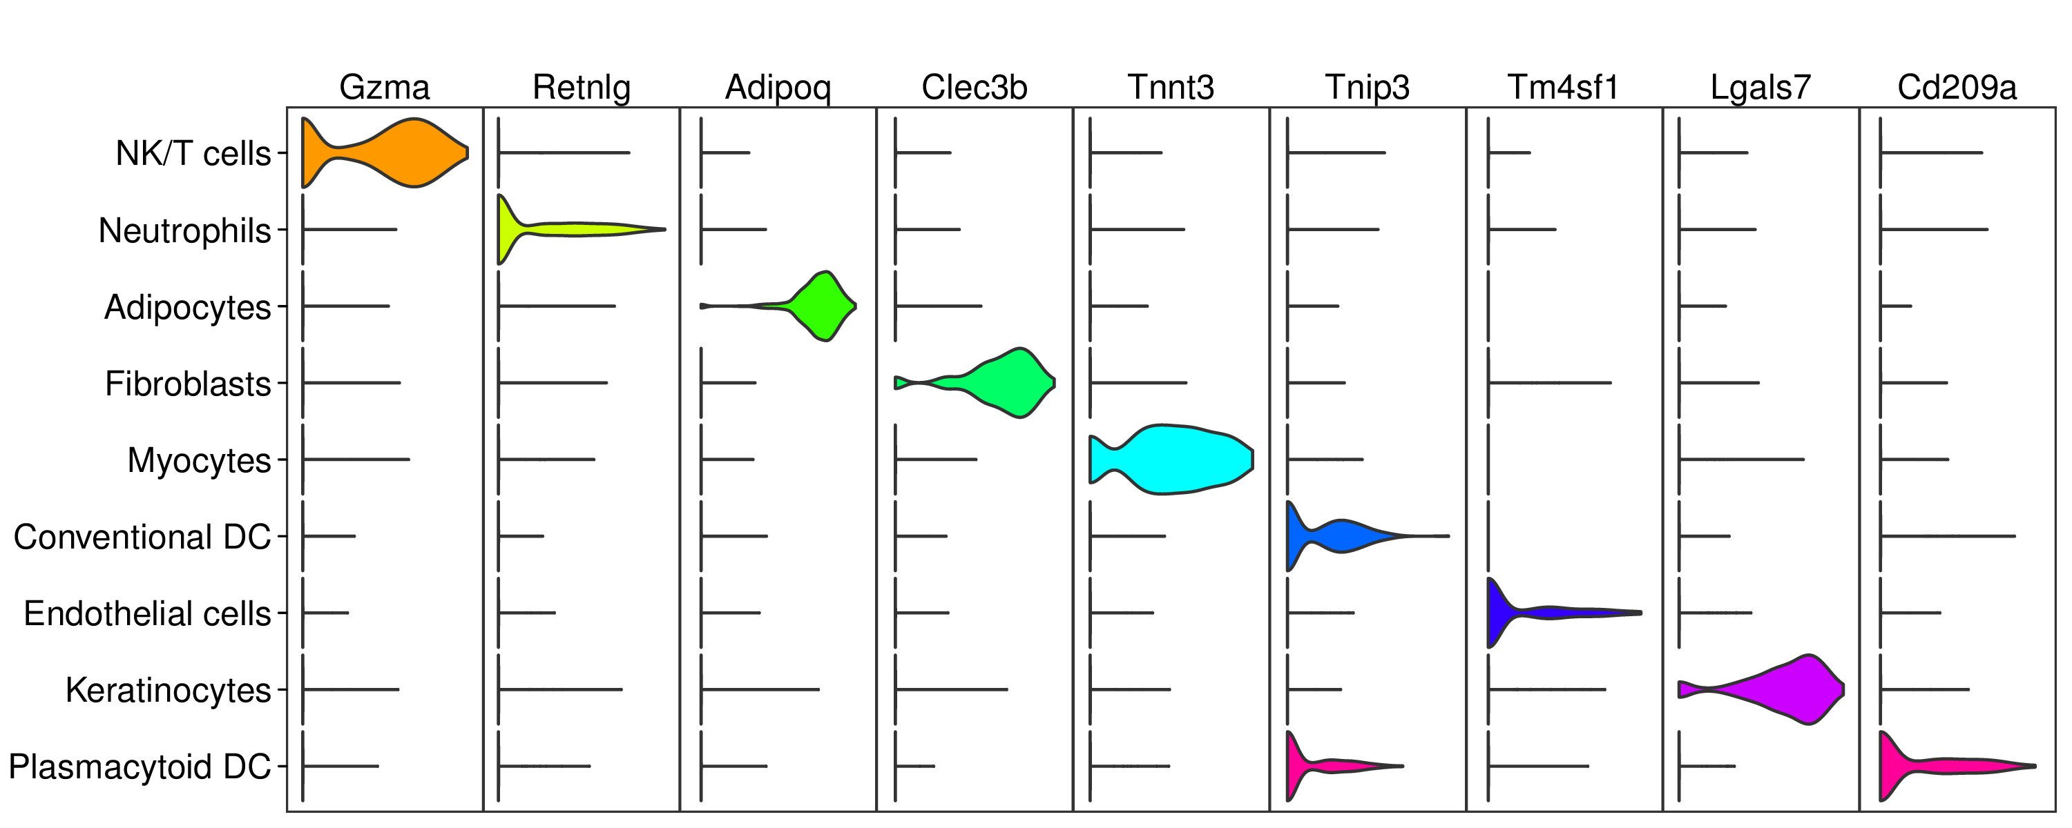

Figure S3

Figure S4
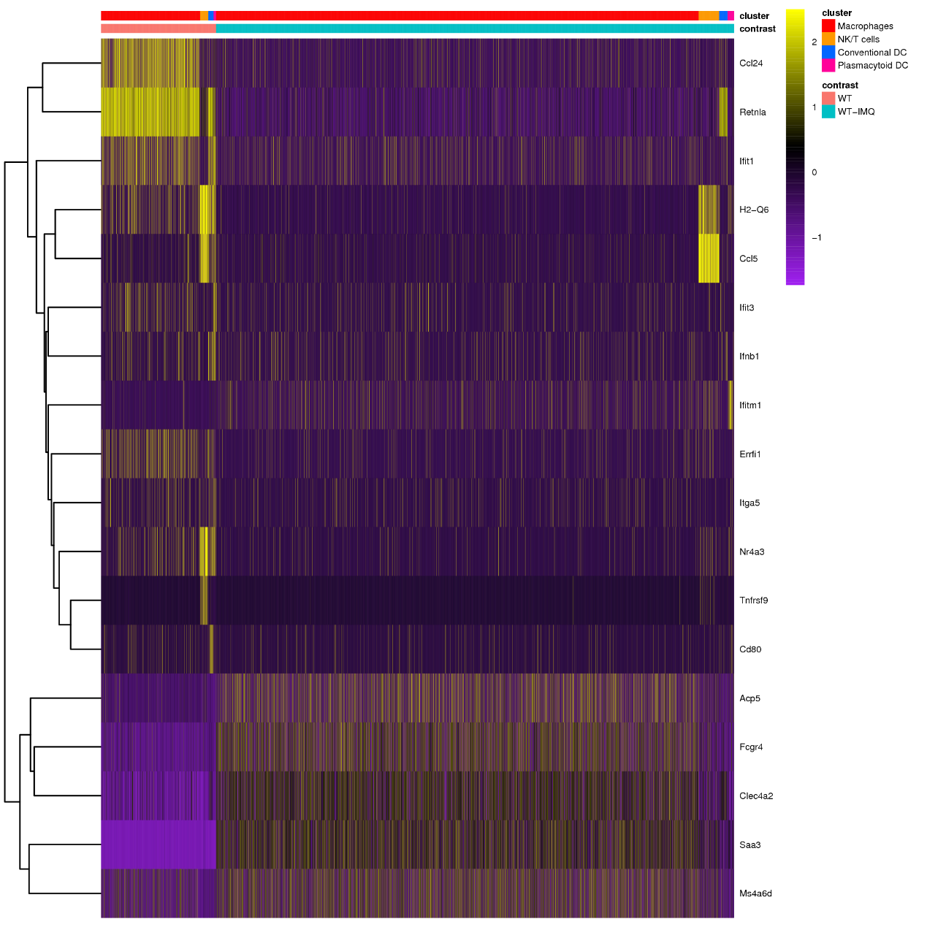

Figure S5

Figure S6

Figure S7

