1A
1B

1C
Supplementary Figure 1. Mutations of ribosomal proteins L3, L4 and L22 in S. xylosus and R-tylosin S. xylosus. Sequencing and blast were used to explore the mutations of ribosomal proteins L3, L4 and L22 in S. xylosus and R-tylosin S. xylosus. (A) Amino acid sequence comparison of ribosomal protein L3 in S. xylosus and R-tylosin S. xylosus. (B) Amino acid sequence comparison of ribosomal protein L4 in S. xylosu sand R-tylosin S. xylosus. (C) Amino acid sequence comparison of ribosomal protein L22 in S. xylosus and R-tylosin S. xylosus.

2A
2B
2C
Supplementary Figure 2. Comparison of sequencing results of mutant fragments in S. xylosus and Tylosin-resistant S. xylosus. (A) Comparison of sequencing results of mutant ribosomal protein L3 fragment. (B) Comparison of sequencing results of mutant ribosomal protein L4 fragment. (C) Comparison of sequencing results of mutant ribosomal protein L22 fragment.

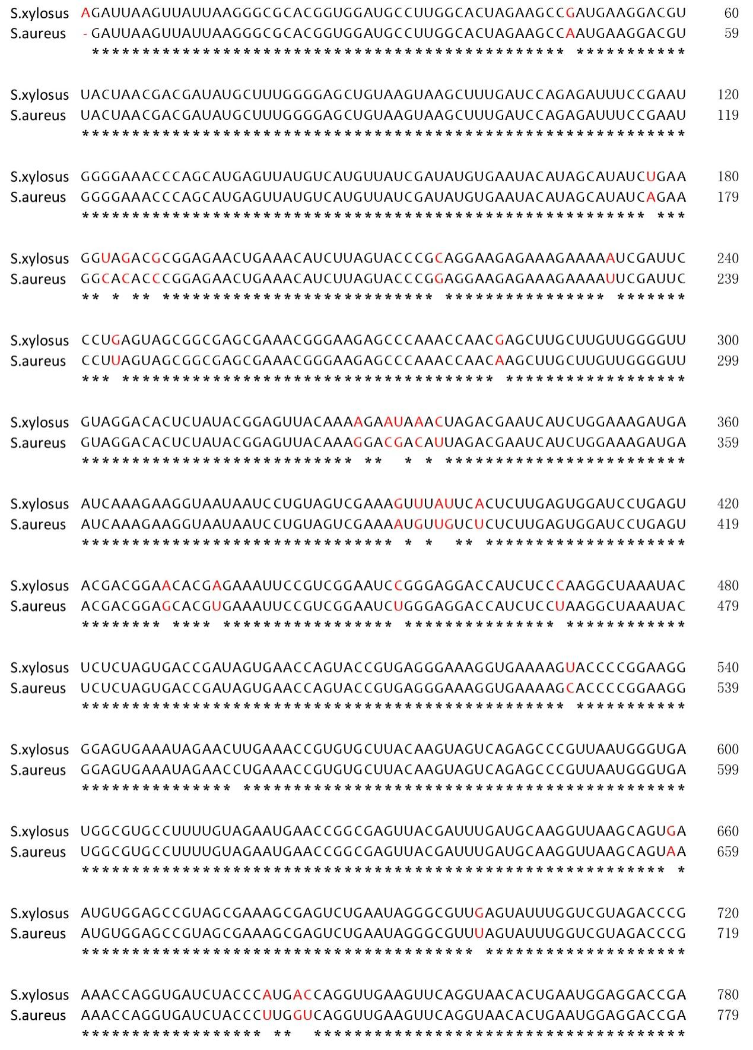
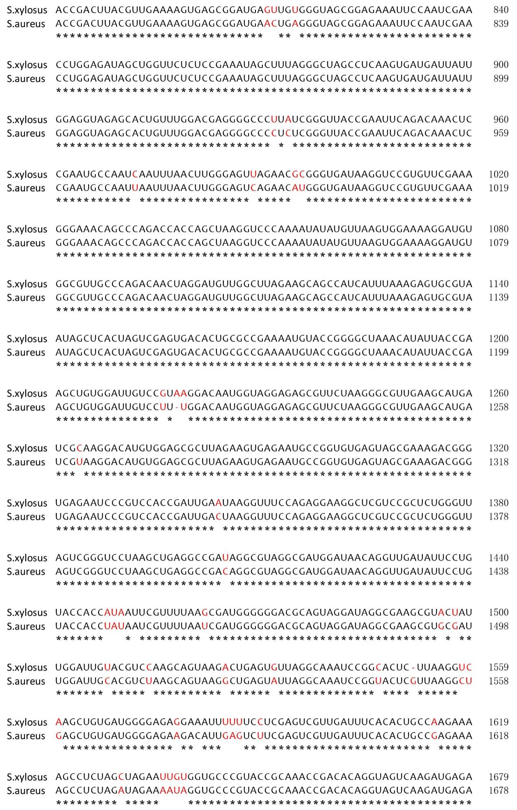
Supplementary Figure 3. Continue
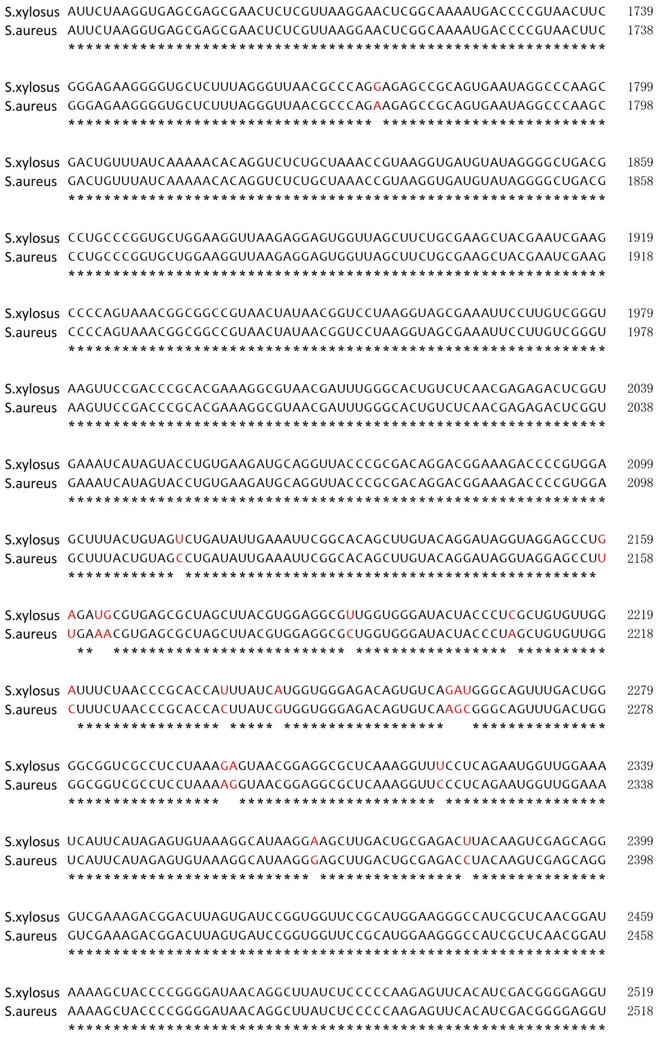
Supplementary Figure 3. Continue

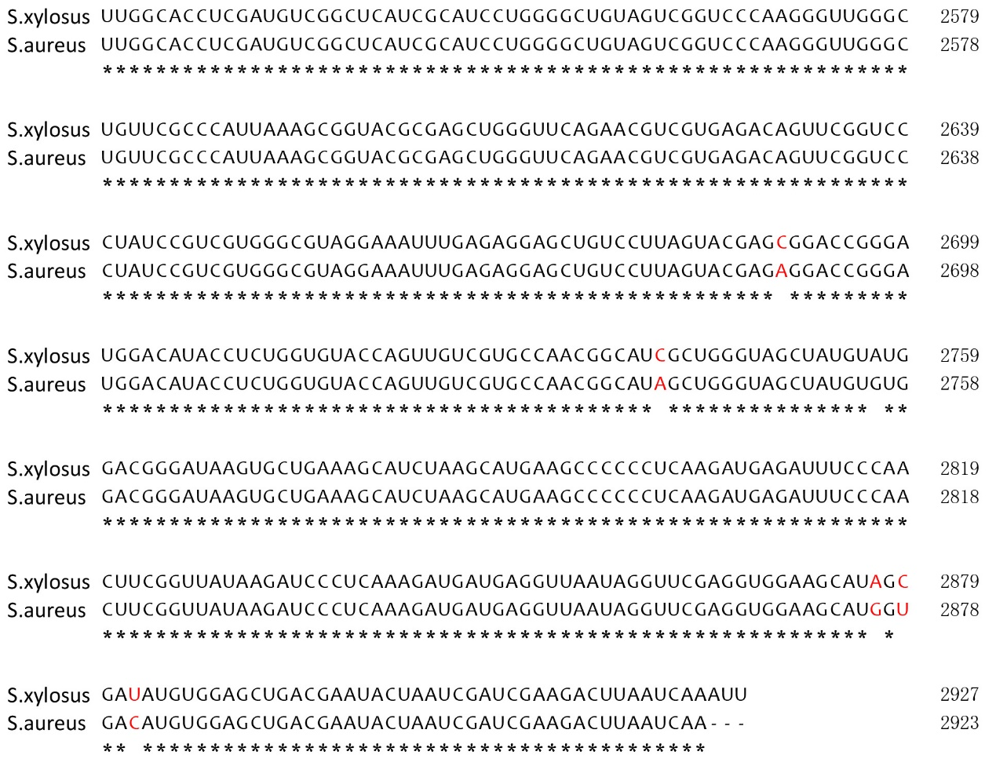
Supplementary Figure 3. The sequence alignment of 23S rRNA between S. xylosus and S. aureus. The different bases were shown in red.

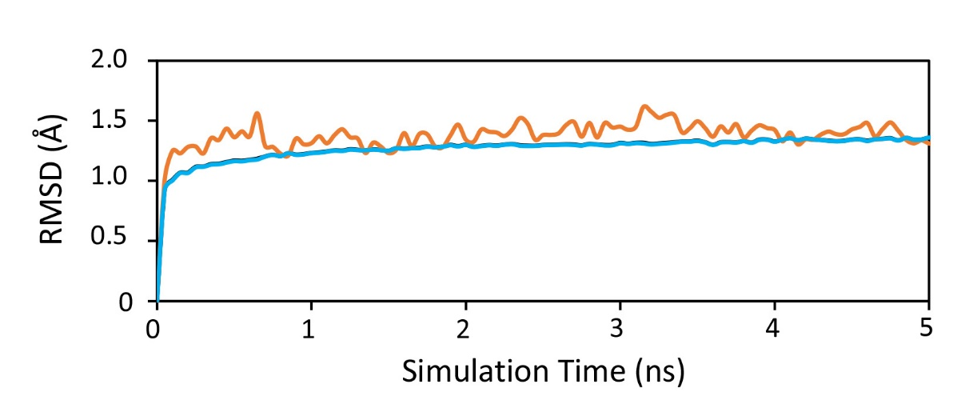
Supplementary Figure 4. RMSD of 23S rRNA (cyan) and L22 (orange) along 5 ns MD simulation.

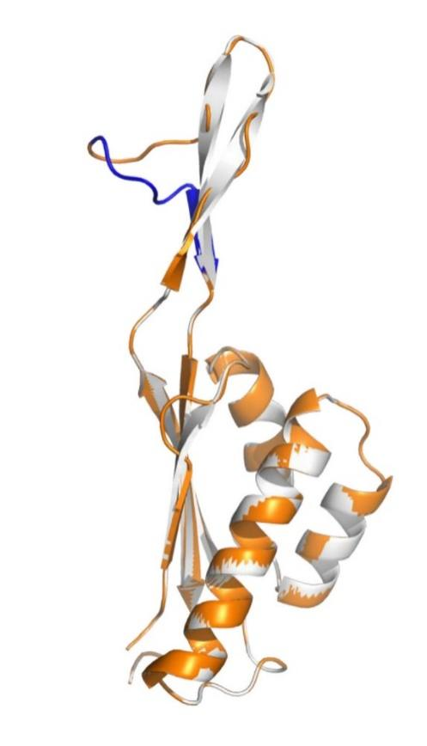
Supplementary Figure 5. Structural difference in L22 (white) and L22 97KRTSAIN98 insertion mutant (orange). The segment of 97KRTSAIN98 insertion is shown in blue.

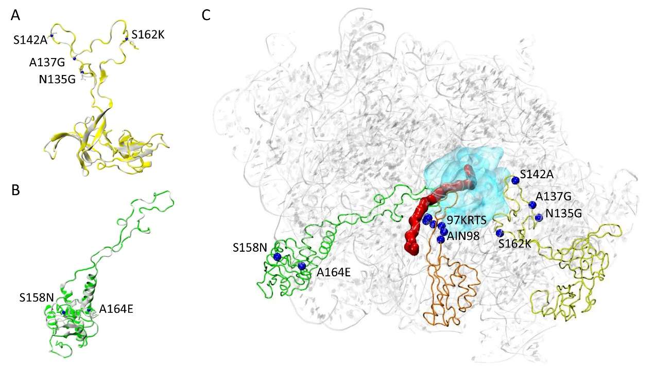
Supplementary Figure 6. The role of mutations in L3 and L4. (A) Structural difference in L3 (white) and L3 mutant (N135G, A137G, S142A and R162K) (yellow). (B) Structural difference in L4 (white) and L4 mutant (S158N and A164E) (green). (C) The structure of ribosome is composed with the 23S rRNA and the homology models of L3 mutant, L4 mutant and L22 mutant. The 23S rRNA is shown in gray, the antibiotic binding site is shown in cyan, the mutant amino acids are marked in blue. The theoretical nascent polypeptide chain is shown in red.

Supplementary Table 1 Plasmids used in this study
Name | function
gfp- T | Used to clone gfp gene
rplC- T | Used to clone rplC mutant fragment
rplD -T | Used to clone rplD mutant fragment
rplV -T | Used to clone rplV mutant fragment
23s rRNA-3-T | Used to clone 23s rRNA-3 mutant fragment
23s rRNA-4-T | Used to clone 23s rRNA-4 mutant fragment
23s rRNA-5-T | Used to clone 23s rRNA-5 mutant fragment
pClone007-rplC | Used to construct the shuttle plasmid PBT₂-rplC
pClone007-rplD | Used to construct the shuttle plasmid PBT₂-rplD
pClone007-rplV | Used to construct the shuttle plasmid PBT₂-rplV

Supplementary Table 2 Strains used in our study
System | Strains
1 | S. xylosus
2 | Tylosin-resistant S. xylosus
3 | L3 (rplC) mutant s.xylosus (N135G、A137G、S142A and R162K)
4 | L4 (rplD) mutant s.xylosus (S158N and A164E)
5 | L22 (rplV) mutant s.xylosus (97KRTSAIN98 insertion)

Supplementary Table 3 Primers of ribosomal genes
Oligonucleotide name | Sequence (5’ to 3’) a
rplC F | ATGACCAAAGGAATCTTAGGAAGAAAAA
rplC R | TTATTTATTACCTTTGATTGATGTTGTG
rplD F | ATGGCTAATTATGATGTATTAAAAGTAG
rplD R | TTATCCGAGCACCTCCTCAACTTTTTTA
rplV F | AAAGCGGTTGCTAAAACAATAAGAATCG
rplVR | GCTTCTTTAGCTTCTTCTTTACCGTCAC

Supplementary Table 4 Primers of shuttle plasims
Oligonucleotide name | Sequence (5’ to 3’) a
rplC-1 F | TGCACTGCAGTGCA ACTAAAAGAGTAGTGCGAATTGCA
rplC-1 R | GTATCAACTGAGACTTCTTGACCTACTTCGTATTCATCAA
rplC-2 F | GTCTCAGTTGATACATTCGAAACTG
rplC-2 R | TTTACTCATTTATTTATTACCTTTGATTGATGTTGTGATT
rplC-3 F | AGGTAATAAATAAATGAGTAAAGGAGAAGAACTTTTCACT
rplC-3 F | CTTTCGTATTATATTATTTGTATAGTTCATCCATGCCATG
rplC-4 F | TATACAAATAATATAATACGAAAGGAGGAATTGCATAATG
rplC-4 R | TACGACGACCATTAGTAATTGGCCGCGGATCCGCG
rplD-1 F | TGCACTGCACTGCAAAATTAGGAGGTGGACTTTCGATG
rplD-1 R | TAATGCTAAACGACGCATTTTCTTAGGCATTTTGTATGAG
rplD-2 F | GTCGTTTAGCATTACGTTCAGC
rplD-2 R | AAGTTCTTCTCCTTTACTCATTTATGCGAGCACCTCCCTC
rplD-3 F | GGTGCTCGCATAAATGAGTAAAGGAGAAGAACTTTTCACT
rplD-3 R | TCTCTTGCTTCCATTATTTGTATAGTTCATCCATGCCATG
rplD-4 F | ATGAACTATACAAATAATGGAAGCAAGAGACGTTCTTAAG
rplD-4 R | GCGTAGGTTTACCCCAAGGTCGCGGATCCGCG
rplV-1 F | TGCACTGCAGTGCATTTATGCTGATGGTGAAAAACGC
rplV-1 R | TTTGCTAAAGCGGACATTAATAATTTTTCAACTACTGGTG
rplV-2 F | GCTTTAGCAAATGCTGAACATAACTA
Note: Primers including the indicated restriction site (underlined)

Supplementary Table 5 Primers used for real-time PCR of drug resistant proteins
Oligonucleotide name | Sequence (5’ to 3’) a
rplW F | TGGAAGCAAGAGACGTTCTTAAGCG
rplW R | TAGCACGAGTATCAACGTCGAATGTG
infB F | AGCAGGTGGTATTACACAGCATATCG
infB R | GCGTGGCCTGGCGTATCAAG
ldh F | GAACCACGCTGCACCTTATGG
ldh R | GCGCCAGCAGTAATTACAACTATGTC
aldA-1 F | GTGACCGCAGGCATCGTTCC
aldA-1 R | CTGCTGGTATTGTTGACTCACGAATG
katA F | GAGAGGTGATTCCAGAACGACGTATG
katA R | ATCCACGAATATCACGCTCTGCATC
trxA F | CAACTTGGTGTGGCCCTTGT
trxA R | ACAACTTTATCTACTGGTTCGCCA
gros F | AGAGCAAACAACAAAGAGCGG
gros R | GCCCTGCACCTACTGCAATTA
cl F | GGCAGCGTTAATCGTGGTGA
cl R | CTAGCACACTGACTGCGACG
16S rRNA F | CGGGCAATTTGTTTAGCA
16S rRNA R | ATTAGGTGGAGCAGGTCA

