Table S1. The clinical characteristics of subjects enrolled in this study
 | Males (n=312) | Females (n=298) | All subjects (n=610)
Age (years) | 58.45±13.23 | 62.66±12.06 | 60.51±12.84
Diabetes duration (years) | 7.59±6.71 | 9.11±7.51 | 8.33±7.17
BMI (kg/m²) | 23.84±3.23 | 24.79±4.13 | 24.30±3.72
NC (cm) | 37.63±3.18 | 35.41±2.99 | 36.54±3.28
WC (cm) | 90.14±11.19 | 90.96±12.88 | 90.54±12.03
WHR | 0.93±0.07 | 0.92±0.08 | 0.92±0.07
SBP (mmHg) | 132.28±18.79 | 134.67±18.92 | 133.45±18.87
DBP (mmHg) | 80.72±10.81 | 80.16±9.44 | 80.45±10.16
TG (mmol/L) | 1.64±1.41 | 1.83±1.92 | 1.73±2.03
TC (mmol/L) | 4.61±1.08* | 5.01±1.34 | 4.81±1.26
HDL (mmol/L) | 1.14±0.44 | 1.28±0.39 | 1.21±0.42
LDL (mmol/L) | 2.81±0.85 | 3.01±0.96 | 2.91±0.97
FPG (mmol/L) | 7.61±3.11 | 7.71±3.30 | 7.66±3.20
PPG (mmol/L) | 13.91±4.96 | 13.47±4.28 | 13.70±5.12
FCP (ng/ml) | 1.36 (0.81, 2.12) | 1.52 (0.86, 2.26) | 1.47 (0.84. 2.19)
PCP (ng/ml) | 2.95 (1.68, 4.44) | 3.05 (1.94, 4.52) | 3.03 (1.75, 4.48)
FINS（μIU/ml） | 11.7 (5.73, 18.37) | 13.47 (6.33, 22.77) | 12.5 (6.17, 20.21)
PINS（μIU/ml） | 47.32 (24.15, 80.69) | 58.03 (25.40, 97.26) | 49.49 (24.82, 88.35)
HbA1c (%) | 7.99±1.89 | 8.25±2.20 | 8.23±2.36
UA (mmol/L) | 0.29±0.1 | 0.27±0.10 | 0.28±0.10
UACR (mg/g) | 17.5 (5.25, 134.25) | 10.5 (5, 40.25) | 13 (5, 111)
Diabetic retinopathy, n (%) | 22 (7.1%) | 28 (9.4%) | 50 (8.2%)
with Arterial plaque, n (%) | 156 (52.5%) | 171 (54.7%) | 327 (53.6%)
Using antihypertensive drugs, n (%) | 112 (35.9%) | 91 (30.7%) | 203 (33.3%)
Using blood-lipid lowering drugs, n (%) | 69 (22.1%) | 61 (20.5%) | 130 (21.3%)
Using insulin therapy, n (%) | 160 (51.3%) | 144 (48.4%) | 304 (49.8%)

Continuous variables of normal distribution are expressed as mean ± standard deviation, while skewed distribution data were shown as medians (Q1, Q3). Independent-sample t test or Mann–Whitney U test were used for comparison between groups. Categorical variables are expressed as percentages, and χ2 analysis was used to compare differences between groups.

BMI: body mass index; WC: waist circumference; WHR: waist-to-hip ratio; SBP: systolic blood pressure; DBP: diastolic blood pressure; TG: triglyceride; TC: total cholesterol; HDL-c: high-density lipoprotein cholesterol; LDL-c: low-density lipoprotein cholesterol; FPG: fasting plasma glucose; PPG: 2-hour postprandial plasma glucose; FCP: fasting C-peptide; PCP: 2-hour postprandial C-peptide ; FINS: fasting insulin; PINS: 2-hour postprandial insulin; UA: uric acid; UACR: Urinary albumin/creatinine ratio.

Table S2. Comparison of all studied variables in patients with MetS and without MetS
 | MetS (n=397) | Non-MetS (n=213) | P value
Age (years) | 61.89±11.87 | 52.93±14.16 | 0.000
Male, n (%) | 201 (50.63%) | 111 (52.11%) | 0.727
Diabetes duration(years) | 8.63±7.59 | 7.78±6.94 | 0.176
BMI (kg/m²) | 25.39±3.49 | 22.28±3.28 | 0.000
NC (cm) | 37.29±3.12 | 35.15±3.11 | 0.000
WC (cm) | 94.22±11.07 | 83.68±10.70 | 0.000
WHR | 0.94±0.07 | 0.88±0.07 | 0.000
SBP (mmHg) | 138.80±18.28 | 123.39±15.62 | 0.000
DBP (mmHg) | 83.49±10.05 | 74.78±7.63 | 0.000
TG (mmol/L) | 2.12±2.41 | 1.00±0.42 | 0.000
TC (mmol/L) | 4.88±1.34 | 4.67±1.11 | 0.053
HDL (mmol/L) | 1.13±0.42 | 1.35±0.39 | 0.000
LDL (mmol/L) | 2.96±0.94 | 2.81±1.01 | 0.080
FPG (mmol/L) | 7.99±3.43 | 7.05±2.61 | 0.000
PPG (mmol/L) | 13.94±5.19 | 13.25±4.98 | 0.115
FCP (ng/ml) | 1.65 (0.97, 2.38) | 3.4 (2.09, 4.66) | 0.001
PCP (ng/ml) | 2.95 (1.68, 4.44) | 2.41 (1.16, 4.04) | 0.001
FINS（μIU/ml） | 14.07 (6.32, 22.87) | 11.25 (6.03, 16.14) | 0.000
PINS（μIU/ml） | 60.92 (27.43, 96.57) | 43.94 (22.88, 78.69) | 0.000
HbA1c (%) | 8.03±2.36 | 7.66±2.21 | 0.145
UA (mmol/L) | 0.30±0.11 | 0.24±0.09 | 0.000

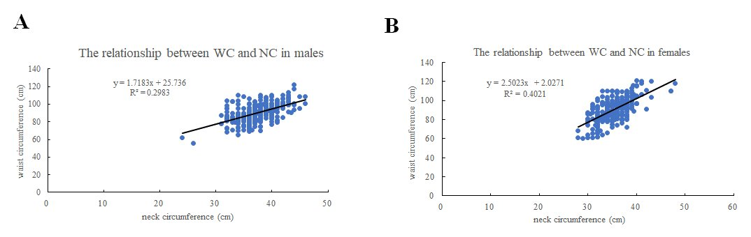

Figure S1: The plot figure for the relationship between waist circumference (WC) and neck circumference (NC) in male subjects (A) and female subjects (B). NC is linearly related to WC in both male and female subjects.

