First-trimester triglyceride-glucose index and risk of pregnancy-related complications: a prospective birth cohort study in Southeast China

Supplementary Materials

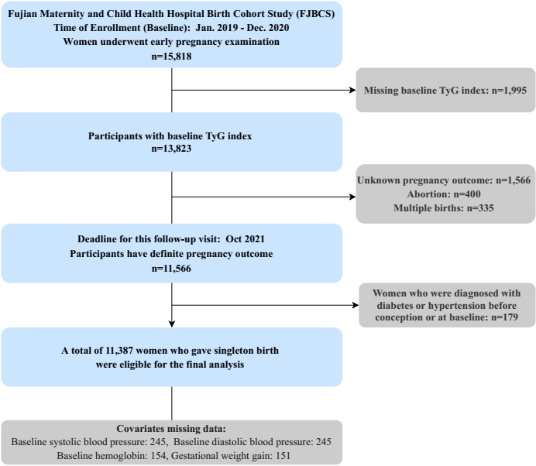
Supplementary Figure 1 Participant flowchart

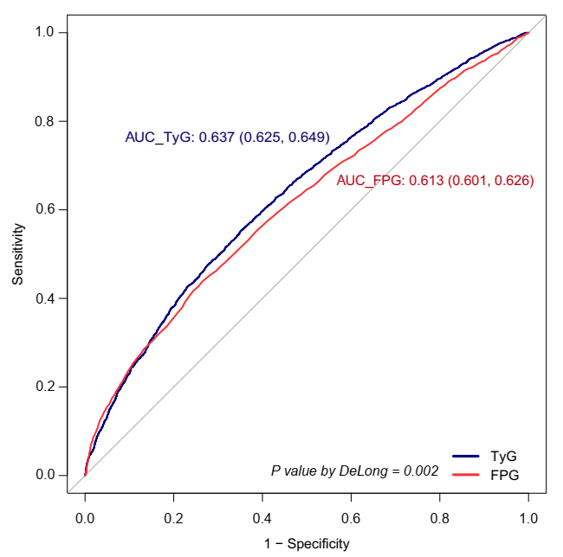
Supplementary Figure 2 Receiver operating characteristic curves of triglyceride-glucose (TyG) index and fasting plasma glucose (FPG) used to predict gestational diabetes mellitus development
The blue line represents triglyceride-glucose (TyG) index and the red line indicates fasting plasma glucose (FPG).
Supplementary Table 1 Anthropometric and biochemical characteristics of the participants according to triglyceride-glucose (TyG) index quintiles in sensitivity analysis dataset
Variables | Overall | TyG index quintiles (n, range) |  |  |  |  | P value
 | Total (n = 10,836) | Q1 (n = 2,167)  (7.36~8.19) | Q2 (n = 2,167)  (8.20~8.38) | Q3 (n = 2,167)  (8.38~8.55) | Q4 (n = 2,166)  (8.55~8.76) | Q5 (n = 2,169)  (8.76~9.89)
Race-Han, n(%) | 10836 (100.0) | 2167 (100) | 2167 (100) | 2167 (100) | 2166 (100) | 2169 (100)
Maternal age, years | 30.0 ± 4.0 | 29.2 ± 3.7 | 29.4 ± 3.8 | 30.0 ± 4.0 | 30.4 ± 4.0 | 31.1 ± 4.1 | < 0.001
Pre-pregnancy BMI, kg/m² | 21.1 ± 2.8 | 20.2 ± 2.4 | 20.6 ± 2.6 | 20.8 ± 2.6 | 21.3 ± 2.9 | 22.4 ± 3.2 | < 0.001
Assisted reproduction, n (%) | 567 ( 5.2) | 64 (3) | 79 (3.6) | 96 (4.4) | 141 (6.5) | 187 (8.6)
Abortion history, n (%) | 3982 (36.7) | 655 (30.2) | 731 (33.7) | 773 (35.7) | 873 (40.3) | 950 (43.8)
Gravidity, n(%) |  |  |  |  |  |  | < 0.001
1 | 4653 (42.9) | 1187 (54.8) | 1049 (48.4) | 948 (43.7) | 806 (37.2) | 663 (30.6)
2 | 3267 (30.1) | 536 (24.7) | 614 (28.3) | 646 (29.8) | 729 (33.7) | 742 (34.2)
3 | 1775 (16.4) | 273 (12.6) | 325 (15) | 349 (16.1) | 380 (17.5) | 448 (20.7)
≥4 | 1141 (10.5) | 171 (7.9) | 179 (8.3) | 224 (10.3) | 251 (11.6) | 316 (14.6)
Parity, n(%) |  |  |  |  |  |  | < 0.001
0 | 6325 (58.4) | 1510 (69.7) | 1388 (64.1) | 1277 (58.9) | 1161 (53.6) | 989 (45.6)
1 | 4066 (37.5) | 594 (27.4) | 696 (32.1) | 802 (37) | 916 (42.3) | 1058 (48.8)
≥2 | 445 ( 4.1) | 63 (2.9) | 83 (3.8) | 88 (4.1) | 89 (4.1) | 122 (5.6)
Gestational week at  examination, weeks | 11.3 ± 1.1 | 11.1 ± 1.2 | 11.3 ± 1.1 | 11.3 ± 1.1 | 11.4 ± 1.0 | 11.5 ± 1.0 | < 0.001
SBP, mmHg | 113.8 ± 10.8 | 111.7 ± 10.9 | 112.9 ± 10.6 | 113.6 ± 10.6 | 114.8 ± 11.1 | 116.1 ± 10.5 | < 0.001
DBP, mmHg | 68.6 ± 8.5 | 66.8 ± 8.5 | 68.0 ± 8.4 | 68.5 ± 8.4 | 69.4 ± 8.4 | 70.2 ± 8.6 | < 0.001
FPG, mg/dl | 85.6 ± 6.4 | 83.4 ± 6.1 | 84.7 ± 5.8 | 85.4 ± 6.0 | 86.4 ± 6.1 | 88.2 ± 6.9 | < 0.001
TG, mg/dl | 111.6 (90.3, 139.9) | 75.3 (68.2, 81.5) | 94.7 (89.4, 100.1) | 111.6 (105.4, 117.8) | 132.8 (124.8, 140.8) | 174.4 (158.5, 201.9) | < 0.001
Total cholesterol, mg/dl | 179.4 ± 28.3 | 166.5 ± 24.7 | 174.6 ± 25.6 | 179.4 ± 26.1 | 185.2 ± 27.6 | 191.4 ± 30.3 | < 0.001
LDL-C, mg/dl | 92.4 ± 23.2 | 82.0 ± 20.0 | 88.3 ± 20.8 | 92.4 ± 21.5 | 97.1 ± 22.9 | 102.2 ± 25.3 | < 0.001
HDL-C, mg/dl | 65.1 ± 11.7 | 67.0 ± 11.3 | 66.9 ± 11.7 | 65.9 ± 11.5 | 64.8 ± 11.5 | 60.7 ± 11.4 | < 0.001
Hemoglobin, g/L | 127.4 ± 9.7 | 126.0 ± 9.6 | 126.9 ± 9.5 | 127.4 ± 9.6 | 128.0 ± 9.5 | 129.0 ± 9.9 | < 0.001
Uric acid, μmoI/L | 231.7 (203.0, 264.5) | 224.6 (197.6, 254.2) | 227.5 (199.2, 260.3) | 230.6 (203.2, 260.6) | 232.4 (204.1, 266.2) | 244.2 (212.7, 280.6) | < 0.001
Creatinine, μmoI/L | 43.0 (38.9, 47.2) | 42.8 (38.6, 46.9) | 43.1 (39.0, 47.2) | 43.1 (38.8, 47.2) | 43.2 (39.0, 47.5) | 43.1 (38.9, 47.2) | 0.312
ALT, U/L | 12.6 (9.7, 17.9) | 11.9 (9.5, 16.2) | 12.2 (9.4, 16.9) | 12.2 (9.5, 17.3) | 12.9 (9.9, 18.9) | 13.9 (10.4, 20.3) | < 0.001
AST, U/L | 16.4 (14.2, 19.1) | 16.4 (14.3, 18.8) | 16.3 (14.3, 18.9) | 16.3 (14.2, 18.9) | 16.4 (14.3, 19.4) | 16.5 (14.2, 19.6) | 0.046
Delivery gestations, weeks | 39.2 ± 1.5 | 39.3 ± 1.5 | 39.3 ± 1.5 | 39.2 ± 1.4 | 39.2 ± 1.5 | 39.0 ± 1.6 | < 0.001
Gestational weight gain, kg | 13.5 ± 4.9 | 14.3 ± 4.6 | 14.0 ± 4.5 | 13.6 ± 4.7 | 13.2 ± 5.2 | 12.4 ± 5.4 | < 0.001
Gestational weight gain, n(%) |  |  |  |  |  |  | < 0.001
<recommendation | 3511 (32.4) | 596 (27.5) | 597 (27.5) | 719 (33.2) | 743 (34.3) | 856 (39.5)
Within recommendation | 4269 (39.4) | 877 (40.5) | 922 (42.5) | 841 (38.8) | 842 (38.9) | 787 (36.3)
>recommendation | 3056 (28.2) | 694 (32) | 648 (29.9) | 607 (28) | 581 (26.8) | 526 (24.3)
Abbreviations: ALT, alanine aminotransferase; AST, aspartate aminotransferase; DBP, diastolic blood pressure; HDL-C, high density lipoprotein cholesterol; LDL-C, low density lipoprotein cholesterol; SBP, systolic blood pressure; TC, total cholesterol.
Data are presented as mean ± standard deviation, median (interquartile range) or n (%).

Supplementary Table 2 Association of triglyceride-glucose (TyG) index with gestational diabetes mellitus (GDM) in sensitivity analysis dataset
Predictor | Number | GDM, n (%) | Crude |  | Model 1 ª |  | Model 2 ^{b}
 |  |  | OR (95%CI) | P value | OR (95%CI) | P value | OR (95%CI) | P value
TyG index, per unit | 10836 | 2620 (24.2) | 4.35 (3.81~4.97) | <0.001 | 3.13 (2.71~3.62) | <0.001 | 3.60 (2.93~4.41) | <0.001
TyG index, per SD | 10836 | 2620 (24.2) | 1.66 (1.58~1.73) | <0.001 | 1.48 (1.41~1.56) | <0.001 | 1.55 (1.45~1.67) | <0.001
TyG index Quintile 1 | 2167 | 314 (14.5) | 1(Ref) |  | 1(Ref) |  | 1(Ref)
Quintile 2 | 2167 | 386 (17.8) | 1.28 (1.09~1.50) | 0.003 | 1.23 (1.04~1.46) | 0.014 | 1.21 (1.02~1.43) | 0.025
Quintile 3 | 2167 | 470 (21.7) | 1.63 (1.40~1.91) | <0.001 | 1.45 (1.23~1.70) | <0.001 | 1.41 (1.19~1.67) | <0.001
Quintile 4 | 2166 | 612 (28.3) | 2.32 (2.00~2.71) | <0.001 | 1.96 (1.67~2.29) | <0.001 | 1.89 (1.59~2.24) | <0.001
Quintile 5 | 2169 | 838 (38.6) | 3.72 (3.21~4.31) | <0.001 | 2.69 (2.30~3.15) | <0.001 | 2.53 (2.09~3.08) | <0.001
Trend test |  |  |  | <0.001 |  | <0.001 |  | <0.001
ª Model 1 adjusted for pre-pregnancy BMI, maternal age, assisted reproduction, abortion history, gravidity, parity, delivery gestations, and gestational weight gain;
^{b} Model 2 further adjusted for gestational week at the examination, systolic blood pressure, diastolic blood pressure, total cholesterol, low density lipoprotein cholesterol, high density lipoprotein cholesterol, hemoglobin, uric acid, creatinine, alanine aminotransferase, and aspartate aminotransferase.
The bolded P values indicates statistical significance.

Supplementary Table 3 Association of triglyceride-glucose (TyG) index with other pregnancy-related complications in sensitivity analysis dataset
Predictor | Number | Pregnancy-related  complications, n (%) | Crude |  | Model 1 ª |  | Model 2 ^{b}
 |  | Pregnancy-related  complications, n (%) | OR (95%CI) | P value | OR (95%CI) | P value | OR (95%CI) | P value
Gestational hypertension | 10836 | 364 (3.4) | 1.92 (1.43~2.58) | <0.001 | 1.65 (1.21~2.26) | 0.002 | 0.97 (0.62~1.53) | 0.911
Preeclampsia | 10836 | 182 (1.7) | 1.63 (1.08~2.48) | 0.020 | 1.01 (0.64~1.57) | 0.979 | 0.48 (0.25~0.9) | 0.022
Placental abruption | 10836 | 250 (2.3) | 1.13 (0.78~1.62) | 0.519 | 1.16 (0.78~1.72) | 0.454 | 1.27 (0.73~2.2) | 0.395
Fetal distress | 10836 | 2035 (18.8) | 0.97 (0.84~1.12) | 0.684 | 1.11 (0.95~1.29) | 0.175 | 1.04 (0.84~1.28) | 0.736
Premature rupture of membranes | 10836 | 2875 (26.5) | 0.84 (0.75~0.96) | 0.008 | 0.99 (0.86~1.13) | 0.867 | 1.08 (0.9~1.3) | 0.426
ª Model 1 adjusted for pre-pregnancy BMI, maternal age, assisted reproduction, abortion history, gravidity, parity, delivery gestations, and gestational weight gain;
^{b}Model 2 further adjusted for gestational week at the examination, systolic blood pressure, diastolic blood pressure, total cholesterol, low density lipoprotein cholesterol, high density lipoprotein cholesterol, hemoglobin, uric acid, creatinine, alanine aminotransferase, and aspartate aminotransferase.
The bolded P values indicates statistical significance.

Supplementary Table 4 ROC analysis of the triglyceride-glucose (TyG) index for detecting pregnancy-related complications in sensitivity analysis dataset
Predictor | AUC (95%CI), % | Threshold | Sensitivity | Specificity | PPV | NPV | Accuracy | Precision
Gestational diabetes mellitus | 63.71 (62.49~64.94) | 8.549 | 0.555 | 0.649 | 0.335 | 0.820 | 0.626 | 0.335
Gestational hypertension | 55.59 (52.44~58.74) | 8.547 | 0.503 | 0.601 | 0.042 | 0.972 | 0.597 | 0.042
Preeclampsia | 54.82 (50.32~59.32) | 8.560 | 0.495 | 0.614 | 0.021 | 0.986 | 0.612 | 0.021
Placental abruption | 50.78 (47.13~54.44) | 8.878 | 0.152 | 0.874 | 0.028 | 0.978 | 0.857 | 0.028
Fetal distress | 50.23 (48.82~51.63) | 8.862 | 0.678 | 0.355 | 0.293 | 0.737 | 0.446 | 0.293
Premature rupture of membranes | 51.74 (50.20~52.97) | 8.574 | 0.652 | 0.381 | 0.275 | 0.752 | 0.453 | 0.275
Abbreviations: AUC: area under curve; PPV positive predictive value; NPV, negative predictive value
The bolded AUC (95%CI) indicates statistical significance.

Supplementary Figure 3 Subgroup analysis of the association between triglyceride-glucose (TyG) index and risk of gestational diabetes mellitus (GDM) in sensitivity analysis dataset
Models adjusted for race, pre-pregnancy BMI, maternal age, assisted reproduction, abortion history, gravidity, parity, gestational weight gain, delivery gestations, gestational week at the examination, systolic blood pressure, diastolic blood pressure, total cholesterol, low density lipoprotein cholesterol, high density lipoprotein cholesterol, hemoglobin, uric acid, creatinine, alanine aminotransferase, and aspartate aminotransferase (not for adjusted variables stratified analysis).

