Supplementary S1 Comparison of preoperative SII values between presence and absence of LVI in distinct stages UTUC (B). SII: systemic immune-inflammation index; LVI: lymphovascular invasion. The p-values (< 0.05) indicate statistical significance.
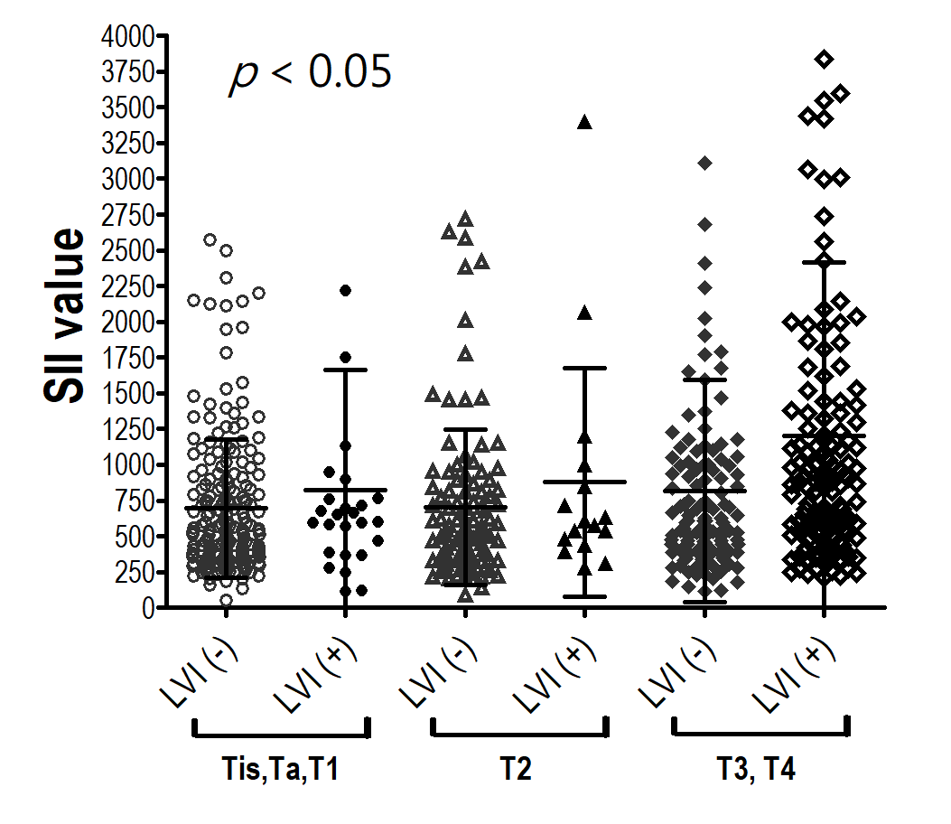

Supplementary S2 Kaplan-Meier survival curves for overall survival (A), cancer-specific survival (B), and progression-free survival (C) according to the presence and absence of LVI in UTUC patients. LVI: lymphovascular invasion; UTUC: upper tract urothelial carcinoma. The P-values (< 0.05) indicate statistical significance.
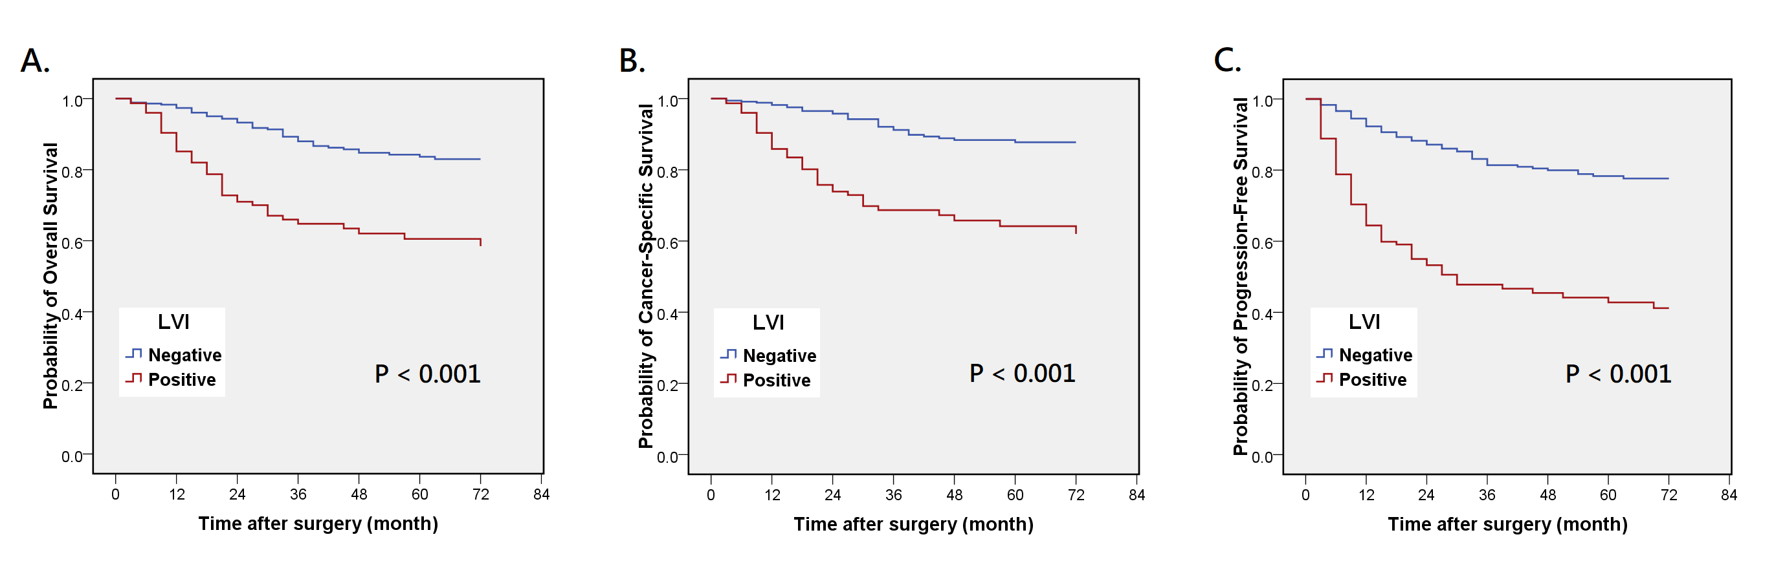

Supplementary S3 Kaplan-Meier survival curves for overall survival (A), cancer-specific survival (B), and progression-free survival (C) according to low- and high-level SII in UTUC patients. SII: systemic immune-inflammation index; UTUC: upper tract urothelial carcinoma. The P-values (< 0.05) indicate statistical significance.
