Supplementary Figure 1. Inclusion and exclusion criteria and study flow chart
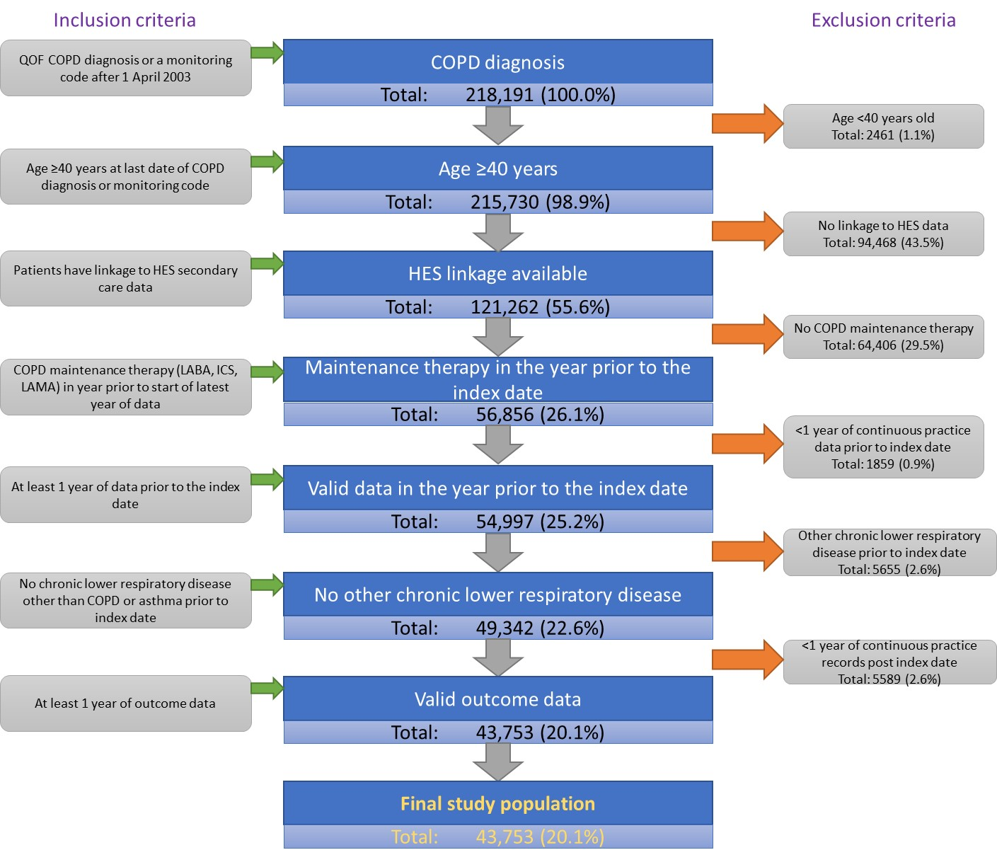

Abbreviations: COPD, chronic obstructive pulmonary disease; HES, hospital episode statistics; ICS, inhaled corticosteroid; ID, index date; LABA, long-acting β2-agonist; LAMA, long-acting muscarinic antagonist; QOF, Quality and Outcomes Framework.
Supplementary Table 1. Percentage of Patients Experiencing Exacerbations During the Outcome Year According to Characteristics in the Year Prior to the Index Date
 | Maintenance-Treated COPD Cohort  (N=43,753), % |  |  |  | Frequently Exacerbating Cohort  (N=6480), %
Exacerbations in the outcome year: | 0 | 1 | 2 | ≥3 | 0 | 1 | 2 | ≥3
Exacerbations in the year prior to the index date
0 | 65.7 | 21.2 | 7.7 | 5.4
1 | 43.7 | 28.3 | 14.4 | 13.5 | 37.5 | 31.4 | 15.0 | 16.1
2 | 27.6 | 27.8 | 19.5 | 25.1 | 22.7 | 26.6 | 20.0 | 30.7
≥3 | 15.0 | 18.3 | 19.2 | 47.6 | 13.0 | 17.2 | 18.7 | 51.1
Average daily OCS dose in the year prior to the index date (mg/day)
None | 62.6 | 22.9 | 8.6 | 5.9 | 32.0 | 30.0 | 18.2 | 19.7
0.1–2.4 | 30.1 | 25.8 | 18.8 | 25.4 | 18.2 | 22.8 | 21.0 | 37.9
2.5–4.9 | 20.1 | 17.6 | 15.8 | 46.5 | 12.8 | 15.8 | 16.5 | 55.0
5.0–7.4 | 24.3 | 19.1 | 14.7 | 41.8 | 11.0 | 17.7 | 15.1 | 56.2
≥7.5 | 27.2 | 18.1 | 12.7 | 42.0 | 16.7 | 15.1 | 12.6 | 55.6
BEC (cells/µL) in the year prior to the index date
<50 | 37.6 | 25.2 | 14.1 | 23.1 | 16.7 | 22.8 | 10.5 | 50.0
50–140 | 46.9 | 24.1 | 12.7 | 16.4 | 16.9 | 21.5 | 19.0 | 42.6
150–240 | 46.8 | 23.9 | 12.8 | 16.5 | 18.1 | 21.7 | 19.2 | 41.0
250–340 | 46.9 | 23.6 | 12.7 | 16.7 | 16.5 | 21.8 | 19.5 | 42.1
350–440 | 47.0 | 23.4 | 12.2 | 17.5 | 17.6 | 22.7 | 19.8 | 39.9
450–540 | 46.4 | 22.3 | 13.1 | 18.3 | 17.8 | 17.4 | 18.2 | 46.5
≥550 | 43.8 | 21.3 | 15.1 | 19.8 | 18.7 | 19.7 | 18.4 | 43.2
Hospitalizations in the outcome year: | 0 | 1 | 2 | ≥3 | 0 | 1 | 2 | ≥3
Exacerbations in the year prior to the index date
0 | 97.1 | 2.5 | 0.3 | 0.1
1 | 94.9 | 4.0 | 0.7 | 0.4 | 82.9 | 11.4 | 3.6 | 2.1
2 | 92.4 | 5.5 | 1.3 | 0.7 | 89.3 | 7.7 | 1.9 | 1.2
≥3 | 86.6 | 8.9 | 2.5 | 1.9 | 83.7 | 10.6 | 3.1 | 2.6
Hospitalizations in the year prior to the index date
0 | 95.5 | 3.6 | 0.6 | 0.3 | 89.8 | 7.9 | 1.5 | 0.8
1 | 80.0 | 13.4 | 4.2 | 2.4 | 77.9 | 14.7 | 4.8 | 2.6
2 | 57.0 | 21.1 | 12.7 | 9.3 | 56.5 | 19.7 | 13.5 | 10.3
≥3 | 31.4 | 24.0 | 14.3 | 30.3 | 33.3 | 19.5 | 13.0 | 34.1
Abbreviations: BEC, blood eosinophil count; COPD, chronic obstructive pulmonary disease; OCS, oral corticosteroids.

Supplementary Table 2. Percentage of Patients in the Frequently Exacerbating Cohort Experiencing Hospitalizations and Exacerbations in the Outcome Year According to Hospitalizations, Exacerbations, and BECs in the Year Prior to the Index Date
 | Patients in the Frequently Exacerbating Cohort Who Were Hospitalized During the Year Prior to the Index Date  (N=1350), % |  |  |  | Patients in the Frequently Exacerbating Cohort Who Were NOT Hospitalized During the Year Prior to the Index Date  (N=5130), %
Hospitalizations in the outcome year: | 0 | 1 | 2 | ≥3 | 0 | 1 | 2 | ≥3
Exacerbations in the year prior to the index date
1 | 82.9 | 11.4 | 3.6 | 2.1
2 | 72.6 | 16.6 | 7.2 | 3.6 | 91.5 | 6.5 | 1.2 | 0.8
≥3 | 65.1 | 17.4 | 8.1 | 9.5 | 88.6 | 8.9 | 1.8 | 0.8
Exacerbations in the outcome year: | 0 | 1 | 2 | ≥3 | 0 | 1 | 2 | ≥3
Exacerbations in the year prior to the index date
1 | 37.5 | 31.4 | 15.0 | 16.1
2 | 26 | 21.7 | 15.9 | 36.5 | 22.3 | 27.2 | 20.6 | 29.9
≥3 | 12.2 | 16.3 | 17.5 | 54.0 | 13.2 | 17.4 | 19.0 | 50.4
 | Patients in the Frequently Exacerbating Cohort with BECs of ≥250 Cells/µL Who Were Hospitalized During the Year Prior to the Index Date  (N=412), % |  |  |  | Patients in the Frequently Exacerbating Cohort with BECs of ≥250 Cells/µL Who Were NOT Hospitalized During the Year Prior to the Index Date  (N=1699), %
Hospitalizations in the outcome year: | 0 | 1 | 2 | ≥3 | 0 | 1 | 2 | ≥3
Exacerbations in the year prior to the index date
1 | 82.1 | 14.1 | 3.8 | 0
2 | 72.7 | 20.8 | 5.2 | 1.3 | 91.5 | 6.4 | 1.2 | 0.9
≥3 | 68.1 | 16.7 | 6.2 | 8.9 | 89.1 | 8.7 | 1.5 | 0.7
Exacerbations in the outcome year: | 0 | 1 | 2 | ≥3 | 0 | 1 | 2 | ≥3
Exacerbations in the year prior to the index date
1 | 38.5 | 37.2 | 11.5 | 12.8
2 | 27.3 | 27.3 | 16.9 | 28.6 | 23.3 | 26.8 | 16.3 | 33.6
≥3 | 14.4 | 15.2 | 21.0 | 49.4 | 11.8 | 17.3 | 21.5 | 49.4
 | Patients in the Frequently Exacerbating Cohort with BECs of ≥350 Cells/µL Who Were Hospitalized During the Year Prior to the Index Date  (N=227), % |  |  |  | Patients in the Frequently Exacerbating Cohort with BECs of ≥350 Cells/µL Who Were NOT Hospitalized During the Year Prior to the Index Date  (N=922), %
Hospitalizations in the outcome year: | 0 | 1 | 2 | ≥3 | 0 | 1 | 2 | ≥3
Exacerbations in the year prior to the index date
1 | 76.6 | 19.1 | 0 | 4.3
2 | 75.8 | 18.2 | 3.0 | 3.0 | 92.1 | 5.8 | 1.4 | 0.8
≥3 | 72.1 | 16.3 | 4.1 | 7.5 | 89.8 | 7.7 | 1.8 | 0.7
Exacerbations in the outcome year: |  |  |  |  | 0 | 1 | 2 | ≥3
Exacerbations in the year prior to the index date
1 | 31.9 | 34.0 | 14.9 | 19.1
2 | 30.3 | 24.2 | 21.2 | 24.2 | 21.9 | 26.6 | 15.9 | 35.6
≥3 | 19.0 | 17.7 | 17.7 | 45.6 | 13.3 | 16.0 | 21.5 | 49.2
Abbreviation: BEC, blood eosinophil count.

